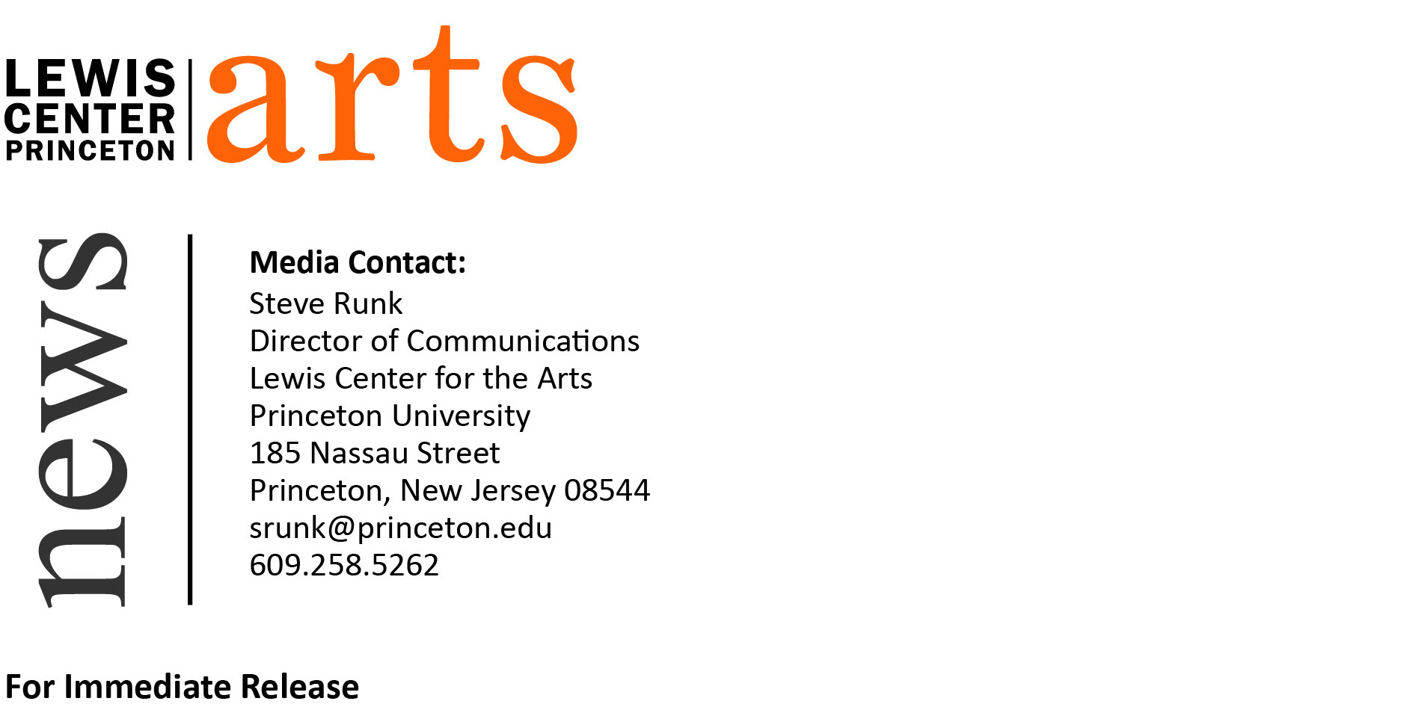
May 12, 2015

The Lewis Center for the Arts presents
End of Semester Screening
featuring the work of students in three film and video production courses

Photo caption: A still from the collaborative film created by Princeton students in the spring course, “Narrative Filmmaking: Working from the Script” taught by Su Friedrich
Photo credit: Mauricio Gonzalez-Aranda

What: End of semester screening of recent film and video works
Who: Work created by students in three film and video production courses: “How to Make a Film” led by Keith Sanborn, and “Documentary Filmmaking” and “Narrative Filmmaking: Working from the Script” led by Su Friedrich
When: Thursday, May 14, 2015 at 3:30 - 5:30 p.m. and continuing at 7:30 p.m.
Where: James M. Stewart ’32 Theater at 185 Nassau St.
Free and open to the public

(Princeton, NJ) The Lewis Center for the Arts’ Program in Visual Arts will present an End of Semester Screening featuring the recent film and video work of students in Keith Sanborn’s course “How to Make a Film” and Su Friedrich’s two courses, “Documentary Filmmaking” and “Narrative Filmmaking: Working from the Script.” The screening will take place on Thursday, May 14, in the James M. Stewart ’32 Theater at 185 Nassau Street. Work by students in “How to Make a Film” and “Documentary Filmmaking” will be shown from 3:30 p.m. to 5:30 p.m.; work by students in “Narrative Filmmaking: Working from the Script” will be shown beginning at 7:30 p.m. The screening is free and open to the public.

The course led by Sanborn, “How to Make a Film,” teaches students the basic tools and approaches for film production with digital media through hands-on studio work, screenings, critical readings, and group critiques. Friedrich’s “Documentary Filmmaking” course introduces students to documentary film production using digital video with an emphasis on the practical challenges of working in the real world. In Friedrich’s other course, “Narrative Filmmaking: Working from the Script,” students were given a segment of a script and were asked to interpret that text as creatively as possible, in whatever style they felt represented their individual visions as filmmakers.

Both Sanborn and Friedrich are award-winning and highly prolific filmmakers themselves.

The students whose video work will be shown at this screening include: Robia Amjad ’18, Annie Chen ’15, Richard Cheng ’15, Gabriella Chu ’18, Graham Cousins ’17, Alex Ford ’17, Mauricio Gonzalez-Aranda ’15, Taylor Jones ’18, Van Kluytenaar (GS Architecture), Mouse Lee ’17, Eliot Linton ’15, Adam Locher ’17, Emma Michalak ’17, Olamide Oladosu ’15, Chanyoung Park ’17, Julian Perez ’18, Pat Rooney ’17, Lance Rutkin ’17, Hawa Sako ’15, Grayson Shepperd ’16, Malcolm Steinberg ’17, Wilglory Tanjong ’18, Jack Thornton ’15, Roxana Turcanu ’16, and Najia Zahir ’15.

To learn more about the Programs in Visual Arts and the more than 100 events offered annually by the Lewis Center visit arts.princeton.edu.

###

