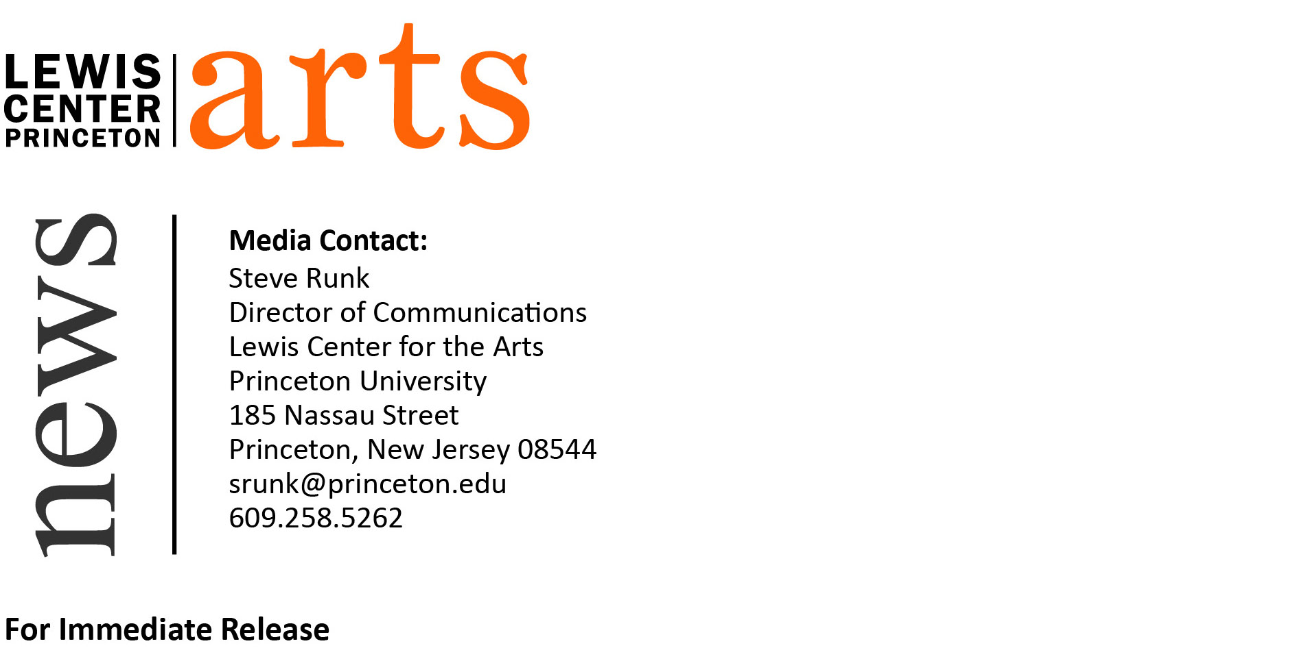

July 15, 2015

Tracy K. Smith Named Director of Princeton University’s
Program in Creative Writing
Pulitzer Prize-winning poet to head 75-year-old, unique undergraduate program

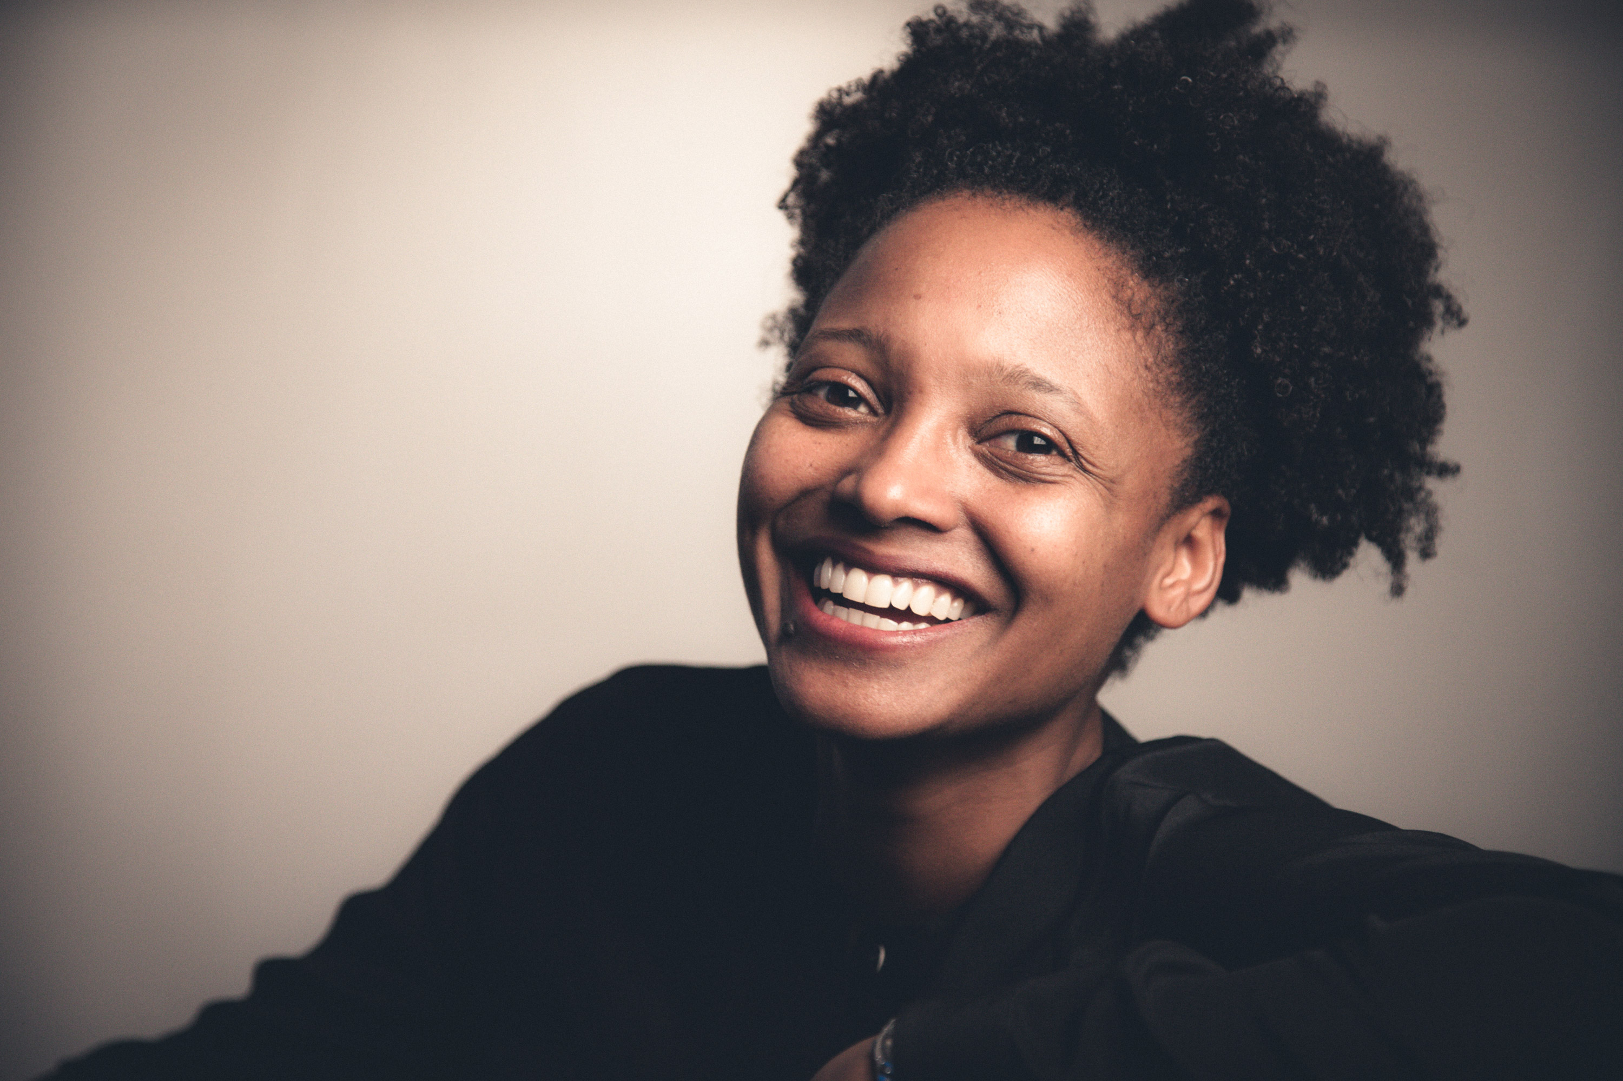
Photo caption: New Director of the Lewis Center for the Arts’ Program in Creative Writing at Princeton University, Tracy K. Smith
Photo credit: Rachel Eliza Griffiths

(Princeton, NJ) Princeton University’s Lewis Center for the Arts named Pulitzer Prize-winning poet Tracy K. Smith as the new director of the University’s Program in Creative Writing. Smith, a Professor of Creative Writing on the Princeton faculty since 2005, succeeds National Book Award finalist and poet Susan Wheeler, who has led the program since 2011.

"I'm delighted that Tracy has agreed to take on this leadership role in our world-renowned, undergraduate-focused program in creative writing,” notes Michael Cadden, Chair of the Lewis Center. “A brilliant wordsmith in both poetry and prose as well as a life-changing teacher, Tracy embodies everything that is best about the arts at Princeton and is a most worthy successor to our colleague Susan Wheeler. I look forward to working with her on her vision for the future of what is already an extraordinary program."

Smith is the author of the memoir Ordinary Light (2015) and three poetry collections: Life on Mars (2011), winner of the 2012 Pulitzer Prize and named as a "Best Book of the Year" by The New Yorker, Publishers Weekly, and Library Journal, a "Notable Book of 2011" by the New York Times, and as an "Editor's Choice" by the New York Times Book Review; Duende (2007), winner of the James Laughlin Award and the Essence Literary Award; and The Body's Question (2003), winner of the Cave Canem Poetry Prize. Smith is also the recipient of the Academy of American Poets Fellowship, a Rona Jaffe Award, and a Whiting Award. From 2009 to 2011 she was the Literature protégé in the Rolex Mentor and Protégé Arts Initiative.

Born in Massachusetts and raised in northern California, Smith earned her A.B. from Harvard University and an M.F.A. in creative writing from Columbia University. From 1997 to 1999 she was a Stegner Fellow in poetry at Stanford University. She taught at Medgar Evers College of the City University of New York, the University of Pittsburgh, and Columbia University before joining the faculty at Princeton.

“I have such deep gratitude and enthusiasm for the community of writers and students here at Princeton,” says Smith. “I’m delighted to step into a position I’ve watched several of my colleagues navigate with such generosity, insight, and grace.”

Princeton’s Program in Creative Writing traces its origins to 1939, when Dean Christian Gauss approached the Carnegie Foundation to help the University focus on the cultivation of writers and other artists. He appointed poet and critic Allen Tate as the first Resident Fellow in Creative Writing. Since then world-renowned writers have served as faculty and visiting guest writers including John Berryman, Elizabeth Bowen, Robert Fitzgerald, Thomas Gunn, Edmund Keeley, David E. Kelley, Lorrie Moore, Philip Roth, Delmore Schwartz, Kevin Young, and Nobel laureates Toni Morrison and Mario Vargas Llosa, as well as Joyce Carol Oates, who recently retired after 37 years on the faculty. Oates will continue to teach one class each year as a Professor Emerita.

Currently the faculty includes award-winning writers Jeffrey Eugenides, Chang-rae Lee, Paul Muldoon, James Richardson, Susan Wheeler, and Edmund White, along with Smith and Jhumpa Lahiri, who joins the faculty in September. Other writers teaching this fall include Michael Dickman, A.M. Homes, Christina Lazaridi, Patrick McGrath, Fiona Maazel, Idra Novey, Hanna Pylväinen, and Monica Youn.

It is with these internationally known writers that over 300 Princeton undergraduates take courses in poetry, fiction, screenwriting, and literary translation each semester, a number that continues to grow.

“For those students serious about becoming writers, the one-on-one mentoring and intimate workshops we offer are on par with the attention and rigor characterizing the best M.F.A. programs,” notes Smith. “Regardless what our students decide to do after graduation, the experience of working alongside such illustrious writers changes their view of language and literature immeasurably.” Students who seek a certificate in creative writing (similar to a minor) in addition to their major area of study, work one-on-one with a member of the faculty on a novel, collection of poems, short stories or translations, or a screenplay.
Some of these senior thesis projects become the first published work by graduates of the program, as was the case for writers Jonathan Ames ’87 and Jonathan Safran Foer ’99. Other graduates from the program include Catherine Barnett ’82, Boris Fishman ’01, Jane Hirshfield ’73, Kristiana Kahakauwila ’03, Galway Kinnell ’48, Walter Kirn ’83, William Meredith ’40, W. S. Merwin ’48, Emily Moore ’99, Jodi Picoult ’87, Julie Sarkissian ’05, Akhil Sharma ’92, Whitney Terrell ’91, and Monica Youn ’93.
In addition to this course of study, the program invites writers of national and international distinction to give a reading and discuss their work. The Althea Ward Clark W’21 Reading Series features acclaimed poets and fiction writers, which this year will include Edwidge Danticat, Natalie Diaz, Robert Hass, and Claudia Rankine, among others. The Emerging Writers Reading Series presented in partnership with Labyrinth Books in Princeton showcases new work by seniors in the program along with established writers as special guests, who this year will include Alexander Chee, Eduardo Corral, Ocean Vuong, and Tiphanie Yanique. Occurring monthly from September through May, readings in both series are free and open to the public.

The Program in Creative Writing also hosts an international high school poetry contest and awards the Theodore H. Holmes ’51 and Bernice Holmes National Poetry Prize with recipients such as Mark Doty, Matt Rasmussen, and Evie Shockley. The biennial Princeton Poetry Festival, curated by faculty member Paul Muldoon, features poets from around the world, in recent years presenting readings by Bei Dao, Kwame Dawes, Jorie Graham, Major Jackson, Ellen Bryan Voight, and Ray Young Bear, among others.

To learn more about the Lewis Center for the Arts and the Program in Creative Writing visit arts.princeton.edu.

###

