January 18, 2016

Visual Arts Program, Lewis Center for the Arts to Screen Independent Films
Filmmakers Alex Ross Perry, Matías Piñeiro, and Josephine Decker
screen and field questions about their work
Audiences join students in the spring course “World on a Wire: 12 Films, 12 Filmmakers”

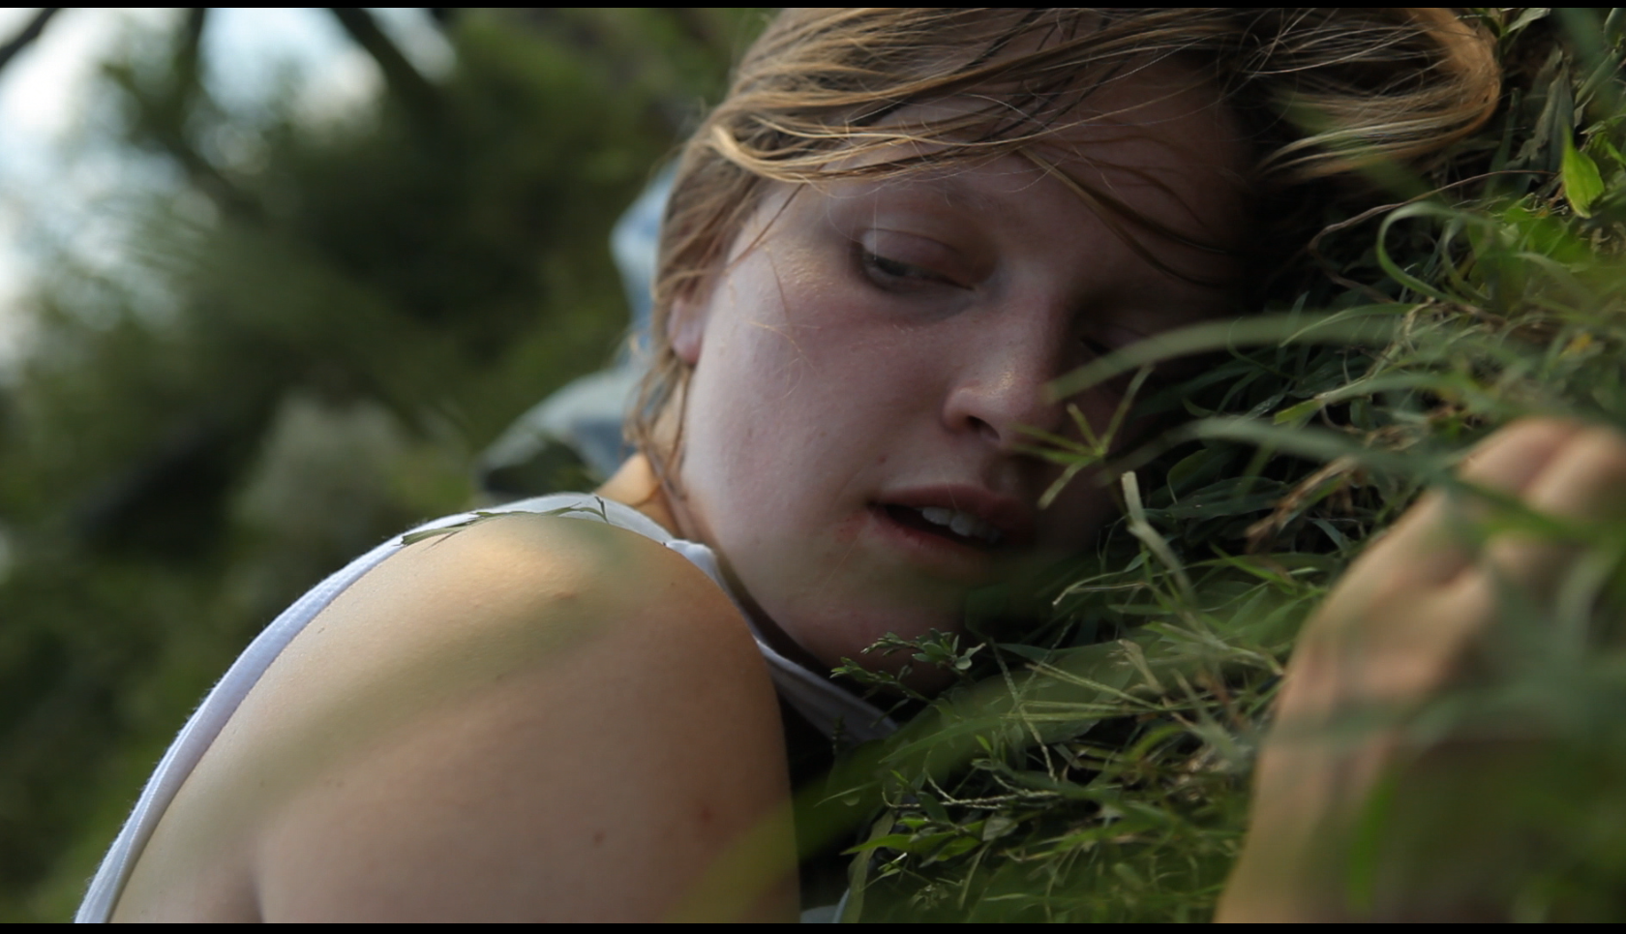
Photo caption: Still from Thou Wast Mild and Lovely, Josephine Decker’s experimental farm-set thriller
Photo credit: Courtesy of Josephine Decker

What: Screenings of recent independent films followed by discussions with the filmmakers, part of a film series presented through the course “World on a Wire: 12 Films, 12 Filmmakers”
Who: Filmmakers Alex Ross Perry, Matías Piñeiro, and Princeton alumna Josephine Decker, organized by Princeton Arts Fellow and faculty member Pacho Velez, presented by the Visual Arts Program, Lewis Center for the Arts
When: February 11, 18, and 25 at 7:30 p.m.
Where: James M. Stewart ’32 Theater at Lewis Center for the Arts, 185 Nassau St., Princeton
Free and open to the public

(Princeton, NJ) Audiences are invited to join Princeton University students to screen recent independent films and meet the filmmakers as part of the Visual Arts Program course “World on a Wire: 12 Films, 12 Filmmakers.” One film will be screened each Thursday evening starting February 11 and continuing through the end of April. All the films have been produced within the last 18 months and each of the filmmakers will be on hand to discuss their work and answer questions from the audience.

Films to be screened in February include Listen Up Philip by Alex Ross Perry on February 11; The Princess of France by Matías Piñeiro on February 18; and Thou Wast Mild and Lovely by Princeton alumna Josephine Decker on February 25. The screenings will take place at 7:30 p.m. in the James M. Stewart ’32 Theater at 185 Nassau Street and are free and open to the public.

In Alex Ross Perry’s Listen Up Philip, a writer on the brink of publishing his second novel is given the chance to live for a time at his literary idol’s summer home. Richard Brody of The New Yorker said of the film, "I can't think of a recent movie that stages with as much joy and wonder the sense of living a life that becomes, directly or obliquely, in action or in idea, the stuff of art."

The Princess of France by Matías Piñeiro follows a man newly returned to Buenos Aires after his father’s death to turn Love’s Labour’s Lost into a radio play and reconnect with past romantic entanglements. In a review for Indiewire, Eric Kohn praises Piñeiro’s “secretively advanced narrative technique” and “confident sensibility that pushes the original text in fresh directions.”

Josephine Decker’s Thou Wast Mild and Lovely is an experimental thriller inspired by East of Eden that details a farmhand’s menacingly erotic relationship with the family that hired him. It was named #2 on The New Yorker’s Top Ten of 2014 list of films. Decker is a member of Princeton’s Class of 2003.

The filmmakers and films were selected by Princeton Arts Fellow and faculty member Pacho Velez, who is teaching the course. Velez is a filmmaker who works at the intersection of ethnography, contemporary art, and political documentary. His current project, The Reagan Years, explores a prolific actor’s defining role: Leader of the Free World. Velez’s previous film, Manakamana, screened at Princeton last October and won a Golden Leopard Award at the Locarno Film Festival. It played around the world, including at the Whitney Biennial and the Toronto International Film Festival. His earlier film and theater work have been presented at venues such as the Edinburgh Fringe Festival, the Museum of Ethnography in Stockholm, and on Japanese National Television.

The course makes use of recent works by twelve engaging contemporary filmmakers to come to a deeper understanding of current film culture. Class discussions center on the issues preoccupying filmmakers today, the most fertile grounds for new cinematic work, and the process of navigating funding and distribution in the making of a film.

Other filmmakers scheduled in the series include Nicholas Pereda, Guy Maddin, Joanna Arnow and Khalik Allah in March, followed by Roger Ross Williams, Hassen Ferhani, Brett Story, and Deborah Stratman in April.

To learn more about these screenings, the Program in Visual Arts, and the more than 100 events offered annually by the Lewis Center visit arts.princeton.edu.

###

