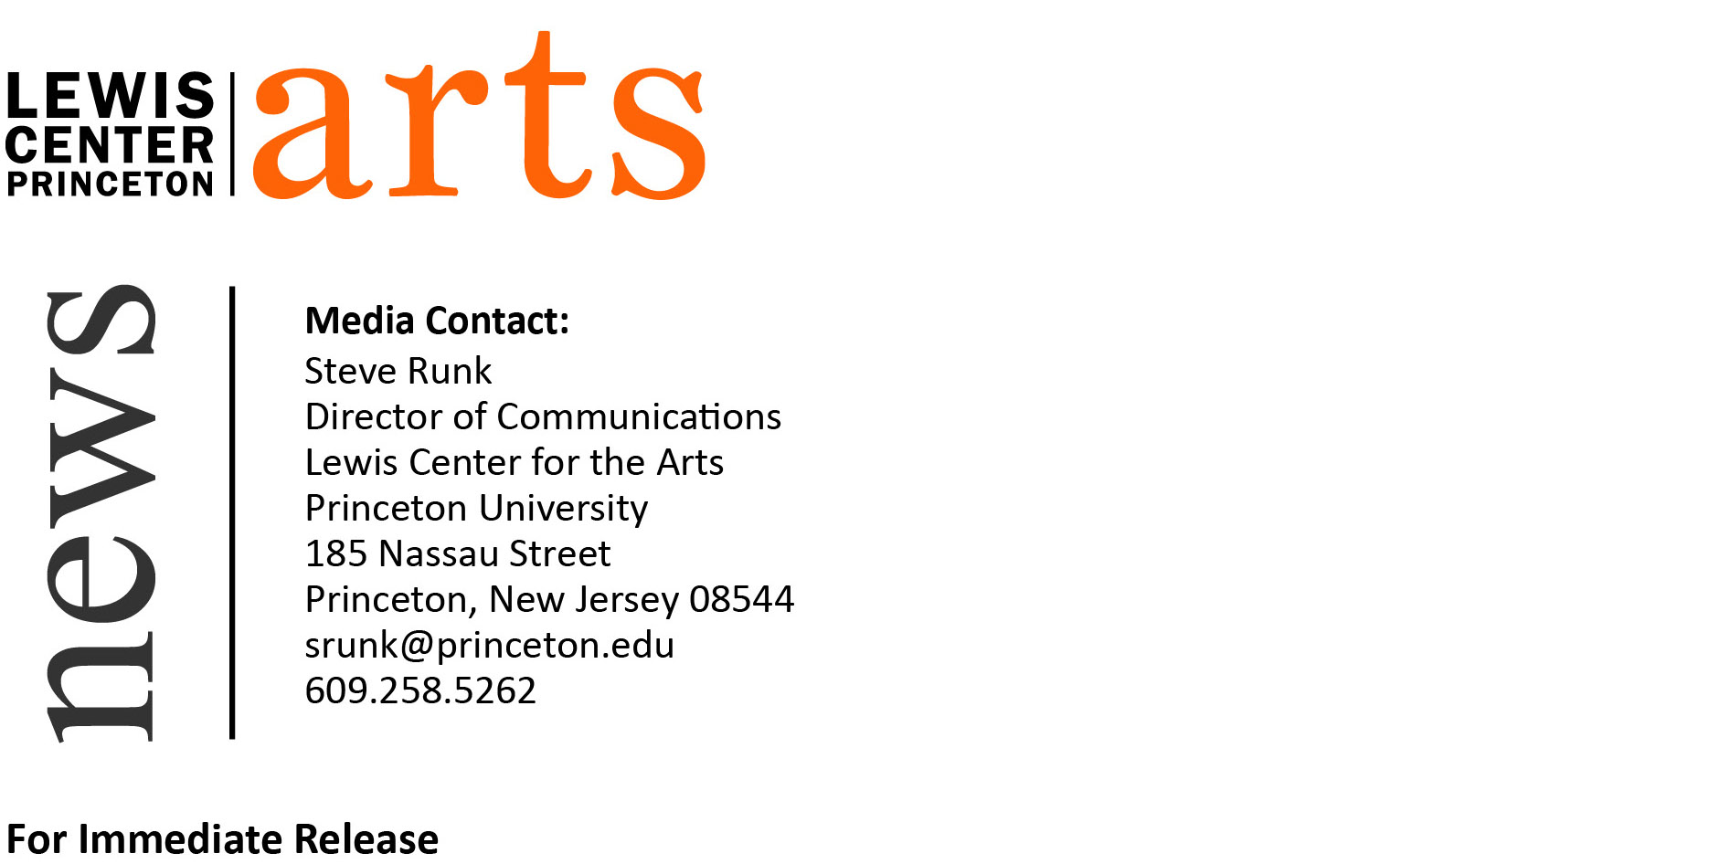
January 15, 2016

Lewis Center for the Arts presents
"Where Can I Imagine You Have Been?:
A Reading and Conversation with Claudia Rankine."
Award-winning poet next in Althea Ward Clark W’21 Reading Series

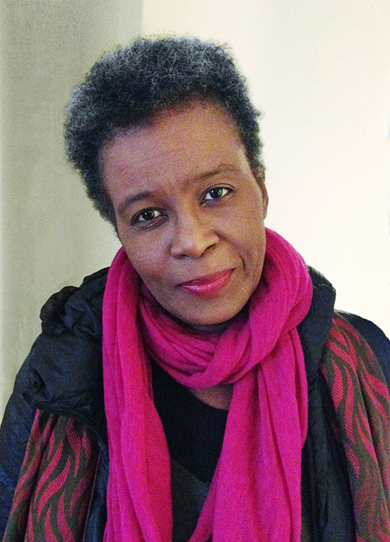
Photo caption: Award-winning poet Claudia Rankine will read as part of the Althea Ward Clark W’21 Reading Series on February 10
Photo credit: John Lucas

Who: Reading by award-winning poet Claudia Rankine followed by an onstage converstation with poet Tracy K. Smith, director of the Program in Creative Writing
What: Fourth reading in the 2015-16 Althea Ward Clark W’21 Reading Series
When: Wednesday, February 10 at 4:30 p.m.
Where: Berlind Theatre at McCarter Theatre Center, 91 University Place, Princeton
Free and open to the public

(Princeton, NJ) Award-winning poet Claudia Rankine will read from her work on Wednesday, February 10, as part of the Althea Ward Clark W’21 Reading Series of the Program in Creative Writing at the Lewis Center for the Arts. After the reading, Tracy K. Smith, director of the Program in Creative Writing, will join Claudia Rankine for an onstage conversation. The event, beginning at 4:30 p.m. at the Berlind Theatre at the McCarter Theatre Center, is free and open to the public.

Claudia Rankine is the author of five collections of poetry, including Citizen: An American Lyric (2014), Don’t Let Me Be Lonely (2004), Plot (2001), The End of the Alphabet (1998), and Nothing in Nature is Private (1994). Rankine is also the author of a play, Provenance of Beauty: A South Bronx Travelogue (2009), which is performed on a bus ride through the Bronx. She won the PEN Open Book Award and National Book Critics Circle Award for Poetry for Citizen, the first book ever to be named a finalist in both the poetry and criticism categories. Citizen also holds the distinction of being the only poetry book to be a New York Times bestseller in the nonfiction category. In 2014 Rankine was awarded the Poets & Writers’ Jackson Poetry Prize and was a National Book Award Finalist. She has also been a recipient of the Academy of American Poets Fellowship. She co-edited the anthologies The Racial Imaginary: Writers on Race in the Life of the Mind and American Women Poets in the 21st Century: Where Lyric Meets Language, and her work is included in several anthologies, including Great American Prose Poems: From Poe to the Present, Best American Poetry 2001, Giant Step: African American Writing at the Crossroads of the Century, and The Garden Thrives: Twentieth Century African-American Poetry. She lives and teaches in California.

The Lewis Center’s Program in Creative Writing annually presents the Althea Ward Clark W’21 Reading Series, which provides an opportunity for students, as well as all in the greater Princeton region, to hear and meet the best writers of contemporary poetry and fiction. All readings are free and open to the public and take place on select Wednesdays at 4:30 p.m. at the Berlind Theatre at McCarter Theatre Center. Upcoming readings scheduled in the 2015-2016 series include Edwidge Danticat and Robert Hass on March 9 and Ciaran Berry and Nell Zink on April 6.

For more information on the series, the Program in Creative Writing, and the more than 100 other events annually offered by the Lewis Center for the Arts, most of them free, visit arts.princeton.edu.

###

