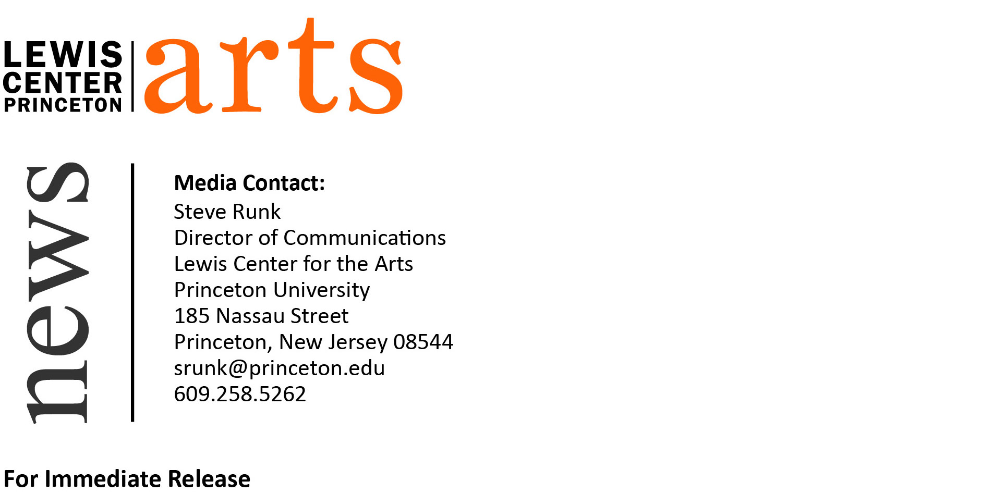
March 1, 2016

Lewis Center for the Arts presents
A Reading by Edwidge Danticat and Robert Hass
National Book Award nominee and Poet Laureate next in
Althea Ward Clark W’21 Reading Series

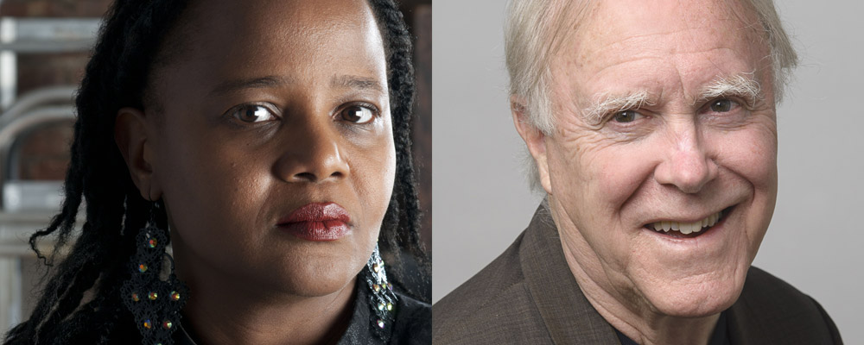
Photo caption: Writer Edwidge Danticat (left) and poet Robert Hass will read at the Althea Ward Clark W’21 Reading Series on March 9
Photo credits: Courtesy of Edwidge Danticat; photo of Robert Hass by Shoey Sindel

Who: Reading by two-time National Book Award nominee Edwidge Danticat and former U.S. Poet Laureate and translator Robert Hass
What: 2015-16 Althea Ward Clark W’21 Reading Series presented by Princeton’s Program in Creative Writing
When: Wednesday, March 9 at 4:30 p.m.
Where: Berlind Theatre at McCarter Theatre Center, 91 University Place, Princeton, NJ
Free and open to the public

(Princeton, NJ) On Wednesday, March 9, writer Edwidge Danticat and poet Robert Hass will read from their works as part of the Althea Ward Clark W’21 Reading Series of the Program in Creative Writing at the Lewis Center for the Arts at Princeton University. The reading, beginning at 4:30 p.m. at the Berlind Theatre at the McCarter Theatre Center, is free and open to the public.

Novelist and short story writer Edwidge Danticat was born in Haiti and moved to Brooklyn at the age of twelve. She graduated from Barnard College and earned an M.F.A. at Brown University. Her first novel, Breath, Eyes, Memory, was selected for Oprah’s Book Club; the short story collection that followed, Krik? Krak!, was nominated for the National Book Award. She earned another National Book Award nomination and the National Book Critics Circle Award for her 2007 memoir, Brother, I’m Dying. She was named by The New York Times Magazine as one of “30 under 30” Creative People to Watch” and noted as “likely to change the culture for the next 30 years,” Her many other awards and honors include a MacArthur Genius Grant in 2009. Danticat has taught creative writing at New York University and the University of Miami.

Writer and editor Robert Hass served as U.S. Poet Laureate from 1995 to 1997 and is the author of numerous collections of poetry, essays, and translations. He has published several books of poetry, including The Apple Trees at Olema: New and Selected Poems (2011), Time and Materials (2007), Field Guide (1973), Praise (1979), Human Wishes (1979), and Sun Under Wood (1996). He has written several books of essays and poetry criticism, including Now & Then (2007) and What Light Can Do: Essays on Art, Imagination, and the Natural World (2013), which received the PEN/Diamonstein-Spielvogel Award for the Art of the Essay. Hass has translated many of the works of Nobel Prize-winning Polish poet Czesław Miłosz. He has edited several anthologies, including Selected Poems: 1954-1986 by Tomas Transtromer; The Essential Haiku: Versions of Basho, Buson, and Issa; Poet's Choice: Poems for Everyday Life; and Modernist Women Poets: An Anthology (with Paul Ebenkamp). As Poet Laureate, his deep commitment to environmental issues led him to found River of Words (ROW), an organization that promotes environmental and arts education in affiliation with the Library of Congress Center for the Book. Hass is a winner of a Pulitzer Prize and a National Book Award, and he was chosen as Educator of the Year by the North American Association on Environmental Education and elected to the American Academy of Arts & Sciences. His next book, A Little Book on Form: An Exploration Into the Formal Imagination of Poetry, is forthcoming from HarperCollins in fall 2016.

The Lewis Center’s Program in Creative Writing annually presents the Althea Ward Clark W’21 Reading Series, which provides an opportunity for students, as well as all in the greater Princeton region, to hear and meet the best writers of contemporary poetry and fiction. All readings are free and open to the public and take place on select Wednesdays at 4:30 p.m. at the Berlind Theatre at McCarter Theatre Center. The next reading scheduled in the 2015-2016 series features Ciaran Berry and Nell Zink and will take place on April 6, and concludes in May with readings by students in the Program.

For more information on the series, the Program in Creative Writing, and the more than 100 other events annually offered by the Lewis Center for the Arts, most of them free, visit arts.princeton.edu.

###

