

February 9, 2015

Lewis Center for the Arts’ Program in Dance presents
International Dance Platform: Contemporary Dance in
Turkey, Poland, Canada
Four-day series of informal performances, a panel discussion, and master classes around the premiere of Rebecca Lazier’s new work “There Might be Others”

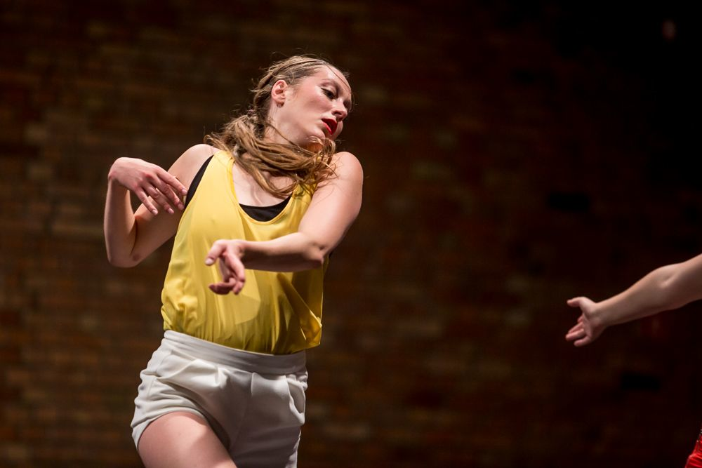
Photo caption: Ramona Nagabczynska from Poland, one of seven guest artists who will visit Princeton for the International Dance Platform February 27-March 1
Photo credit: Jakob Wittchen for Art Stations Foundation by Grażyna Kulczyk

What: International Dance Platform: Contemporary Dance in Turkey, Poland, Canada, a series of master classes, a panel discussion, and informal performances
Who: Professional dancer-choreographers from Turkey, Poland and Canada in conjunction with faculty and students in the Lewis Center for the Arts’ Program in Dance organized by dance faculty member Rebecca Lazier
When: February 27 – March 1
Where: 185 Nassau St. in Princeton
Free and open to Princeton students to participate and the public to observe
(Princeton, NJ) The Lewis Center for the Arts’ Program in Dance at Princeton University will present International Dance Platform: Contemporary Dance in Turkey, Poland, Canada, which brings seven international dancer-choreographers to Princeton for a series of master classes, a panel discussion, and informal performances. The series leads up to the New York Live Arts premiere of faculty member Rebecca Lazier’s new work “There Might Be Others.”

The events of the International Dance Platform will take place at various times between Saturday, February 27 and Tuesday, March 1 at 185 Nassau Street and New South on the Princeton campus and are presented in collaboration with Princeton’s Institute for International and Regional Studies and Program in Canadian Studies.

The platform’s aim is to bring international perspectives to the study and practice of dance at Princeton. Students will have the opportunity to learn about the various ecologies of dance in each country—which, according to organizer and Program in Dance Senior Lecturer Rebecca Lazier, are “wildly different.” “My hope is to not only expose students to new approaches to dance,” says Lazier, “but also provide the chance for them to become part of larger conversations in dance that span the borders of culture, nation, and discipline.”

On Saturday, February 27, two master classes will be held: “Spinning Around the Heart: Sufi Whirling” with Turkish artist Tan Temel from 12:00 to 2:00 p.m.; and “Contact Improvisation” with Canadian artist Sara Coffin of Mocean Dance from 2:15 to 4:00 p.m., both classes in the Patricia and Ward Hagan ’48 Dance Studio at 185 Nassau Street.

On Sunday, February 28 at 5:00 p.m., an open rehearsal of Lazier’s new work “There Might Be Others” will be presented by the international guest artists, dancers from the New York Live Arts premiere cast, and ten Princeton students who are seniors in the Program in Dance in the Hagan Dance Studio.

On Monday, February 29, a lunchtime panel, “Politics of Artistic Production: Turkey, Poland and Canada,” will be presented from 12:00 to 1:30 p.m. Independent artists from each country will discuss how their work evolved in the social, political, cultural, and economic conditions of their homelands. The panel, moderated by Lazier, will examine how dance is transmitted through education and production in each country and share how choreographers train, produce, and support themselves in shifting landscapes.

Later on Monday, from 4:30 to 6:20 p.m., Polish dance artist Ramona Nagabczynska will present a master class on “The Art of Stealing (Badly)” in the New South Dance Studio. From 7:30 to 9:20 p.m. Canadian dance artist Rhonda Baker of Mocean Dance will present a master class on “Contemporary Technique with Influences from Axis Syllabus and Gaga Technique” in the Hagan Dance Studio.

On Tuesday, March 1, from 4:30 to 6:20 p.m., Polish dance artist Jan Lorys will present a master class on “Partnering and Fighting Monkey Practice” in the Hagan Dance Studio.

The Platform event will conclude the evening of March 1 with a showing of international guest choreographer work by Tan Temel, Sara Coffin, Pawel Sakawicz, and Ramona Nagabczynska from 6:30 to 8:00 p.m. in the James M. Stewart ’32 Theater at 185 Nassau Street.

The panel, open rehearsal and showing are free and open to the public. The master classes are open to Princeton University students to participate and the public to observe. Reservations are not required for any of the events.

Lazier’s new work, “There Might Be Others,” is inspired by Terry Riley’s In C and work builds on the tradition of open scores, where performers compose in real-time based on a predetermined array of content to stage negotiation. Lazier developed the score during residencies in Poland, Turkey, Canada, and New York. A company of professional dancers will premiere the work at New York Live Arts on March 16 through 19. The music for the premiere has been composed by Princeton Department of Music faculty member Dan Trueman in collaboration with Sō Percussion, the Edward T. Cone Ensemble-in-Residence at Princeton, and Mobius Percussion.
This past summer the dancers, Lazier, and Trueman joined Sō Percussion’s Summer Institute at Princeton, SōSi, for a residency to create the work. Trueman and Lazier have also been collaborating with Naomi Leonard, Professor of Mechanical and Aerospace Engineering at Princeton, to further their research in group decision-making and collective motion. With post-doctoral researchers Kayhan Özcimder and Biswadip Dey, Leonard acts as a dramaturge to help Lazier, Trueman and the cast of “There Might Be Others” push their investigations of collective composition beyond their initial impulses. Leonard, Özcimder, and Dey have authored a paper, “Investigating Group Behavior in Dance: An Evolutionary Dynamics Approach.”

Lazier taught the score to ten senior certificate dance students who will perform a unique, condensed version of the piece as part of Under Pressure, their senior dance thesis concert in Berlind Theatre at McCarter Theater Center on March 25 and 26. Throughout the rehearsal process Princeton students have had the opportunity to rehearse with the New York cast and the international guests on campus and in New York City.

In addition to the support provided by the Princeton Institute for International and Regional Studies and the Program in Canadian Studies, the platform event is being funded in part by the
Özyegin University in Turkey; Yildiz Technic University in Turkey; The Province of Nova Scotia's Department of Communities, Culture and Heritage in Canada; Mocean Dance; and Culture.pl as part of the Campus Project. The Campus Project aims at fostering lasting relations between Poland and selected American academic institutions that span theater, music, visual arts, film, literature, architecture and the social sciences. As well as initiating workshops, study visits, concerts, lectures, conferences and exhibitions, the Campus Project supports the initiatives of its partner universities: MIT, Harvard, Yale, Princeton, Columbia, the University of Michigan, University of Illinois at Chicago, Emerson College Boston and L.A., Bard College, Barnard College, the New School New York, Brandeis University, UCLA, USC and CalArts. The Campus Project was launched in 2012 by the Adam Mickiewicz Institute, a national cultural institution aiming to strengthen Polish cultural impact and to enrich international cultural exchange. The Campus Project and all other activities of the Institute are carried out under the flagship brand Culture.pl.

For more information on this event, the Program in Dance, and the more than 100 other public events presented each year by the Lewis Center for the Arts visit arts.princeton.edu.

###

Artist Biographies:
Rhonda Baker ​is a Dora Award-nominated artist living in Halifax, Nova Scotia. She has performed for Coleman Lemieux & Compagnie, Mocean Dance, and Gallim Dance since graduating from The School of Toronto Dance Theatre in 2009. Baker maintains a practice of solo improvisation and has trained in Gaga and the Axis Syllabus. She also works independently as a soloist and performed Nutshell (choreography by Sharon Moore) at the Guelph Dance Festival.
Sara Coffin ​is a Halifax-based dance artist and co­artistic director of Mocean Dance. She completed her M.F.A. at Smith College, holds a B.F.A. in Dance from Simon Fraser and a B.Sc. in Kinesiology from Dalhousie. Coffin has worked with many collaborators and companies across Canada and the U.S. including Chris Aiken, Angie Hauser, and Annie Kloppenberg. She has taught at Smith College, Hampshire College, Earth Dance, and Holland College School for Performing Arts (PEI). Her work has been presented in many of Canada’s major dance festivals, commissioned by Mocean Dance (2014, 2016), and her 2011 self-produced piece, Taking Your Experience for Mine, was been described by the press (Georgia Straight) as “hauntingly gorgeous.”
Sara Coffin and Rhonda Baker appear courtesy of Mocean Dance. Based in Halifax, Nova Scotia, Mocean Dance is nationally recognized in Canada as a leading company from the Atlantic region. Led by co-artistic directors Susanne Chui and Sara Coffin, Mocean commissions Canadian and international choreographers to create dance that is highly physical, collaborative, and technically and emotionally rich. Founded in 2001, Mocean is committed to its home base in Nova Scotia and contributes to the provincial art scene through creation, performance, collaboration and dance education. Mocean’s participation in this production is generously supported by The Province of Nova Scotia Department of Communities, Culture & Heritage. www.moceandance.com
Agnieszka Kryst graduated from the Warsaw School of Economics and the Fryderyk Chopin University of Music in Warsaw with a M.A. diploma in choreography and dance theory. In 2013 she received a scholarship from the Alternative Dance Academy, Old Brewery New Dance, Poznań, Poland and was a finalist of the choreographic competition New Europe Festival in Prague. As a performer she has collaborated with Karolina Kroczak, Tomas Nepsinski, Juan Domìnguez Rojo, Małgorzata Haduch, Sjoerd Vreugdenhil, and Marta Ziółek and has presented her own choreography throughout Poland and abroad.
Rebecca Lazier choreographs and directs a project-based group of dancers in New York and is a Senior Lecturer in dance at Princeton University. A native of Halifax, Nova Scotia and a Juilliard alum, she has produced her work in Hartford, Los Angeles, Istanbul, and, for the past 20 years, New York. Recently a film of her piece Coming Together/Attica, which premiered at The Invisible Dog in June 2013, was featured in the exhibit IK-00 Spaces of Confinement produced by Moscow based foundation v–a–c the art of being contemporary in Venice, Italy as part of the Architecture Biennale. In July 2014, Coming Together/Attica toured to the Moni Lazariston Festival in Thessaloniki and the Patras International Festival in Patras, produced by the American Embassy in Athens. In New York Lazier’s work has been presented at many venues including La MaMaMoves! Festival, Danspace Project, The Kitchen, the Guggenheim Museum, 92nd Street Y, Joyce SoHo, and Movement Research at the Judson Church. The company has toured to a variety of locales from Martha’s Vineyard to Los Angeles, Jacob’s Pillow to New Orleans, from Nova Scotia to Canada and Turkey. Lazier has received grants from the Puffin Foundation, New Music USA’s 2013 Live Music for Dance Program, Canada Council on the Arts, and the Greater New York Department of Cultural Affairs, administered by the Brooklyn Arts Council, Inc. She has been artist-in-residence at Movement Research, The Joyce Theater Foundation, The Yard and the Djerassi Resident Artist Program. Lazier has been on faculty at Princeton University for 12 years and previously taught at UCLA, Mimar Sinan Conservatory in Istanbul, Trinity College, Hartford Ballet/University of Hartford, and Wesleyan University. She has been a guest artist at numerous institutions including James Madison University, Muhlenberg College, Columbia College, Shenendoah Conservatory, Interlochen Arts Academy, Hartford Springfield College, and Dance Nova Scotia. She is currently on the faculty of the Summer Program at the Mark Morris Dance Center. She recently joined the Editorial Board of the journal Dance Practices in the Classroom published by National Dance Educators Organization. She has led working groups at CORD, presented her paper “Plan Critically to Teach Creatively” at NDEO, and been on panels at Gina Gibney Dance Center, the Institute for Advanced Study at the University of Minnesota, and The Juilliard School.
Jan Lorys was born in Kraków, attended the private acting school Lart Studio and graduated as with a Master of Art from PWST National Academy of Theatre Arts in Krakow Dance Department in Bytom. In addition to acting and choreographing, Lorys has danced with Anna Piotrowska, Eryk Makohon, Kamils Wawrzuta, Jozef Frocek, Annie Vigier and Franck Apertet, Sharon Reshef, and Rebecca Lazier, among others.
Ramona Nagabczynska was born in Toronto but trained in ballet at the Warsaw State Ballet School and in contemporary dance in Frankfurt and London. Nagabczynska has performed with Polish Dance Theatre, Fleur Darkin, Junk Ensemble, Lucy Guerin, Emma Martin, David Wampach, Ula Sickle, Sjoerd Vreugdenhil, Maria Stoklosa, Paulina Ołowska, and Clod Ensemble. She has been making her own work since 2009 and became the Aerowaves Priority Company in 2014.
Pawel Sakowicz graduated from the University of Warsaw with a degree in political studies and holds an M.A. in performance and choreography from the London Contemporary Dance School. He has collaborated with Jeannie Steele, Paolo Mangiola, Ramona Nagabczyńska, Sjoerd Vreugdenhil, Mikołaj Mikołajczyk, Marta Ziółek, Rebecca Lazier, Iza Szostak, Alex Baczyński­-Jenkins, and Isabelle Schad. His own works were supported by the Ministry of Culture and National Heritage and the Art Stations Foundation by Grażyna Kulczyk.
Tan Temel graduated from Mimar Sinan University State Conservatory Modern Dance Department and has since been on faculty at Yıldız Technical University Modern Dance Program. He received his M.A. at Yildiz and his M.F.A. at Case Western University. He has danced with CRR Dance Theater Company and worked with Istanbul Dance Theater (IDT+) as dancer, choreographer, and instructor. He received the “International Choreographer Award” from the Dance Chicago Festival and in 2011 both started his own company TORK Dance Art and was appointed artistic director of L’Officina Dance Company based in Florence, Italy.
###

