February 29, 2016

Lewis Center for the Arts presents Performance Lab
New interdisciplinary work created by students, mentored by faculty

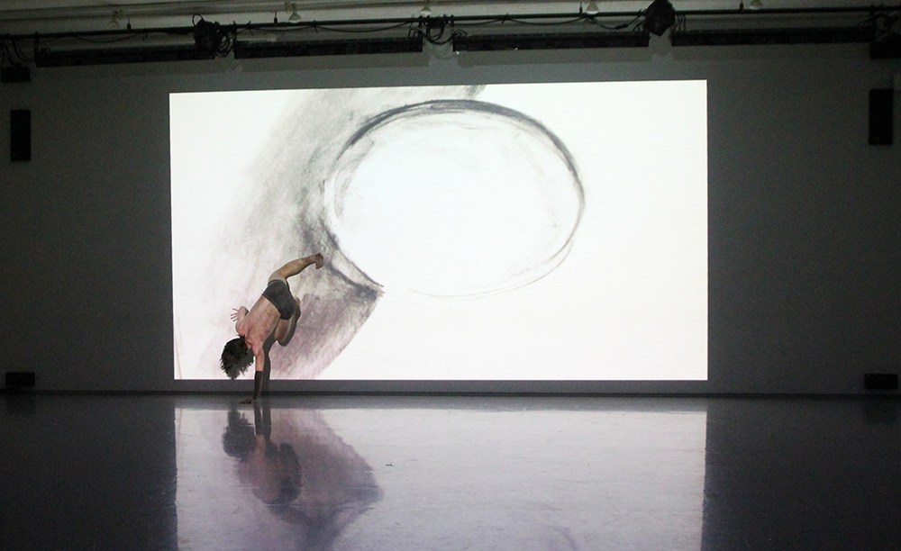
Photo caption: One of the projects presented in last year’s Performance Lab, a dance-visual art interdisciplinary work by Bree White '16
Photo credit: M. Teresa Simao

What: Performance Lab – performance of new interdisciplinary work
Who: Work created by Princeton student artists Yasmine Eichbaum '18, Dana Fesjian '17, Avigail Gilad '19, William Keiser '19 Anna Kimmel '18, Nico Krell '18, Alex Quetell '17, Tsjum Jhor Kai van der Horst '19, and Nathaniel Whitfield GS
When: Thursday, March 3rd and Friday, March 4th at 7:00 p.m. Each performance is followed by a talkback.
Where: Patricia and Ward Hagan ’48 Dance Studio at 185 Nassau Street
Free and open to the public

(Princeton, NJ) The Lewis Center for the Arts’ Program in Dance at Princeton University will present Performance Lab showcasing new work created by nine Princeton students, on Thursday and Friday, March 3 and 4 at 7:00 p.m. in the Patricia and Ward Hagan ’48 Dance Studio. Each performance will be followed by a talkback. The event is free and open to the public.

Performance Lab provides an opportunity for students working in dance, writing, theater, or visual art to showcase their new interdisciplinary work developed through discussion with other artists and mentorship from dance faculty. Through one-on-one meetings over the past several months, students have looked at the ways that structure, intent, and theatrical elements can support their artistic creation. The independent student projects showcased at this event are the product of this mentored creative process.

The work to be performed in Performance Lab represents diverse approaches inspired by a wide variety of themes. Junior Alex Quetell has created a solo called “Rain Phases.”. Junior Dana Fesjian created a dance developed by robots but danced by humans. The piece by sophomore Nico Krell explores the line between abundance and overindulgence through the senses. Sophomore Anna Kimmel’s trio is described by her as exploring, “The process of self discovery and self reflection that allows for self creation,” and sophomore Yasmine Eichbaum created “I am so happy I could cry,” which explores the point at which one experiences the simultaneous feeling of paradoxical emotions such as happiness and sadness. The work by freshman Avigail Gilad is titled “Breaking Point” and explores the intersection of war and family. Freshman Tsjum Jhor Kai van der Horst created a trio that plays with structure and autonomy. The piece by freshman William Keiser is a duet with live music that considers what happens when you turn around and someone is or isn’t there. Graduate student Nathaniel Whitfield created "Dagenham Pigeon" in which he asks (after John Ruskin), “…how would you like the world, if all your meadows, instead of grass, grew nothing but iron wire…”

Students were invited to submit recent new work for consideration by Dance Program faculty in the fall. Faculty member Aynsley Vandenbroucke has been mentoring the students in development of their pieces, which will be performed by other Princeton students.

Lighting design for Performance Lab is by Nick Solyom.

The Program in Dance, led by award-winning choreographer Susan Marshall, offers Princeton undergraduates a wide range of opportunities in dance. Students can enroll in a single course, pursue a certificate in dance (similar to a minor), or participate in co-curricular classes. Studio-based courses taught by dance professionals range from modern and contemporary to ballet, to experimental, urban and African dance, and include the creation of original work, study of master repertory, and rigorous technical training. Frequent performance opportunities are provided including the annual Princeton Dance Festival, a senior thesis collaborative concert, and informal showings.

For more information on this event, the Program in Dance, or any of the more than 100 events presented annually by the Lewis Center for the Arts, visit: http://arts.princeton.edu/plab.

###

