March 29, 2016

“Saw the question (unweighted count); Answered the question (unweighted count); Didn’t think it was serious enough to talk about”
opens at the Lewis Center for the Arts
A Senior Thesis Show by Kasturi Shah, #sawtheq

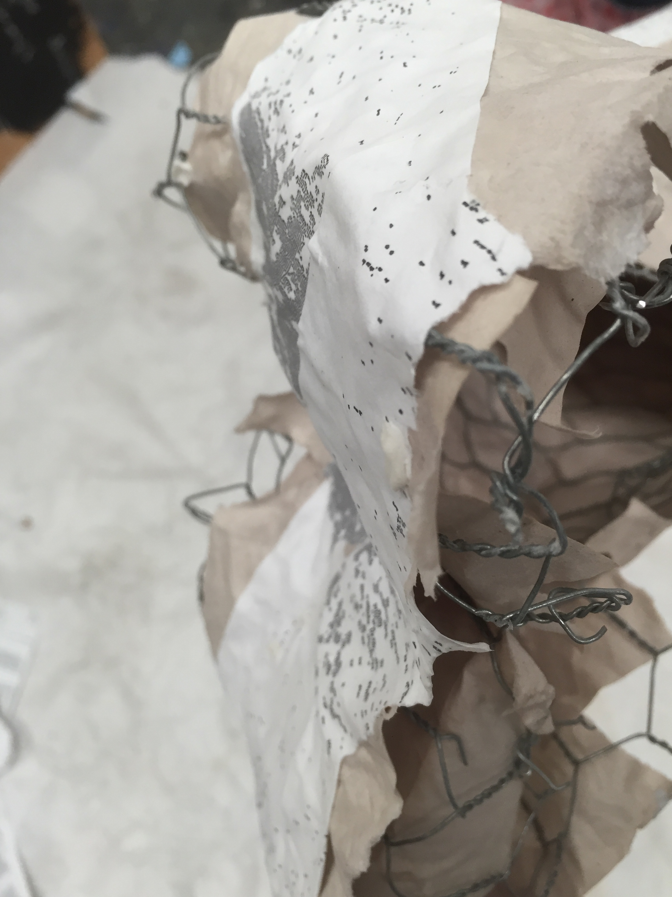
Photo caption: One of senior Kasturi Shah’s site specific sculptures that will be placed across campus
Photo credit: Photo by Kasturi Shah

What: A public interactive piece that visualizes the data presented in the We Speak survey results, a survey of Princeton students’ knowledge of policies and resources related to sexual misconduct. The piece is titled “Saw the question (unweighted count); Answered the question (unweighted count); Didn’t think it was serious enough to talk about”
Who: Created by senior in the Lewis Center’s Program in Visual Arts Kasturi Shah
When: April 4 through 8, opening reception Thursday, April 7 from 7:00 to 8:30 p.m.
Where: Princeton University campus. Reception held in Lucas Gallery at 185 Nassau St.
Free and open to the public

(Princeton, NJ) The Lewis Center for the Arts’ Program in Visual Arts at Princeton University will present a public interactive piece by senior Kasturi Shah that visualizes the data presented in the We Speak survey, scaled up to span the entire campus. The survey investigates experiences with sexual misconduct and knowledge about policies and resources that are available. Titled “Saw the question (unweighted count); Answered the question (unweighted count); Didn’t think it was serious enough to talk about,” the event will be live April 4 through April 8 across campus and on a website. A multimedia, interactive component of the piece will be on view in the Lucas Gallery at 185 Nassau Street. A reception with the artist will be held on April 7 from 7:00 p.m. to 8:30 p.m. in the gallery. The work and reception are free and open to the public.

The We Speak survey, a Title IX compliance requirement, was released to all members of the Princeton University community in Spring 2015, with results being made public in early Fall 2015. The results are comprised of tables of data, which Shah seeks to make palpable and comprehensible through her piece.

Shah is majoring in physics with certificates in visual arts and Latin American studies at Princeton. The artist has used her background in physics to create a parallel between Feynman diagrams that describe particle interactions and the paths on campus that record the trajectories and interactions of people who walk on them. The vertices are placed along some of the frequented paths on campus. However, the interactive nature of the piece does not stop there. The We Speak survey results have been mapped onto the paths on this network. Each path represents options in a tree diagram of sexual misconduct, so that the network of paths becomes a live map of the We Speak data.

The interactive piece consists of seven sectioned sculptures distributed to different locations across campus. The sections are randomly scattered and get assembled through interactions by people across campus and through #sawtheq. Each sculpture has a QCR code that when scanned takes one to a hidden section of the piece’s website: www.sawtheq.com. In the Lucas Gallery a multimedia projection of data in the survey allows viewers to interact with and experience the data in another material way.

Shah lives in India, where an increasing number of people her age face sexual and physical abuse. Her work for her thesis show is not only fueled by the climate surrounding sexual misconduct on U.S. university campuses but also by the perspective she has from her experiences in India.

The piece is live 24 hours a day Monday through Friday on campus. The Lucas Gallery is open Monday through Friday from 11:00 a.m. to 4:30 p.m.

To learn more about the Lucas Gallery, the Program in Visual Arts, and other events presented each year at the Lewis Center visit arts.princeton.edu.

###

