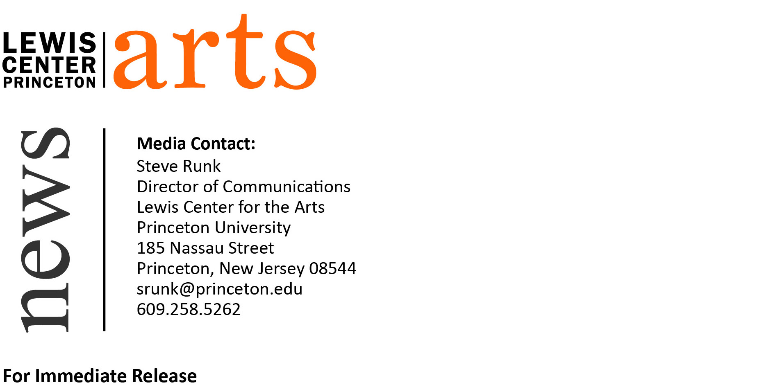

March 17, 2016

“time is a floating point number.” opens at the Lewis Center for the Arts
A Senior Thesis Exhibition by Neeta Patel
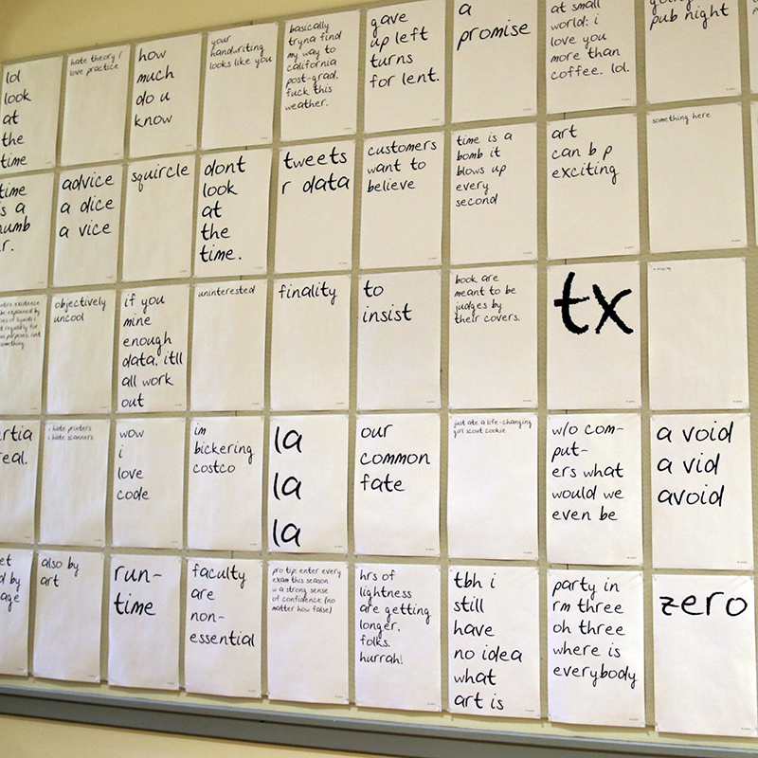
Image caption: A portion of the work that will appear in senior Neeta Patel’s thesis exhibition, “time is a floating point number.”: computer-generated prints based on the artist's Twitter account and using her handwriting font.

What: A multimedia exhibition exploring mark-making, its transposition through a mechanical process, and distribution, entitled “time is a floating point number.”
Who: Neeta Patel, a senior in the Lewis Center’s Program in Visual Arts
When: March 21 through March 25, opening reception March 22 from 5:30 to 7:00 p.m.
Where: Lucas Gallery at 185 Nassau St. open Monday-Friday, 10 a.m.-4:30 p.m.
Free and open to the public

(Princeton, NJ) The Lewis Center for the Arts’ Program in Visual Arts at Princeton University will present a multimedia exhibition by senior Neeta Patel that explores mark-making, its transposition through a mechanical process, and distribution. Entitled “time is a floating point number.” the exhibition will be on view March 21 through 25 in the Lucas Gallery at 185 Nassau Street. A reception where visitors can meet the artist will be held on March 22 from 5:30 p.m. to 7:00 p.m. The exhibition and reception are free and open to the public.

Patel, who is from Blackwood, New Jersey, is majoring in visual arts through a collaborative program between the Department of Art and Archaeology and the Program in Visual Arts at Princeton. She enrolled at Princeton planning to major in computer science, but discovered her diverse academic and creative interests were better satisfied through studio art than computer programming.

Patel’s exhibition will include a number of elements that explore her ideas. Prints she created using a handwritten font she developed last year will occupy an entire wall of the gallery. People passing by 185 Nassau Street may have noticed messages she posted in her studio windows since September using this invented font.

Her show will also include copies of the book If on a winter’s night a traveler by Italo Calvino, rewritten in her handwriting. The project took her over 80 hours to produce as she traveled this past summer under a thesis research grant from the Lewis Center.

An active user of Twitter, Patel has written a computer program that converts her tweets into prints using her invented font. A printer installed in the gallery will produce a new print for each tweet she sends during the course of the exhibition.

The Lucas Gallery is open Monday through Friday from 10:00 a.m. to 4:30 p.m. Admission is free.

To learn more about the Program in Visual Arts and the more than 100 other events presented each year by the Lewis Center visit arts.princeton.edu.

###

