April 26, 2016

“Hot Comb” opens at the Lewis Center for the Arts
A Senior Thesis Show by Aisha Oxley

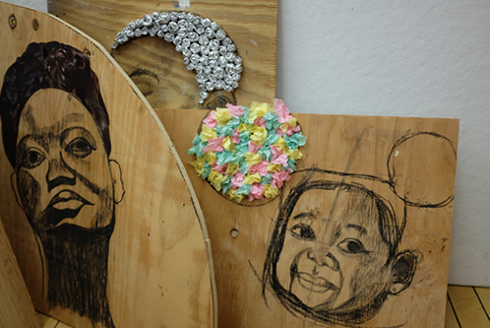
Photo caption: A few of the works-in-progress being created by senior Aisha Oxley for her thesis exhibition, “Hot Comb.”
Photo credit: Photo by Justin Goldberg

What: “Hot Comb,” an exhibition of mixed media portraits, found images and an audio “soundtrack” that explore the politics of hair and black womanhood
Who: Created by senior in the Lewis Center’s Program in Visual Arts Aisha Oxley
When: May 2 through 6, reception Thursday, May 5 from 7:30 to 9:00 p.m.
Where: Lucas Gallery at 185 Nassau St.
Free and open to the public

(Princeton, NJ) The Program in Visual Arts at the Lewis Center for the Arts at Princeton University will present “Hot Comb,” an exhibition by senior Aisha Oxley of mixed media portraits, found images and an audio “soundtrack” that explore the politics of hair and black womanhood. The work will be on view May 2 through May 6 in the Lucas Gallery at 185 Nassau Street. A reception with the artist will be held on Thursday, May 5 from 7:30 p.m. to 9:00 p.m. in the gallery. The exhibition and reception are free and open to the public.

Oxley, a Plainfield, NJ native, is majoring in history, and is pursuing a certificate in the Program in Visual Arts. Her thesis in history analyzes the intersection of art and activism during the 1960s Civil Rights Movement through the lens of the careers of jazz singer, pianist, and songwriter Nina Simone and playwright Lorraine Hansberry. “More than anything,” explains Oxley, “studying those two women informed how I think of myself as a black woman and an artist, creating this politically charged show. Although they were artists of different media, Simone and Hansberry have become models for my work as artists who were agents of social change.”

Oxley has carried this interest into her visual arts thesis. The mixed media portraits consist of charcoal drawings on plywood of black women with a range of materials used to create the subjects’ hair. Manipulated found images of black women from beauty magazines further examine the politics associated with black hair and the representation of black women. An audio “soundtrack” created by the artist from interviews with young black women about their hair, both narrates and complicates the visual components of the show.

Oxley grew up in a family of artists and learned how to draw from her grandfather, Lorenzo Lynch, a children’s book illustrator, who she recalls nurtured her talent and love of art. “I was exposed to the work of many well-known black artists from a young age,” notes Oxley, “which subconsciously ignited my interest in the black subject.”

The artist credits her advisers in the Program in Visual Arts, Eve Aschheim, Pam Lins and Joe Scanlan, Director of the Program, as fundamental to her development as an artist. “They helped me to develop an aesthetic, unpack the themes in my work, and become more aware of the contemporary black artists with whom I am in conversation,” she explains.

After graduating from Princeton in June, Oxley plans to continue working as an artist with a particular interest in film. Next year, through Princeton’s Project 55 program, she will work at Free Sprit Media, a nonprofit organization in Chicago that teaches film and media skills to high school students.

The Lucas Gallery is open Monday through Friday from 10:00 a.m. to 4:30 p.m.

To learn more about this show, the Program in Visual Arts, and the more than 100 other events presented each year at the Lewis Center visit arts.princeton.edu.

###

