April 12, 2016

“ to wake” opens at the Lewis Center for the Arts
A Senior Thesis Show by Aliisa Lee

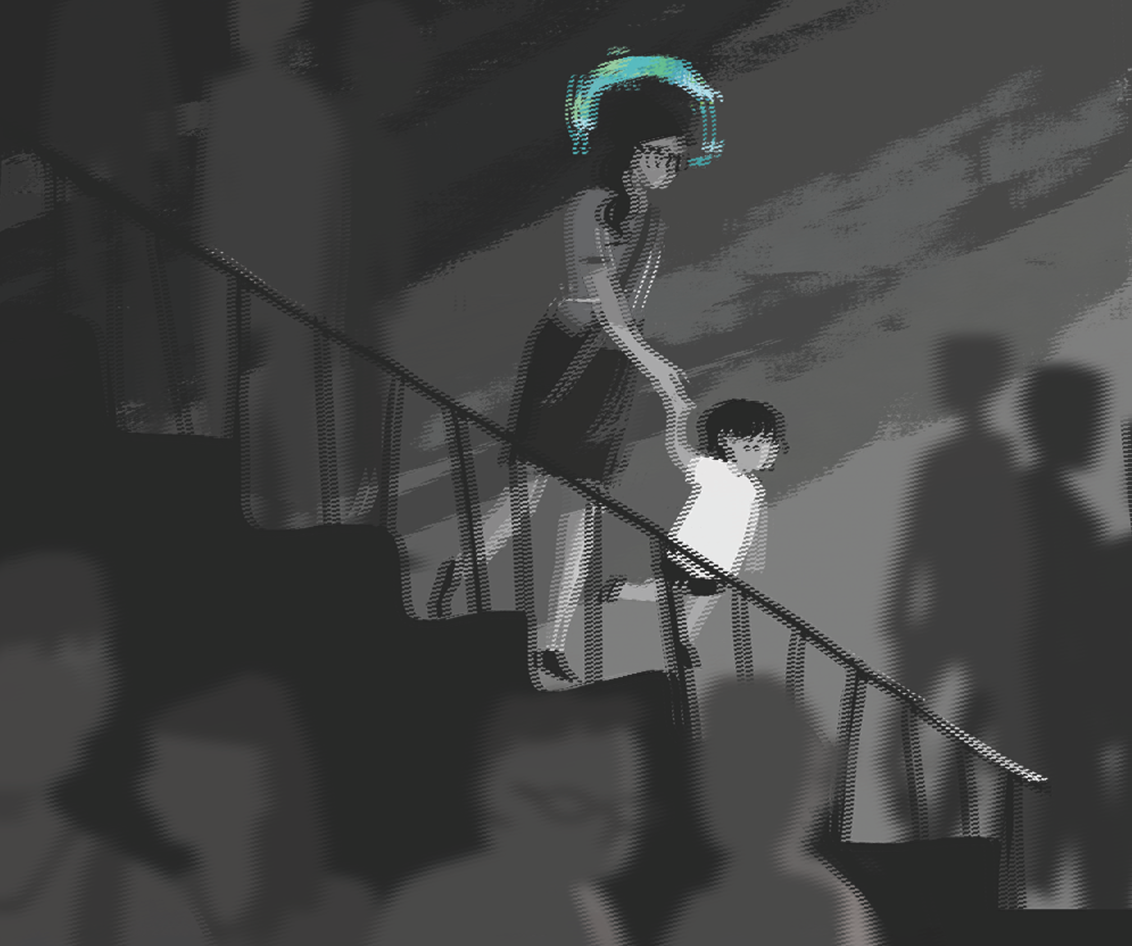
Photo caption: One of the digitally-created illustrations in a narrative series presented by senior Aliisa Lee’s exhibition, “to wake”

What: “to wake,” a series of digitally-created illustrations that provide a sequential visual narrative enabling the viewer to “walk through the story.”
Who: Created by Aliisa Lee, a senior in the Lewis Center’s Program in Visual Arts
When: April 18 through 22, reception Thursday, April 21 from 7:30 to 9:00 p.m.
Where: Lucas Gallery at 185 Nassau St.
Free and open to the public

(Princeton, NJ) The Program in Visual Arts at the Lewis Center for the Arts at Princeton University will present “to wake,” an extensive series of digitally-created illustrations by senior Aliisa Lee. Gallery viewers will have a chance to “walk through the story” as they move through a room lined with a sequential visual narrative. The exhibition will be on view April 18 through April 22 in the Lucas Gallery at 185 Nassau Street. A reception with the artist will be held on April 21 from 7:30 p.m. to 9:00 p.m. in the gallery. The exhibition and reception are free and open to the public.

Lee, who grew up in Hawaii and graduated from high school in the Middle East, is majoring in English and pursuing a certificate in the Program in Visual Arts. Her critical-creative English senior thesis focused on Jane Austen’s writings from ages eleven to seventeen; though separate from her Program in Visual Arts, project, Lee’s English thesis incorporated her skills as an illustrator to explore the early work in various visual and historic forms.

Lee’s visual arts senior show is a narrative that begins with a woman and her child entering the subway, and ends with a woman and her child exiting the subway. What happens on the walls between is an exploration of the movement of time, childhood, the experience of a gallery, and what it means to be created in a larger narrative. Using Photoshop painting software, Lee has created over seventy drawings of various sizes that will be installed through the gallery. The illustrations and installation are unique to the space as their design and placement incorporate the Lucas Gallery’s architectural elements — doorways, exit signs, etc. — into the unfolding of the story. The artist describes the series of panels as partially inspired by an idea to see the form of comics and storyboarding scaled up and translated into the space of a gallery.

Lee credits much of this project’s long development to her advisers: faculty members Eve Aschheim, Kurt Kauper, and Director of the Program in Visual Arts Joe Scanlan. Throughout the past year, all of them pushed, challenged, and encouraged her approaches to drawing, storytelling, and the use of the physical gallery space.

Lee hopes to pursue a career in the fields of communications or illustration. Next year, she will work for the nonprofit organization, International Schools Services, as supported through her post-graduation fellowship position with Princeton’s Project 55. In addition, she will continue to illustrate for Princeton’s Cotsen Children’s Library and other freelance clients.

Lee shares the gallery space with senior Amalya Mergerman, who is presenting a multimedia installation that utilizes a range of materials and media that provide a visual, aural and sometimes aromatic glimpse into nostalgia and the things that evoke childhood memories and relate to her family history.

The Lucas Gallery is open Monday through Friday from 10:00 a.m. to 4:30 p.m.

To learn more about this show, the Program in Visual Arts, and the more than 100 other events presented each year at the Lewis Center visit arts.princeton.edu.

###

