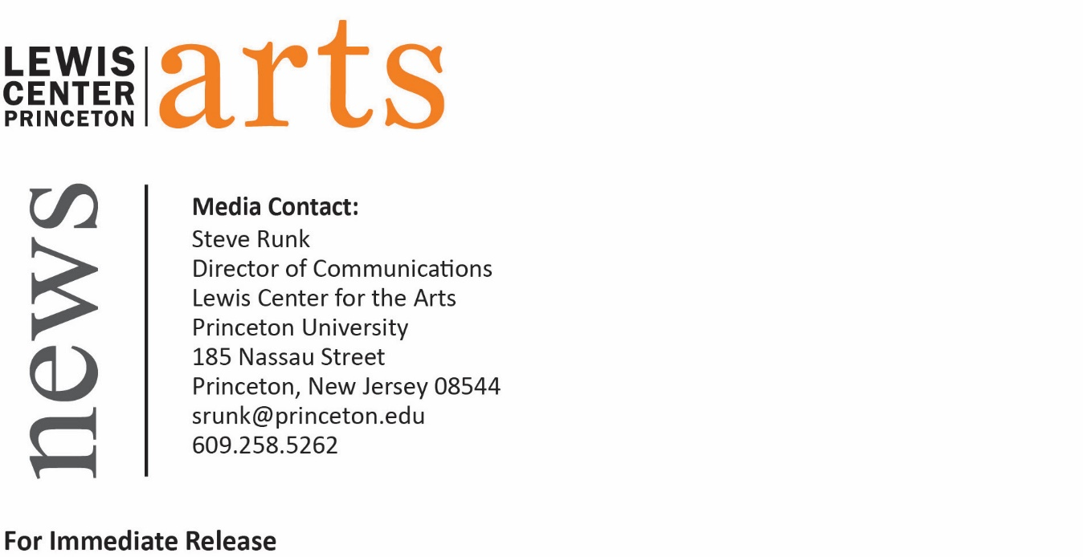

April 28, 2016

“Correlation Theory of Statistically Optimal Systems”
opens at the Lewis Center for the Arts
A Senior Thesis Show by Angela Zhou

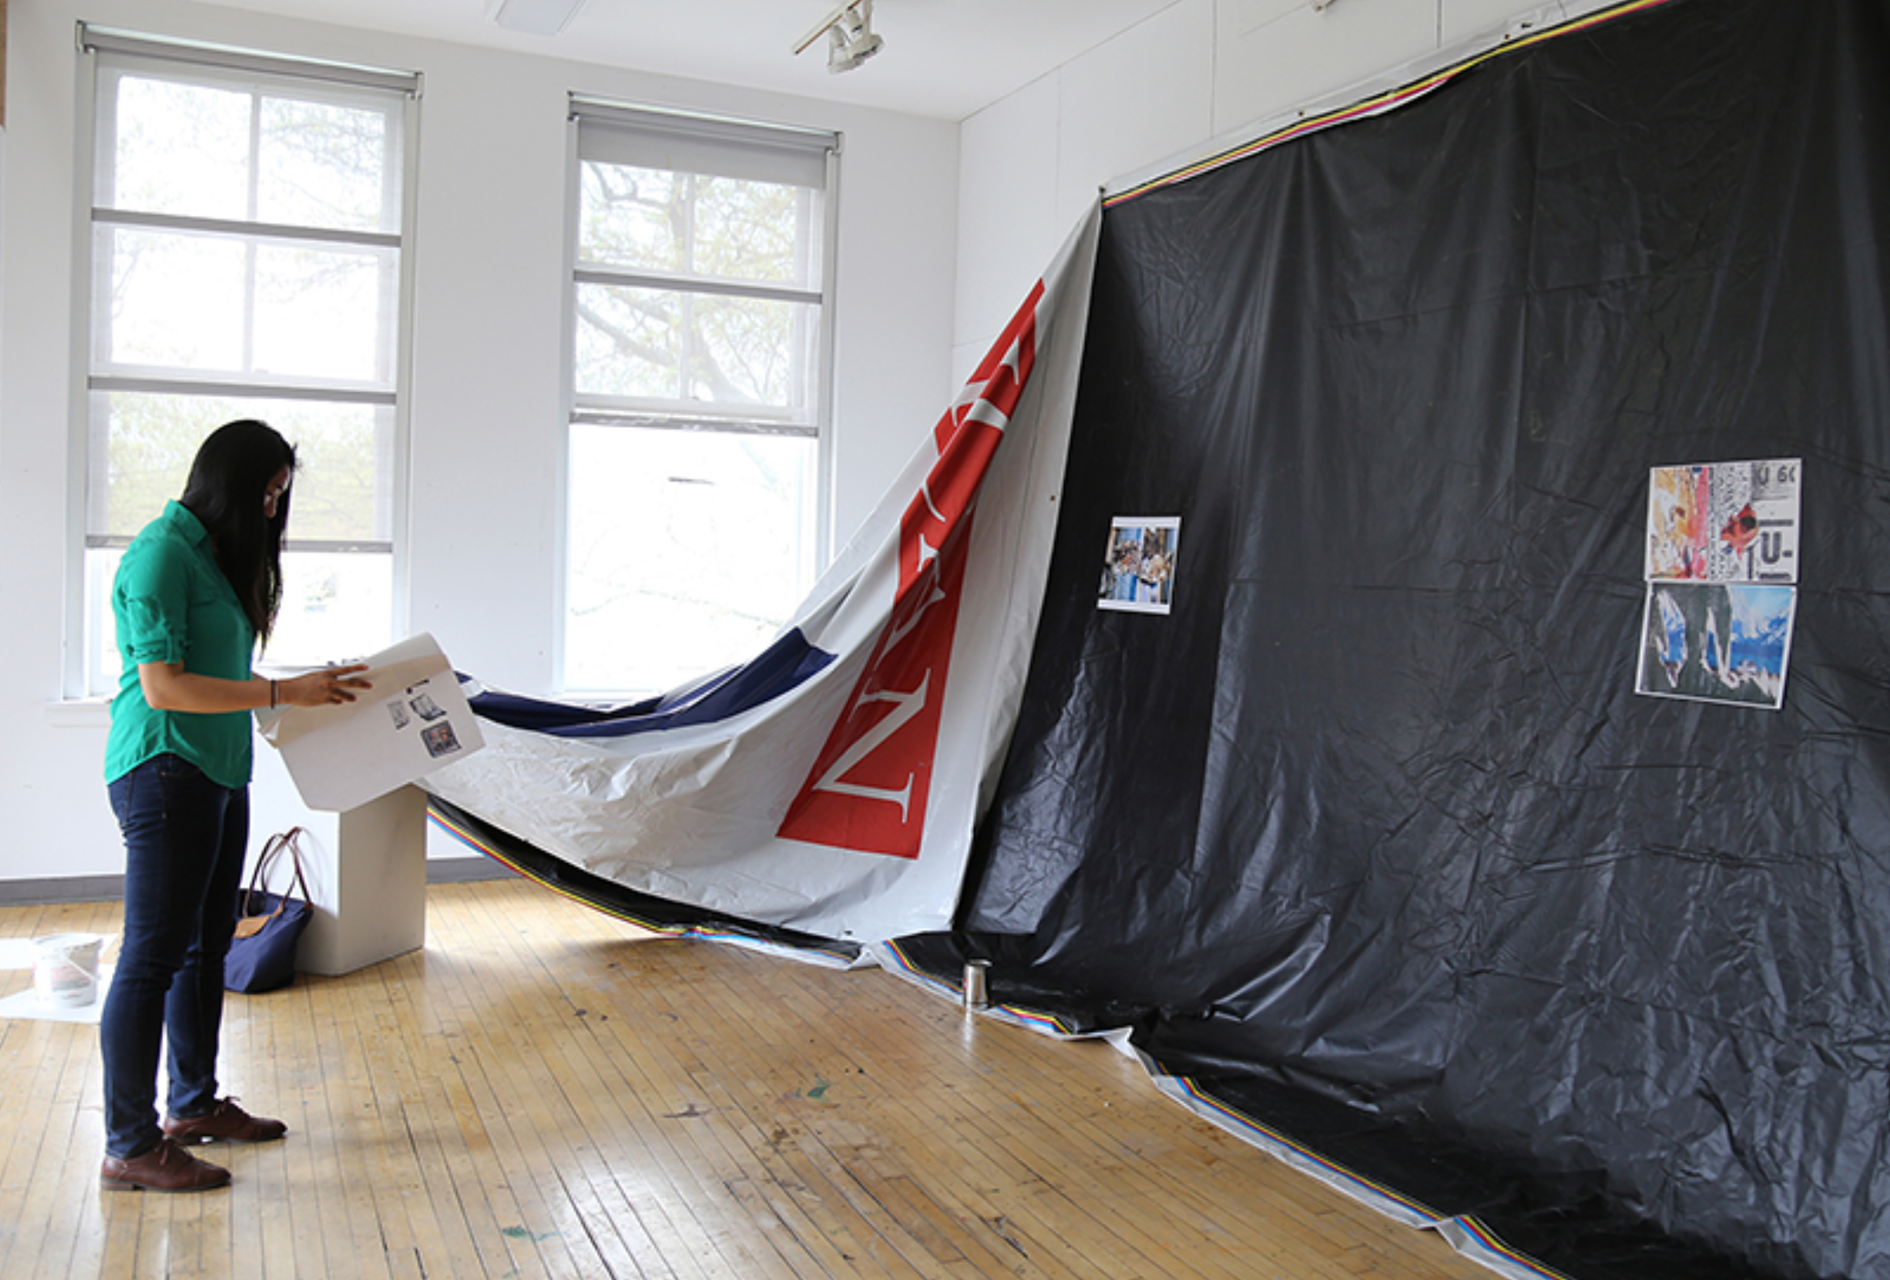
Photo caption: Senior Angela Zhou beginning installation of her mixed media exhibition, “Correlation Theory of Statistically Optimal Systems.”
Photo credit: Photo by Justin Goldberg

What: “Correlation Theory of Statistically Optimal Systems,” a mixed media exhibition exploring both visual systems of urban environments in the form of stickers and advertising material and the role of visual thinking in mathematics.
Who: Created by senior in the Lewis Center’s Program in Visual Arts Angela Zhou
When: May 2 through 6, reception Thursday, May 5 from 7:30 to 9:00 p.m.
Where: Room 301 at 185 Nassau St.
Free and open to the public

(Princeton, NJ) The Program in Visual Arts at the Lewis Center for the Arts at Princeton University will present “Correlation Theory of Statistically Optimal Systems,” a mixed media exhibition by senior Angela Zhou that explores the visual archaeology of advertising material in an urban environment in relation to mathematics. The work will be on view May 2 through May 6 in Room 301 at 185 Nassau Street. A reception with the artist will be held on Thursday, May 5 from 7:30 p.m. to 9:00 p.m. outside of Room 301. The exhibition and reception are free and open to the public.

Zhou, a Marlboro, NJ native, is a major in the Department of Operations Research and Financial Engineering and is pursuing a certificate in the Program in Visual Arts. Zhou had worked in traditional media like painting and drawing before coming to Princeton, however courses in cultural and media studies provided new and different ways of viewing the world than she encountered in her studies in engineering.

Zhou’s exhibition examines two different but parallel interests. Through photographs of stickers and other forms of print advertising posted in urban environments, she explores a visual system she describes as “at once inscrutable and ubiquitous.” Through additional photographs and text she traces the language of diagrams and visualizations in mathematics.

After graduating from Princeton, Zhou plans to pursue graduate school in engineering but hopes to continue working on art projects related to research practices.

The exhibition will be open Monday through Friday from 10:00 a.m. to 4:30 p.m.

To learn more about this show, the Program in Visual Arts, and the more than 100 other events presented each year at the Lewis Center visit arts.princeton.edu.

###

