April 5, 2016

Visual Arts Program, Lewis Center for the Arts
continues Screenings of Independent Films
Filmmakers Roger Ross Williams, Hassen Ferhani, Kirsten Johnson, and Deborah Stratman
screen and field questions about their work
Audiences join students in the spring course “World on a Wire: 12 Films, 12 Filmmakers”

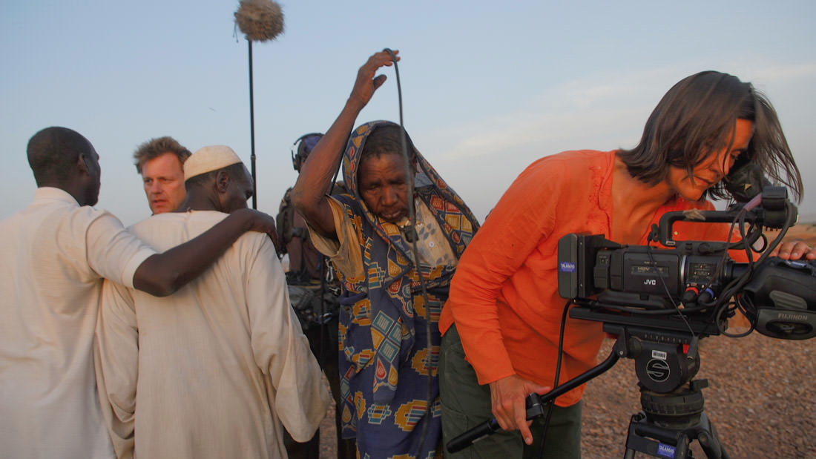
Photo caption: Still from Cameraperson, Kirsten Johnson’s documentary of her life as a global cinematographer.

What: Screenings of recent independent films followed by discussions with the filmmakers, part of a film series presented through the course “World on a Wire: 12 Films, 12 Filmmakers”
Who: Filmmakers Roger Ross Williams, Hassen Ferhani, Kirsten Johnson, and Deborah Stratman organized by Princeton Arts Fellow and faculty member Pacho Velez, presented by the Visual Arts Program, Lewis Center for the Arts
When: April 7, 14, 21, and 28 at 7:30 p.m.
Where: James M. Stewart ’32 Theater at Lewis Center for the Arts, 185 Nassau St., Princeton
Free and open to the public

(Princeton, NJ) Audiences are invited to join Princeton University students to screen recent independent films and meet the filmmakers as part of the Visual Arts Program course “World on a Wire: 12 Films, 12 Filmmakers.” One or two films are being screened each Thursday evening through the end of April. All the films have been produced within the last 18 months and each of the filmmakers will be on hand to discuss their work and answer questions from the audience.

Films to be screened include Life, Animated by Roger Ross Williams on April 7; Roundabout in My Head by Hassen Ferhani on April 14; Cameraperson by Kirsten Johnson on April 21; and The Illinois Parables by Deborah Stratman on April 28. Each screening will be followed by a question-and-answer session with the film’s director. The screenings, which began in February, take place every Thursday at 7:30 p.m. in the James M. Stewart ’32 Theater at 185 Nassau Street and are free and open to the public.

Based on Ron Suskind's best-selling memoir, Roger Ross Williams’ documentary Life, Animated shows one family coping with an autistic child trapped in a world of Disney animation and finding unexpected hope and connections. It premiered at the 2016 Sundance Film Festival, where it won Williams the Sundance Directing Award: U.S. Documentary.

Roundabout in My Head, a documentary about a slaughterhouse in Algiers and the lives of its employees, is the feature-length debut work of Algerian filmmaker Hassen Ferhani. It was awarded first prize at the 26th Marseille International Film Festival (FIDMarseille).

Celebrated cinematographer Kirsten Johnson, whose previous work includes Citizenfour and Darfur Now, among others, turns the lens on her own life, professional and personal, in Cameraperson. The documentary, prompted by Johnson’s experiences filming in Afghanistan, explores the complexities of the relationship between filmmaker and subject. Nick Schager of Variety hailed it as “a uniquely insightful memoir-cum-critical-treatise on the nature and ethics of her craft.”

The Illinois Parables, by Deborah Stratman, a leader in experimental cinema, is an episodic documentary composed of eleven tales of faith, history and technology in the state of Illinois. In a review for RogerEbert.com, Michael Pattinson praised the film’s aesthetics and poeticism, calling it “the best film I saw at this year’s Berlinale [International Film Festival].”

These films are the last to be screened in conjunction with the spring Lewis Center film course “World on a Wire: 12 Films, 12 Filmmakers,” taught by Princeton Arts Fellow and faculty member Pacho Velez. Velez is a filmmaker who works at the intersection of ethnography, contemporary art, and political documentary. His current project, The Reagan Years, explores a prolific actor’s defining role: Leader of the Free World. Velez’s previous film, Manakamana, screened at Princeton last October and won a Golden Leopard Award at the Locarno Film Festival. It played around the world, including at the Whitney Biennial and the Toronto International Film Festival. His earlier film and theater work has been presented at venues such as the Edinburgh Fringe Festival, the Museum of Ethnography in Stockholm, and on Japanese National Television.

The course makes use of recent works by twelve engaging contemporary filmmakers to come to a deeper understanding of current film culture. Class discussions center on the issues preoccupying filmmakers today, the most fertile grounds for new cinematic work, and the process of navigating funding and distribution in the making of a film.

To learn more about these screenings, the Program in Visual Arts, and the more than 100 events offered annually by the Lewis Center visit arts.princeton.edu.

###

