April 15, 2016

Lewis Center for the Arts presents Petrichor
A new, interactive performance work by senior Bree White incorporating dance, sculpture, music and text/language that explores being “other”

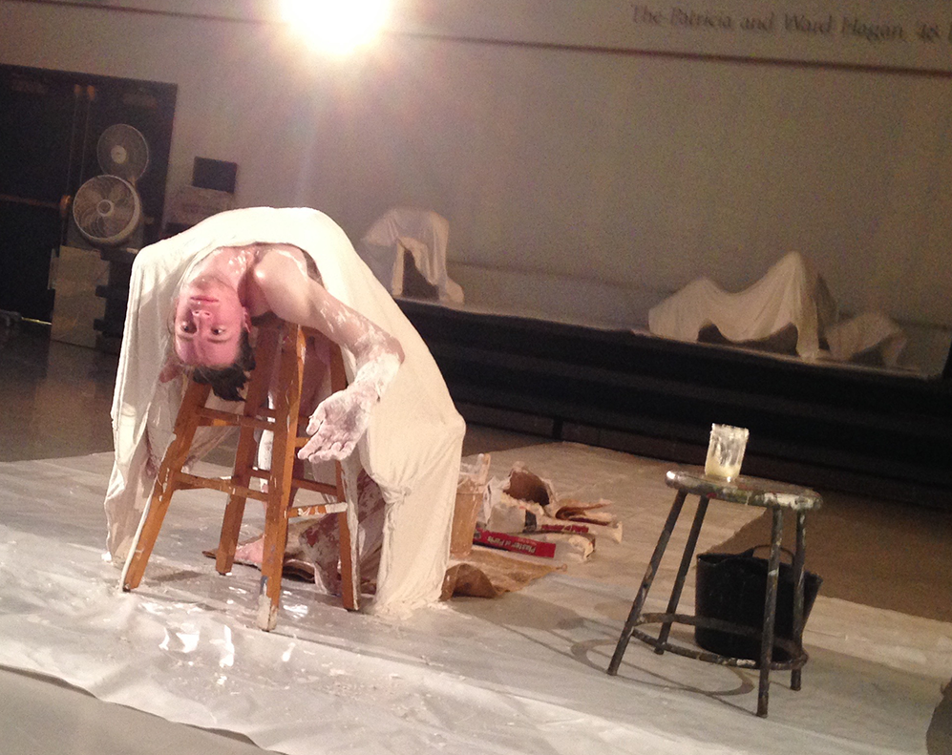
Photo caption: Senior Bree White preparing for a new, interactive performance work incorporating dance, sculpture, music and text/language
Photo credit: Photo courtesy of Bree White

What: Petrichor, a new, interactive performance work incorporating dance, sculpture, music and text/language that explores being “other.” (The performance includes some nudity.)
Who: Conceived and choreographed by Bree White, a senior in the Programs in Dance and Visual Arts, in collaboration with the performers
When: April 19 and 20 at 7:30 p.m. and April 21 and 22 at 7:30 and 9:30 p.m.
Where: Patricia and Ward Hagan’48 Dance Studio at 185 Nassau St., Princeton
Free and open to the public, however seating for each performance is limited and reservations are recommended

(Princeton, NJ) The Lewis Center for the Arts’ Programs in Dance and Visual Arts at Princeton University will present a new, interactive performance work by senior Bree White that incorporates dance, sculpture, music and text/language to explore being “other.” Performances will be held April 19 and 20 at 7:30 p.m. and April 21 and 22 at 7:30 and 9:30 p.m. at the Patricia and Ward Hagan’48 Dance Studio at 185 Nassau Street. The performances are free and open to the public, however seating for each performance is limited and reservations are recommended — arts.princeton.edu/petrichor

White is majoring in visual arts through a collaborative program between the Department of Art and Archaeology and the Program in Visual Arts at Princeton, as well as pursuing a certificate in the Program in Dance. Petrichor brings both areas of study together.

In exploring the idea of being “other,” White examines issues related to dealing with feelings of shame around identity and perceptions of the appearance of one’s body, experienced by both individuals and communities of people. The performance includes some nudity.

Each performance includes the creation of a new and unique sculptural work in front of the audience followed by movement, music and spoken improvisation by a cast of 12 performers, who shared their own experiences and issues of identity with White in the creation of the piece.

“People are so remarkable,” notes White, “because of the extraordinary range of their experiences and identities. These differences, sadly, are often the reason for acts of violence between communities and those who are perceived as different. Petrichor was a way for me to understand the pain I have felt when I have been shunned for my differences. I hope that it has been the same for my extraordinary cast, whose honesty and generosity with their own identities has been an honor to experience.”

The title, Petrichor, is defined as the smell of earth after it has rained.

White’s advisers for the project include Joe Scanlan, Director of the Program in Visual Arts; Program in Dance faculty member Rebecca Lazier, and current Princeton Arts Fellow Pavel Zustiak.

The all-student cast includes Elena Anamos ’19, Jessica Chambers ’18, Sergio Cruz ’18, Yasmine Eichbaum ’18, Jake Hamel ’18, Carson Hughes ’16, Anna Kimmel ’18, Laura Ong ’17, Natalie Plonk ’18, Alexa Pugh ’16, Rachel Schwartz ’18, and Jhor van der Horst ’19.

Lighting for the production is by Cecilia Durbin, a New York City-based designer with music and sound design created by Vince Di Mura, the Lewis Center’s Resident Musical Director and Composer. Laura Ong ’17 serves as dramaturge.

To learn more about this event, the Programs in Dance and Visual Arts, and the more than 100 other activities presented at the Lewis Center visit arts.princeton.edu.

###

