April 4, 2016

The Lewis Center for the Arts’ Program in Theater presents
Singin’ in the Rain
A bold re-imagining of the classic musical, directed and co-choreographed by Adin Walker and featuring Billy Cohen and Maddie Reese, all seniors in the program

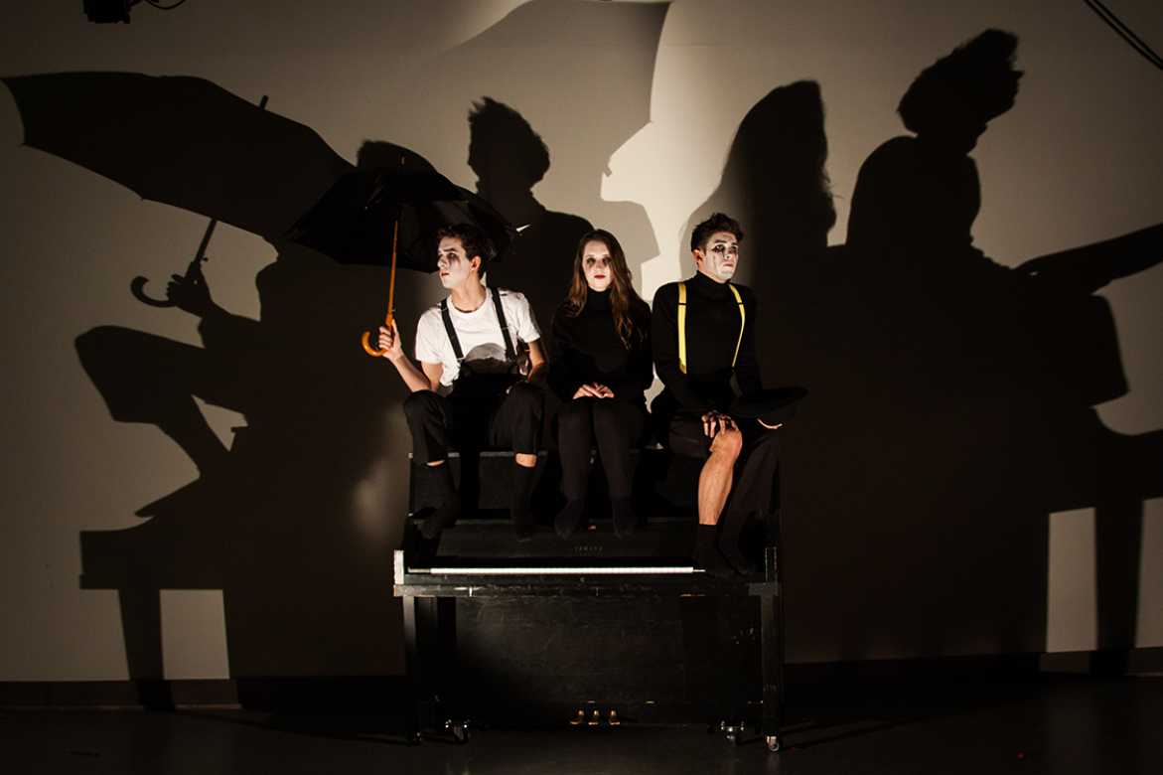
Photo caption: Billy Cohen ’16, Maddie Reese ’16 and Allen Hernandez ’16 (left to right) in a bold re-imagining of the classic musical Singin’ in the Rain.
Photo credit: Crystal Liu

What: A bold re-imagining of the classic musical Singin’ in the Rain. Written by Betty Comden and Adolph Green with lyrics by Arthur Freed and music by Nacio Herb Brown
Who: Presented by Lewis Center for the Arts’ Program in Theater at Princeton University, directed and co-choreographed by senior Adin Walker and featuring seniors Billy Cohen and Maddie Reese
When: April 8, 9, and 13 at 7:30 p.m., April 10 at 3:00 p.m., and April 15 at 7:00 p.m.
Where: Berlind Theatre at McCarter Theatre Center, 91 University Place, Princeton
Tickets: $12 general admission, $11 students and seniors in advance/$17 general admission, $15 students and seniors on the day of performances

(Princeton, NJ) The Lewis Center for the Arts’ Program in Theater at Princeton University will present a re-imagining of the musical Singin’ in the Rain, written by Betty Comden and Adolph Green with lyrics by Arthur Freed and music by Nacio Herb Brown. The show is directed and co-choreographed by senior Adin Walker and features seniors Billy Cohen and Maddie Reese, all of who are students in the theater program. Performances will take place on April 8, 9, and 13 at 7:30 p.m., April 10 at 3:00 p.m., and April 15 at 7:00 p.m. in the Berlind Theatre at McCarter Theatre Center. An audience talkback discussion led by Professor of Theater and musical theater scholar Stacy Wolf will follow the April 13 performance.

The stage musical Singin’ in the Rain, which premiered in London in 1983 and on Broadway in 1985, follows silent film idol Don Lockwood, his sidekick Cosmo Brown, Don’s co-star Lina Lamont, and aspiring actress Kathy Selden through the turmoil of late 1920’s Hollywood. Technology is transitioning film from the silent screen to the “talkies.” The stage musical is based on the classic 1952 Metro-Goldwyn-Mayer film musical starring Gene Kelly, Debbie Reynolds and Donald O’Connor.

Adin Walker, a senior from Washington, DC concentrating in English and receiving certificates in the Program in Gender and Sexuality Studies and the Program in Theater, is directing and co-choreographing the production as his senior thesis in theater. Walker previously choreographed Lewis Center productions of Zoyka’s Apartment and Spring Awakening and he was the founder and director of the Lewis Center’s WINDOWS program in partnership with the Triad and Rainbow Houses in Ewing, New Jersey. Walker’s work outside of Princeton includes assistant directing productions at California Shakespeare Theater and the Guthrie Theater in Minneapolis. This summer, Walker will be making his New York debut choreographing a new musical, Normativity, as part of the New York Musical Festival (NYMF).

The production features two seniors also pursuing certificates in theater: Billy Cohen, from Houston, Texas, majoring in Religion, plays the Hollywood icon Lockwood, and Maddie Reese, hailing from Chicago and majoring in English, plays the passionate performance artist Selden. Cohen has performed in a number of Lewis Center theater and dance productions including Spring Awakening, The Producers and Kiss Me, Kate. Outside of Princeton, he has performed regionally in Peter and the Starcatcher, The Best Little Whorehouse in Texas, Fiddler on the Roof, and the workshop of a new musical by Nell Benjamin and Laurence O’Keefe entitled Huzzah. Reese has also appeared in Lewis Center productions of Spring Awakening and the premiere of a pop-influenced musical about a gay rights revolutionary in East Berlin in the 1970s written by recent alumna Sam Kaseta.

“This production of Singin' in the Rain immerses the story in a whirlwind of dance, actor-musicianship, and wet skin: exploring a world of outsiders trying to find their way inside and the technologization of the body for the movie screen at the onset of talking pictures,” notes Walker. “The company has been working to ground these characters, investigate the physical and choreographed landscape of the story, expose the fragile mortality of artists who fear existing merely as shadows on film, and grasp an honesty in the storytelling that is driven by whispers of darkness that lie beneath its gilded surface.”

A team of three other students collaborated with Walker on the choreography for the show — seniors Sophia Andreassi and Colby Hyland, and junior Trent Kowalik — which includes contemporary ballet, hip hop, and rhythm tap. Kowalik was in the original London cast for Billy Elliott the Musical and was cast in the Broadway production, winning a Tony Award for Best Actor in a Musical in 2009. A weeklong workshop last November was central to developing the choreography for the production. Choreographic influences Walker notes for this production are the work of German modern dance choreographer Pina Bausch, American choreographers Jerome Robbins and Twyla Tharp, and Quebec-based choreographer Dave St. Pierre.

Another approach this interpretation embraces is having the cast members play instruments, serving as part of the musical ensemble for the show, a technique originated by Tony Award-winning director and Lewis Center faculty member John Doyle, with whom Walker and Cohen studied in Doyle’s Atelier courses investigating Ibsen’s Peer Gynt and actor-musicianship. Vince di Mura, the Lewis Center’s Resident Music Director and Composer serves as musical director for the production.

Cohen and Reese cite a musical theater class they took with John Rando as an important factor influencing their decision to choose a golden-age musical as their thesis. Inspired by Rando’s recent Broadway revival of On the Town (also written by Comden and Green), Cohen and Reese were motivated to take a deeper look at the ‘cliché’ songs and dances that occupy so much of the show and investigate how music and dance can best be seen as continuations of, and not departures from, the dialogue-heavy scenes in the show.

Walker also cites a course he took with the late Director of the Program in Theater Tim Vasen and Professor of Slavic Languages and Literatures and Comparative Literature, Emeritus, Caryl Emerson on the work of Russian fiction writer and playwright Sigizmund Krzhizhanovsky.

The show features a large cast of student actors, singers and dancers including senior Allen Hernandez as Cosmo and junior Abby Melick as Lina, along with undergraduates Ayla Allen, Raheem Barnett, Ross Barron, Alex Daniels, Ben Diamond, Katie Frorer, Clark Griffin, Kamber Hart, Jared Brendan Hopper, Colby Hyland, Trent Kowalik, Natalie Lu, Stanley Mathabane, Natalie Plonk, Alex Quetell, Cecilia Shang, Emma Watkins, Calvin Wentling, Emily Wohl, and Maria Yu.

Set design is by Edward Morris and lighting by Masha Tsimring, both New York-based professional designers. Professional designer Julia Kosanovich mentors and co-costume designs with student designer Catherine Ivanovich. New-Jersey-based sound designer Josh Friedman mentors and co-designs with student Stanley Mathabane on the production’s sound design. Edwin Rosales is the stage manager and Delaney Carlson is the assistant stage manager.

Musical director di Mura is a jazz pianist, composer, arranger and musical director, appearing on concert stages and theaters throughout North America, Canada, and Latin America. He has completed commissions for a number of universities, as well as professional theater companies across the U.S.

The Berlind Theatre is an accessible venue. Assistive listening devices are available upon request when attending a performance. Patrons in need of other access accommodations are invited to contact the Lewis Center at 609.258.5262 or LewisCtr-Comm@princeton.edu for assistance at least two weeks prior to the selected performance.

Tickets for Singin’ in the Rain are $12/$11 for students and seniors when purchased in advance, or $17/$15 for students and seniors on the day of performances. Tickets are available online through arts.princeton.edu/singin, by calling the McCarter box office at 609.258.2787, at the Frist Campus Center Ticket Office, and at the door on the dates of performances.

The Lewis Center’s Program in Theater annually presents a major, professionally produced play, as well as a number of student senior thesis productions throughout the year. The current season will conclude with a new musical, The Luckiest Girl by senior Sonya Hayden inspired by Oscar Wilde’s novel The Picture of Dorian Gray but with a female protagonist, and I.M. Lost: A Show About Clowns, a new ethnographic play by senior Nathalie Ellis-Einhorn.

To learn more about this event, the Program in Theater, and the over 100 other events presented each year at the Lewis Center visit arts.princeton.edu.

###

