April 12, 2016

“Beautiful Memory Desserts” opens at the Lewis Center for the Arts
a Senior Thesis Show by Veronica Nicholson

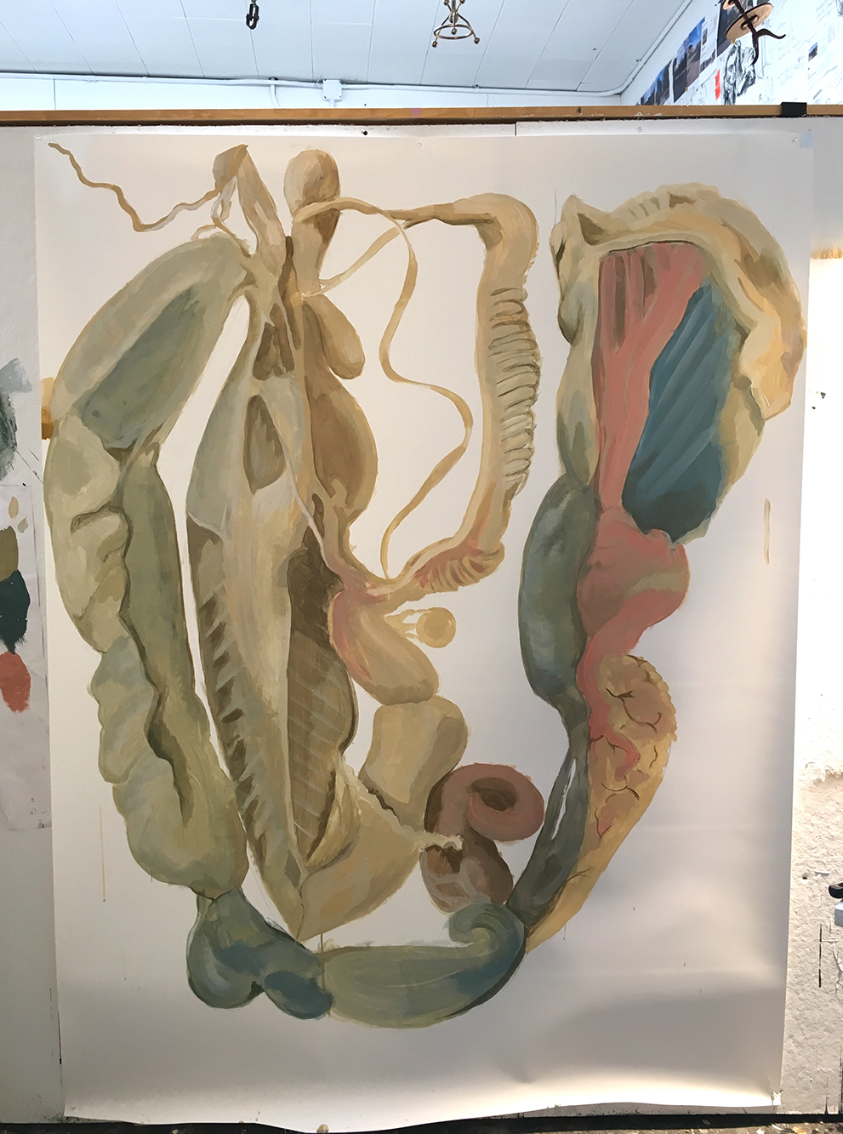
Photo caption: One of the paintings in senior Veronica Nicholson’s installation “Beautiful Memory Desserts”
Photo credit: Photo by Veronica Nicholson

What: “Beautiful Memory Desserts,” an installation exploring memory through a range of media
Who: Created by senior in the Lewis Center’s Program in Visual Arts Veronica Nicholson
When: April 11 through 15, reception on Thursday, April 14 from 7:30 to 9:00 p.m.
Where: Room 301 at 185 Nassau St., Princeton
Free and open to the public

(Princeton, NJ) The Lewis Center for the Arts’ Program in Visual Arts at Princeton University will present an installation by senior Veronica Nicholson that explores memory through a range of media. The installation will be open April 11 through April 15 in Room 301 at 185 Nassau Street on the Princeton campus each day from 10:00 a.m. to 4:30 p.m. A reception with the artist will be held on April 14 from 7:30 p.m. to 9:00 p.m. in Room 301. The installation and reception are free and open to the public.

Nicholson, who is from Moorestown, New Jersey, is majoring in visual arts through a collaborative program between the Department of Art and Archaeology and the Program in Visual Arts at Princeton.

Her exhibition is an installation of a living space that can also be viewed as a psychological space. Three-dimensional collages are created from family-related objects and images. Another element uses a collection of paper materials, like wallpaper, notebooks, journals, schoolbooks, and science magazines from her father, and photographs from trips to New York, Asia, and Germany. She compiles her collections into large three-dimensional paintings that explore the strange, alien and surreal.

Among her influences for this project are artist and faculty member Pam Lins with whom Nicholson has taken four courses, as well as a course titled, “Painting without Canvas” that encourages students to expand their definition of painting by investigating methods of painting other than the convention of stretched fabric over a wood support.

To learn more about this exhibition, the Program in Visual Arts, and other events presented each year at the Lewis Center visit arts.princeton.edu.

###

