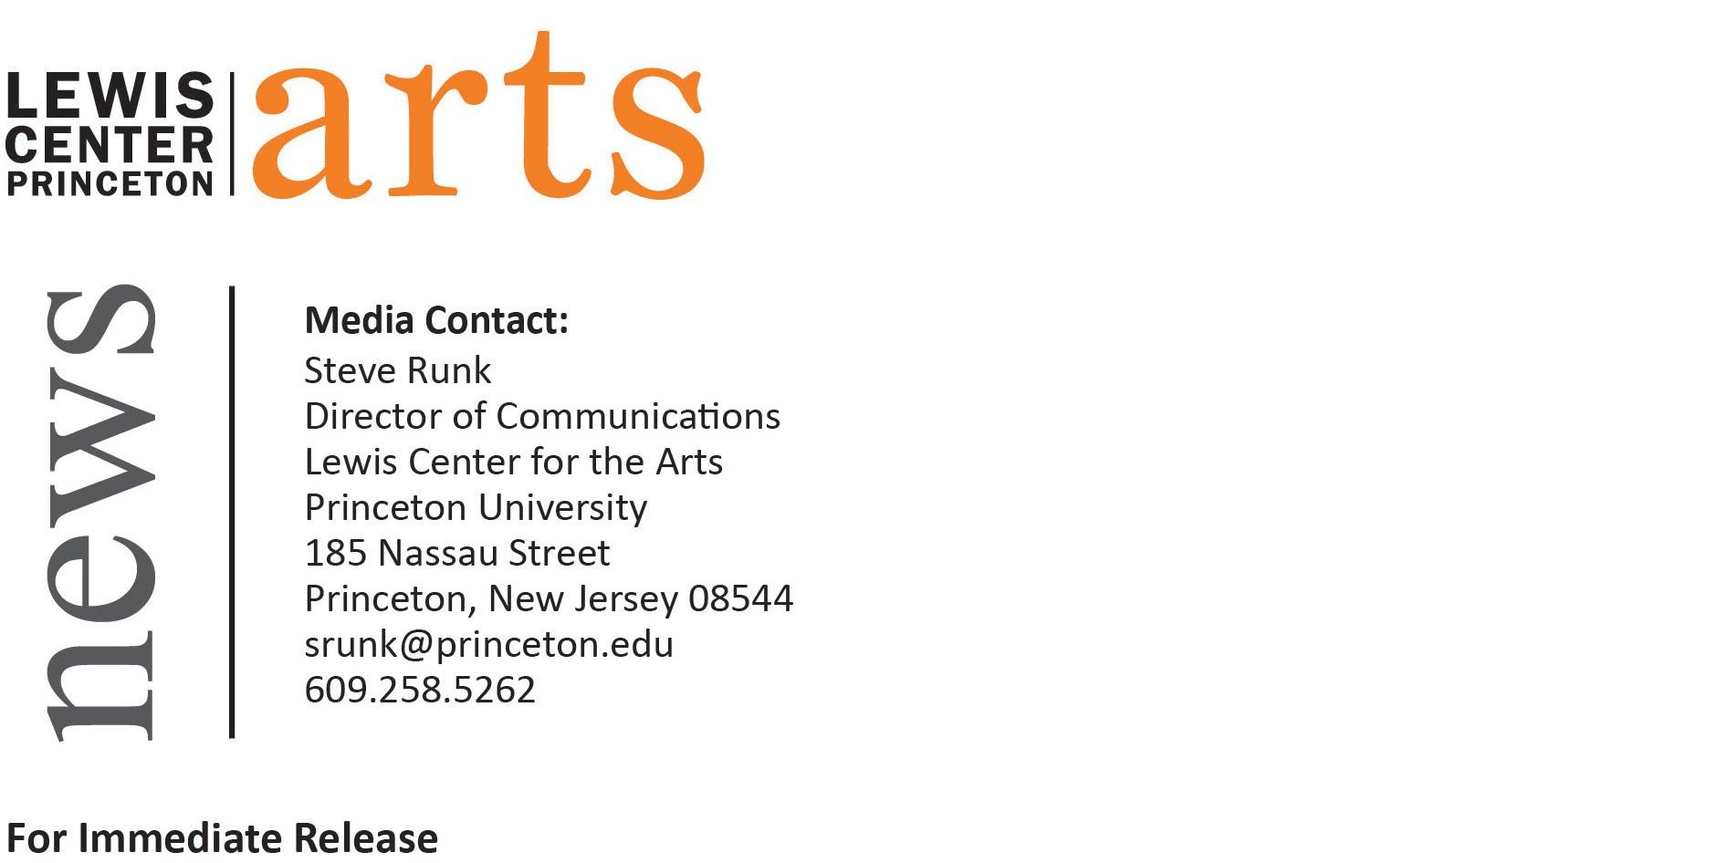
May 10, 2016
The Lewis Center for the Arts presents
Senior All-Star Show
featuring recent work in a wide range of media by graduating seniors

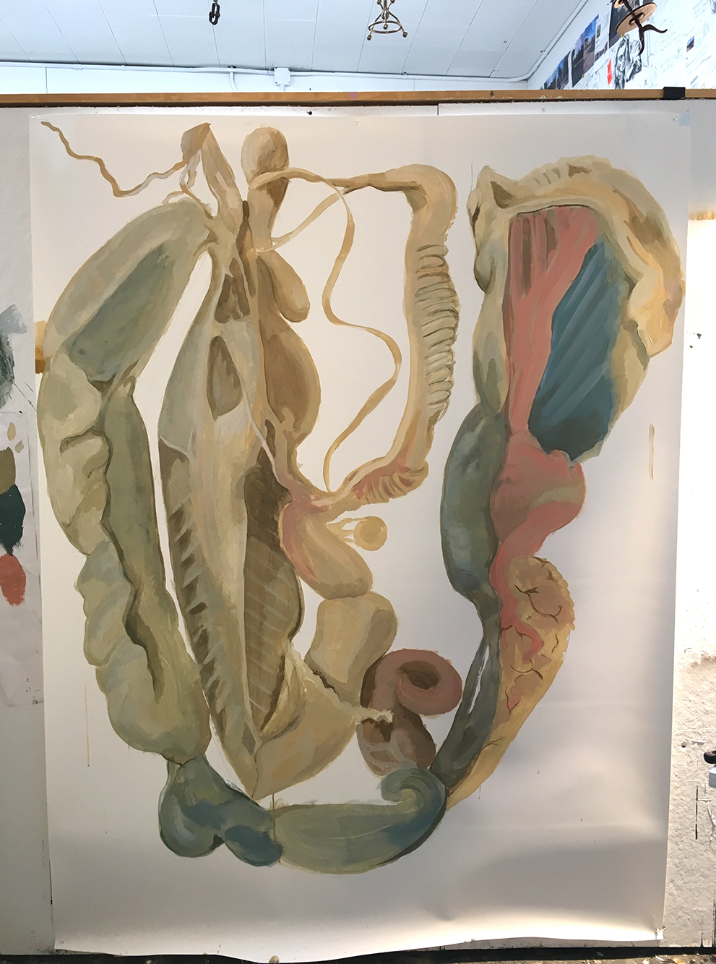
Photo caption: A large-scale painting by senior Veronica Nicholson, one of the artists to be featured in the Senior All-Star Show
Photo credit: Photo by Veronica Nicholson

What: Senior All-Star Show, an exhibition of recent work in a wide range of media
Who: Work created by graduating seniors in the Lewis Center for the Arts’ Program in Visual Arts
When: Thursday, May 12 - Tuesday, May 31
Where: Lucas Gallery at 185 Nassau St.
Gallery Hours: Monday - Friday from 10:00 a.m. - 4:30 p.m.; additional hours Saturday, May 28 from 10:00 a.m. to 4:30 p.m.
Free and open to the public

(Princeton, NJ) The Program in Visual Arts in the Lewis Center for the Arts at Princeton University will present an exhibition of recent work in a wide range of media by graduating seniors in the Program. The exhibition, Senior All-Star Show, will highlight work by students completed as part of their senior thesis projects and will be on view from Thursday, May 12 to Tuesday, May 31 in the Lucas Gallery at 185 Nassau Street. The exhibition is free and open to the public.

The work featured in this exhibition has been selected from among photography, paintings, drawings, prints, sculpture, photography, film, video and multimedia installations created by students earning a certificate in Visual Arts along with a degree in their major or a studio art degree. Each presented a solo exhibition or a screening of new work during the past semester as a requirement of the program.

Examples of some of the projects exhibited this year from which work for the Senior All-Star Show will be drawn include: an exhibition of mixed media portraits, found images and an audio “soundtrack” that explore the politics of hair and black womanhood; a series of digitally-created illustrations that provide a sequential visual narrative enabling the viewer to “walk through the story” in the gallery; a series of mixed media drawings that explore food and body obsessions, female athleticism, fitness and food; a public interactive piece that visualizes the data presented in a campus survey investigating experiences with sexual misconduct and knowledge about policies and resources; an exhibition of large scale photographs, a video installation, and performance pieces that explores ideas of identity, agency, and subjectivity; a film that incorporates animation and live action to create the immersive and disturbing journey of Daniel, a college student, who unwittingly becomes a stalker; and an interactive performance work incorporating dance, sculpture, music and text/language that explores being “other.”

This multimedia show, including film work showcased on monitors in the gallery, features the work of seniors Olivia Adechi, Emily Chang, Lynse Cooper, Lydia Cornett, Jaime Ding, Cameron Johanning, Aliisa Lee, Gerson Leiva, Charlotte Maher Levy, Amalya Megerman, Veronica Nicholson, Aisha Oxley, Neeta Patel, Noah Shartle, Kasturi Shah, Grayson Shepperd, Bree White, and Angela Zhou.

Many of the seniors plan on continuing to work in the visual arts field when they graduate, while others will take what they have learned as student artists into a career in another field.

The Lucas Gallery is open Monday through Friday from 10:00 a.m. to 4:30 p.m. Special additional hours during the University’s Reunions Weekend are Saturday, May 28 from 10:00 a.m. to 4:30 p.m. Admission to the Lucas Gallery is free.

To learn more about the exhibition, the Program in Visual Arts, and the more than 100 other events presented each year at the Lewis Center visit arts.princeton.edu.

###

