
May 2, 2016

Lewis Center for the Arts presents The Last Boat
An immersive theater experience created in a Princeton Atelier course co-taught by graphic novelist Kevin Pyle and dance-theater artist Jennine Willett

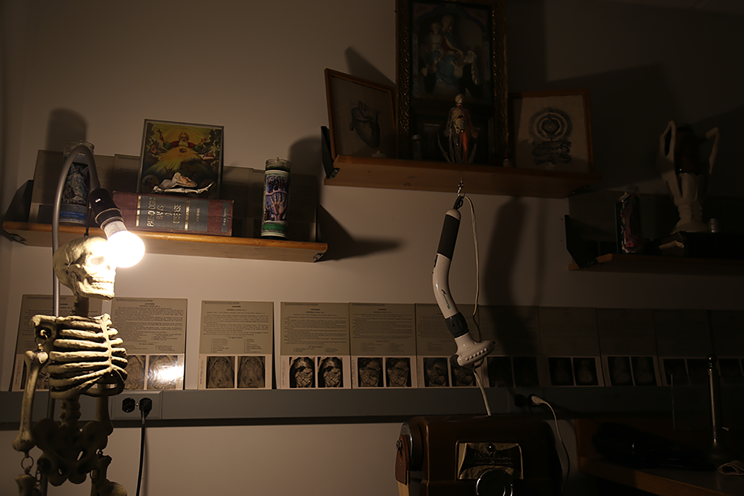
Photo caption: A small glimpse into one of the installations in The Last Boat, an immersive theater experience created as part of a Princeton Atelier course inspired by cultural meditations on mortality.
Photo credit: Photo by Justin Goldberg

What: The Last Boat, an original immersive theater experience of movement, installation, images, and text inspired by cultural meditations on mortality.
Who: Created by students in a spring Princeton Atelier course, “Waking the Dead,” working in collaboration with graphic novelist Kevin Pyle and Jennine Willett, Co-Artistic Director of Third Rail Projects, a dance theater company known for site-specific and immersive works.
When: May 5 at 2:00-4:00 p.m. and 7:00-9:00 p.m. The 28-minute experience admits a new group every 15 minutes.
Where: Attendees assemble in the main lobby of New South on the Princeton campus and are escorted to B level for the event
Free, however advance reservations for specific time slots are required at arts.princeton.edu/lastboat

(Princeton, NJ) The Lewis Center for the Arts’ Princeton Atelier will present an original immersive theater experience inspired by cultural meditations on mortality, created by Princeton students as the culminating project of a spring course co-taught by graphic novelist Kevin Pyle and Jennine Willett, Co-Artistic Director of Third Rail Projects, a dance theater company known for immersive works. The 28-minute experience will be presented in intervals on May 5 from 2:00 to 4:00 p.m. and 7:00 to 9:00 p.m. in New South on the Princeton campus.

The project grew out of the Atelier course, “Waking the Dead,” in which Pyle and Willett, two storytellers, working in different media, combined their processes and approaches to narrative. They collaborated with students across multiple disciplines to integrate movement, images, and text into a new story-telling format. The students and faculty examined artists’ responses throughout history to the subject of death and the journey of the soul. Memento Mori, Vanitas painting, Hans Holbein’s Dance of Death, and the wide variety of visual interpretations of Dante’s Inferno were among the works considered. The Last Boat, devised by the faculty and students working in collaboration, is the culminating project that incorporates projected imagery, art installations, text, and movement in an immersive theatrical environment.

Audiences will assemble in the lobby level of New South and be escorted in small groups to the basement or “B” level of the building to begin the experience. Through a series of rooms and vignettes utilizing a range of media and performance, audiences will engage with various meditations on the inevitability of death and the unknowable quality of the afterlife.

The Princeton Atelier was founded by Princeton Professor Emerita Toni Morrison and is directed by Paul Muldoon, Princeton’s Howard G.B. Clark ’21 Professor in the Humanities and Professor of Creative Writing. This academic program brings together professional artists from different disciplines to create new work in the context of a semester-long course. Every course is unique and happens only once. A painter might team with a composer, a choreographer might join with an electrical engineer, a company of theater artists might engage with environmental scientists, or a poet might connect with a videographer. Princeton students have an unrivaled opportunity to be directly involved in these collaborations.

Kevin Pyle is the author/illustrator of numerous graphic novels and non-fiction comics. He is a long-time co-editor and contributor to World War 3 illustrated. Much of the work done for WW3 illustrated was collected in his 2001 docu-comic, Lab U.S.A: illuminated documents. Lab U.S.A. won the Silver Medal for Sequential Art from the Society of Illustrators. Pyle has done performance and installations based on the text that have been exhibited in the Brooklyn Museum of Art, Mass MOCA, and numerous gallery settings. His first of three graphic novels, Blindspot, was published in 2007 by Henry Holt. It was included in the Best American Comics 2008, edited by Lynda Barry. He recently collaborated with the scholar McKenzie Wark on a series of graphic essays on the Situationist International, which were published by Verso Books and have been presented at the Conflux pyschogeography convention and MoMA PS1. He is currently working on a series of graphic essays about the intersection of mortality and art.

Jennine Willett is a New York Dance and Performance (Bessie)-Award winning choreographer, director, performer, writer, and educator. She is one of the Co-Artistic Directors, along with Tom Pearson and Zach Morris, of Third Rail Projects, a dance theater company based in Brooklyn. Her work takes many forms including site-specific performances that reframe and transform public spaces, staged dance works, and large-scale immersive experiences where the edges between performer and audience are blurred and the narrative is experienced from inside of the story itself. Third Rail Projects is known for its award-winning immersive hit Then She Fell, named as one of the “Top Ten Shows of 2012” by Ben Brantley of The New York Times, and acclaimed as one of the best theater experiences of 2013 by Vogue Magazine. The company continues to run Then She Fell alongside its current immersive hit The Grand Paradise, which opened in February of 2016. Willett is currently collaborating with the widely acclaimed Albany Park Theater Project, a Chicago-based youth ensemble, to create Learning Curve, a full-scale immersive journey into Chicago public education. Learning Curve is slated to premiere this summer with a cast of 32 high school age performers.

Admission to The Last Boat is free, however visitors are required to sign up for a time slot at arts.princeton.edu/lastboat with small groups admitted to the immersive theater experience every 15 minutes.

To learn more about this event, the Program in Theater, and the over 100 other activities presented at the Lewis Center visit arts.princeton.edu.

###

