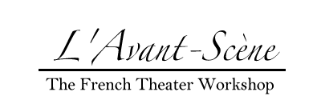

Media Contacts:
Steve Runk Florent Masse
Director of Communications Senior Lecturer in French and Italian
Lewis Center for the Arts Department of French and Italian
Princeton University Princeton University
185 Nassau Street 029 East Pyne Hall
Princeton, NJ 08544 Princeton, NJ 08544
609.258.5262 609.258.3429
srunk@princeton.edu fmasse@princeton.edu

For Immediate Release

September 1, 2016

Seuls en Scène - Princeton French Theater Festival
Celebrated French theater artists converge onstage at Princeton University
5th Edition of this Growing Festival

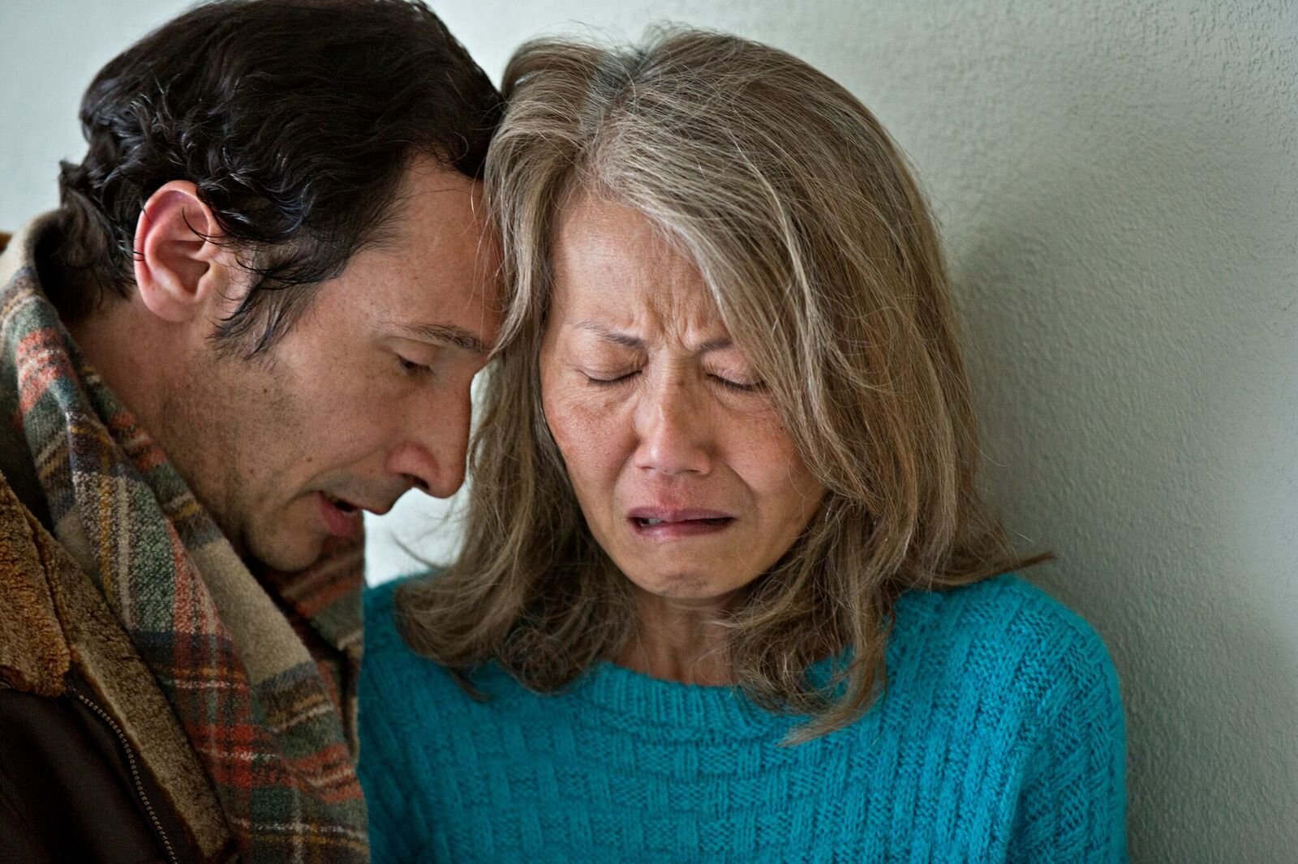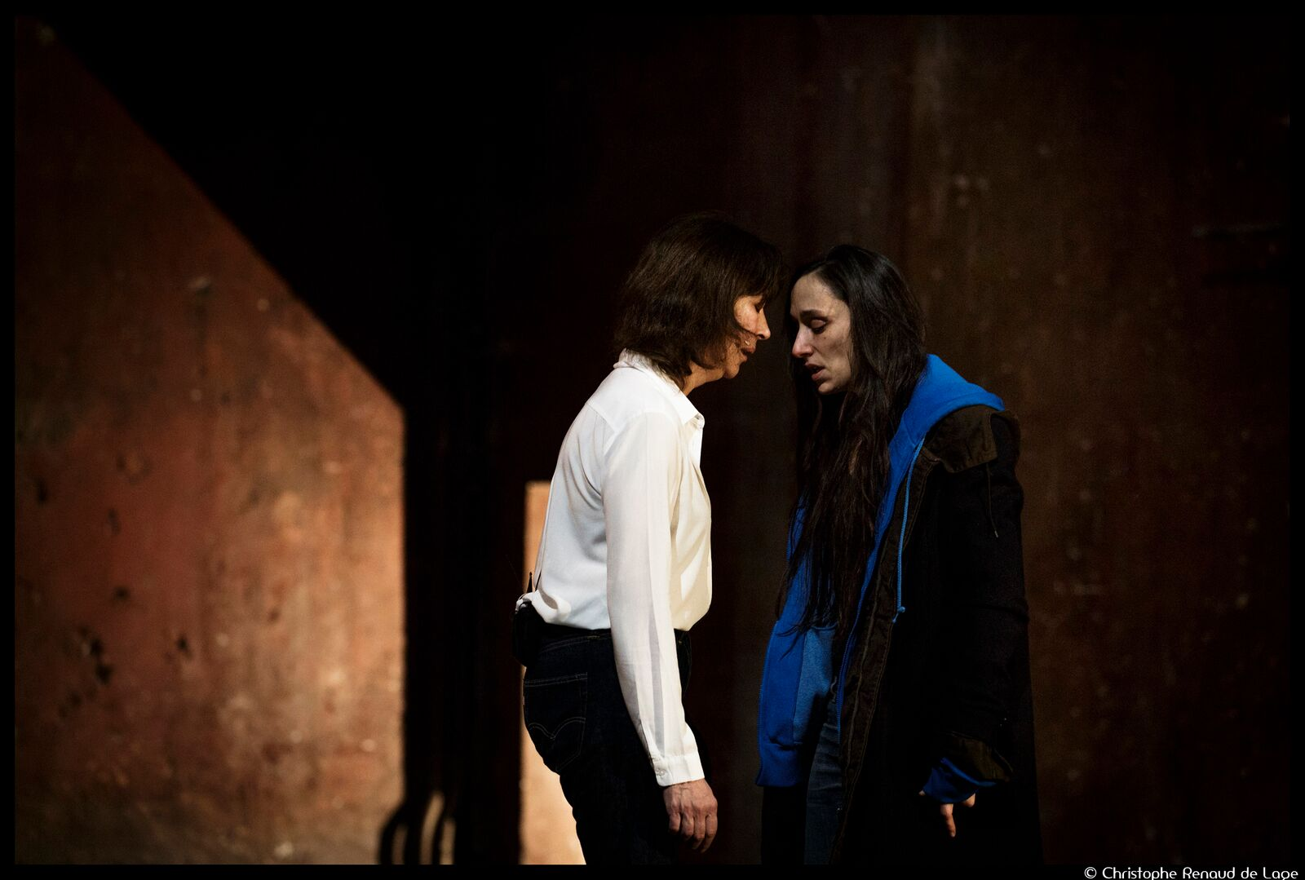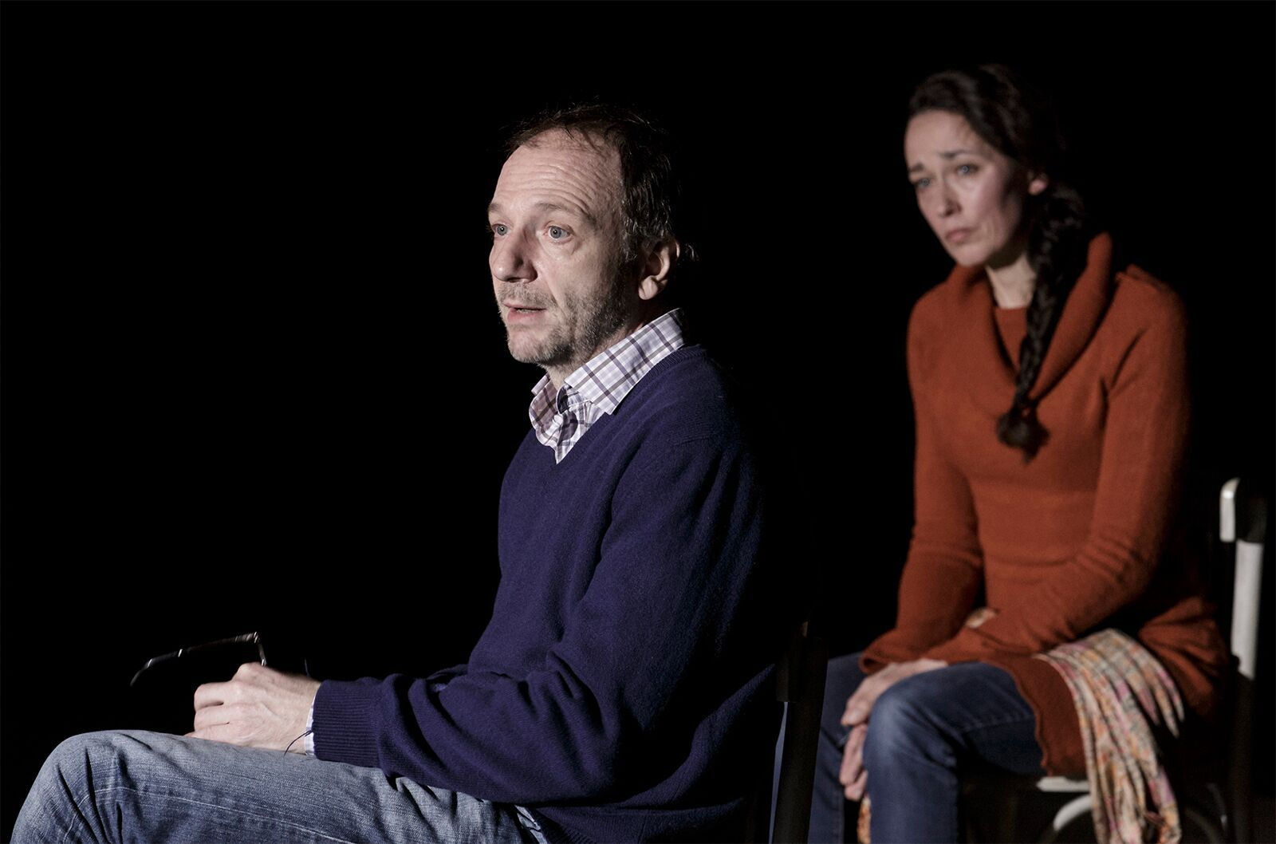
Photo caption 1: Luc Bataïni and My Chau Nguyen Thi in Mon grand amour (My Great Love) by Caroline Guiela Nguyen, which will be performed on September 30 and October 1 as part of the Princeton French Theater Festival.
Photo credit 1: Photo by Jean Louis Fernandez
Photo caption 2: Anne Alvaro (left) and Audrey Bonnet in Dans la solitude des champs de coton (In the Loneliness of the Cotton Fields) by Bernard-Marie Koltès, which will be performed on September 22 and 23 as part of the Princeton French Theater Festival.
Photo credit 2: Photo by Raynaud de Lage
Photo caption 3: Antoine Mathieu and Marie Desgranges in Ceux qui restent (The Ones Who Remain), which will be presented on September 30 and October 1 as part of the Princeton French Theater Festival
Photo credit 3: Photo by Raynaud de Lage

(Princeton, NJ) Princeton University’s Lewis Center for the Arts, Department of French and Italian, and L’Avant-Scène will present the fifth annual Seuls en Scène, French Theater Festival, which will take place from September 22 through October 6 at venues across the University’s campus. Most performances will be in French, some with English supertitles, and are free and open to the public.

Marking the launch of the 16th season of the student French theater workshop L’Avant-Scène, Seuls en Scène brings celebrated French actors and directors to the University and the local community. This year's festival includes an acclaimed play from the 2011 Avignon Theater Festival, a hit of the 2015 Avignon Fringe Festival, works by some of the most noted contemporary French playwrights, and a dance piece. The festival will showcase the diversity currently on French stages, and, as in recent years, it will unite members of the new leading generation in French theater with their more prominent peers, as well as with early career theater artists. Seuls en Scène has been organized by Florent Masse, Senior Lecturer in the Department of French and Italian and director of L’Avant-Scène. While most performances will be in French, three productions will include English supertitles, and one will be presented in English.

Kicking off the festival, Roland Auzet will direct Anne Alvaro and Audrey Bonnet in Dans la solitude des champs de coton (In the Loneliness of the Cotton Fields) by Bernard-Marie Koltès on September 22 and 23 at 8 p.m. in the Frick Chemistry Building Atrium on the Princeton campus. In the play, in an undefined place and time, a dealer (Alvaro) and a client (Bonnet) meet. The two protagonists assess one another before launching into a quarrel of words, full of poetry. Auzet stages and sets this famous play by Koltès to music in all-new version, with a twist: each spectator will participate using a set of headphones. The play was created in a mall in Lyon, France, before touring France and playing for a month at Théâtre des Bouffes du Nord in Paris.

Renowned playwright, director, and head of T2G-Théâtre de Gennevilliers Pascal Rambert will return to Princeton to present Clôture de l’amour (Closing of Love) on September 24 at 8 p.m. and September 25 at 5 p.m. He will direct Audrey Bonnet and perform in the play himself. Written for the 2011 Avignon Theater Festival, the play Closing of Love was awarded the 2012 Prix de la Meilleure création d’une pièce en langue française (Best French Language Play) by the Syndicat de la Critique and the Grand Prix de littérature dramatique by the Centre national du théâtre. Rambert wrote this play about the end of a relationship, based on his own experience. Through the play Rambert asks, “Who do we love when we love?” but does not provide an easy answer. The play became an instant classic at the Avignon Festival, and was subsequently translated and produced in many other languages. Rambert’s productions have toured the world, and he has been a regular visitor to the tri-state region, performing often at the French Institute Alliance Française Crossing the Line festival (CTL), where the American version of Clôture de l’amour (Closing of Love) was presented as part of CTL 2012.

On September 28 and 29 at 8 p.m., Mohamed El Khatib, a prominent new artist who made a lasting impression at the Avignon Fringe Festival in 2015 will perform in his play Finir en beauté (A Beautiful Ending). From interviews, emails, texts, administrative documents and other “real sources,” Mohamed El Khatib, alone on stage, (re)constructs a delicate tale of mourning the death of his mother in a touching piece of work that achieves a certain timelessness. After studying at the CADAC (Dramatic Arts Center of Mexico), and completing a Ph.D. in sociology about artistic reviews in the French press, Khatib co-founded the Zirlib collective in 2008. Since 2011, Khatib has been supported by the L’L in Brussels, where he has been conducting research on the writing of the intimate in an attempt to explore different modes of anti-spectacular exposition. He was also an associate artist at the Centre Dramatique National Orléans/Loiret/Centre in 2014-15.

Caroline Guiela Nguyen, a prominent new artist on the French stage, will direct Mon grand amour (My Great Love) on September 30 at 5:00, 7:30, and 10:00 p.m. and October 1 at 3:00, 5:00, and 7:30 p.m., in a site-specific performance, which she recently premiered at Festival Ambivalence(s) of Comédie de Valence in the Rhône Valley region. With her company Les Hommes Approximatifs, and her French and Vietnamese actors, Nguyen often integrates her native Vietnam into her plays. She also takes great care in choosing the right place to tell her stories, often presenting them in non-traditional venues, which will be the case for the performances in Princeton. Mon grand amour is the story of a place changed by the life of another place, far away, in Saigon. Nguyen is artistic associate of Comédie de Valence and Odéon Thêâtre de l’Europe, and her most recent work, Saïgon, will be part of the 2017 Avignon Theater Festival.

On September 30 and October 1 at 8 p.m., playwright and director David Lescot, will direct Marie Desgranges and Antoine Mathieu in Ceux qui restent (The Ones Who Remain). April 19, 2013 marked the 70th anniversary of the Warsaw Ghetto uprising, after which it was destroyed. Paul Felenbok was seven years old and Wlodka Blit-Robertson was twelve years old when they escaped the destruction of the Warsaw ghetto. They are among the few remaining living witnesses of this tragedy. Lescot interviewed them and, closely reflecting his documentation, transposed their testimonies into theatrical writing to create a performance with rare strength and intensity that moved audiences during the production’s run in Paris and a tour throughout France.

For the second consecutive year the Jeune Théâtre National will participate in the Festival. This year it will bring a staged reading of Paroles de soldats (Soldiers’ Words) on October 4, at 8 p.m. that will feature several early career theater artists including Victoire Du Bois and Julien Drion (who will return to the festival from past editions), Yacine Ait Benassi, William Edimo and Pierre Yvon. Paroles de Soldats, directed by Marc Sussi, Jeune Théâtre National’s artistic director, explores the enduring effects of war on the French soldiers engaged in international conflicts over the last 30 years in Iraq, Rwanda, Afghanistan, and other conflicts. The Jeune Théâtre National actors will lend their voices to these accounts, sharing the fear and anguish these soldiers encountered when faced with brutal combat that left no one unscathed.

On October 5 and 6 at 8 p.m., Noé Soulier will perform the solo dance Movement on Movement. In this project, Soulier physically reproduces sequences from internationally recognized choreographer William Forsythe's Improvisation Technologies, in which Forsythe presents different tools to generate and analyze movements. By using these tools as dance material, Soulier makes an explanation of a dance the dance itself. Words and gestures interact to create correspondences, frictions and gaps. Born in Paris in 1987, Soulier studied at the National Ballet School of Canada and PARTS in Brussels. He received a Masters degree in philosophy at La Sorbonne University and took part in Palais de Tokyo’s residency program, Le Pavillon. Soulier’s work explores the ways in which we perceive and interpret movements. He is an associated artist of Centre National de la Danse in Paris through 2017 and a regular guest artist of Festival d’Automne in Paris.

All but one of the performances will be presented in French. Three will have English supertitles: Clôture de l’amour (Closing of Love), Finir en beauté (A Beautiful Ending), and Ceux qui restent (The Ones Who Remain). Movement on Movement will be presented in English.

Also planned in conjunction with the Festival, theater artists from Québec, Brigitte Poupart and Annabel Soutar, Princeton Class of 1994, will visit the festival and engage in conversation with the artists of the festival. Open to the public, this conversation will be held on September 30 at noon with support from the Délégation Générale du Québec in New York. This will be the first step in new collaborations between Seuls en Scène and the Québec government with the hope of bringing other shows from Québec to Princeton in the near future and in celebration of Francophone theater.

This edition of the festival will continue partnerships with New York City French cultural organizations and institutions, Cultural Services of the French Embassy/French Institute Alliance Française, and introduces new partnerships with other North American festivals and theaters. Several shows and guest artists of this year’s edition of Seuls en Scène will be presented elsewhere during their stay in North America. Prior to coming to Princeton, Dans la solitude des champs de coton will be presented at Théâtre Prospero in Montréal for a full-week run. Mohamed El Khatib will premiere Finir en beauté at the 2016 Time-Based Art Festival of Portland Institute for Contemporary Arts (PICA) before visiting Princeton, and playwright/director David Lescot will visit New York University, Fordham University and the Chicago area to speak and/or perform. Noé Soulier will present another of his dance pieces, Removing, in Atlanta on the occasion of the France Atlanta 2016 celebrations.

“We rejoice in these new collaborations,” notes Masse.

Discussion with the artistic teams of the shows will follow each performance. During their visits, festival artists will offer master classes for Princeton students related to their current theatrical productions. They will also participate in Program in Theater classes, such as the French Theater Workshop course, and L’Avant-Scène.

Masse, who curates the Festival, was trained as an actor and director at the University of Lille and Lille National Theater under Daniel Mesguich. He later pursued his theater studies at Amherst College as a Levy-Despas Fellow and a teaching assistant in the Department of French. It is there that he originated L’Avant-Scène, a program, which combines language and dramatic training. He has directed more than 40 full-length productions of canonical and new works of French theater since arriving at Princeton in 2001, and has hosted several prominent theater artists. He has curated five editions of Seuls en Scène and introduced new master class series programs at L’Avant-Scène. This past summer Masse taught a Global Seminar on French Theater in Paris and Avignon, one of six Global Seminars offered this year by the Princeton Institute for International and Regional Studies.

Upcoming 2016-17 L’Avant-Scène productions include, among others, Le Début de l’A by Pascal Rambert on November 18 and 19 in the Marie and Edward Matthews Acting Studio at 185 Nassau Street; Le Misanthrope by Molière on March 3 and 4 at Rockefeller College Common Room; and Huis clos by Sartre on April 19 and 20 at Rockefeller College Theater. The season will conclude with a performance of scenes by members of the troupe at the Florence Gould Hall of French Institute Alliance Française in New York City in May. A new master class series produced by L’Avant- Scène will bring actors Xavier Gallais and Nicholas Bouchaud, directors Pascal Rambert and Èlise Vigier, and playwright Kevin Keiss to campus, as well as students from Théâtre National de Strasbourg.

The Festival is being presented by the Lewis Center for the Arts, the Department of French and Italian, and L’Avant-Scène with support through the Lewis Center’s Arts Initiative Partners program, which annually seeks unique arts partnership projects with other University departments and affiliated groups and individuals. This year’s Festival is also made possible by grants from the Fund for Contemporary Theater of the French-American Cultural Exchange Foundation (FACE) administered by the Cultural Services of the French Embassy, and Institut français. Additional support is provided by Princeton University’s Department of French and Italian, the Council of the Humanities, the Department of Music, the Princeton Institute for International and Regional Studies (PIIRS), the Program in Judaic Studies, the Department of Art and Archaeology, Rockefeller College, and Jeune Théâtre National (JTN).

Most Festival performances will take place in the Marie and Edward Matthews ’53 Acting Studio at 185 Nassau Street. Other venues include the Whitman College of 1970 Theater, and the Atrium of Frick Chemistry Building. All events are free but reservations are required online at: http://arts.princeton.edu/events/tag/french-theater-festival/
Further information about L’Avant-Scène can be found at http://fit.princeton.edu/initiatives
For more information on the Princeton French Theater Festival and the more than 100 events presented by the Lewis Center each year, visit arts.princeton.edu.
EVENT SCHEDULE
Thursday, September 22, 2016 at 8:00 p.m.
Dans la solitude des champs de coton by Bernard-Marie Koltès – directed by Rolaud Auzet, performed in French by Anne Alvaro and Audrey Bonnet
Frick Chemistry Building Atrium

Friday, September 23, 2016 at 8:00 p.m.
Dans la solitude des champs de coton by Bernard-Marie Koltès – directed by Rolaud Auzet, performed in French by Anne Alvaro and Audrey Bonnet
Frick Chemistry Building Atrium

Saturday, September 26, 2016 at 8:00 p.m.
Clôture de l’amour written and directed by Pascal Rambert
Performed in French by Audrey Bonnet and Pascal Rambert, with English supertitles
Marie and Edward Matthews ’53 Acting Studio at 185 Nassau Street

Sunday, September 27, 2016 at 5:00 p.m.
Clôture de l’amour written and directed by Pascal Rambert
Performed in French by Audrey Bonnet and Pascal Rambert, with English supertitles
Marie and Edward Matthews ’53 Acting Studio at 185 Nassau Street

Wednesday, September 28, 2016 at 8:00 p.m.
Finir en beauté by Mohamed El Khatib
Performed in French by Mohamed El Khatib, with English supertitles
Whitman College Class of 1970 Theater

Thursday, September 29, 2016 at 8:00 p.m.
Finir en beauté by Mohamed El Khatib
Performed in French by Mohamed El Khatib, with English supertitles
Whitman College Class of 1970 Theater

Friday, September 30, 2016 at 12:00 p.m
Guest artists of the Festival in Conversation with French-Canadian artists Annabel Soutar, Princeton Class of 1994, and Brigitte Poupart
Whitman College, Octogonal Room

Friday, September 30, 2016 at 5:00/7:30/10:00 p.m.
Mon grand amour written and directed by Caroline Guiela
Performed in French by Luc Bataïni, Dan Artus, and My Chau Nguyen Thi
Location TBA

Friday, September 30, 2016 at 8:00 p.m.
Ceux qui restent directed by David Lescot
Performed in French by Marie Desgranges and Antoine Mathieu, with English supertitles
Marie and Edward Matthews ’53 Acting Studio at 185 Nassau Street

Saturday, October 1, 2016 at 3:00/5:00/7:30 p.m.
Mon grand amour written and directed by Caroline Guiela
Performed in French by Luc Bataïni, Dan Artus, and My Chau Nguyen Thi
Location TBA

Saturday, October 1, 2016 at 8:00 p.m.
Ceux qui restent directed by David Lescot
Performed in French by Marie Desgranges and Antoine Mathieu, with English supertitles
Marie and Edward Matthews ’53 Acting Studio at 185 Nassau Street

Tuesday, October 4, 2016 at 8:00 p.m.
Paroles de soldats directed by Marc Sussi
A staged reading in French by Victoire Du Bois, Pierre Yvon, Julien Drion, William Edimo and Yacine Ait Benassi
Marie and Edward Matthews ’53 Acting Studio at 185 Nassau Street

Wednesday, October 5, 2016 at 8:00 p.m.
Movement on Movement by Noé Soulier
Performed in English by Noé Soulier
Whitman College Class of 1970 Theater

Thursday, October 6, 2016 at 8:00 p.m.
Movement on Movement by Noé Soulier
Performed in English by Noé Soulier
Whitman College Class of 1970 Theater

Admission to all Festival events is free but reservations are required by visiting: http://arts.princeton.edu/events/tag/french-theater-festival/

For more information on the Festival, please contact Steve Runk, Communications Director Lewis Center for the Arts srunk@princeton.edu or Florent Masse, Department of French and Italian fmasse@princeton.edu

