October 10, 2016

The Lewis Center for the Arts’ Program in Theater presents
Lobby Hero by Kenneth Lonergan
A senior thesis show featuring Charlie Baker ’17 & Stanley Mathabane ’17 and directed by faculty member Mark Nelson at Princeton University

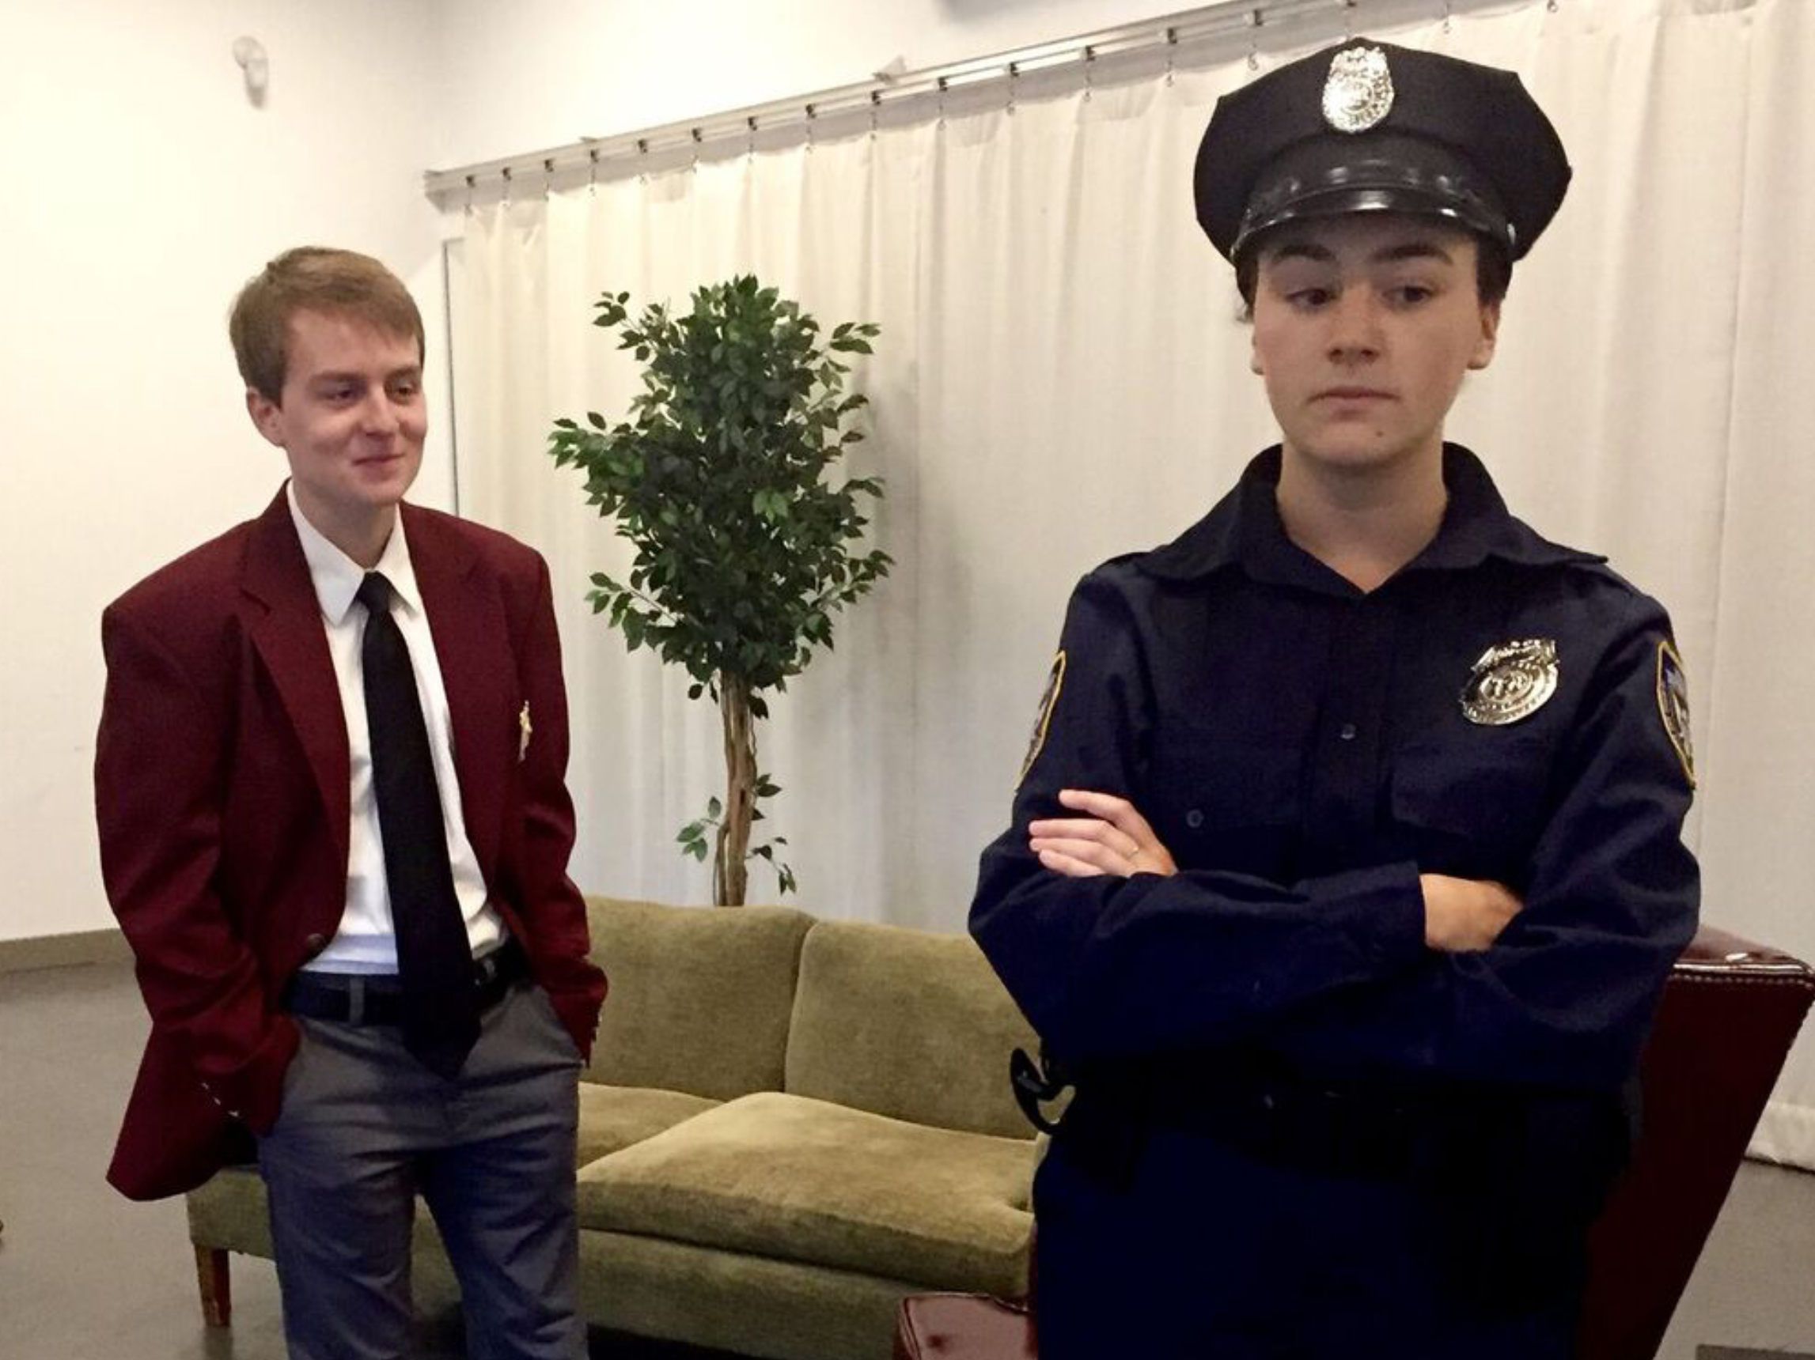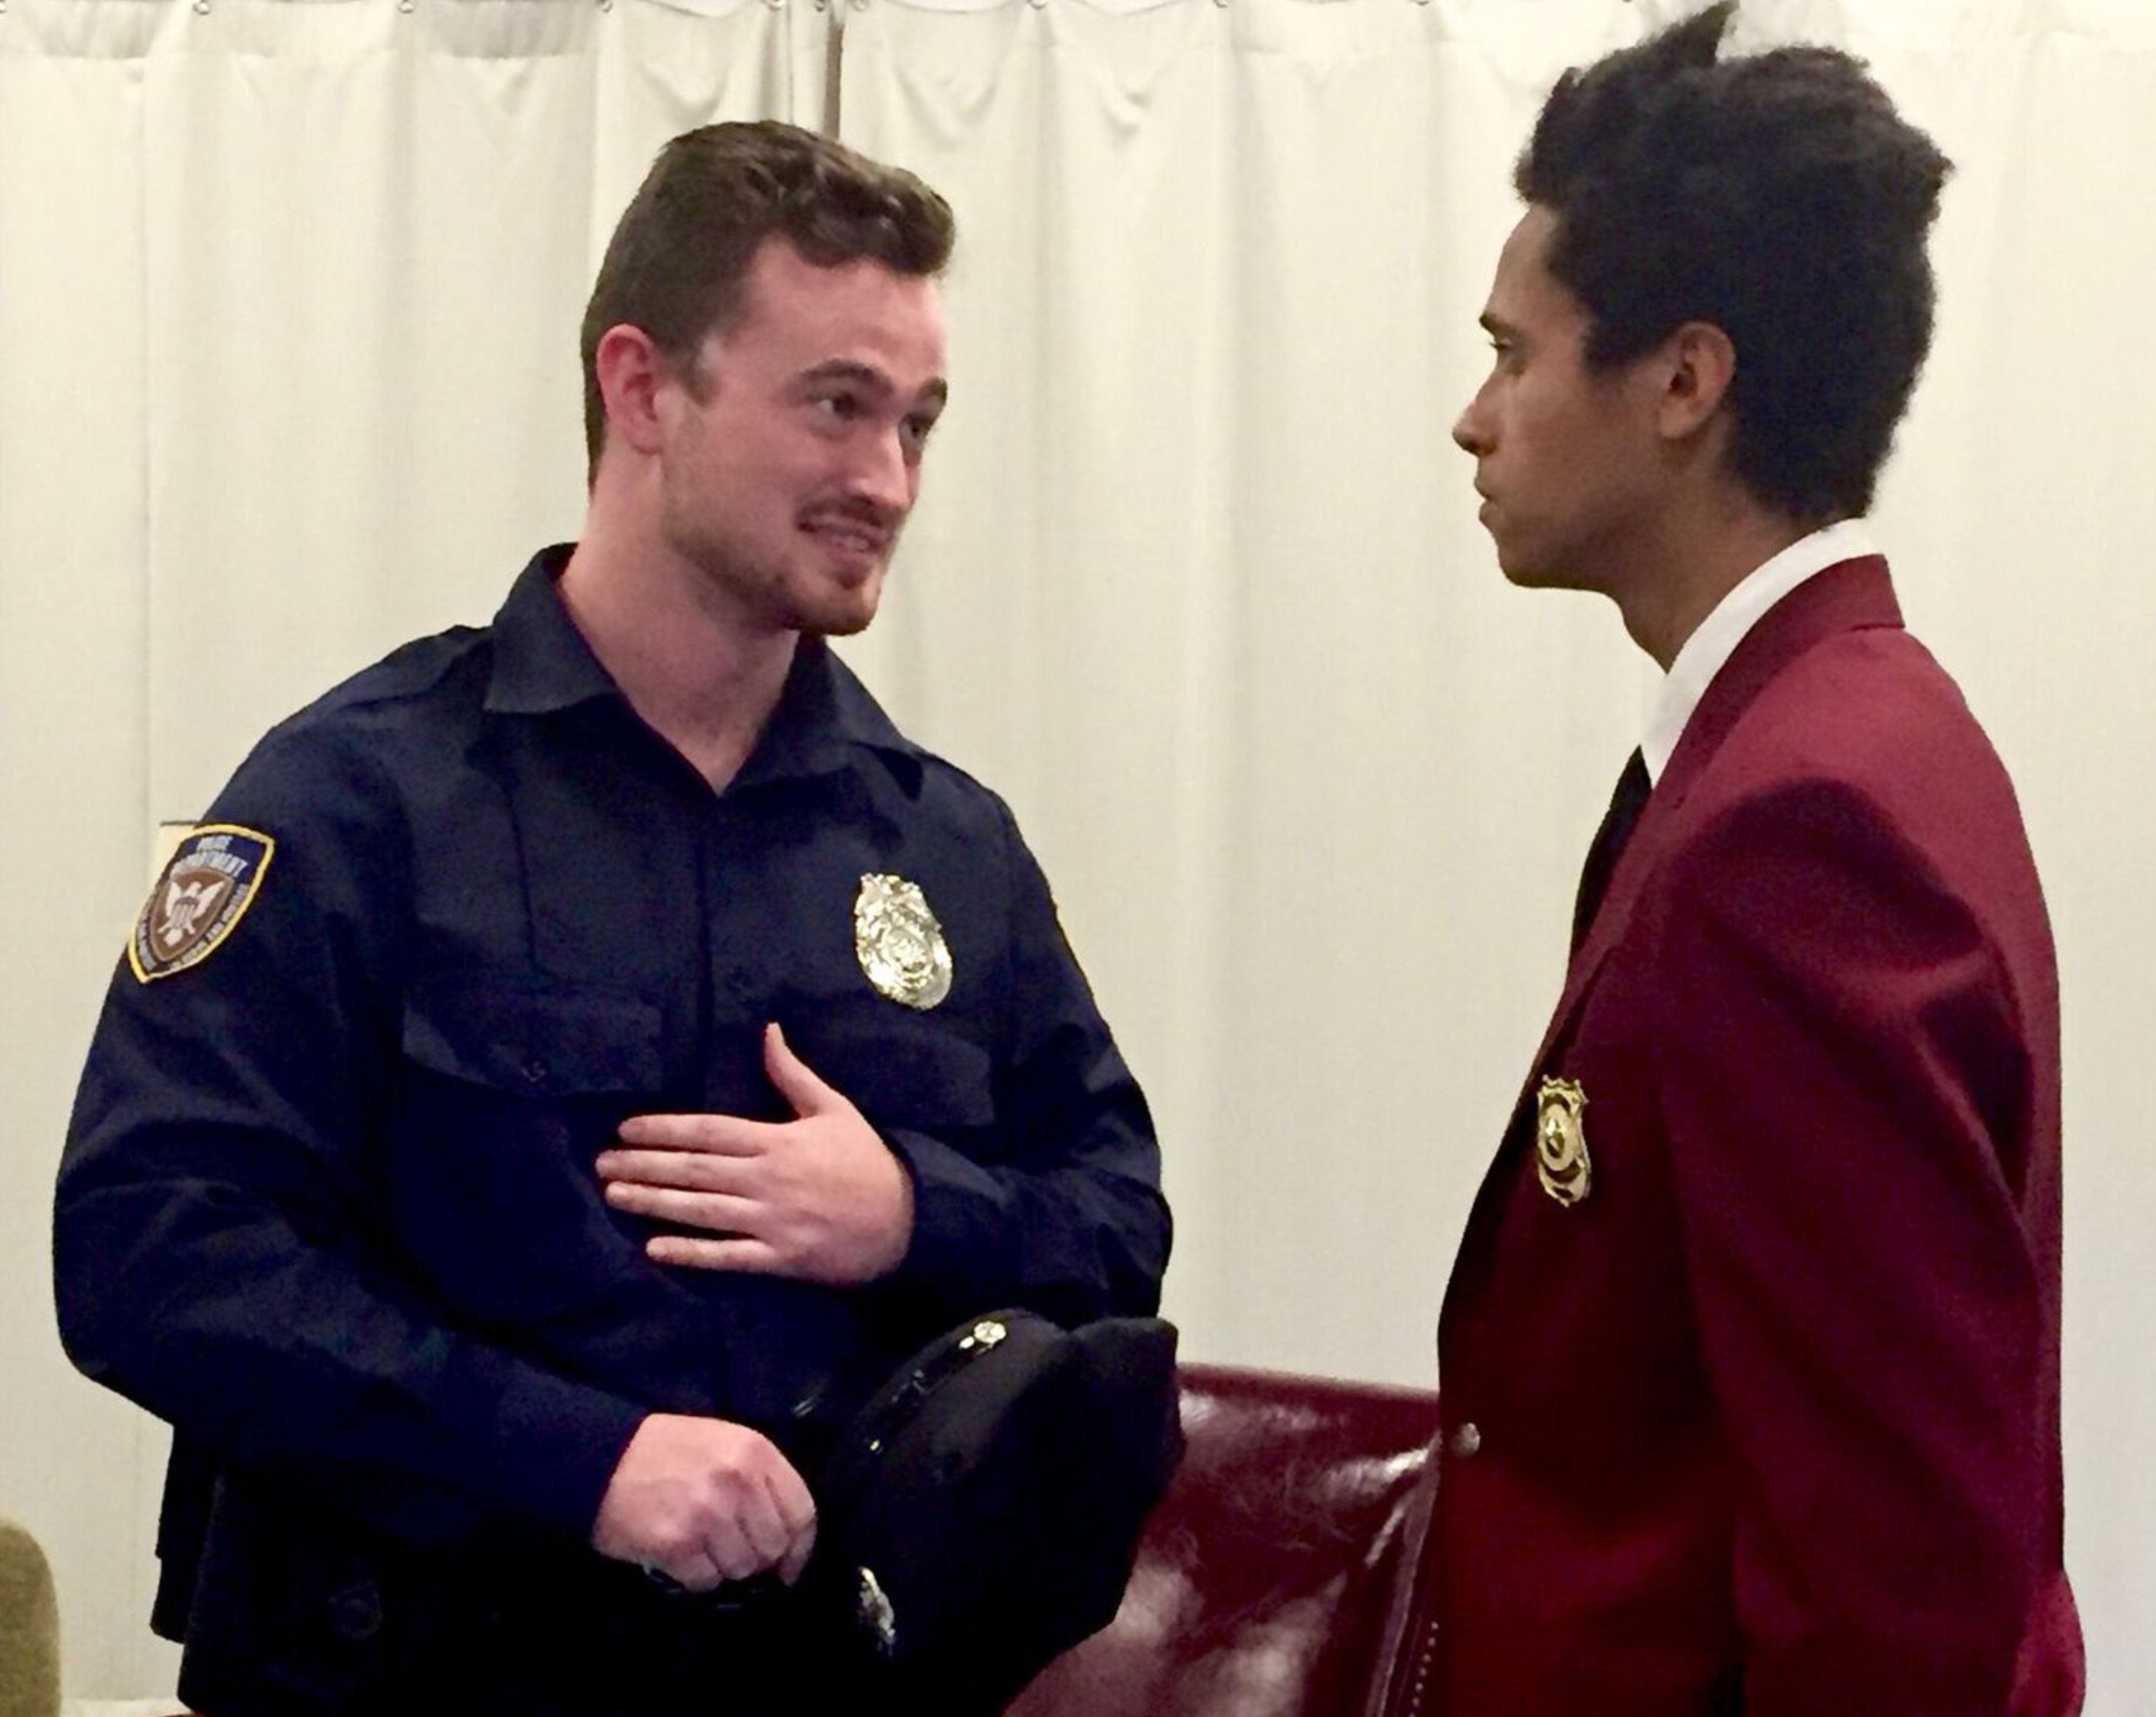
Photo caption 1: Seniors Charlie Baker as Jeff and Nadia Diamond as Dawn in rehearsal for Lobby Hero
Photo caption 2: Seniors Robby Keown as Bill and Stanley Mathabane as William in rehearsal for Lobby Hero
Photo credits: Mark Nelson

What: Lobby Hero by Kenneth Lonergan, heralded as “the best drama, the best comedy and the best romance of the year, all rolled into one” by Time Out New York. In the lobby of a Manhattan apartment building in the middle of the night, two security guards are drawn into a murder investigation. Facing dilemmas of race, gender and friendship, will they do the right thing for the wrong reason? Or maybe the wrong thing for the right reason?
Who: Presented by Lewis Center for the Arts’ Program in Theater, directed by faculty member Mark Nelson and featuring Princeton seniors Charlie Baker and Stanley Mathabane
When: October 21, 26, 27 and 28 at 8 p.m., October 22 at 3 p.m. with talkback following
Where: Marie and Edward Matthews ’53 Acting Studio at 185 Nassau St. in Princeton
Tickets: In advance of show date -$12 general admission/$11 students and seniors; box office on days of performances -$17 general admission/$15 students and seniors

(Princeton, NJ) The Lewis Center for the Arts’ Program in Theater at Princeton University will present Lobby Hero by Kenneth Lonergan, directed by faculty member Mark Nelson and featuring seniors Charlie Baker and Stanley Mathabane, on October 21, 26, 27 and 28 at 8:00 p.m. and October 22 at 3:00 p.m. Performances will take place in the Marie and Edward Matthews ’53 Acting Studio located at 185 Nassau Street. A talkback discussion with the director and cast will follow the October 22 performance.

In the lobby of a Manhattan apartment building in the middle of the night, two security guards are drawn into a murder investigation. Facing dilemmas of race, gender and friendship, the play asks: will they do the right thing for the wrong reason? Or maybe the wrong thing for the right reason? Lobby Hero, written by Oscar-nominated playwright, screenwriter and film director Kenneth Lonergan, first opened off-Broadway in 2001 at the Playwrights Horizons Theater, and since then has been revived both off-Broadway and in the United Kingdom. Time Out New York describes the play as “the best drama, the best comedy and the best romance of the year, all rolled into one.”

Lobby Hero grapples with contemporary, pressing questions about race, gender, friendship and personal codes of honor. As director Nelson puts it, “It’s a serious comedy with a moral question at its heart: in a world so unfair that the best option is often choosing between bad and worse, what does it mean to do the right thing?”

Lonergan is also the author of the plays This Is Our Youth and The Waverly Gallery, and he wrote and/or directed the films You Can Count On Me starring Laura Linney and Mark Ruffalo; Analyze This starring Robert De Niro and Billy Crystal; and Margaret starring Anna Paquin and Matt Damon. His newest film, Manchester by the Sea starring Casey Affleck and Michele Williams, won the Grand Jury Prize at Sundance last summer and opens around the country in November.

Mark Nelson, an actor, director, and member of Princeton’s class of 1977, is a current faculty member in the Lewis Center’s Program in Theater. He has appeared frequently on and off-Broadway, and recently toured for eight months in Sam Mendes’ Tony Award-winning production of Cabaret, performing in 18 cities around the country as Herr Schultz. Nelson has directed plays at Manhattan Theatre Club, McCarter Theatre, George Street Playhouse, and Chautauqua Theatre Company, and directed last year’s Lewis Center senior thesis production of Anton Chekhov’s The Seagull, in which three members of the Lobby Hero cast performed.

Baker, a senior in the Department of German, and Mathabane, a senior in the Department of Psychology, will appear in this production as part of their theses in the Program in Theater. Baker and Mathabane are both active members in Princeton’s theater community.

Baker was born and raised in New York City, where he attended the Fiorello H. LaGuardia High School of Music & Art and Performing Arts. He is a member of Princeton’s award-winning improv troupe Quipfire! and is the host of the undergraduate late night comedy talk-show All-Nighter. He has performed in a number of Program in Theater productions and with the student theater groups Theatre Intime and Grind Arts. He is also one half of the music duo Baker & Goods and a member of the rock band St. Danger.

Baker will be playing the role of Jeff, the wise-guy doorman who observes the world coolly from the fringes until he's finally forced to take a risk.

Mathabane, born and raised in Portland, Oregon, is a singer/songwriter and is also serving as sound designer and composing original music for Lobby Hero. Mathabane has performed in a number of Lewis Center productions, as well as with the student company Princeton University Players, the Princeton Triangle Club, the Tigertones a cappella group, and L’Avant Scene, the French-language theater group.

Mathabane will be playing the role of William, a security guard who questions his own rigid code of honor when his brother is caught up in the justice system.

Baker and Mathabane proposed doing this play as their senior thesis after working on a scene from the show in Nelson’s scene study course.

The cast also includes Nadia Diamond ’17 as the rookie cop Dawn and Robby Keown ’17 as her partner, the seasoned police officer Bill. Julia Peiperl ’17 is the costume designer for the production and Megan Berry ’18 is the lighting designer. Michelle Goldman ’18 will serve as stage manager, with Anna Zabel ’19 as assistant stage manager.

When asked the question “Why Lobby Hero?,” Nelson notes with passion that what draws him to the play is that “it never judges its characters or offers easy lessons: the messy human complication is the point, and it’s revealed in expert, funny dialogue.” In the rehearsal room, Nelson and his four actors have been concentrating on using the play’s compassion and humor to “put a human face on ethical questions by making these people as particular and funny and torn-up as we can manage.”

Tickets for Lobby Hero are $12 general admission and $11 for students and seniors when purchased in advance, and $17 general admission and $15 for students and seniors purchased the day of performances at the box office. Tickets are available through University Ticketing, which offers online ordering and print-at-home tickets. To purchase tickets online visit http://arts.princeton.edu/events/lobby-hero/2016-10-21/ or call Princeton University Ticketing at 609.258.9220, or stop by the Frist Campus Center Ticket Office. Tickets will also be available at the door prior to performances.

To learn more about this event, the Program in Theater, and the more than 100 other activities presented at the Lewis Center visit arts.princeton.edu.

###

