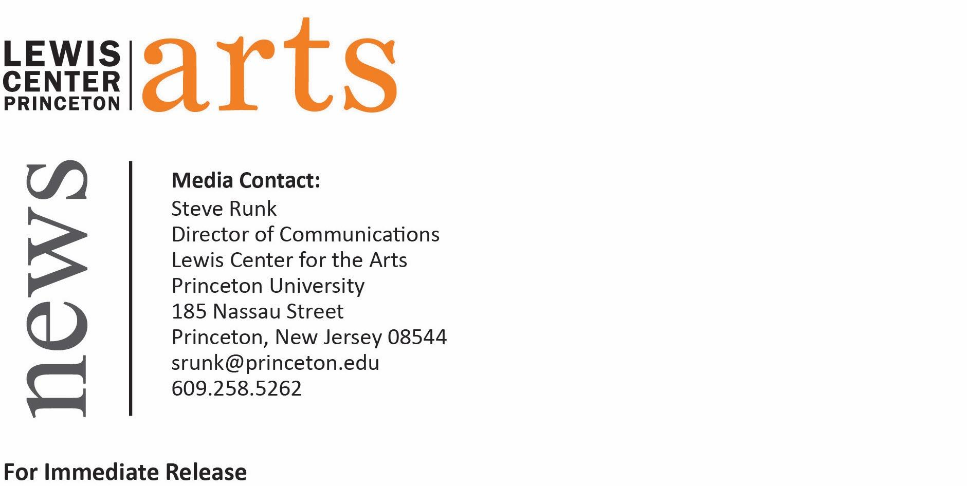

October 20, 2016

Reading and Conversation with Writer Marina Budhos
Award-winning writer reads from her latest novel Watched and discusses her work with faculty member Christina Lazaridi, organized by Princeton Arts Fellow Afia Serena Nathaniel

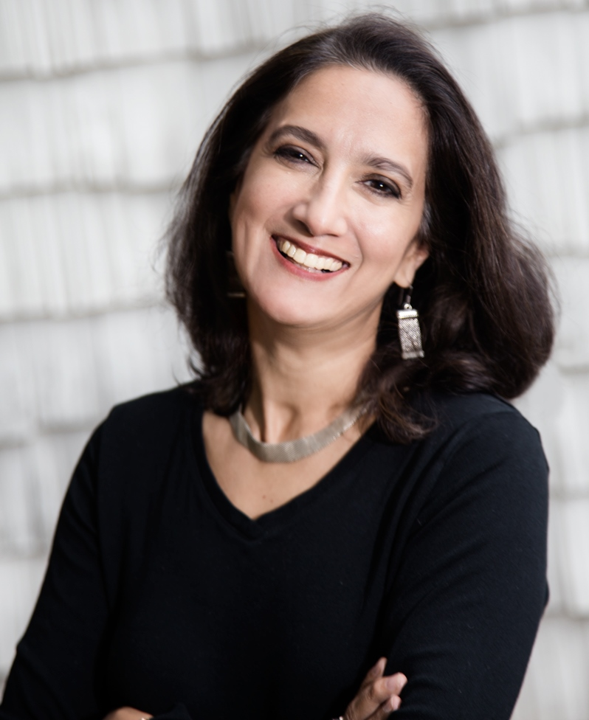
Photo caption: Writer Marina Budhos
Photo credit: Courtesy of marinabudhos.com

Who/What: Reading and conversation with writer Marina Budhos, author of Watched, organized by Princeton Arts Fellow Afia Serena Nathaniel and moderated by Program in Creative Writing faculty member and screenwriter Christina Lazaridi. Watched follows the story of an immigrant teen, Naeem, as he attempts to navigate New York City amidst racial profiling, surveillance of Muslim communities, and post-9/11 tension.
When: Thursday, October 27 at 4:30 p.m.
Where: Room 010 in East Pyne on the Princeton University campus
Free and open to the public

(PRINCETON, NJ) Award-winning writer Marina Budhos will present a reading from her new novel Watched and take part in a discussion about her work on Thursday, October 27 at 4:30 p.m. in Room 010 in the East Pyne building on the Princeton University campus. The event has been organized by Princeton Arts Fellow and filmmaker Afia Serena Nathaniel, and the conversation will be moderated by Program in Creative Writing faculty member and screenwriter Christina Lazaridi. The event is free and open to the public.

Watched follows the story of an immigrant teen, Naeem, as he attempts to navigate New York City amidst racial profiling, surveillance of Muslim communities, and post-9/11 tension. Copies of Watched will be available for sale and signed by the author at the conclusion of the event.

Marina Budhos is an award-winning author of both fiction and nonfiction, exploring the situations and perspectives of immigrants and Muslim communities in the post-9/11 era. Her other critically acclaimed works include young adult literature such as Tell Us We’re Home and Ask Me No Questions and nonfiction such as Sugar Changed the World: A Story of Magic, Spice, Slavery, Freedom & Science, which was a 2010 Los Angeles Times Book Award Finalist and was co-authored with her husband Marc Aronson. Budhos’s awards include the Exceptional Merit Media Award and the Rona Jaffe Award for Women Writers. She has been a Fulbright Scholar to India and received two fellowships from the New Jersey State Council on the Arts. A graduate of both Cornell and Brown, Budhos currently teaches English at William Paterson University in Wayne, New Jersey. Her next book, Eyes of the World: Robert Capa & Gerda Taro & The Invention of Modern Photojournalism, which is also co-authored with Aronson, is expected to be published in 2017.

Christina Lazaridi’s screenwriting career began with her nomination for an Academy Award for One Day Crossing, a World War II family drama. Since then she has worked as a screenwriter and story consultant within the West Coast studio system (New Line and Bruckheimer Productions among others), as well as the New York indie film scene and on multiple international productions. She joined Princeton’s faculty at the Lewis Center and the Program in Creative Writing in 2008 and is a full-time lecturer in screenwriting. A Princeton alum, Class of 1992, Lazaridi also works internationally as a story analyst and screenwriting consultant, with a deep research interest in the neuroscience of storytelling and audience response. She has written three books on screenwriting methodology, Stories That Change: a Diagnostic Manual for Troubleshooting Your Screenplay and Stories That Change: Studies of Screenplays in Motion Part I &II, commissioned and published by the Mediterranean Film Institute in conjunction with European Union’s Media Development Program. Lazaridi has also taught extensively at Columbia University’s Graduate Film division and is a screenwriting mentor at the Mediterranean Film Institute, one of Europe’s major script development programs.

Afia Serena Nathaniel is the 2016-18 Peter B. Lewis Arts Fellow at Princeton University. She is a computer scientist-turned filmmaker who “loves pushing the boundaries of narrative filmmaking.” Her debut feature film Dukhtar (Daughter) premiered at Toronto in 2014 and was Pakistan’s official submission for Foreign Language Film at the 87th Academy Awards. The film has played to critical acclaim in over 20 countries and became the Critics’ Pick in New York and a People Magazine’s Pick of the Week. Nominated for the 2013 Gotham Award, Nathaniel has been awarded the Adrienne Shelly Award for Directors, the Ezra Litwak Award for Distinction in Screenwriting, and a Hollywood Foreign Press Association grant. She has taught at Columbia University’s School of the Arts and New York University’s Tisch School of the Arts. As a Princeton Arts Fellow, she teaches film directing and screenwriting courses.

For more information about this event, the Princeton Arts Fellowship program, the Program in Creative Writing, and the more than 100 other events offered annually by the Lewis Center for the Arts, visit arts.princeton.edu.

###

