

**NEWS**

**Press Contact: Rachel Joyce 612.375.7635 rachel.joyce@walkerart.org**

**Online Press Room: press.walkerart.org**

**Twitter: WalkerArtMedia**

# WALKER ART CENTER PRESENTS MIDWEST DEBUT OF BESSIE-AWARD WINNING CHOREOGRAPHER PAVEL

# ZUŠTIAK’S *CUSTODIANS OF BEAUTY*

“Plunges headlong into questions about what is ‘beautiful’ by interrogating sources like Plato, Pope Benedict XVI, and of course, the dancing body.” —*Time Out New York*

Minneapolis, September 26, 2016—Bessie Award–winning choreographer/director [Pavel Zuštiak](http://www.palissimo.org/) and his Palissimo Company examine beauty and its intrinsic relationship with art through minimalist movement, sensuous abstraction, and potent stage imagery. Drawn from a dark Eastern European dance-theater aesthetic, this Walker-commissioned, richly postmodern dance/live music event casts the human body as a sculptural form, an emotional trigger, or a political symbol. *Custodians of Beauty* will be performed in the William and Nadine McGuire Theater Thursday**–**Saturday, October 20**–**22, 8 pm.

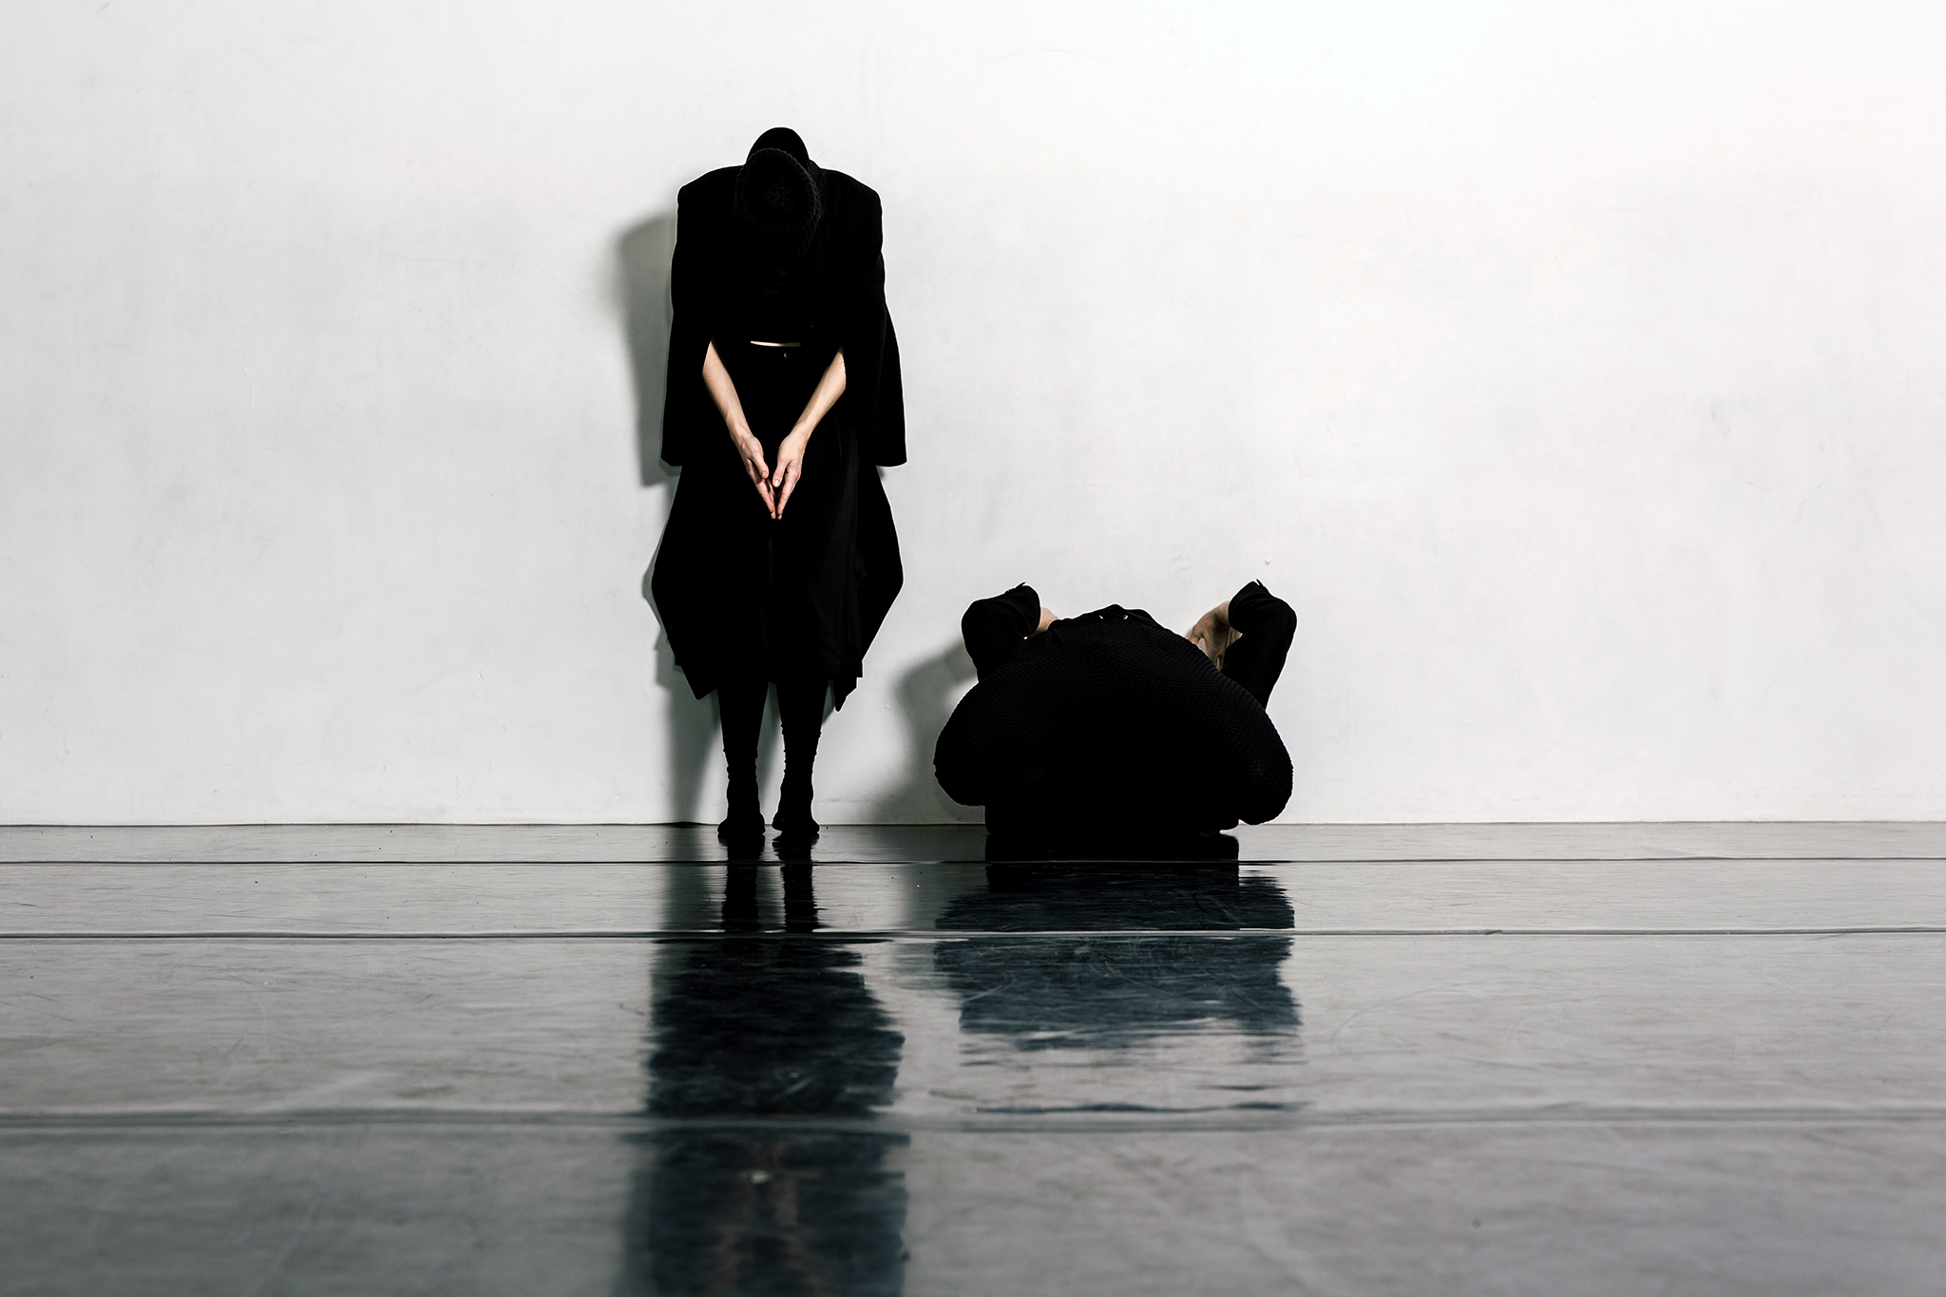

[Pavel Zuštiak](http://www.palissimo.org/) *Custodians of Beauty* Photo: Photo: Scott Shaw

Zuštiak is a New York City-based director, choreographer, performer and sound designer, known as the creative spirit behind sophisticated interdisciplinary productions of Palissimo Company, which he founded and has been leading since 2004. His work, often described as both human and humane, merges the abstract aspects of dance with nonlinear qualities of “theatre of images” and mise-en-scène. His approach results in art that is rich in evocative imagery, piercing emotional resonance and non-narrative/nonverbal content, art that strives to provide innovative, transformative insight into human condition.

Born in the communist Czechoslovakia and introduced at an early age to acting (he was a child star of the popular TV show The Golden Gate), film, music and modern dance, Zuštiak left for Amsterdam shortly after the fall of communism to study at the School for New Dance Development; eventually, he moved to New York City. Zuštiak’s instantly recognizable style – combining immigrant feeling of otherness and displacement with very American sense of freedom to explore disparate cultural, artistic and intellectual resources in search for new means of expression.

Praised as a sound designer of “enormous talent,” (*The New York Sun*), Zuštiak points to his classical music training as important factor in developing unique approach to music and sound, conceived as equally tactile as other elements of production design. Carefully orchestrated and intertwined with all components of a performance, his music “alternately lulls and whips the listener, opening up regions of disturbing awareness” (InfiniteBody). Scores for Palissimo Company aside, he has also created large-scale sound works for New York choreographers Jeremy Nelson and Ashleigh Leite.

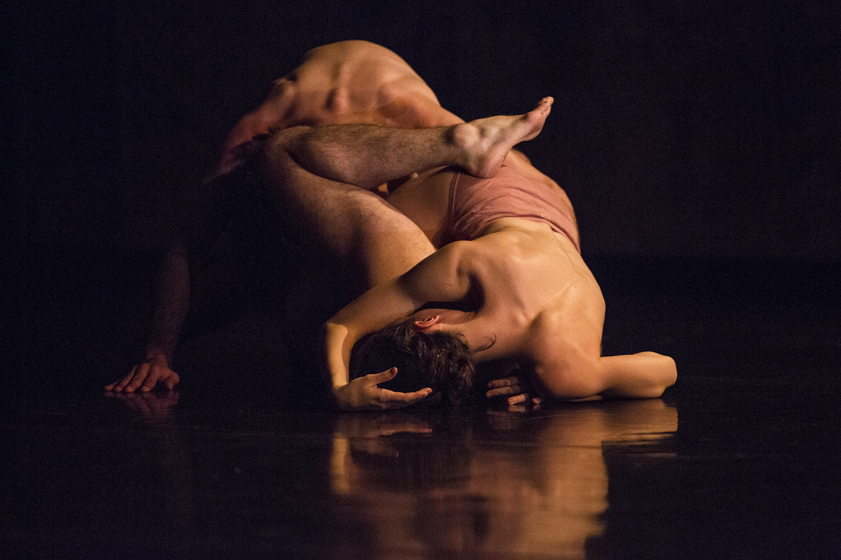

[Pavel Zuštiak](http://www.palissimo.org/) *Custodians of Beauty* Photo: Photo: Scott Shaw

Zuštiak is the 2015 Bessie Juried Award winner for his “poetic layering of movement and visual imagery, conceiving the stage space as a decentralized world in which the corporeal body is the focus and canvas for a wide range of human expression,” a 2015-17 Princeton Arts Fellow, the recipient of 2013 LMCC President's Award for Excellence in Artistic Practice and 2012 NEFA/NDP Production and Residency Grants, 2010 Guggenheim Fellow and 2014, 2009, and 2007 Princess Grace Awards Winner. His 5-hour trilogy *The Painted Bird* received a 2013 Bessie Award nomination for Outstanding Production. For more information on the company visit www.palissimo.org

**Tickets**

Tickets to[Pavel Zuštiak](http://www.palissimo.org/) are $22 ($17.60 Walker members) and are available at walkerart.org/tickets or by calling 612.375.7600.

**Drinks at the Lounge**

The Walker Lounge (in the former Gather by D’Amico space) is the place to be before and after the performance. Grab a cocktail before the show, or stay afterward for a drink and conversations.

**Free Gallery Admission**

Extend your art experience—come back with your ticket within seven days of a performance, and get in free to the Walker galleries.

**Acknowledgments**

Commissioned by the Walker Art Center with support provided by the William and Nadine McGuire Commissioning Fund, the Andrew W. Mellon Foundation, and the National Performance Network’s (NPN) Creation Fund project created in partnership with the Walker Art Center, Legion Arts, New York Live Arts, and NPN. The NPN Creation Fund is supported by the Doris Duke Charitable Foundation, Ford Foundation, and the National Endowment for the Arts. Additional commissioning support provided by the American Dance Institute (ADI); the world premiere was presented as part of ADI’s Incubator program.

In honor of Dale Schatzlein (1948–2006) and his important work in dance and jazz in the Twin Cities, additional support is provided by Emily Maltz.

*Custodians of Beauty* is supported by the Jerome Foundation and, in part, by public funds from the New York City Department of Cultural Affairs in partnership with the City Council. The piece was developed as part of Lower Manhattan Cultural Council’s Process Space artist residency program and in creative and developmental residencies at Walker Art Center and the Cowles Center for Dance and the Performing Arts in Minneapolis. Pavel Zuštiak researched, developed and honed *Custodians of Beauty* with financial, administrative and residency support from the Dance in Process Program at Gibney Dance. Additional resources for *Custodians of Beauty* were received through Materials for the Arts.

The Walker Art Center’s performing arts programs are made possible by generous support from the Doris Duke Charitable Foundation through the Doris Duke Performing Arts Fund, the William and Nadine McGuire Commissioning Fund, the Andrew W. Mellon Foundation, and the National Endowment for the Arts.

**Producers’ Council**

Performing Arts programs and commissions at the Walker are generously supported by members of the Producers’ Council: Goodale Family Foundation, Nor Hall and Roger Hale; King’s Fountain/Barbara Watson Pillsbury and Henry Pillsbury; Emily Maltz; Dr. William W. and Nadine M. McGuire; Leni and David Moore, Jr./The David and Leni Moore Family Foundation; Mike and Elizabeth Sweeney; and Frances and Frank Wilkinson.



**Walker Art Center Premier Partners**

Description: S:\Design_Logo_Land\ Premier_Partners_2014\PremierPartners2014_email.png



This activity is made possible by the voters of Minnesota through a Minnesota State Arts Board Operating Support grant, thanks to a legislative appropriation from the arts and cultural heritage fund.

**The Walker Art Center is located at 1750 Hennepin Avenue—where Hennepin meets Lyndale—one block off Highways I-94 and I-394, in Minneapolis.**

**For public information, call 612.375.7600 or visit walkerart.org. Stay connected via your mobile device and follow us on Twitter and Facebook.**