November 3, 2016

Award-winning experimental filmmaker Christopher Harris at Princeton
Filmmaker will screen and discuss several of his short films and installations, sponsored by the John Sacret Young ’69 Film Studies Fund

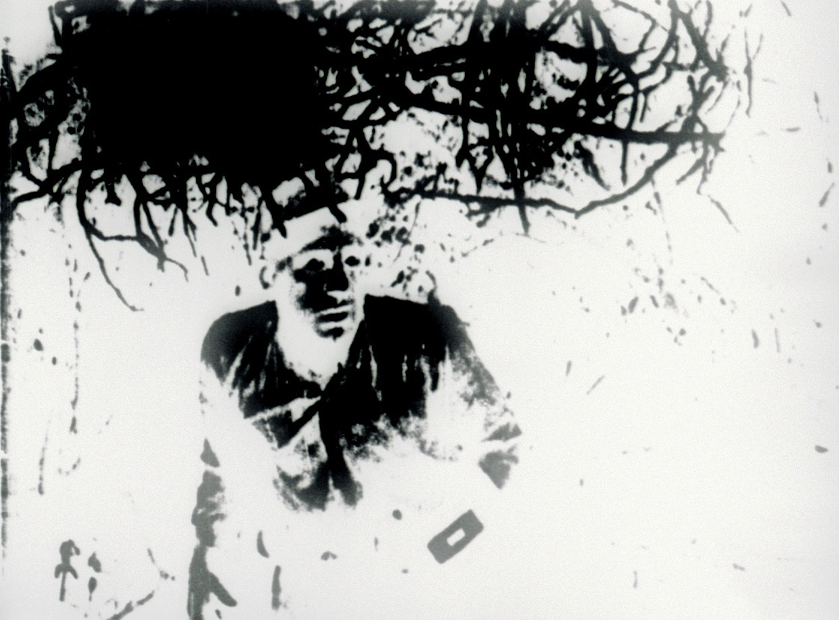
Photo caption: A still from Christopher Harris’s film, Reckless Eyeballing
Photo credit: Courtesy of Christopher Harris

Who: Award-winning experimental filmmaker Christopher Harris, presented by the Visual Arts Program, Lewis Center for the Arts
What: Screening of several of his short films and video installations followed by discussion with the filmmaker, sponsored by the John Sacret Young ’69 Film Studies Fund and the Lewis Center’s Committee on Race and the Arts
When: Wednesday, November 9 at 7:30 p.m.
Where: James M. Stewart ’32 Theater at 185 Nassau St, Princeton, NJ
Free and open to the public

(Princeton, NJ) The Visual Arts Program of the Lewis Center for the Arts at Princeton University will present a screening of several short experimental films and video installations by Christopher Harris followed by a discussion with the filmmaker on Wednesday, November 9 at 7:30 p.m. at the James M. Stewart ’32 Theater at 185 Nassau Street. Harris is a guest to Lynne Sach’s fall course, “Documentary Filmmaking,” and his visit is sponsored by the John Sacret Young ’69 Film Studies Fund and the Lewis Center’s Committee on Race and the Arts. The event is free and open to the public.

Harris’ award-winning experimental films include a look at a post-industrial urban landscape, an optically printed and hand-processed film about Black outlaws, a pinhole film about the cosmic consequences of the sun’s collapse, a macro lens close up of a child’s nightlight, and a double projection film about a theme park performance of Christ’s Passion. He recently completed two multi-screen HD video installations that reenact and reimagine the slave daguerreotypes commissioned by Louis Agassiz in 1850. He was awarded a 2015 Creative Capital grant in support of his upcoming film Speaking in Tongues. His work has screened at festivals, museums and cinematheques throughout North America and Europe including the 2014 Artists’ Film Biennial at the Institute of Contemporary Arts in London, the International Film Festival Rotterdam (2005, 2008, 2010), the VIENNALE-Vienna International Film Festival, the Edinburgh International Film Festival, the Leeds International Film Festival (2007, 2009), the San Francisco Cinematheque, and Rencontres Internationales Paris, among many others. “Cosmologies of Black Cultural Production: A Conversation with Afro-Surrealist Filmmaker Christopher Harris” was published in the summer 2016 issue of Film Quarterly.

“Artist filmmaker Christopher Harris uses a bold, experimental filmmaking technique to excavate repressed histories and cultural memories,” notes Sachs. “Fully aware of the sweep of avant-garde film as described by Princeton Professor Emeritus P. Adams Sitney in his renowned book Visionary Film, Harris has developed his own ingenious form of cinema to, in his words, ‘counter-act Western hegemony over African culture in the New World.’ His 16mm films, videos and installations interweave a wide range of sensibilities, including reenactment performances, lyrical abstractions, daguerreotypes, and kitsch. Harris will share his thoughts on image-making, education, the art world, philosophy, politics and plenty of other surprises yet to be imagined.”

The short films Harris will introduce and discuss include: Distant Shores (2016) about a sunny afternoon on a tour boat in Chicago that is haunted by the specter of other voyages; Halimuhfack (2016) in which a performer lip-synchs to archival audio of anthropologist Zora Neale Hurston as she describes her method of documenting African American folk songs in Florida; A Willing Suspension of Disbelief + Photography and Fetish, a three-channel video installation and a split-screen video installation in response to an 1850 daguerreotype of a young American-born enslaved woman named Delia, who was photographed stripped bare as visual evidence in support of an ethnographic study by the Swiss-born naturalist professor Louis Agassiz, who held that racial characteristics are a result of differing human origin; Descending Figures (2011), a silent film comprised of footage Harris shot at a performance of Christ’s Passion, staged as an attraction at a Florida amusement park; Bedouin Spark (2009); a pinhole film, Sunshine State (Extended Forecast) (2007); and Reckless Eyeballing (2004), an optically-printed and hand-processed short that examines the racial implications of film spectatorship through the chemical treatment of black-and-white film stock.

Sachs, a senior lecturer in Princeton’s Program in Visual Arts, makes films, installations, performances and web projects that explore the intricate relationship between personal observations and broader historical experiences by weaving together poetry, collage, painting, politics and layered sound design. Her five essay films took her to Vietnam, Bosnia, Israel, Italy and Germany—sites affected by international war—where she looked at the space between a community’s collective memory and her own subjective perceptions. Her films have screened at the New York Film Festival, the Sundance Film Festival and Toronto’s Images Festival. Her work has also been exhibited at the Museum of Modern Art, the Whitney, Walker Art Center, Wexner Center for the Arts and other venues nationally and internationally. Both the Buenos Aires International Film Festival and the China Women’s Film Festival presented retrospectives of Sachs’ films. She was awarded a Guggenheim Fellowship in 2014.

John Sacret Young, for whom the Visual Arts Program’s film studies fund is named, is a 1969 graduate of Princeton and an author, producer, director, and screenwriter. Young has been nominated for seven Emmy Awards and seven Writers Guild of America (WGA) Awards, winning two WGA Awards. He is perhaps best known for co-creating, along with William F. Broyles Jr., China Beach, the critically acclaimed ABC-TV drama series about medics and nurses during the Vietnam War, and for his work on the television drama The West Wing. Young has also received a Golden Globe and a Peabody Award, and his original mini-series about the Gulf War, Thanks of a Grateful Nation, was honored with his fifth Humanitas Prize nomination.

To learn more about this event and the more than 100 events presented each year by the Lewis Center for the Arts, most of them free, visit: arts.princeton.edu.

###

