November 22, 2016

Lewis Center for the Arts presents Princeton Dance Festival
Annual festival features a diverse program of repertory and new works

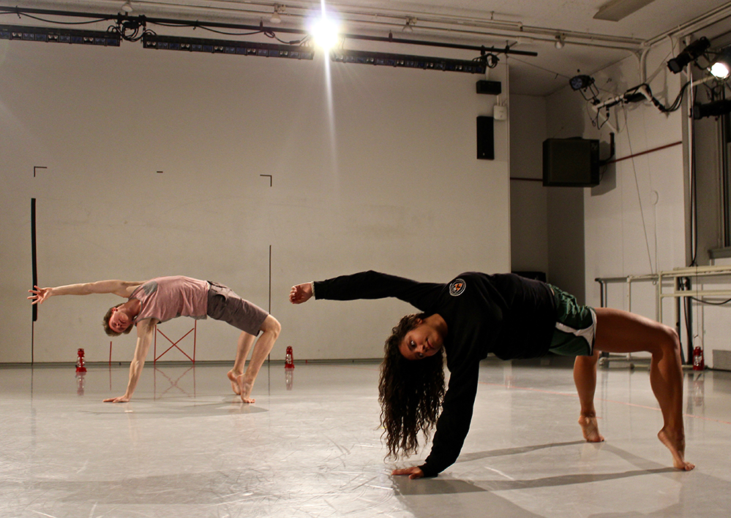
Photo caption: Two Princeton students in rehearsal for a new work by choreographer Olivier Tarpaga to be performed at the Princeton Dance Festival
Photo credit: Elena Anamos

What: Princeton Dance Festival presented by the Lewis Center for the Arts’ Program in Dance
Who: Student dancers perform repertory works by Zvi Gotheiner, John Jasperse, and Mark Morris, and new dances by Kimberly Bartosik, Francesca Harper, and Olivier Tarpaga
When: December 2 at 8 p.m., December 3 at 2 p.m. and 8p.m., and December 4 at 1 p.m.
Where: Berlind Theatre at McCarter Theatre Center, 91 University Place in Princeton
Tickets: In advance of show date -$12 general admission/$11 students and seniors; box office on days performances -$17 general admission/$15 students and seniors, available at arts.princeton.edu/dancefestival

(Princeton, NJ) The Lewis Center for the Arts’ Program in Dance at Princeton University presents the annual Princeton Dance Festival, in which 40 Princeton dance students will perform repertory works by Zvi Gotheiner, John Jasperse, and Mark Morris, along with new works by Kimberly Bartosik, Francesca Harper, and Olivier Tarpaga. Four performances will take place December 2 at 8 p.m., December 3 at 2 p.m. and 8 p.m., and December 4 at 1 p.m. at the Berlind Theatre at McCarter Theatre Center.

Zvi Gotheiner, assisted by Chelsea Ainsworth, has staged “Rothko” on the students. This excerpt, from his evening-length work titled Escher/Bacon/Rothko, was premiered by ZviDance at New York Live Arts in 2015. The work is inspired by the American painter, Mark Rothko's (1903 -1970) work, which is characterized by his use of symmetrical rectangular blocks of two to three opposing or contrasting, yet complementary colors. These colors appear to vibrate when these fields collide/merge, creating an optical flicker at their point of intersection. Gotheiner is the director of ZviDance, which performs frequently in such New York venues as the Joyce Theater, Dance Theater Workshop, New York Live Arts, and Lincoln Center Out-of-Doors. ZviDance has toured across North America and abroad to Germany, Poland, Russia, Israel, Colombia, Brazil, Ecuador and Japan. Gotheiner is a recipient of two New York Foundation for the Arts Choreography Fellowships and The National Arts Club Weiselberg Award.

Stuart Singer has re-staged excerpts of John Jasperse's Within between, a playful and complex dance exploring emptiness and in-between places. With an original score by Jonathan Bepler, Within between earned two New York Dance and Performance "Bessie" Awards after its 2014 premiere. Within between is the sixteenth evening-length work that Jasperse, a 2014 Doris Duke Award Recipient and newly appointed Director of the Dance Program at Sarah Lawrence College, has created for his company, John Jasperse Projects. The Princeton Dance Festival marks the first time that the work will be re-staged on students.

Dance faculty member Tina Fehlandt has staged Mark Morris’ “Polka,” an audience favorite at Princeton’s 2010 Dance Festival. “Polka” premiered in 1992 and was later incorporated into Morris’ major work, Grand Duo, of which the Times of London wrote, “A fierce energy eats up space in a frenzied momentum which culminates in a transcendent moment of power. Astonishing stuff." The music, by American composer, Lou Harrison, will be performed live. Fehlandt, a full-time Lecturer in Dance at Princeton University, was an integral part of the Mark Morris Dance Group for 20 years, from its inception in 1980 to January 2000, appearing in over 50 works choreographed by Morris. Morris has created close to 150 works for the company and has been called “the most successful and influential choreographer alive, and indisputably the most musical” by The New York Times.

The Festival will also premiere three new works by choreographers who are serving as guest faculty or guest choreographers during the fall semester.

In her new work with the working title like a deep wave, guest choreographer Kimberly Bartosik uses a choreographic mix of extreme movement virtuosity, and stripped down, highly charged stillness both to define the performers’ interactions and to unbalance and destabilize the expectations of the audience. Her work, which is deeply informed by literature and cinema, involves complex plays on space, time, and audience perspective, dramatically illuminating the ephemeral nature of performance. Bartosik is the recipient of awards from the Jerome Foundation; the French-U.S. Exchange in Dance; Mid-Atlantic Arts Foundation’s U.S. Artists International program; New York Foundation for the Arts’ Building Up Infrastructure Levels for Dance (BUILD) program; the MAP Fund; American Dance Abroad; New Music USA’s Live Music for Dance program; and Foundation for Contemporary Arts. She received a New York Dance and Performance “Bessie” Award for Artistic Excellence for her work with Merce Cunningham for whom she danced for nine years.

Skin Code, features Princeton students in an original work with choreography by Francesca Harper assisted by Terrence Diable. A movement inspired by inclusivity, Skin Code examines the current state of labeling in the 21st Century, asking: How does the human body respond to judgment? How do we empathize? Harper is an internationally acclaimed artist. After being named Presidential Scholar in the Arts and performing at the White House, Harper performed soloist roles with the Dance Theater of Harlem and spent several years as a principal in William Forsythe’s Ballet Frankfurt. Harper is an adjunct professor at New York University, has been a resident artist at Harvard University, Associate Professor at Barnard College, and continues in the role of teacher and choreographer for The Ailey School, Fordham University’s B.F.A. Program and the Susan Batson Studio. She was also the recipient of the Innovation and Technology Award for Louis Vuitton Reconstruction 3.0 for New York Fashion Week 2013 at Lincoln Center. She was honored with a Living History Award during Black History Month.

Olivier Tarpaga has created a new work for and with his students, Fly like a butterfly, Sting like a bee, based on a previously created solo piece. Tarpaga is a Lester Horton Award-winning choreographer and is the co-artistic director of transnational contemporary dance theatre company Baker & Tarpaga Dance Project. Originally from Burkina Faso, a small nation in West Africa, he has danced for David Rousseve/REALITY and is a recipient of several grants including a National Dance Project touring support and the CHIME mentorship. Over the past sixteen years, Tarpaga’s music and dance has been performed and taught in over 40 countries around the world.

"This year’s program offers an exceptionally diverse program of dance, ranging from the cool, elegant contemporary work of John Jasperse, to the rowdy West African contemporary dance of Olivier Tarpaga and everything in between.” notes Susan Marshall, Director of the Program in Dance. “Our opening the first week of December unveils these dances at the peak of the fall semester crescendo -- our students will be hurtling onto the stage having newly mastered and polished the demands of this challenging work. It will be an exciting evening."

The Berlind Theatre is an accessible venue with access details available at www.mccarter.org [embed link:http://www.mccarter.org/VisitorInfo/VisitorDefault.aspx?page_id=32]. Assistive listening devices are available upon request when attending a performance. Patrons in need of other access accommodations are invited to contact the Lewis Center at 609.258.5262 or LewisCtr-Comm@princeton.edu for assistance at least two weeks prior to the selected performance.

Reserved seating tickets for Princeton Dance Festival are $12 ($11 for students and seniors) when purchased in advance, or $17 ($15 for students and seniors) on the day of performances. Tickets are available online through arts.princeton.edu/dancefestival, by calling the McCarter box office at 609-258-2787, at the Frist Campus Center Ticket Office, and at the door on the night of performances.

In addition to the Festival, the Program in Dance will present a concert on March 31 and April 1, 2017 showcasing seniors in the program with the premiere of senior thesis choreography and performance of repertory works. In spring the Performance Lab offers an informal showing of new student work, and dance master classes will be open to the public to observe. The program will also present two end-of-semester showings of work created and learned during the fall and spring semesters from a range of classes including ballet, modern, African dance, urban dance, and courses that present interdisciplinary explorations of dance with other areas.

To learn more about the Princeton Dance Festival, the Program in Dance, and the more than 100 other events presented each year by the Lewis Center for the Arts visit: arts.princeton.edu.

###

