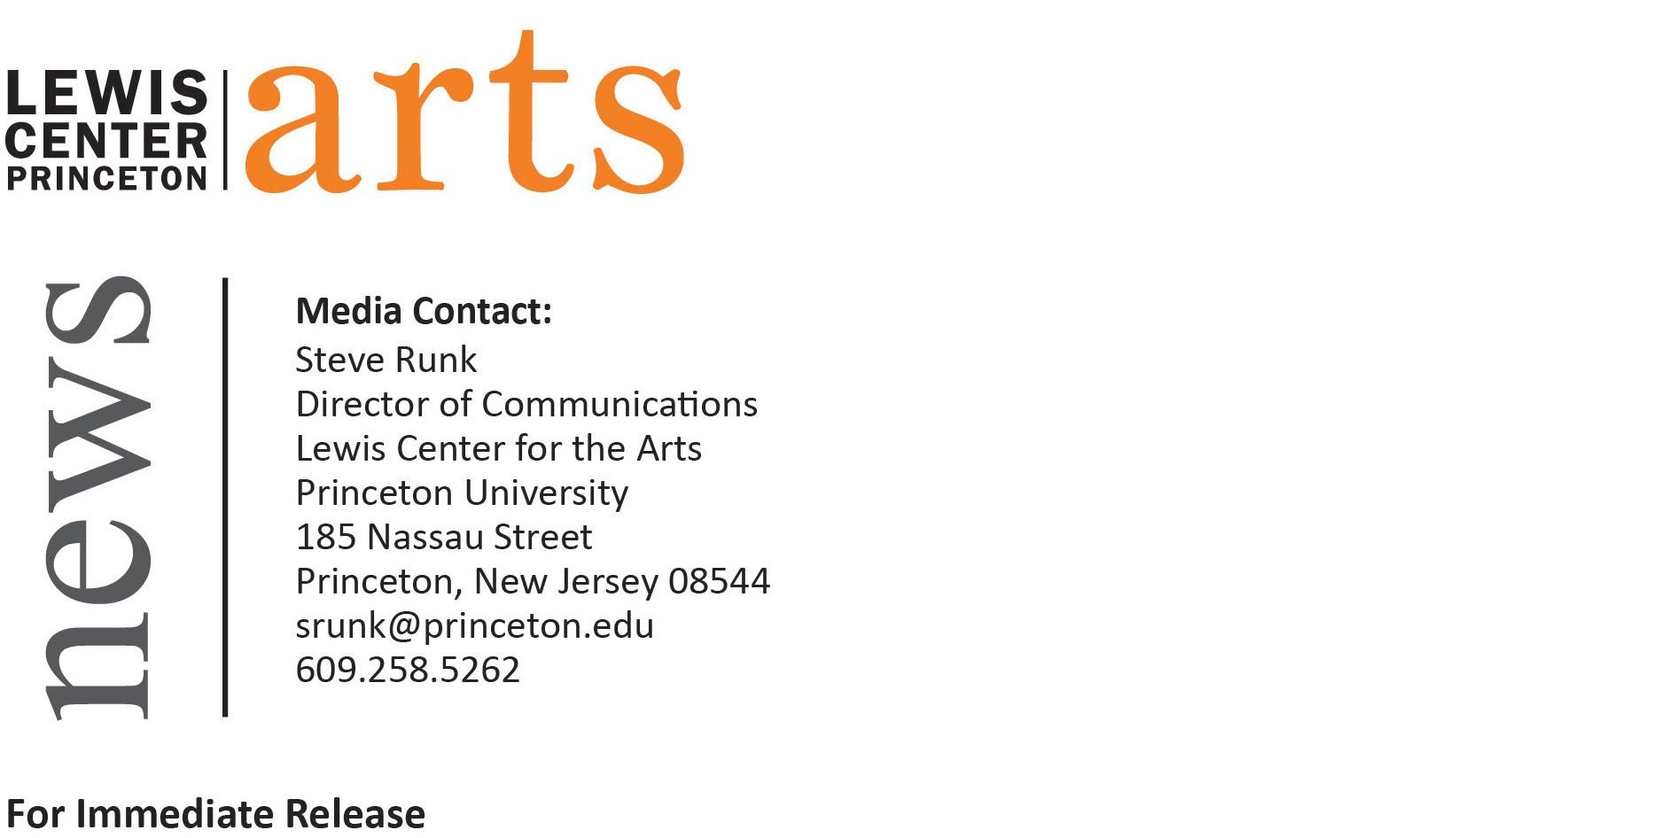

December 5, 2016

Princeton University Fund for Irish Studies presents
“Twinsome Minds: Recovering 1916 in Images and Stories”
Writer Richard Kearney and artist Sheila Gallagher perform their celebrated multimedia talk

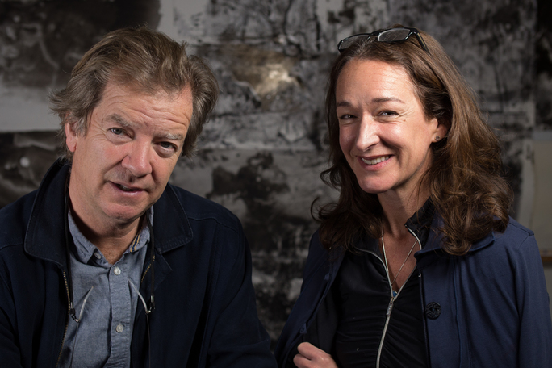
Photo caption: Professor/writer Richard Kearney and multimedia artist Sheila Gallagher
Photo credit: Courtesy of Richard Kearney and Sheila Gallagher

Who: Professor/writer Richard Kearney and multimedia artist/curator Sheila Gallagher
What: A multimedia performed lecture, “Twinsome Minds: Recovering 1916 in Images and Stories” that reimagines the narratives of “twinned” pairs of people who ended up on different sides in 1916, focusing on Dublin’s Easter Rising and the Belgium front in World War I for a reinterpreted portrait of an integral period in Irish history
When: Friday, December 9 at 4:30 p.m.
Where: James M. Stewart ’32 Theater at 185 Nassau Street
Free and open to the public

(Princeton, NJ) Writer Richard Kearney and artist Sheila Gallagher will perform their celebrated multimedia talk “Twinsome Minds: Recovering 1916 in Images and Stories” at 4:30 p.m. on Friday, December 9 in the James M. Stewart ’32 Theater at 185 Nassau Street. Part of the 2016-17 Fund for Irish Studies series at Princeton University, this event is free and open to the public.

“Twinsome Minds: Recovering 1916 in Images and Stories” is a transformative multimedia performance that reimagines the narratives of “twinned” pairs of people who ended up on different sides in 1916. Focusing on Dublin’s Easter Rising and the Belgium front in World War I, the talk combines history, legend, imagination, and memory to present a reinterpreted portrait of an integral period in Irish history. “Twinsome Minds” features text by Kearney, screen projections by Gallagher, and an original score by Dana Lyn.

Kearney is a writer, professor, and cultural organizer of several international projects, most recently “Exchanging Stories, Changing History” (Guestbookproject.org). He has written two novels, Sam's Fall and Walking at Sea Level, which have been translated into several languages, and a volume of poetry, Angel of Patrick's Hill. He has also written several books on the role of imagination and narrative in Irish culture, literature, and the arts, most notably The Irish Mind (1984), Transitions: Narratives in Modern Irish Culture (1988), Post Nationalist Ireland: Culture, Philosophy, Politics (1998), and Navigations: Collected Irish Essays (1976-2006). As a member of the Irish Arts Council, chair of the University College Dublin Film School, and public intellectual and broadcaster, he is actively involved in organizing many national and international cultural projects.

Gallagher is an interdisciplinary artist, curator, and professor of art at Boston College. She works in many media including video, smoke, drawing, animation, live flowers, and light projections. She has had numerous solo exhibitions and has exhibited widely at commercial galleries, museums, and universities in the U.S. and internationally, including the Moving Image Festival in London, The Institute of Contemporary Art, The Museum of Fine Arts in Boston, Crystal Bridges Museum in Arkansas, and the Dodge Gallery in New York City. Gallagher is the co-curator of the Becker Collection, a private archive of Civil War drawings, currently touring the U.S. Together with Kearney, she co-directs the Guestbook Project.

The Fund for Irish Studies, chaired by Princeton Professor Clair Wills, provides all Princeton students, and the community at large, with a wider and deeper sense of the languages, literatures, drama, visual arts, history, politics, and economics not only of Ireland but of “Ireland in the world.”

Information about the Fund for Irish Studies series events can be found at fis.princeton.edu. Other events currently scheduled in the 2016-2017 series include:
- Theater critic and scholar Fintan O’Toole gives the Robert Fagles Memorial Lecture, “If It Wasn’t for the Irish and Jews,” on February 17
- A day-long symposium on Irish lyric and song, “Words for Music, Perhaps,” features musical performances by Irish artists and panels of renowned scholars, including John Burkhalter, Matt Campbell, Aileen Dillane, Paul Hamilton, David Kellett, Darya Koltunyuk, Barry McCrea, Maureen McLane, Paul Muldoon, Diarmuid Ó Giollain, Iarla Ó Lionáird, and Dan Trueman, on March 31
- Mary Daly, Professor of Modern Irish History at University College Dublin on April 14
- Writer Kevin Barry returns to Princeton for a reading on April 28

To learn more about the more than 100 events presented each year by the Lewis Center for the Arts, visit arts.princeton.edu.

###

