December 12, 2016

Lewis Center for the Arts presents End-of-Semester Showings in Dance
Students perform choreography learned and new student choreography created
during the fall semester

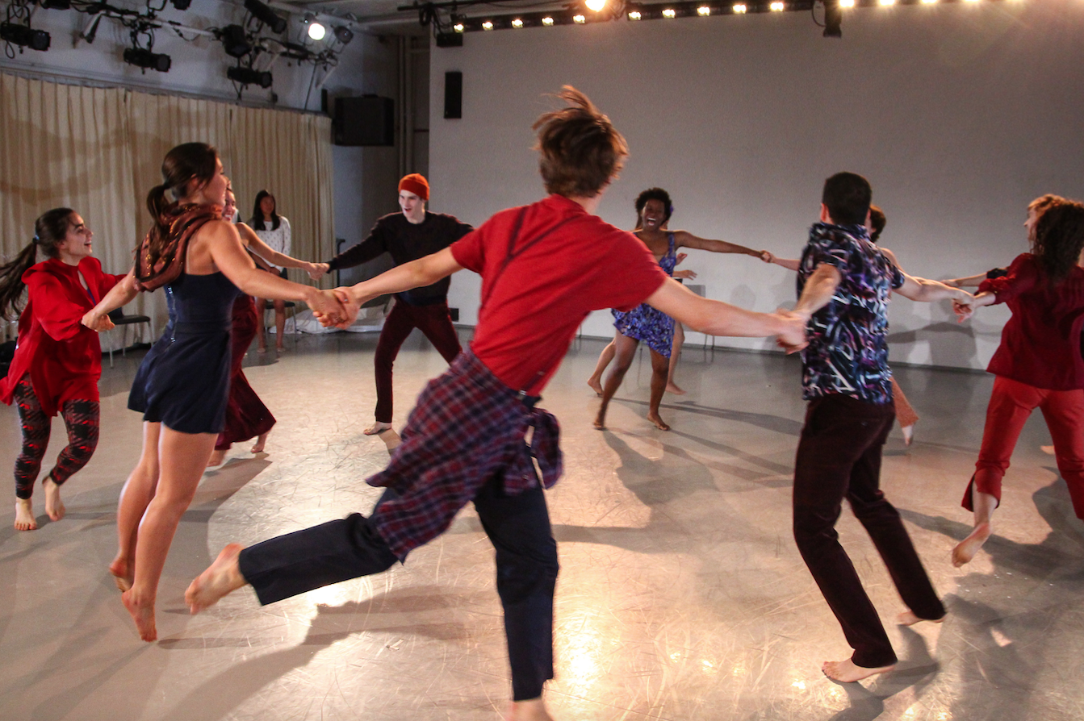
Photo caption: Princeton dance students in rehearsal in the Dance Studio
Photo credit: Larry Levanti

What: End of semester showings of choreography learned and new student choreography created during fall 2016 courses in the Program in Dance at Princeton’s Lewis Center for the Arts
Who: Performed by students in the Program in Dance
When: December 14 at 3:00 p.m. and 3:30 p.m.; December 15 at 3:15 p.m.; December 16 at 11:30 a.m. and 2:00 p.m.; and January 23 at 12:00 p.m.
Where: Dance Studios at 185 Nassau St. and Dance Studio (Room 108) at New South on Princeton campus
Free and open to the public

(Princeton, NJ) The Lewis Center for the Arts’ Program in Dance will present a series of showings of new choreography created by students and choreography learned during the past semester on December 14 through 16 and on January 23 in the Patricia and Ward Hagan ’48 Dance Studio and 3rd floor Dance Studio at 185 Nassau Street and New South Dance Studio. All performances are free and open to the public.

The schedule for the end-of-semester showings of student work and performances is:

Wednesday, December 14 at 3:00 p.m. in the 3rd floor Dance Studio: “Music and Dance: Choreographing Collaboration” taught by choreographer Susan Marshall and composer/percussionist Jason Treuting. This course explored playful interdisciplinary approaches to creating works of art collaboratively, namely dance and music performances. Students analyzed sound, music, and the body in motion in order to study how one medium influences another while in collaboration.

Wednesday, December 14 at 3:30 p.m. in the New South Studio: “The American Dance Experience and Africanist Dance Practices” taught by Dyane Harvey-Salaam. This studio course introduced students to American dance aesthetics and practices with a focus on how its evolution has been influenced by African American choreographers and dancers, including the study of movement practices from traditional African dances, dance of the African diaspora, American jazz dance, modern dance, and American ballet. Also on December 14 at 3:30 p.m. is the “Introduction to Ballet” performance taught by Tina Fehlandt in the Hagan Dance Studio. Students will demonstrate their semester-long study of ballet’s physicality, artistry, and principles of alignment.

Thursday, December 15 at 3:15 p.m. in the Hagan Dance Studio: “Introduction to Contemporary Dance” taught by Alexandra Beller, a class designed for people who are curious about the art of contemporary dance, in which students have studied contemporary techniques and choreography with the goal of broadening dance knowledge and physical abilities. Throughout the semester, students have developed movement articulation, coordination, strength, and flexibility, as well as explored current issues debated by fellow contemporary dancers.

Friday, December 16 at 11:30 a.m. in the Hagan Dance Studio: “Choreography Workshop II” taught by Pavel Zuštiak, a Princeton Arts Fellow. Focusing on contemporary practices and performance, students in this course worked in movement-based laboratories and presented original choreography weekly. Students also learned to discuss and critique the work of their peers, combining readings and viewings to contextualize their studies. Also on December 16 at 2:00 p.m. in the Hagan Dance Studio is a combined showing from the classes “Choreography Workshop I” taught by Rebecca Lazier and “Choreography Workshop III,” taught by Pavel Zuštiak. Both classes will present original student choreography. Working in movement-based laboratories throughout the semester, students have learned decision-making choreographic skills, as well as developed pieces around central ideas.

Later, on Monday, January 23 at 12:00 p.m. in the Hagan Dance Studio: “Choreography Workshop IV” taught by Rebecca Lazier, a course designed for seniors pursuing the certificate in dance. Students workshop their senior thesis projects either creating a choreographic production or enhancing their artistry as a performer. Students examined varying approaches to dance making, including examining practices from modern and post-modern dance, as well as diverse genres and cultural forms and participated in workshops in lighting and costume design to better understand the contributions of these forms and enhance the collaborative process.

For more information on these events, the Program in Dance, or any of the more than 100 events presented annually by the Lewis Center for the Arts, visit: arts.princeton.edu.

###

