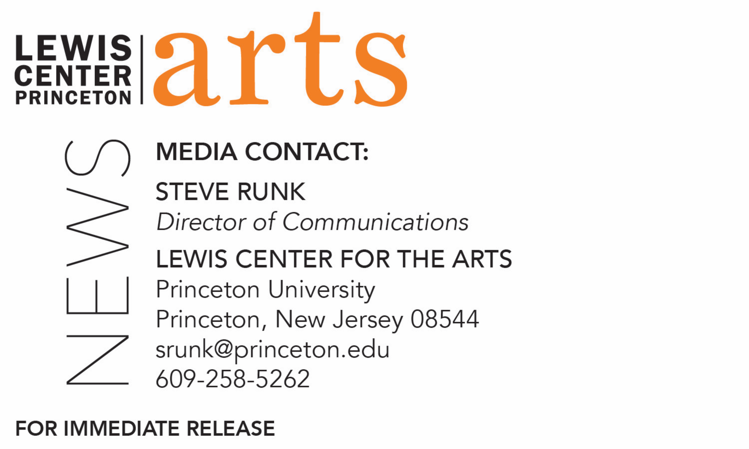

December 6, 2017

Lewis Center for the Arts’ Program in Creative Writing presents
Fall Student Reading and A Poetry Performance
Students in fall course share recent work as part of the
Althea Ward Clark W’21 Reading Series at Princeton

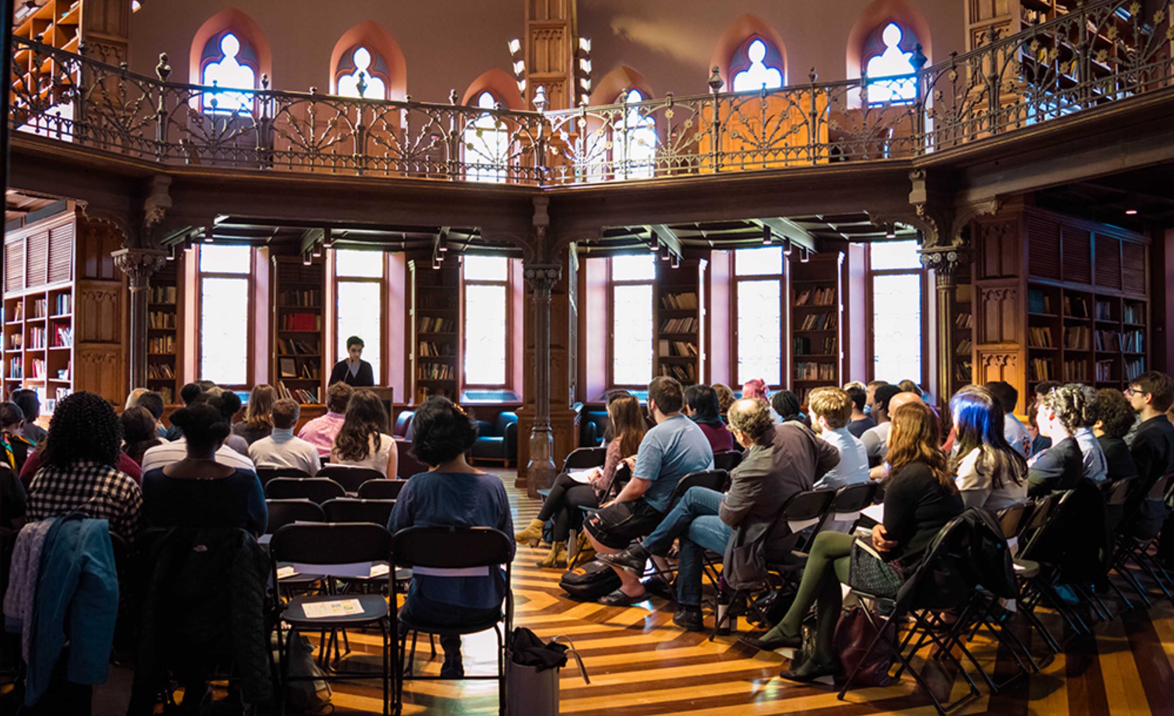
Photo caption: A student reading at Chancellor Green Rotunda
Photo credit: Tiffany Richardson

What: Somebody Should Tell This Place to Go Home Poetry Performance, presented by the Lewis Center for the Arts’ Program in Creative Writing
Who: Students from the fall cross-listed creative writing/theater course, "Exploding Text: Poetry Performance," taught by Bob Holman
When: Tuesday, December 12 at 8:00 p.m.
Where: Forum at Lewis Arts complex on the Princeton University campus
Free and open to the public

What: Fall Student Reading, part of Althea Ward Clark W’21 Reading Series
Who: Students in the Lewis Center for the Arts’ Program in Creative Writing read from faculty-selected new work in fiction, poetry, screenwriting and literary translation written during the fall semester
When: Wednesday, December 13 at 5:00 p.m.
Where: Chancellor Green Rotunda on the Princeton University campus
Free and open to the public

(Princeton, NJ) Students in the Lewis Center for the Arts’ renowned Program in Creative Writing will read from their recent work as part of the Program’s Althea Ward Clark W’21 Reading Series on Wednesday, December 13 at 5:00 p.m. in the Chancellor Green Rotunda on the Princeton University campus. On December 12 at 8:00 p.m., students in a spoken word poetry performance course will present new work in the Forum at the Lewis Arts complex on the Princeton University campus. Both events are free and open to the public.

For the Clark Reading, Students will read from new works of fiction, poetry, screenwriting, and literary translation written during the past semester as part of the fall creative writing workshops. “The student reading is always a bright point. It’s such a privilege to listen in on what’s been happening all semester in the workshops,” notes Tracy K. Smith, Director of the Program in Creative Writing and the current U.S. Poet Laureate.

The spoken word poetry performance, Somebody Should Tell This Place to Go Home, will include work created by students during the fall cross listed creative writing/theater class “Exploding Text,” taught by acclaimed poet Bob Holman. Throughout the course, students learned to use both recording and digital media in conjunction with writing and performance, with hip hop and slam heavily influencing the curriculum. Students will perform their work.

Bob Holman is the author of seventeen poetry collections and has previously taught at Columbia University, New York University, Bard College, and The New School. As the original “Slam Master” and a director at the Nuyorican Poets Cafe, creator of the world's first spoken word poetry record label, Mouth Almighty/Mercury, and founder/proprietor of the Bowery Poetry Club, Holman has played a central role in the spoken word and slam poetry movements of the last several decades. Holman's study of the roots of hip hop in West African oral traditions led to his current work with endangered languages. Holman has produced or hosted various films, including The United States of Poetry (PBS), On the Road with Bob Holman (LinkTV), and Poetry Spots for WNYC-TV, which won two Emmy Awards. His most recent film, Language Matters with Bob Holman, winner of the Berkeley Film Festival's Documentary of the Year award, was produced by David Grubin and aired nationally on PBS, where it is still being streamed. Holman brought the film to language revitalization centers across Alaska and Hawaii in 2015, sponsored by the Ford Foundation. His video poem Khonsay: Poem in Many Tongues, is a cento in 50 different languages. Most recently he served as Creative Consultant to LINES Ballet in San Francisco for “Figures of Speech,” based on his endangered language work.

Through the Creative Writing Program, students can earn a certificate in creative writing in addition to their degree in a major. They have the opportunity to pursue original work in fiction, poetry, screenwriting and translation under the guidance of practicing, award-winning authors, including faculty members Jeffrey Eugenides, Jhumpa Lahiri, Paul Muldoon, Kirstin Valdez Quade, James Richardson, Tracy K. Smith, Susan Wheeler, Yiyun Li, and a number of distinguished lecturers.

The small workshop courses offered by the Program are limited in enrollment to ten students to ensure the benefits of working closely with faculty. Workshops meet for up to three hours weekly and are devoted primarily to discussion of student work. Each year, 15 to 20 seniors also work individually with a member of the faculty on a creative thesis, such as a novel, a screenplay, or a collection of short stories, poems, or translations.

Alumni of the Program include such well-known writers as Jonathan Ames ’87, Jonathan Safran Foer ’99, Jane Hirshfield ’73 and Monica Youn ’93, who is currently teaching in the program.

The Althea Ward Clark W’21 Reading Series annually brings a number of distinguished writers to campus to read and discuss their work. Writers reading in the coming months include Alaa Al Aswany and Linda Gregerson on February 7, Osama Alomar and Luc Sante on March 7, and Jane Hirshfield ‘73 and Walter Mosley on April 18. All readings are free and open to the public.

To learn more about this reading series, the Program in Creative Writing, and the more than 100 public performances, exhibitions, readings, screenings, concerts and lectures presented each year by the Lewis Center for the Arts, most of them free, visit arts.princeton.edu.

###

