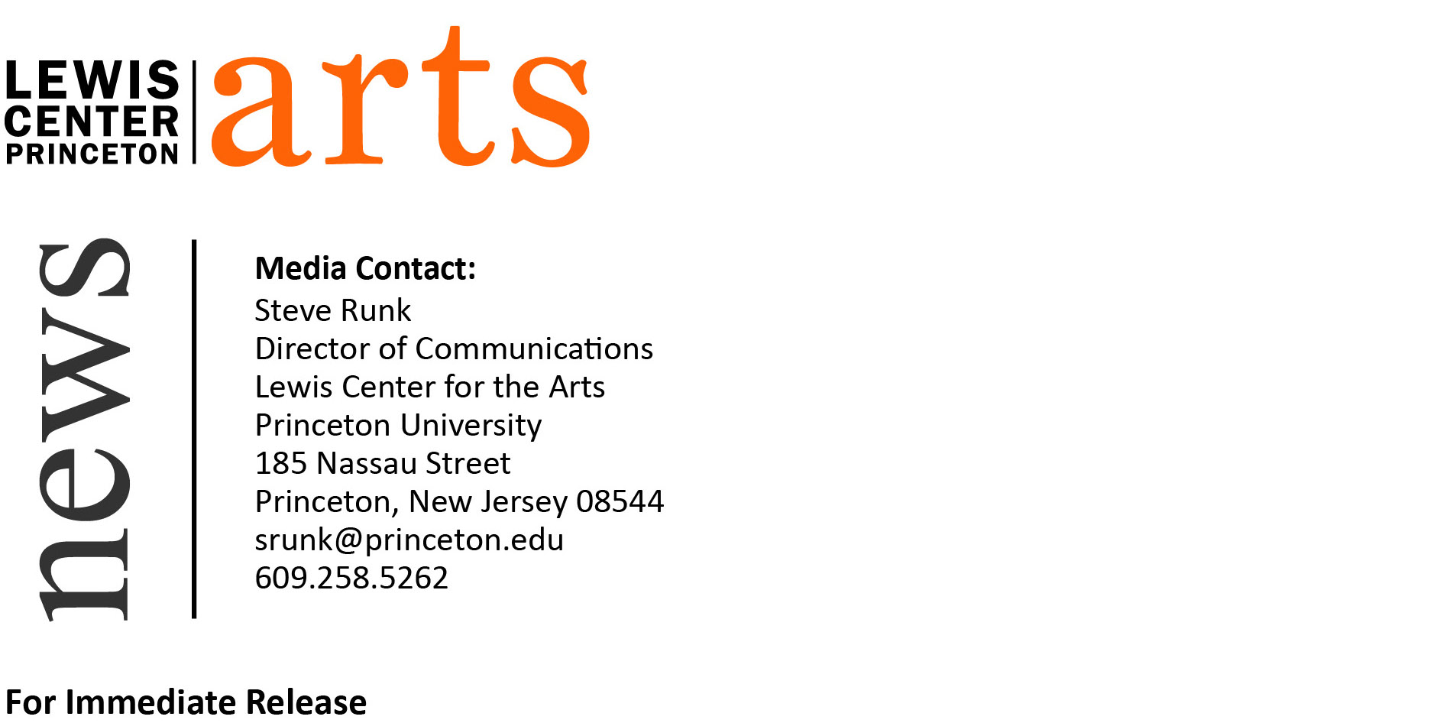

December 21, 2017

Award-winning Filmmaker Moon Molson appointed to Visual Arts Faculty of Lewis Center for the Arts at Princeton University

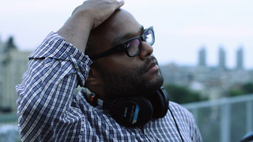
Photo caption: Award-winning filmmaker Moon Molson
Photo credit: Courtesy of Moon Molson

(Princeton, NJ) Award-winning filmmaker Moon Molson will join the Lewis Center for the Art’s Program in Visual Arts faculty at Princeton University in February as an Assistant Professor of Visual Arts, teaching undergraduate courses in film production.

Molson’s short films Pop Foul (2007), Crazy Beats Strong Every Time (2011), and most recently The Bravest, the Boldest (2014) premiered at the Sundance Film Festival, screened at over 250 international film festivals, and have since received more than 100 awards worldwide, including the Grand Jury Prizes at Palm Springs, South by Southwest (SXSW), and the Student Academy Awards. He has attended the 2008 Sundance Screenwriters & Directors Labs, the 2008 Film Independent (FIND) Directors Labs, the 2015 Warner Brothers Television Directors' Workshop, and 2016 FOX Global Directors Initiative as a Fox Director Fellow. Molson was named a 2017 Pew Foundation Fellow, a 2015 Guggenheim Fellow in Film-Video, and was one of Filmmaker Magazine's “25 New Faces of Independent Film” in Summer 2007. He has received grants from The Jerome Foundation, New York Foundation for the Arts, New York State Council on the Arts, and the Sundance Institute.

Molson’s films tell epic stories through the lives of contemporary characters using, in his words, “the language of the streets." Molson’s work examines urban masculinity, legacies of trauma, and family dynamics as he strives to “strike a balance between gritty realism, vernacular lyricism, stark humor, and the surrealism of dreams and hallucinations.”

“We couldn’t be more excited to welcome Moon to the visual arts community at the Lewis Center,” said Martha Friedman, Director of the Program in Visual Arts. “On top of being a gifted teacher and deft technician in the craft of film, what most strikes me about Moon is his ability to plumb the depths of the achingly irreducible character of human relationships, and even more profoundly, the human condition.”

“Moon represents a major addition to Princeton’s burgeoning film scene,” adds Lewis Center Chair Michael Cadden. “I have no doubt he’ll catalyze the energy and commitment our students bring to their subject.”

Molson has taught as an assistant professor at Temple University in Philadelphia, Pennsylvania since 2015. He has previously taught at the Savannah College of Art and Design, as well as the New York Film Academy, the Matthew S. Hisiger Film Foundation/The Picture House, and Reel Works Teen Filmmaking. He received his A.B. in English literature, film studies and philosophy from Dartmouth College and his M.F.A. in film from Columbia University.

“I was so happy when we succeeded in hiring Moon Molson,” said Su Friedrich, filmmaker, professor of visual arts in the Lewis Center, and co-chair of the search committee who recommended Molson for this position. “I was deeply impressed by his films, both for the stories they told and how he chose to tell them. His talents in scriptwriting, casting, and directing will be a huge boon to our students, and I really look forward to working with him.”

The Program in Visual Arts offers studio courses that emphasize direct, hands-on art making in painting, drawing, graphic design, photography, sculpture, film and video, and film history and theory, under the guidance of practicing professional artists. Students accepted into the program can pursue a degree or certificate in visual arts. The program is based at 185 Nassau Street and has recently expanded at that venue as the Programs in Dance, Theater, Music Theater and the Princeton Atelier moved to the new Lewis Arts complex. In order to develop their work, students have access to state-of-the-art technical, analog, and digital labs, including a fully functional letterpress studio. Throughout the year, their work is exhibited in the Lucas Gallery at 185, the new Hurley Gallery at the Lewis Arts complex, and screened in the James M. Stewart ’32 Theater and the Princeton Garden Theatre, as well in other traditional and non-traditional venues on campus.

To learn more about the Program in Visual Arts and the Lewis Center for the Arts,
including the more than 100 performances, exhibitions, readings, screenings, concerts and
lectures presented each year, most of them free, visit arts.princeton.edu.

###

