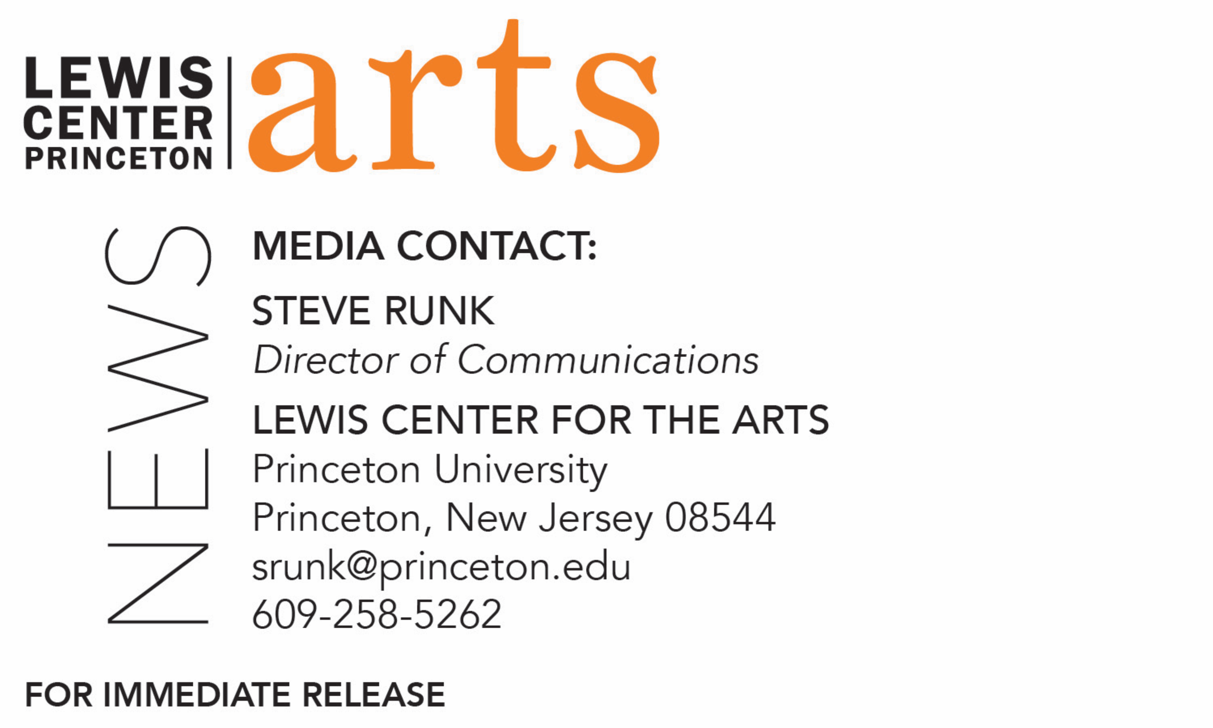

December 7, 2017

Lewis Center for the Arts’ Princeton Atelier presents
(This is NOT)* Mozart Symphony #40: Am Immersive Experience of
Extended Technique
Original work presents a new perspective on Mozart’s beloved classic – and is
NOT a concert

What: (This is NOT)* Mozart Symphony #40: An Immersive Experience of Extended Technique, presented by the Lewis Center for the Arts’ Princeton Atelier *This is really NOT a concert
Who: Students from fall Atelier course “Reimagining a Masterpiece: Mozart’s Symphony #40” in collaboration with composer/conductor Jayce Ogren and theatrical designer/director Michael Counts
When: Sunday, December 10 at 7 p.m. and 9 p.m.
Where: Matthews Acting Studio at 185 Nassau Street in Princeton
Free and open to the public, but space is limited and advance tickets are encouraged at http://arts.princeton.edu/events/not-mozart-symphony-40-immersive-experience-extended-technique/

(Princeton, NJ) The Lewis Center for the Arts’ Princeton Atelier will present an original, immersive experience that utilizes visual arts, theatrical lighting, scenic and installation design, as well as movement and musical performance, to offer a new perspective on Mozart’s iconic and beloved classic, Symphony #40. This new work was created by Princeton students as the culminating project of a fall Atelier course co-taught by composer/conductor Jayce Ogren and theatrical designer/director Michael Counts. The event, which the organizers make clear is not a concert, will take place on Sunday, December 10, with two 30-minute-long performances at 7 p.m. and 9 p.m. in the Matthews Acting Studio at 185 Nassau Street. The event is free and open to the public, but space is limited and advance tickets are encouraged.

The project was developed in the Atelier course, “Reimagining a Masterpiece: Mozart’s Symphony #40,” in which Ogren and Counts collaborated with more than twenty-five students from within and beyond the class to craft an experiential work inspired by the substance of Mozart’s transformative and celebrated work. A wide assortment of performative elements, including dance, music, text, and video, combine to provide the audience with a new appreciation and understanding of the piece while engaging with it in new, immersive ways. Students in the course all assisted in composing as a part of the new work, although a background in music composition was not a prerequisite for the course.

The Princeton Atelier was founded by Princeton Professor Emerita Toni Morrison and is directed by Paul Muldoon, Princeton’s Howard G.B. Clark ’21 Professor in the Humanities, Professor of Creative Writing, and Pulitzer Prize-winning poet. This academic program brings together professional artists from different disciplines to create new work in the context of a semester-long course. Every course is unique and happens only once. A painter might team with a composer, a choreographer might join with an electrical engineer, a company of theater artists might engage with environmental scientists, or a poet might connect with a videographer. Princeton students have an unrivaled opportunity to be directly involved in these collaborations.

Jayce Ogren has built a reputation as one of the acclaimed young conductors to emerge from the United States in recent seasons. He has recently been named the new artistic director of Orchestra 2001 in Philadelphia. Ogren has led the National Arts Centre Orchestra in Ottawa with Emanuel Ax; Basil Twist's Rite of Spring with the Orchestra of St. Luke's at Lincoln Center's White Light Festival; and new productions of Benjamin Britten's Turn of the Screw and Rossini's Mosè in Egitto with the New York City Opera, where he was music director, as well as Mozart's The Magic Flute and Bernstein's A Quiet Place, for which he won extensive critical acclaim. He also made his Canadian Opera debut in Stravinsky's The Nightingale & Other Short Fables and reprised The Turn of the Screw in staged performances with the Saint Paul Chamber Orchestra. His several engagements with the New York Philharmonic have included leading premieres of new works on their CONTACT! Series, and leading two concerts during the inaugural NY PHIL BIENNIAL. He has conducted the Los Angeles Philharmonic and the New World Symphony, and he has led all-Stravinsky programs with the New York City Ballet. Ogren's extensive work in contemporary music has included collaborations with the International Contemporary Ensemble (ICE) in programs at Columbia University's Miller Theatre, Lincoln Center's Mostly Mozart Festival, and at the Wien Modern Festival. He also conducted world premieres in Nico Muhly's contemporary festival, A Scream and an Outrage, with the BBC Symphony at the Barbican. As a composer, Ogren's works have been performed at the Royal Danish Conservatory of Music, the Brevard Music Center, the American Choral Directors Association Conference and the World Saxophone Congress. His Symphonies of Gaia has been performed by ensembles on three continents and is the title track on a DVD featuring the Tokyo Kosei Wind Orchestra. A native of Washington State, Ogren received his Bachelor's Degree in Composition from St. Olaf College in 2001 and his Master's Degree in Conducting from the New England Conservatory in 2003.
Michael Counts is a 20-year pioneer of immersive entertainment, creating large-scale installations, theatrical productions, and innovative media and entertainment experiences, often in unconventional spaces throughout the world. In late summer of 2016 he created and co-produced PARADISO: Chapter 1, taking place in Midtown Manhattan. The experience elevates the traditional escape room with innovative special effects while bringing a complex storyline to life within a fully-immersive environment, complete with actors embedded in the attraction who add multiple layers of entertainment. Also in the summer of 2016, two years of work with an international team of collaborators culminated in the Boston premiere of the Ouroboros Trilogy. The highly anticipated production included the Pulitzer Prize-winning Madame White Snake, composed by Zhou Long, as well as two world premiere productions, Naga composed by Scott Wheeler and Gilgamesh composed by Paola Prestini. Two of his recent productions (Moses in Egypt with New York City Opera and Philharmonic 360 with the New York Philharmonic) were listed on The New York Times Top 10 Lists for their respective years, and his projects in a wide range of media have been critically acclaimed and featured in press and media around the world. His recent brand launch for Michael Kors in Shanghai, China, was a critical success and garnered an enormous amount of international press for the brand and designer. Counts’ recent work on the Walking Dead Escape, an immersive experience extension of the television, comic book and video game franchise, was called “the high point of the 2014 San Diego Comic Con” by Oculus VR CEO Brendan Iribe.
To learn more about this event, the Program in Theater, and the more than 100 performances, exhibitions, readings, screenings, concerts and lectures presented each year by the Lewis Center, most of them free, visit arts.princeton.edu.

###

