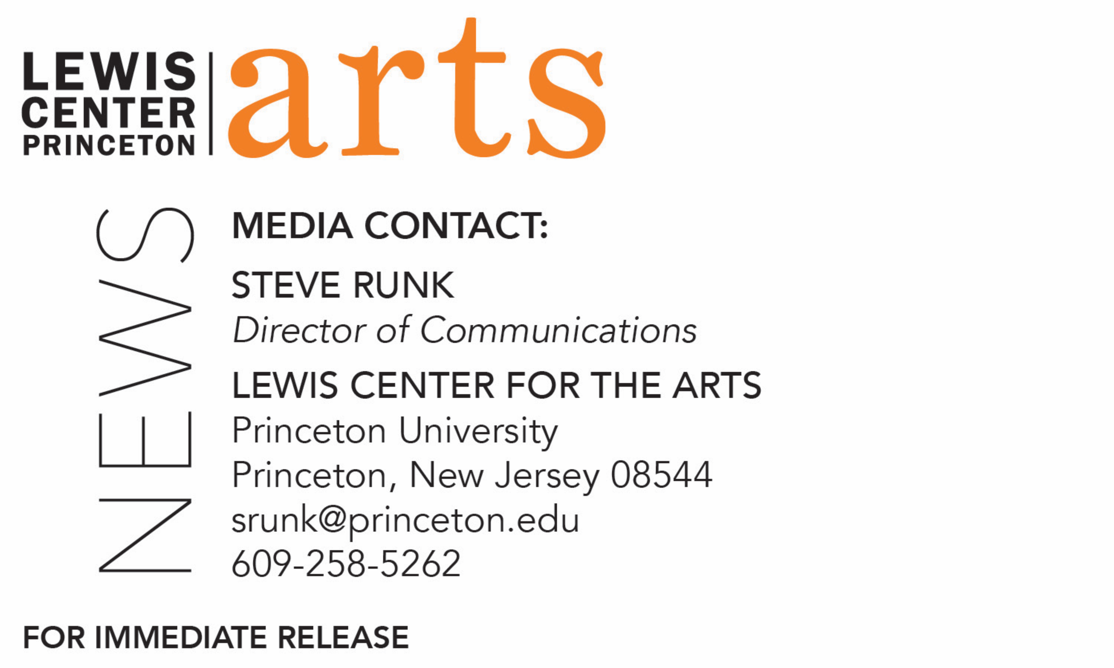

January 23, 2018

Lewis Center for the Arts’ Program in Creative Writing presents
A Reading with Alaa Al Aswany and Linda Gregerson
Award-winning writers next in Althea Ward Clark W’21 Reading Series at Princeton

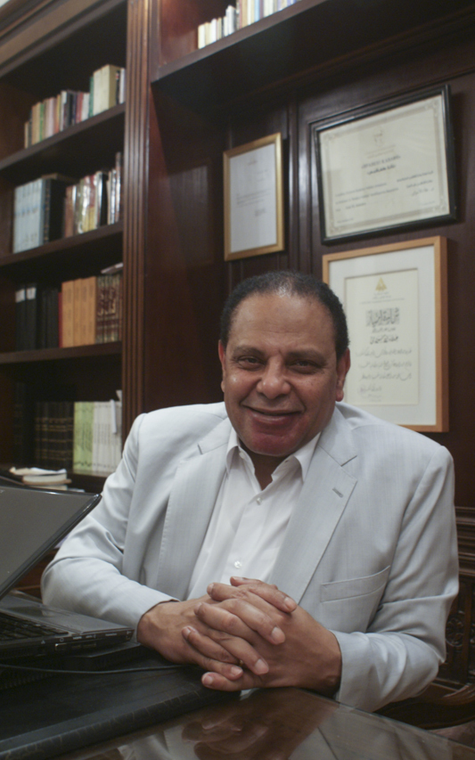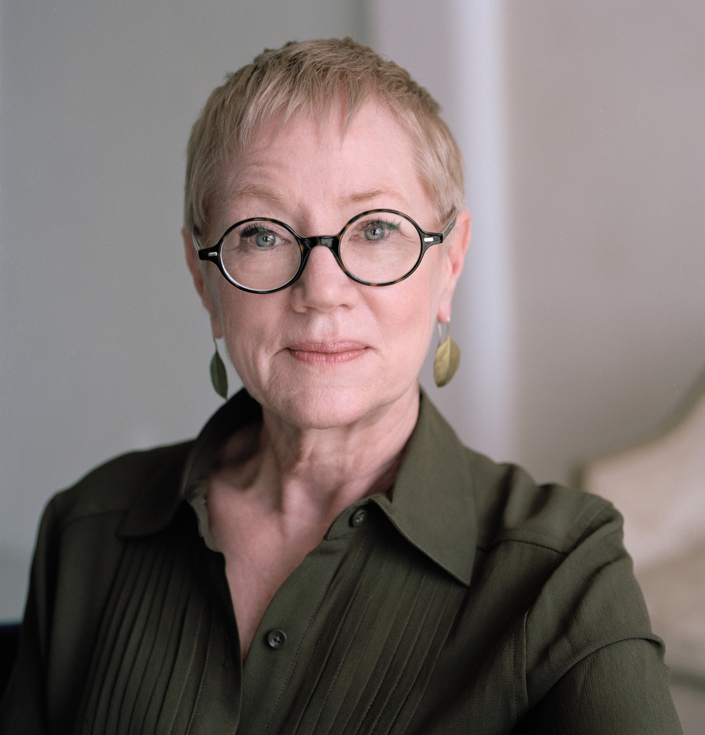

Photo caption 1: International award-winning writer Alaa Al Aswany
Photo credit 1: Nada Al Aswany
Photo caption 2: Acclaimed poet Linda Gregerson
Photo credit 2: Courtesy Blue Flower Arts

Who/What: Reading by international award-winning writer Alaa Al Aswany and acclaimed poet Linda Gregerson, part of the 2017-18 Althea Ward Clark W’21 Reading Series
When: Wednesday, February 7, at 7:30 p.m.
Where: Donald G. Drapkin Studio at Lewis Arts complex on the Princeton University campus
Free and open to the public
***NOTE different time and location than previous readings in this series***

(Princeton, N.J.) On Wednesday, February 7, international award-winning writer, bestselling novelist and activist Alaa Al Aswany will read with acclaimed poet Linda Gregerson, recipient of an American Academy of Arts and Letters Award in Literature, the Kingsley Tufts Award, and four Pushcart Prizes, as part of the Althea Ward Clark W’21 Reading Series of the Program in Creative Writing at the Lewis Center for the Arts at Princeton University. The reading, beginning at 7:30 p.m. in the Donald G. Drapkin Studio at the Lewis Arts Complex, is free and open to the public.

Alaa Al Aswany is the author of The Yacoubian Building, which was long-listed for the International Dublin Literary Award in 2006 and was the best-selling novel in the Arab world for more than five years; Chicago, named by Newsday as the best translated novel of 2006; The Automobile Club of Egypt; and the story collection Friendly Fire. He has received numerous awards internationally, including the Bashrahil Prize for the Arabic novel, the Kavafis Award from Greece, and the Premio Grinzane Cavour from Italy. He was recently named by the London Times as one of the best 50 authors to have been translated into English over the last 50 years.

Aswany will be introduced by Jhumpa Lahiri, Pulitzer Prize-winning writer, National Humanities Medal recipient, and member of the Creative Writing faculty at Princeton.

Linda Gregerson is the author of seven collections of poetry, including New and Selected Poems (2015); The Selvage (2012); The Woman Who Died in Her Sleep, which was a finalist for the Lenore Marshall Prize and The Poets Prize; Magnetic North, which was a finalist for the 2007 National Book Award; and Waterborne, which won the 2003 Kingsley Tufts Poetry Award. Gregerson’s poems have appeared in The New Yorker, The Atlantic Monthly, Poetry, Granta, The Paris Review, The Kenyon Review, Best American Poetry, and many other journals and anthologies.

Gregerson will be introduced by Monica Youn, award-winning poet, Princeton Class of 1993, a member of the Creative Writing faculty at Princeton, and chair of the Lewis Center for the Arts’ Committee on Race and the Arts.

The reading series, usually held in the Berlind Theatre at McCarter Theatre Center at 4:30 p.m., will hold some events this year in the new Lewis Arts complex with an evening start time of 7:30 p.m.

The Lewis Center’s Program in Creative Writing annually presents the Althea Ward Clark W’21 Reading Series, which provides an opportunity for students, as well as all in the greater Princeton region, to hear and meet the best contemporary writers. All readings are free and open to the public. Other readings scheduled in the 2017-2018 series include:
- Osama Alomar and Luc Sante on Wednesday, March 7, 7:30 p.m., in the Donald G. Drapkin studio at the Lewis Arts complex
- Jane Hirshfield, Princeton Class of 1973, and Walter Mosley, on Wednesday, April 18, 4:30 p.m., at the Berlind Theatre at McCarter Theatre Center

To learn more about this reading series, the Program in Creative Writing, and the more than 100 public performances, exhibitions, readings, screenings, concerts and lectures presented each year by the Lewis Center for the Arts, most of them free, visit arts.princeton.edu.

###

