January 2, 2018

The Lewis Center for the Arts’ Program in Theater presents
Etched in Skin on a Sunlit Night by Kara Lee Corthron
A senior thesis production directed by Abigail Jean-Baptiste
at Princeton University

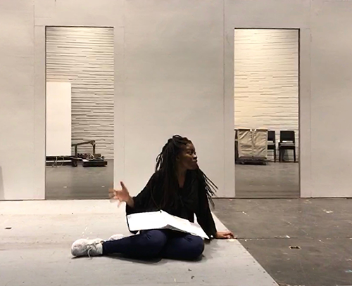
Photo caption: Princeton senior Ugonna Nwabueze as Jules in rehearsal for the Lewis Center for the Arts’ production of Etched in Skin on a Sunlit Night
Photo credit: Abigail Jean-Baptiste

What: Etched in Skin on a Sunlit Night, Kara Lee Corthron’s haunting drama, follows Black American painter, Jules, to Iceland where she has exiled herself to escape her tumultuous past, and where she builds a new life and family. However, a troubling children’s book, a surprise visitor and clashing racial identities destroy her idyllic life, exposing her past and causing her entire sense of self to crumble.
Who: Presented by Lewis Center for the Arts’ Program in Theater, directed by Princeton senior Abigail Jean-Baptiste
When: January 11, 12 & 14 at 8 p.m. and January 13 at 9 p.m.
Where: Wallace Theater at the Lewis Arts complex on the Princeton campus
Tickets: $12 general admission in advance of show dates, $8 for students, and $17 general admission purchased the day of performances at the box office
Event info: http://arts.princeton.edu/events/etched-skin-sunlit-night-kara-lee-corthron/2018-01-11/

(Princeton, NJ) The Lewis Center for the Arts’ Program in Theater at Princeton University will present the haunting drama Etched in Skin on a Sunlit Night by Kara Lee Corthron, directed by senior Abigail Jean-Baptiste, on January 11, 12 and 14 at 8:00 p.m. and January 13 at 9:00 p.m. Performances will take place in the Wallace Theater at the Lewis Arts complex on the Princeton campus.

The play follows Black American painter, Jules, to Iceland where she has exiled herself to escape her tumultuous past and where the titular sunlit nights are not uncommon. She marries a white Icelander, Ólafur, and they have a child named Kina. For a time, Jules feels safe and happy in Reykjavik, however in 2008 she begins to miss home as she follows Barack Obama’s run for office. Simultaneously, Iceland is going through a financial crisis that destabilizes the world around her. When Ólafur buys a disturbing book for Kina and a mysterious guest arrives at Jules’ studio, the dream life Jules thinks she has created crumbles. All of these events leave Jules questioning her personal and racial identity and force her to face the past she thought she left behind.

Etched in Skin on a Sunlit Night had its world premiere in 2012 at Philadelphia’s InterAct Theatre Company; the production at Princeton will be the first since the premiere. In early December, playwright Corthron visited Princeton for a conversation with students about the development of Etched and to watch some rehearsals.

Jean-Baptiste, who is from New York City, is majoring in English and pursuing certificates in the Program in Theater and the Department of African American Studies. Jean-Baptiste notes that the Program, in not offering theater as a major, tailors opportunities to the individual student and enables her to pursue a personalized exploration of theater. She has taken at least one theater course each semester since her freshman year. She has appeared in Lewis Center productions of Gurls, Hairspray, and Ding!, a senior thesis that was designed as an audience participation experience that made use of toys, games, and other childhood objects as non-traditional instruments for collaborative music-making. Jean-Baptiste served as assistant stage manager for the Program in Theater’s production of Red Noses her freshman year and late in her freshman year, she directed a one-act play for Theatre Intime. During her time at Princeton, Jean-Baptiste also directed two musicals for Princeton University Players. Last year, she was assistant director of the spring musical, Into the Woods, and worked on a senior thesis production of Request Programme, an immersive, intimate one-person play without words. In May she will direct the new musical Trailing Rhiannon by fellow senior Emma Watkins that interweaves Celtic folk music with storytelling tradition, reimagining one of Welsh mythology's most fiercely outspoken female protagonists.

The Lewis Center provided funding last summer for Jean-Baptiste to visit various Nordic countries, including Iceland, to meet Black artists working there and to study racial dynamics in these predominantly white cultures as research for directing the play. The only Icelandic undergraduate currently on campus, Guðrún Valdís Jónsdóttir ’18, has acted as the show’s Icelandic language and dialect coach throughout the rehearsal process. In November, the Lewis Center organized an ArtEquity workshop for the production, in which theater producer Deadria Harrington and theater director David Mendizábal led exercises to ignite conversations around race, equity, and Etched.

Pre-recorded songs by Icelandic band Sigúr Rós are written into the play’s script.

The cast of Princeton undergraduates features senior Ugonna Nwabueze as Jules; Nwabueze performed a lead in the Lewis Center’s November production of Eclipsed. The cast also includes junior Anna Zabel and freshmen Andrew Tye, Haydon John, and Imane Mabrouk.

The all-white set, by professional guest designer Lawrence Moten, is inspired by Scandinavian design and the visual of black bodies in white space. Costumes are by professional guest designer Sarita Fellows. Students Megan Berry and Zara Jayant provide lighting and sound design, respectively. Sophomore Michele Montas is stage manager with students Abigail Rettew and Annan Timon as assistant stage managers.

Etched in Skin on a Sunlit Night has the distinction of being the first senior thesis production in the new Wallace Theater in the Lewis Arts complex. The theater was inaugurated in October with the world premiere of Gurls, written by Branden Jacobs-Jenkins and directed by Liliana Blain-Cruz, both from Princeton’s Class of 2006. Gurls was presented during a four-day festival of the arts that celebrated the opening of the new arts complex.

Tickets for Etched in Skin on a Sunlit Night are $12 general admission in advance of show dates, $8 for students, and $17 general admission purchased the day of performances at the box office. Tickets are available starting January 8 through University Ticketing online at tickets.princeton.edu or by calling 609.258.9220, or at the Frist Campus Center or Lewis Arts complex ticket offices. Tickets will also be available at the door prior to performances.

To learn more about this event, the Program in Theater, and the more than 100 other performances, exhibitions, readings, screenings, concerts, and lectures presented by the Lewis Center, most of them free, visit arts.princeton.edu.

###

