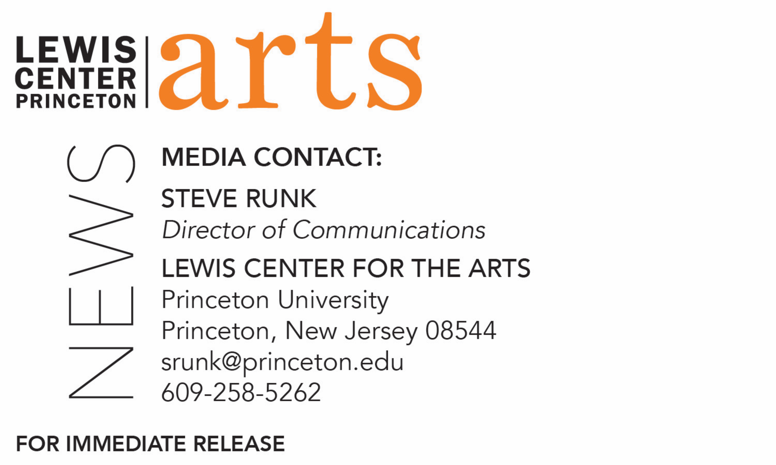

February 8, 2018

Award-winning Writer Nicole Dennis-Benn reads with Five Seniors in
Princeton’s Creative Writing Program February 16
The C.K. Williams Reading Series is organized by Princeton students in collaboration with Labyrinth Books

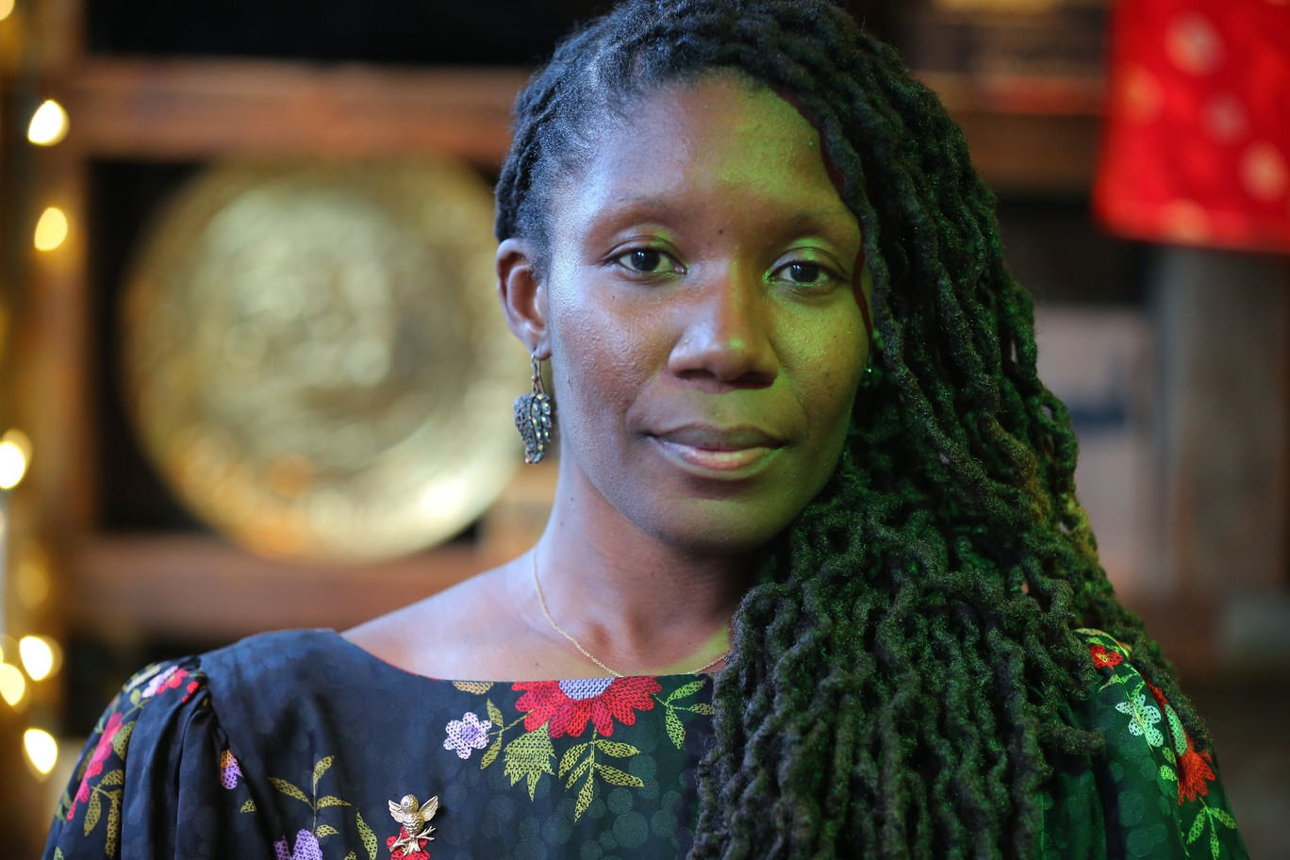
Photo caption: Award-winning author Nicole Dennis-Benn
Photo credit: Ozier Muhammad

What/Who: Reading by award-winning writer Nicole Dennis-Benn and five seniors in Princeton's Program in Creative Writing, part of the C.K. Williams Reading Series
When: Friday, February 16 at 6:00 p.m.
Where: Labyrinth Books, 122 Nassau St., Princeton
Free and open to the public

(Princeton, N.J.) Award-winning writer Nicole Dennis-Benn and five seniors in the Lewis Center for the Arts’ Program in Creative Writing at Princeton University will read from their work at 6:00 p.m. on Friday, February 16 at Labyrinth Books, 122 Nassau Street. The reading is part of the C. K. Williams Reading Series, named in honor of the Pulitzer Prize and National Book Award-winning poet who served on Princeton’s creative writing faculty for 20 years.

The series showcases senior thesis students of the Program in Creative Writing alongside established writers as special guests. Featuring student writers Kyle Berlin, Aidan Gray, Allison Light, Allie Mendelsohn, and Kevin Romero, the event is free and open to the public.

Nicole Dennis-Benn is the author of the debut novel, Here Comes the Sun (2016), which was named a New York Times Notable Book of the Year, an NPR Best Books of 2016, an Amazon, Barnes & Noble, Entertainment Weekly, and Kirkus Reviews Best Book of 2016, and a BuzzFeed Best Literary Debuts of 2016, among others. Her writing has appeared in The New York Times, ELLE Magazine, Electric Literature, Lenny Letter, Catapult, Red Rock Review, Kweli Literary Journal, Mosaic, Ebony, and the Feminist Wire. Dennis-Benn’s honors include a Lambda Literary Award and the Richard and Julie Logsdon Fiction Prize, in addition to fellowships from MacDowell Colony, Hedgebrook, Lambda, Barbara Deming Memorial Fund, Hurston/Wright, and Sewanee Writers' Conference. She teaches in the M.F.A. Fiction program at Sarah Lawrence College.

The five seniors, who are pursuing a certificate in creative writing in addition to their major areas of study, will read from their senior thesis projects. Each is currently working on a novel, a screenplay, translations, or a collection of poems or short stories as a part of a creative thesis for the certificate. Thesis students in the Program in Creative Writing work closely with a member of the faculty, which includes Jeffrey Eugenides, Jhumpa Lahiri, Yiyun Li, Paul Muldoon, Kirstin Valdez Quade, James Richardson, Tracy K. Smith, Susan Wheeler, and a number of distinguished lecturers.

The Program in Creative Writing also presents the Althea Ward Clark W’21 Reading Series monthly on Wednesdays on the Princeton campus. Upcoming guests include Osama Alomar, Luc Sante, Jane Hirshfield, and Walter Mosley.

To learn more about this reading series, the Program in Creative Writing, and the more than 100 public performances, exhibitions, readings, screenings, concerts and lectures presented each year by the Lewis Center for the Arts, most of them free, visit arts.princeton.edu.

###

