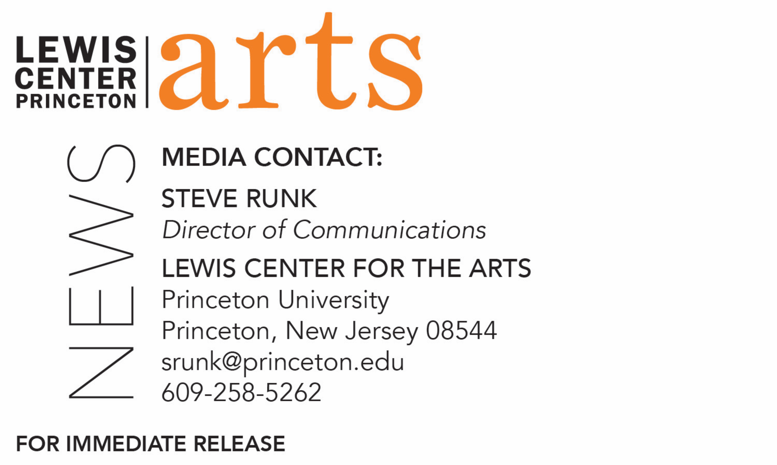

February 27, 2018

Lewis Center for the Arts’ Program in Creative Writing presents
A Reading with Osama Alomar and Luc Sante
Award-winning writers next in Althea Ward Clark W’21 Reading Series at Princeton

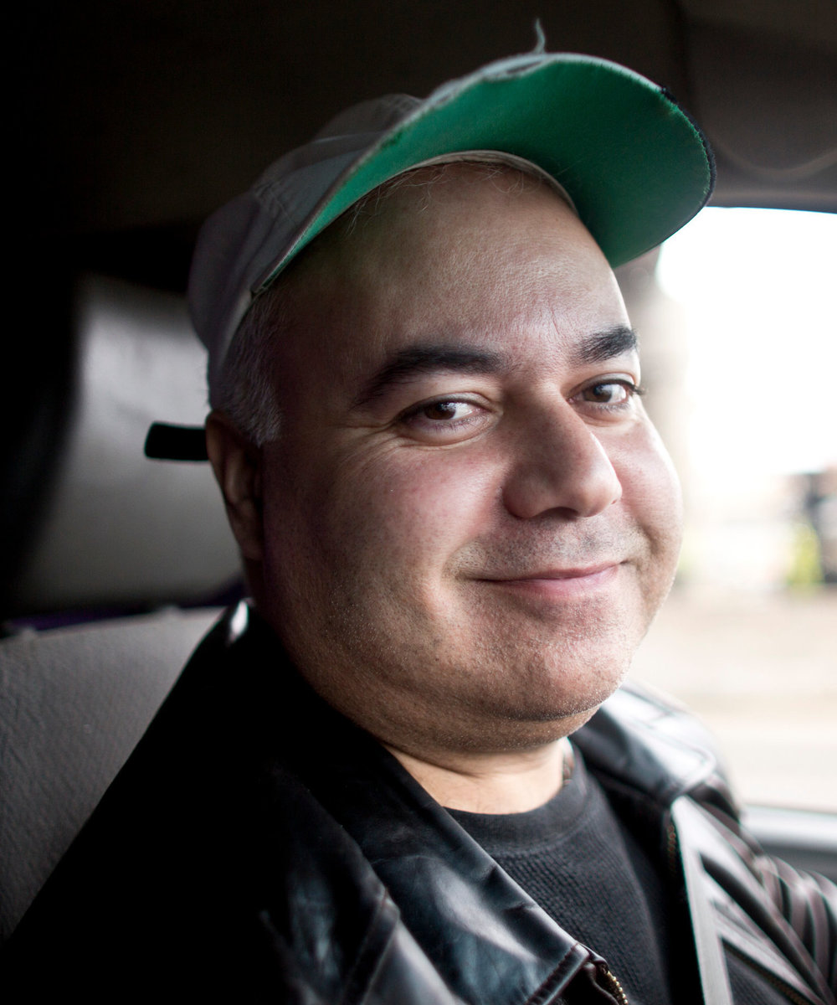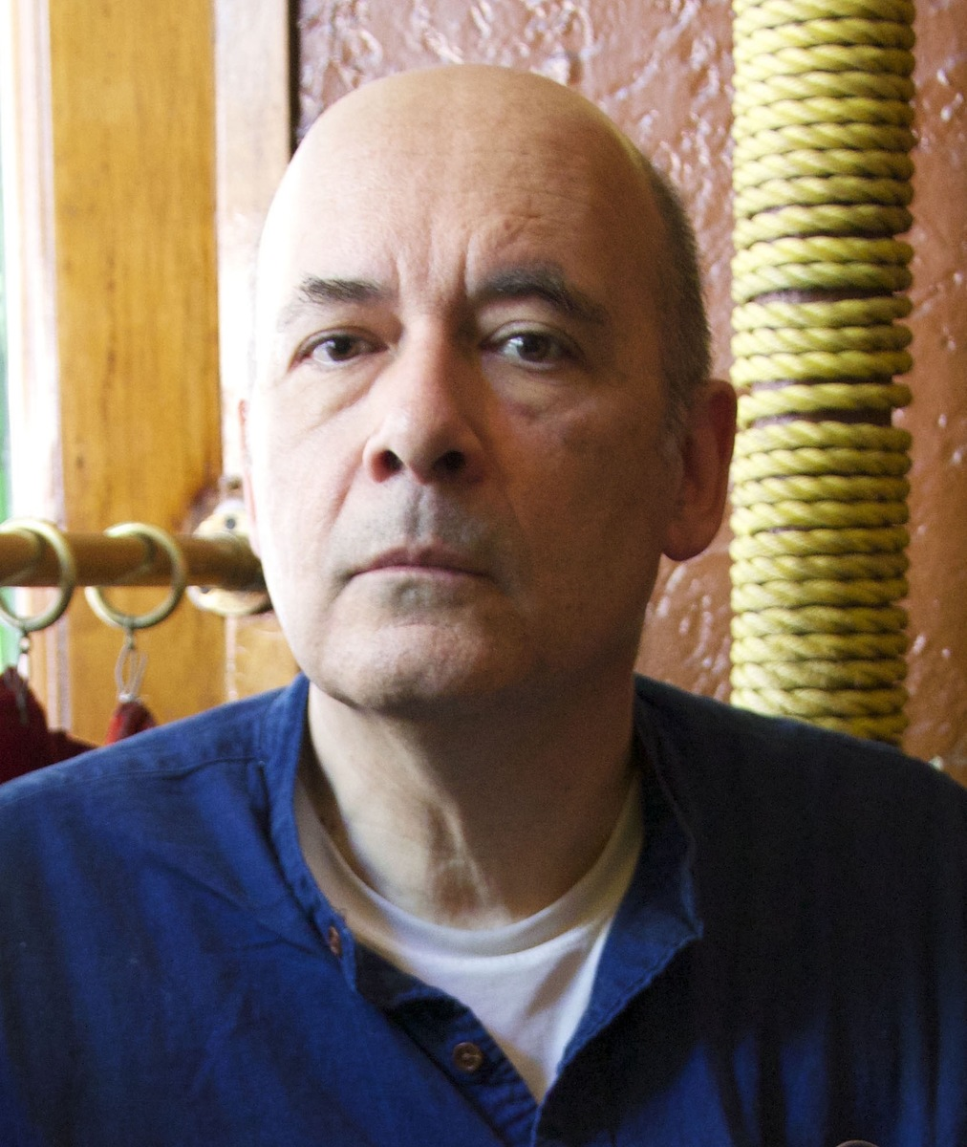

Photo caption 1: Poet and fiction writer Osama Alomar
Photo credit 1: Blue Flower Arts
Photo caption 2: Award-winning author Luc Sante
Photo credit 2: Linda Levine

Who/What: Osama Alomar, Syrian-born poet and fiction writer, and Luc Sante, Whiting Award-winning author, read from their work as part of the 2017-18 Althea Ward Clark W’21 Reading Series
When: Wednesday, March 7 at 7:30 p.m.
Where: Donald G. Drapkin Studio at Lewis Arts complex on the Princeton University campus
Free and open to the public
Event link: http://arts.princeton.edu/events/reading-osama-alomar-luc-sante/

***NOTE different time and location than previous readings in this series***

(Princeton, N.J.) On Wednesday, March 7, Osama Alomar, a Syrian-born poet and fiction writer and Luc Sante, Whiting Award-winning author, will read from their work as part of the Althea Ward Clark W’21 Reading Series of the Program in Creative Writing in the Lewis Center for the Arts at Princeton University. The reading, beginning at 7:30 p.m. in the Donald G. Drapkin Studio at the Lewis Arts complex, is free and open to the public.

Born in Damascus, Syria, in 1968 and now living in Chicago, Osama Alomar is one of the most highly regarded, prize-winning writers in Syria, author of four books and many journal publications. He is a prominent practitioner of the Arabic al-qisa al-qasira jiddan, the “very short story.” He is the author of Fullblood Arabian in English, and three collections of short stories and a volume of poetry in Arabic. Alomar’s first full-length collection of stories, The Teeth of the Comb, will be published by New Directions in April 2018. Publisher’s Weekly notes, “There are no wasted words in Alomar’s beautiful collection of very short fictions. Philosophical and subversive, these tiny parables deconstruct human failings with a keen insight.” His short stories have been published by The New Yorker, Noon, Conjunctions.com, The Coffin Factory, Electric Literature, and The Literary Review. He also performs as a musician.

Alomar wil be introduced by Paul Muldoon, Pulitzer Prize-winning poet, Princeton’s Howard G.B. Clark ’21 University Professor in the Humanities, and Professor of Creative Writing and Director of the Princeton Atelier at the Lewis Center.
Luc Sante's books include Low Life, Evidence, The Factory of Facts, Kill All Your Darlings, and The Other Paris. A New York Times Book Review of Evidence notes, “Sante has a talent for the striking, impressionistic insight and the ability to write transcendental prose. This is a book about the mysteries of life and death.” The Belgium-born writer has been a frequent contributor to the New York Review of Books since 1981 and has written for a wide variety of other publications. His awards, in addition to a Whiting award, include an award in literature from the American Academy of Arts and Letters, a Grammy (for album notes), an Infinity award in writing from the International Center of Photography, and Guggenheim, MacDowell Colony, and Cullman fellowships. He teaches writing and the history of photography at Bard College.

Sante will be introduced by Susan Wheeler, author of five books of poetry, Bag ‘o’ Diamonds, Smokes, Source Codes, Ledger, Assorted Poems and Meme, which was shortlisted for a National Book Award.

The reading series, usually held in the Berlind Theatre at McCarter Theatre Center at 4:30 p.m., will hold some readings this year in the new Lewis Arts complex with an evening start time of 7:30 p.m.

The Lewis Center’s Program in Creative Writing annually presents the Althea Ward Clark W’21 Reading Series, which provides an opportunity for students, as well as all in the greater Princeton region, to hear and meet the best contemporary writers. The final reading in the 2017-2018 series will feature Jane Hirshfield, Princeton Class of 1973, and Walter Mosley, on Wednesday, April 18 at 4:30 p.m. at the Berlind Theatre at McCarter Theatre Center.

To learn more about this reading series, the Program in Creative Writing, and the more than 100 public performances, exhibitions, readings, screenings, concerts and lectures presented each year by the Lewis Center for the Arts, most of them free, visit arts.princeton.edu.

###

