February 9, 2018

Lewis Center for the Arts presents The Name of the Game
A collection of works choreographed by Princeton senior Clark Griffin

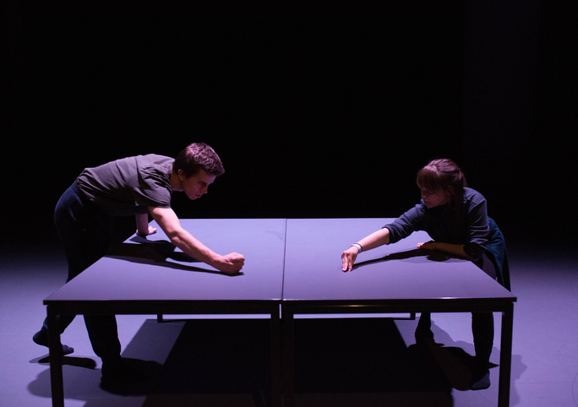
Photo caption: Students in rehearsal for Clark Griffin’s The Name of the Game
Photo credit: Mariah Wilson

What/Who: The Name of the Game, an evening of dance choreographed by Princeton senior Clark Griffin in collaboration with his cast, investigating the inherent social and relational dynamics of the human body through forms of non-classical virtuosity, presented by the Lewis Center for the Arts’ Program in Dance.
When: February 22 and 23 at 8:30 p.m. and February 24 at 6 p.m. and 9 p.m.
Where: Hearst Dance Theater at the Lewis Arts complex on the Princeton University campus
Free and open to the public

(Princeton, NJ) The Lewis Center for the Arts’ Program in Dance at Princeton University will present an evening of dance choreographed by Princeton senior Clark Griffin in collaboration with his cast, investigating the inherent social and relational dynamics of the human body through forms of non-classical virtuosity. Performances will be held February 22 and 23 at 8:30 p.m. and February 24 at 6 p.m. and 9 p.m. at the Hearst Dance Theater at the Lewis Arts complex on the Princeton University campus. The performances are free and open to the public.

The collection of works created by Griffin is presented in three sections. The first explores posture and body language as it relates to power and group dynamics. In this section Griffin worked closely with his cast of five dancers to create an internal narrative, known to the dancers yet unessential to the final instantiation of the piece. The second section contrasts the first in a more upbeat and humorous celebration of movement, investigating groove and fun within the generally dark and serious field of concert dance. The third section, a solo performed by Griffin, examines the limitations and endurances of the polyrhythmic body through personal observation and experimentation.

Griffin is majoring in anthropology and pursuing a certificate in dance. He views both disciplines as being “about people.” The flexibility within anthropology has allowed him to conduct his independent research on dance and its position in art culture. Griffin’s written thesis will feature auto-ethnographic research on his creative process for The Name of the Game, his relationship with dance, and his experience as an artist on Princeton’s campus.

Griffin studied ballet and jazz in high school and has attended intensive training programs both nationally and internationally including Springboard Dance Montréal, Hubbard Street Dance Chicago, Northwest Dance Project’s “Launch,” Netherlands Dance Theater, Juilliard Summer Dance Intensive, Vim Vigor, and San Francisco Conservatory of Dance. He chose to come to Princeton because of the opportunity to pursue a liberal arts education while continuing to study dance. He began choreographing during his freshman year. In addition to his work within the Program in Dance, he is a part of the student dance groups Disiac and Princeton University Ballet. After graduation Griffin plans to pursue a career in contemporary dance.

The student cast includes senior Jacqueline Kopra, juniors James Jared and Jhor van der Horst, and first year students, Sophie Blue and Sam Grayson.

Lighting for the production is designed by senior Kathleen Feng, mentored by Tess James, a New York City-based lighting designer.

To learn more about this event, the Program in Dance, and the more than 100 other performances, exhibitions, readings, screenings, concerts and lectures presented each year at the Lewis Center, most of them free, visit arts.princeton.edu.

###

