February 6, 2018

Visual Arts Program at the Lewis Center for the Arts presents
a screening of student work in video and digital animation
Work from fall courses “Short Comedy Filmmaking,” “Digital Animation,”
and “Documentary Filmmaking”

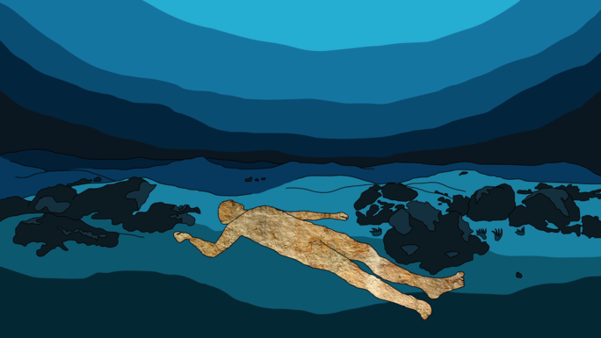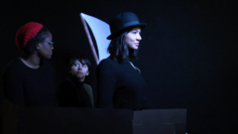
Photo caption 1: A still from “Underground,” a short digital animation film by senior Adam Berman, one of 27 student films to be screened at Princeton’s Lewis Center for the Arts
Photo credit 1: Adam Berman
Photo caption 2: A still from the short comedy film that reimagines the voyage of “discovery” to the Galapagos Islands, where explorers could only tell their countrymen about tortoises, as they had eaten them all before their return to Spain.
Photo credit 2: Students in the fall Princeton course, “Short Comedy Filmmaking”

Who/What: A screening of student-created films from fall semester courses “Documentary Filmmaking” taught by Jason Fox, “Short Comedy Filmmaking” taught by Yaara Sumeruk, and "Digital Animation" taught by Tim Szetela.
When: Wednesday, February 14 at 4:30-7:00 p.m.
Where: James M. Stewart ’32 Theater at 185 Nassau Street
Free and open to the public

(Princeton, NJ) The Visual Arts Program at Princeton University’s Lewis Center for the Arts will present a screening of 27 short student films created in the fall semester courses “Documentary Filmmaking” taught by Jason Fox, “Short Comedy Filmmaking” taught by Yaara Sumeruk, and "Digital Animation" taught by Tim Szetela. The screening, which is free and open to the public, will be presented on Wednesday, February 14 from 4:30 to 7:00 p.m. in the James M. Stewart ’32 Theater, located on the first floor of 185 Nassau Street. A reception will follow the screening.

In “Documentary Filmmaking,” taught by Fox, students explored what relationships have the necessary friction to generate compelling films. Through production assignments, screenings, and seminar discussions, students entered into the world of nonfiction filmmaking and examined the formal, social, and political concerns within their lives.

Fox is a filmmaker and professor based in New York. He has taught in the Graduate School of Cinema Studies at New York University, Vassar College, Cooper Union, and CUNY Hunter College. His award-winning work as a director, cinematographer, and editor has screened internationally in film festivals including Sundance, AFI Fest, and Venice, on broadcast television, and in gallery installation settings. He has worked as a film programmer in conjunction with The American Museum of Natural History, The Flaherty Seminar, and the Museum of Modern Art, among other venues. He is a recipient of a Union Square Award for social justice, and he is also the founding editor of the peer-reviewed journal of documentary studies, World Records, published by UnionDocs in Brooklyn, NY.

Sumeruk’s course, “Short Comedy Filmmaking,” begins with the premise that a working filmmaker today has to master the short film—being a filmmaker no longer means creating feature films exclusively, if at all. This course focused on the technical challenges of being short, as well as the conceptual challenge of being funny. The collaborative, in-class production of short film comedies was augmented by critical analysis of the short comedy genre throughout film history and by visits from industry professionals. The final short films include a comedy that reimagines the voyage of “discovery” to the Galapagos Islands, where explorers could only tell their countrymen about tortoises, as they had eaten them all before their return to Spain. Another deals with the idea of a “smart house” that’s not so smart after all.

Sumeruk has worked in multiple aspects of filmmaking, from directing to editing, production, and marketing. Her film Ringo premiered at The Locarno International Festival, Switzerland, and is a Vimeo Staff Pick. She has directed videos for Google, Penguin Books, Park Hyatt, USPS, and Rado watches, and has edited trailers for director Spike Lee, The Sundance Institute, and The Malala Fund, and she was the creative director of a series of films screened at the United Nations General Assembly. Sumeruk held the position of director of video production at Bond/360, an independent film distribution company for two years. Her new comedies, American Daddy and Kim’s Kitchen, will be out in 2018. She is currently in production on a documentary set in South Africa titled, If We Say That We Are Friends.

In the new course “Digital Animation,” Szetela worked with students on a variety of timed-based collage, composition, visualization, and storytelling techniques, as well as the fundamental techniques and technology of 2D animation production. Students produced a range of short animated films, which explore cities, caves, outer space, sadness and stress, politics and social media, dreams, relationships, alchemical foods, and a snake’s search for identity.

Szetela is a designer, animator, and digital artist. He uses a varying toolset of analog and digital media, software, code, and technology to make maps, films, games, and other interfaces that visualize and document structures of location, language, and data. Rewordable, the game he co-designed using computational linguistics, was published by Penguin Random House in 2017. His short films have screened at numerous international animation festivals, including Anima Mundi, Annecy, the Holland Animation Film Festival, Ottawa International Animation Festival, Stuttgart Festival of Animated Film, and Zagreb World Festival of Animated Films. He has shown work at the Museum of Modern Art (New York), Metropolitan Museum of Art (New York), Museum of Fine Arts (Boston), Institute of Contemporary Art (Boston), as well as a variety of digital art, game, and technology festivals, conferences, and exhibitions.

To learn more about this event, the Program in Visual Arts, and the more than 100 public performances, exhibitions, readings, screenings, concerts and lectures presented each year by the Lewis Center for the Arts, most of them free, visit arts.princeton.edu.

###

