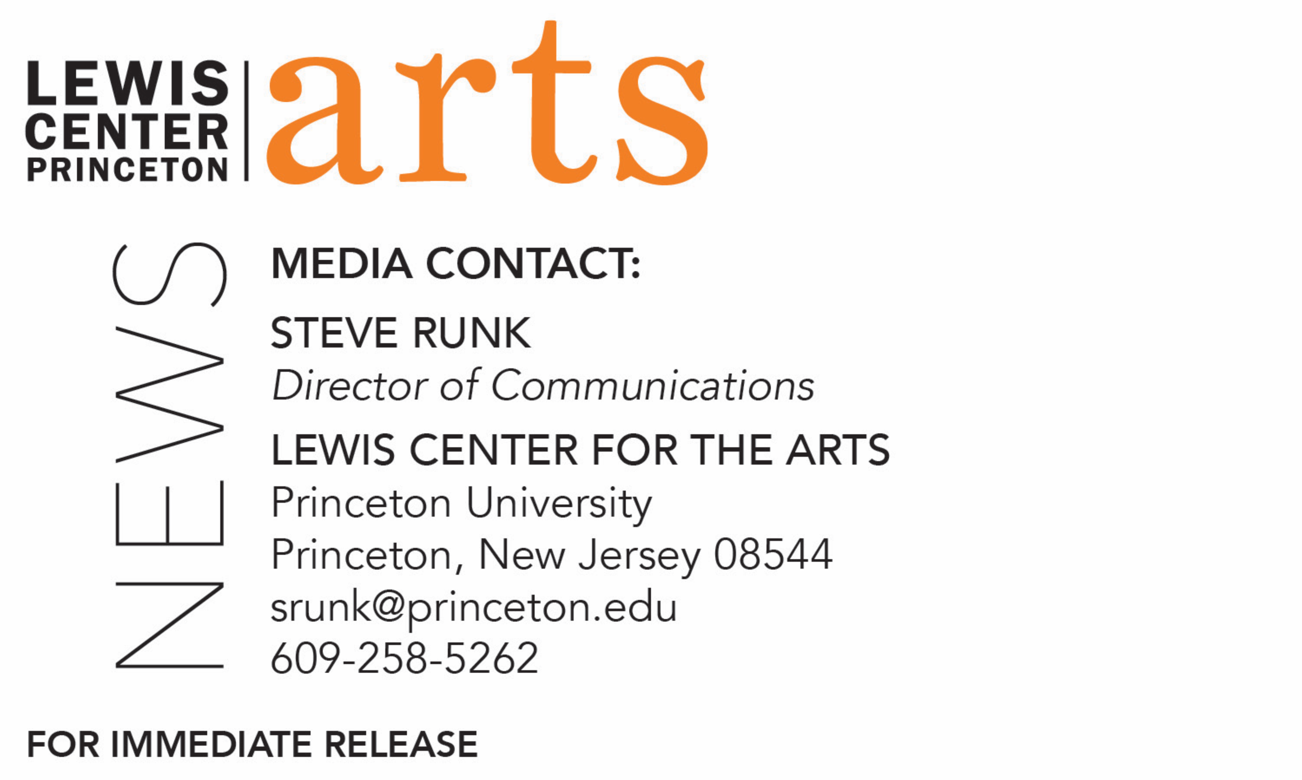
February 27, 2018

Princeton’s Visual Arts Program presents
a series of exhibitions of new work by seniors
Solo shows by visual arts majors and certificate students run through early May in three gallery spaces and some non-traditional venues

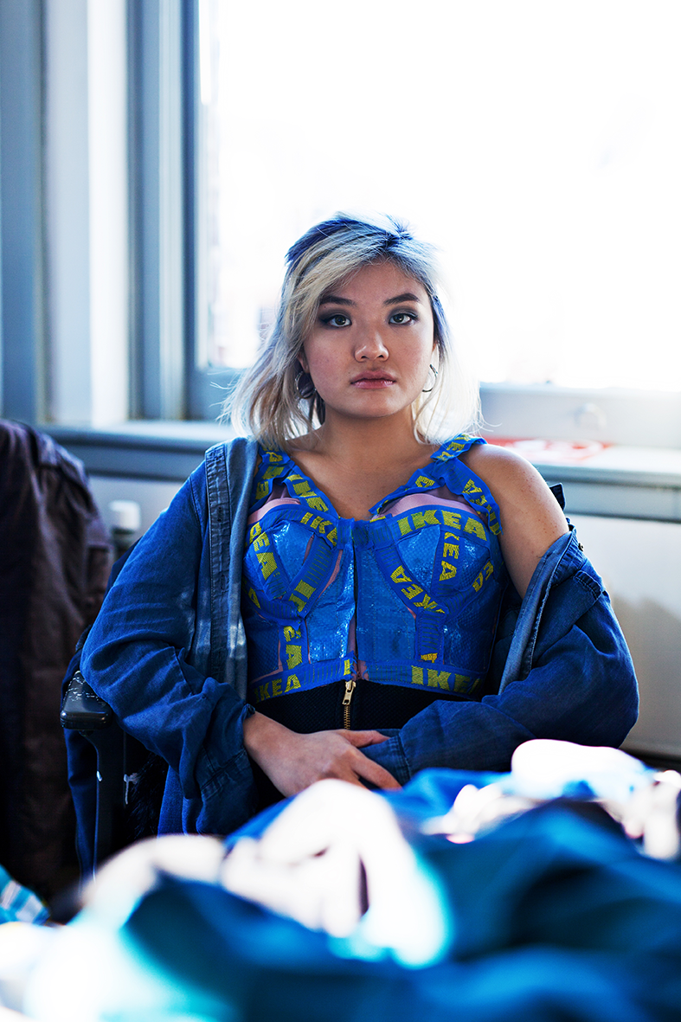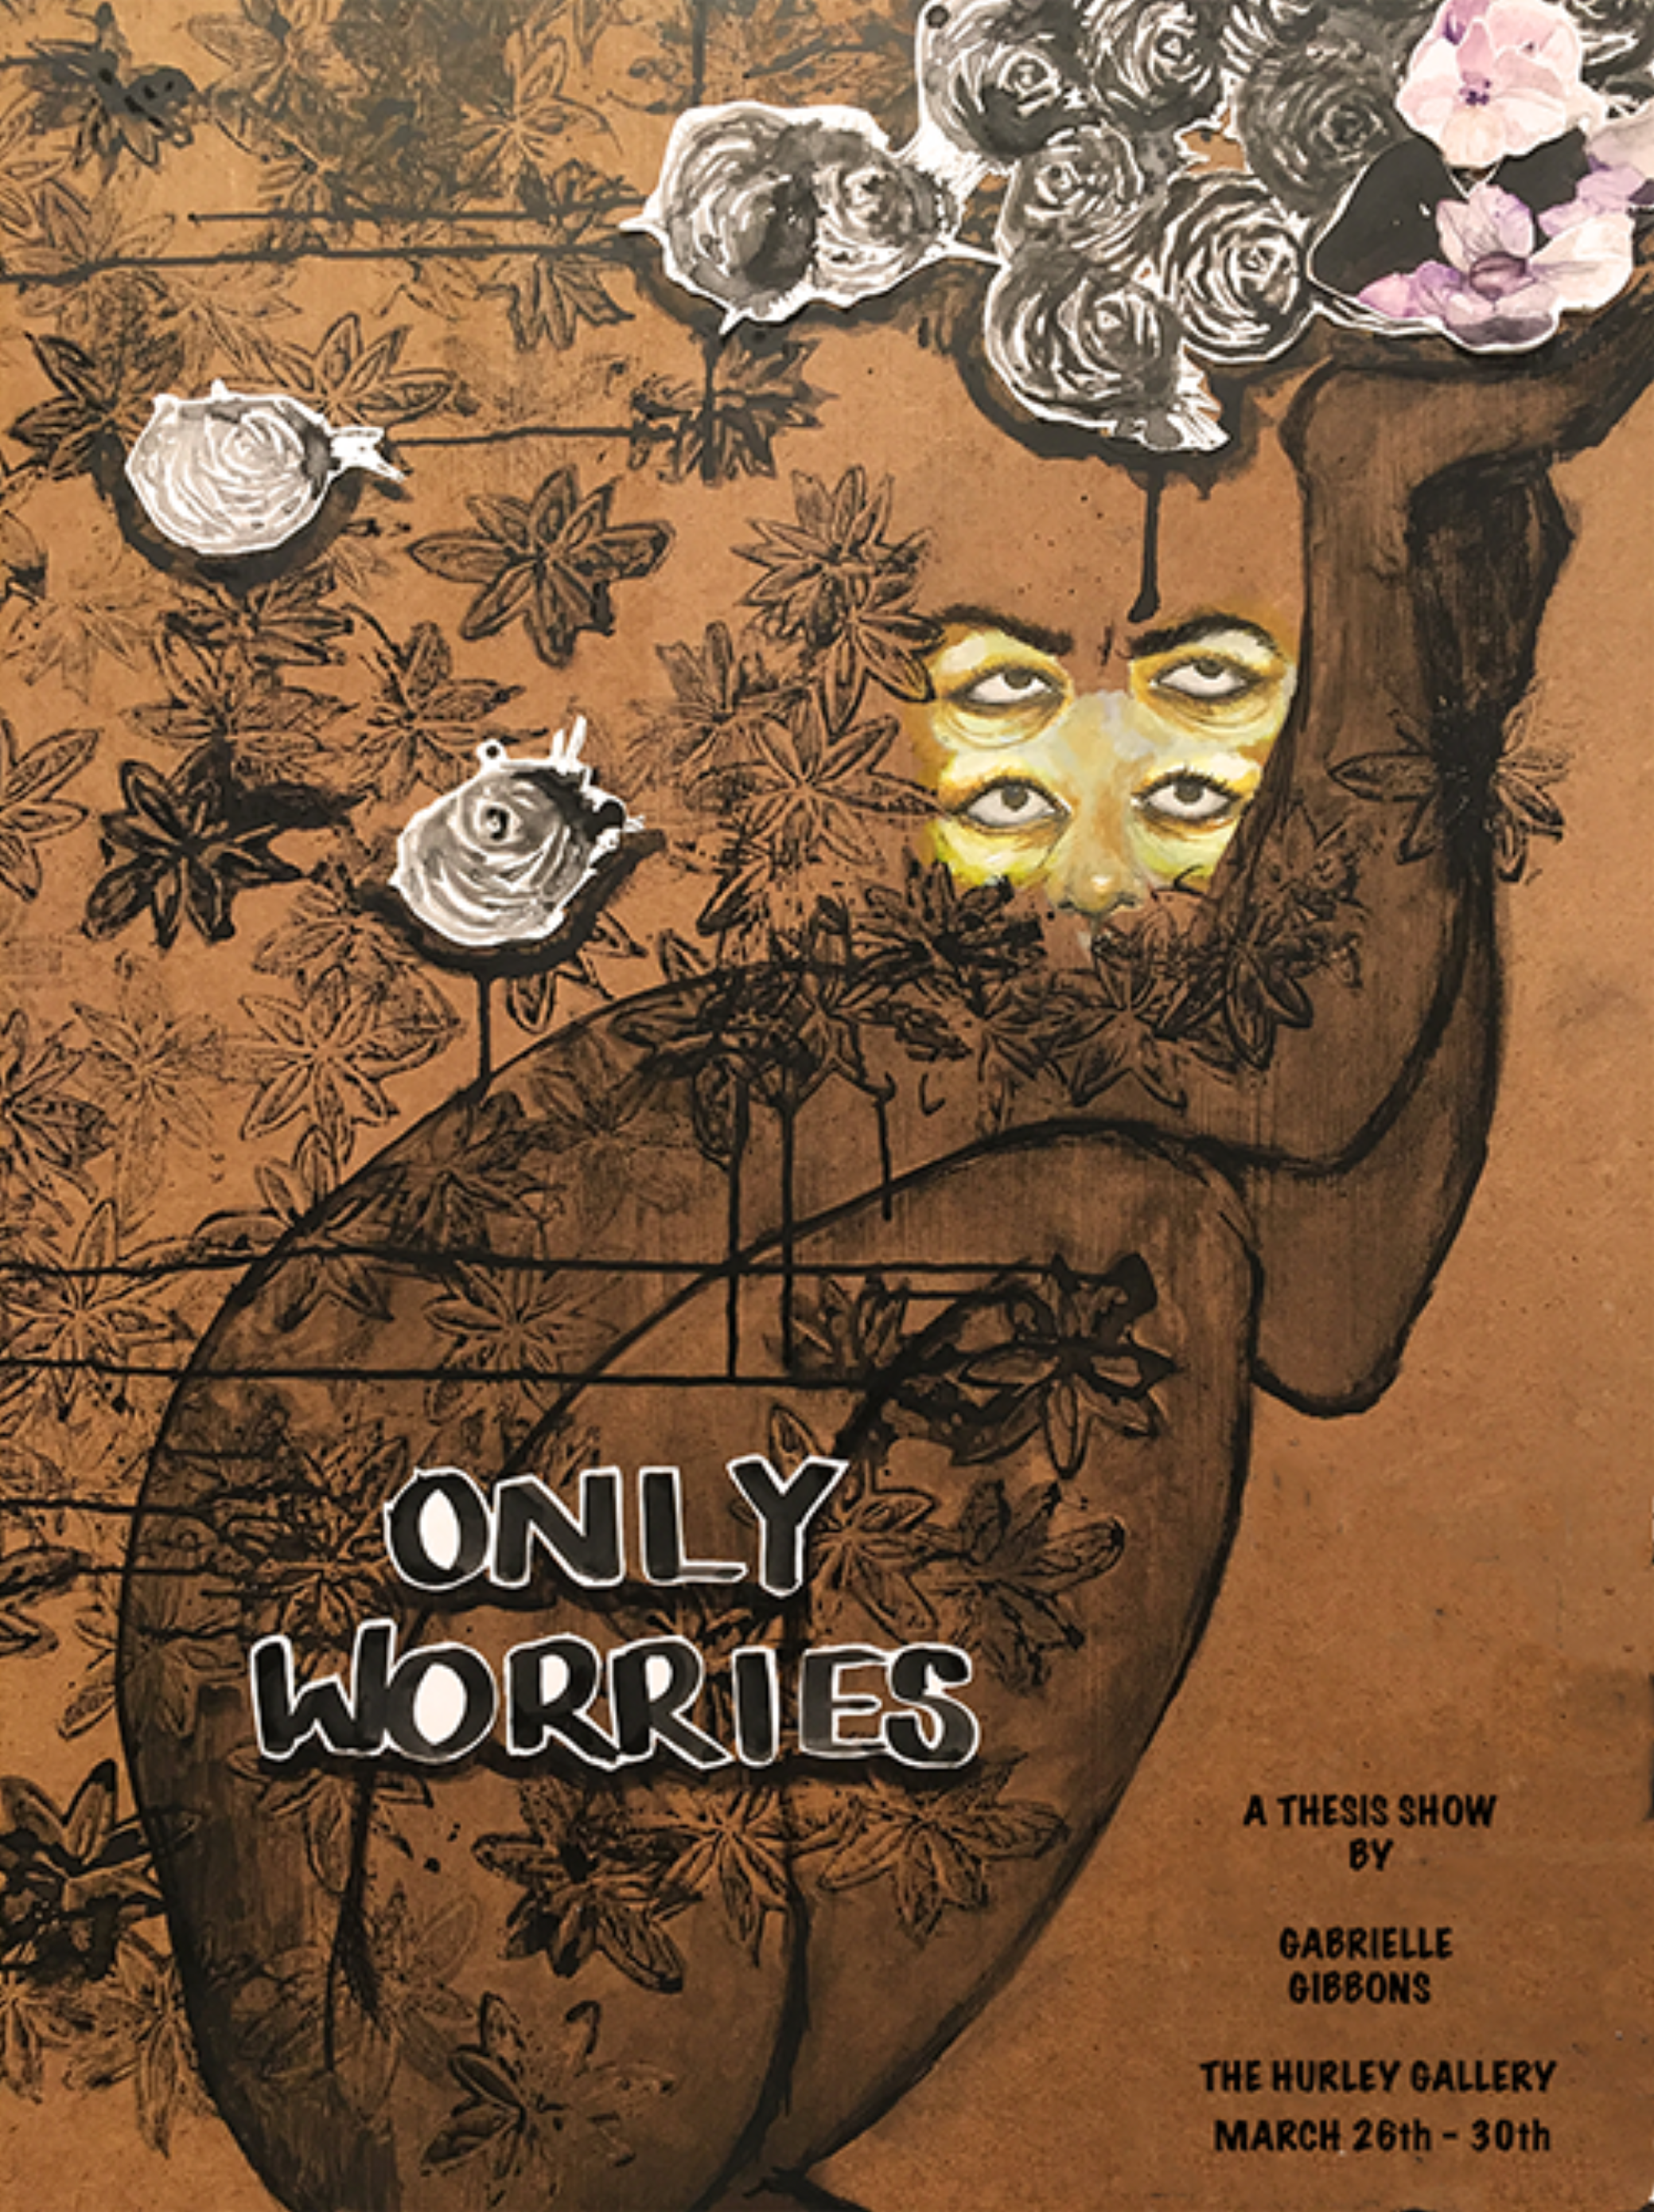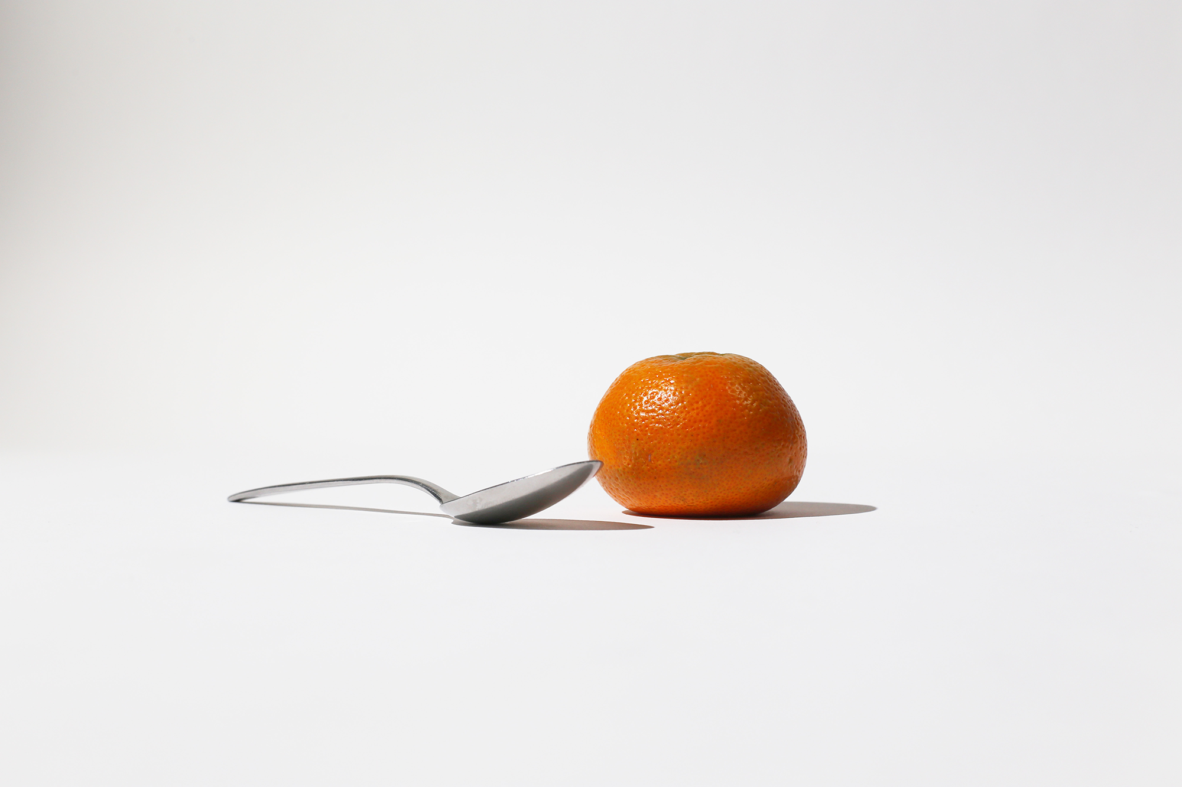
Photos caption 1 and 2: Senior Gabriella Chu in one of the fashion designs she created as part of her upcoming exhibition exploring the reconstruction and repurposing of “fast fashion,” one of 16 solo exhibitions by Princeton seniors scheduled through early May, and at work in her studio.
Photo caption 3: A work by senior Gabrielle Gibbons for her show Only Worries
Photo caption 4: A design by senior Eric Li
Photo credit: courtesy of the artists

What/Who: A series of solo exhibitions by seniors in Princeton University’s Program in Visual Arts
When: February 27 through May 5
Where: Hurley Gallery and Forum at Lewis Arts complex, Lucas Gallery and Hagan Studio at 185 Nassau St., and Frist Campus Center on the Princeton University campus
Free and open to the public

(Princeton, NJ) The Program in Visual Arts at Princeton University’s Lewis Center for the Arts presents a series of 16 solo exhibitions by seniors in the Program through May 5 in galleries and other venues on the Princeton campus.

The series of exhibitions, which will range widely in media and ideas explored, are among the requirements of seniors in the program who are either majoring in visual arts through a collaborative program of the Lewis Center and the Department of Art and Archaeology or are majoring in another area and pursuing a certificate in visual arts. The seniors are required to create a body of work generally organized around a central idea or area of investigation and present that work in a cohesive exhibition, with accompanying mentorship and critiques by their advisors and other faculty in the program. Each exhibition includes a reception where guests can meet and speak with the artist.

“This year’s seniors have created a particularly eclectic and wide-ranging body of work,” notes Martha Friedman, director of the Program in Visual Arts. “Starting February 27th, and running through May 5th, one can stop by the Lucas or Hurley galleries on almost any given day and find themselves exposed to the unique voice of an emerging artist. By visiting the galleries periodically during the thesis exhibitions, one will experience a panoply of vantage points, experiencing the gestalt of our current historical moment viewed through myriad perspectives that only the freshest survey shows typically offer.”

In a show by Eric Li, entitled W-T-F, he focuses primarily on his relationship with graphic design at Princeton and the challenges of practicing it within the context of the visual arts program. He explains that in the show he attempts to address the difficulties of presenting graphic design outside of its context and explores his interest in reconciling the differences in having an independent studio practice while also producing "traditional" printed matter, such as posters and logos. The show also focuses heavily on his interest in the process of design as being equally, if not more important than, the finished product. He notes that his work stems from Max Bill's essay, “Continuity and Change,” where the Swiss designer and theorist discusses design and gestalt as continuously testing and evolving a form in order to push it to some better or idealized "true form." Li notes that whether or not that true form exists is up to debate and asks, what is true form? His exhibition will be presented in the Hurley Gallery on March 13 through 17.
In the exhibition Only Worries, by Gabrielle Gibbons, the artist depicts her perception of the state of humanity as informed by her news consumption. She notes that social media's global reach has facilitated an overwhelming awareness of issues ranging from personal hardship to large-scale devastation. The show features portraits of reactions to traumatic news, tragedy, and life with worry. She uses a stylized isolation and repetition of the more expressive parts of the body for her representations. The paintings are mixed media on masonite panels. Her show will run March 26 through 30 in the Hurley Gallery.

In another exhibition, Gabriella Chu explores the contemporary phenomenon of “fast fashion” where retailers capitalize on the latest trends in high fashion by quickly and cheaply producing clothes that emulate styles seen on the runaway. She explains that fast fashion is an incredibly lucrative industry with companies typically outsourcing production to factories in countries that have lenient labor laws, leading to exploitation of workers and human rights abuses. She adds that fast fashion has become arguably the second largest industry, after oil mining, contributing to environmental pollution because of the resources wasted through mass production of these clothes. Her creative process involves reconstructing and repurposing clothes that she has purchased from fast fashion vendors on clearance, usually around 90% off of their original retail value. Her work is inspired by her East Asian cultural background, as well as general economic and aesthetic trends in fast fashion. Her project will culminate in a fashion show on May 1 at 6:30 pm in the Lewis Arts complex Forum, followed by a display of the garments in the Lucas Gallery at the Lewis Center’s 185 Nassau Street location on May 1 through 5, where they will be exhibited as a fast fashion retail space.

The exhibitions will primarily be presented at the Lucas Gallery at 185 Nassau Street and the Hurley Gallery at the new Lewis Arts complex. With the move of the Lewis Center’s Programs in Dance, Theater, Music Theater and the Princeton Atelier from 185 Nassau to the new arts complex, the Program in Visual Arts has expanded at 185 with the former Hagan Dance Studio converted to a visual arts studio where one of the exhibitions will be presented. The Hurley Gallery at the recently opened arts complex offers a new state-of-the-art exhibition space. At least one show will be presented in the Frist Campus Center, and another, by a senior majoring in visual arts and pursuing a certificate in dance with a project combining these two disciplines, will be held in the CoLab and Hearst Dance Theater at the complex.

The Lucas Gallery and Hagan studio are open Monday through Saturday from 9 a.m. to 5 p.m. with access from the Williams Street parking lot entrance. The Hurley Gallery and spaces at the Lewis Arts complex are open daily 10 a.m. to 8:30 p.m.

The Program in Visual Arts offers studio courses that emphasize direct, hands-on art making under the guidance of practicing visual arts professionals. In order to develop their work, students are also given access to state-of-the-art technical, analog, and digital labs, including a fully functional letterpress studio. Students accepted into the program can pursue a degree or certificate in visual arts.

On May 18 through June 6 a group exhibition of work by all the seniors in the program, the Senior All-Star Show, will be presented in the Hurley Gallery.

To learn more about these events, the Program in Visual Arts, and the more than 100 performances, exhibitions, readings, screenings, concerts and lectures offered each year at the Lewis Center, most of them free, visit arts.princeton.edu.

###

