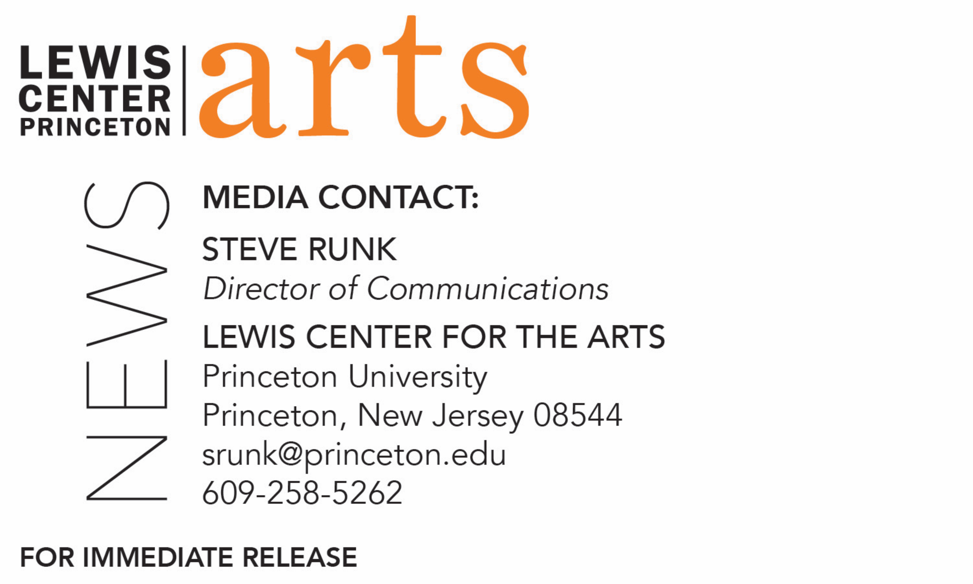

March 29, 2018

Fund for Irish Studies at Princeton University presents
A screening of Song of Granite by Pat Collins
Explores the life and music of Irish sean nós singer Joe Heaney, followed by an audience discussion with the filmmaker

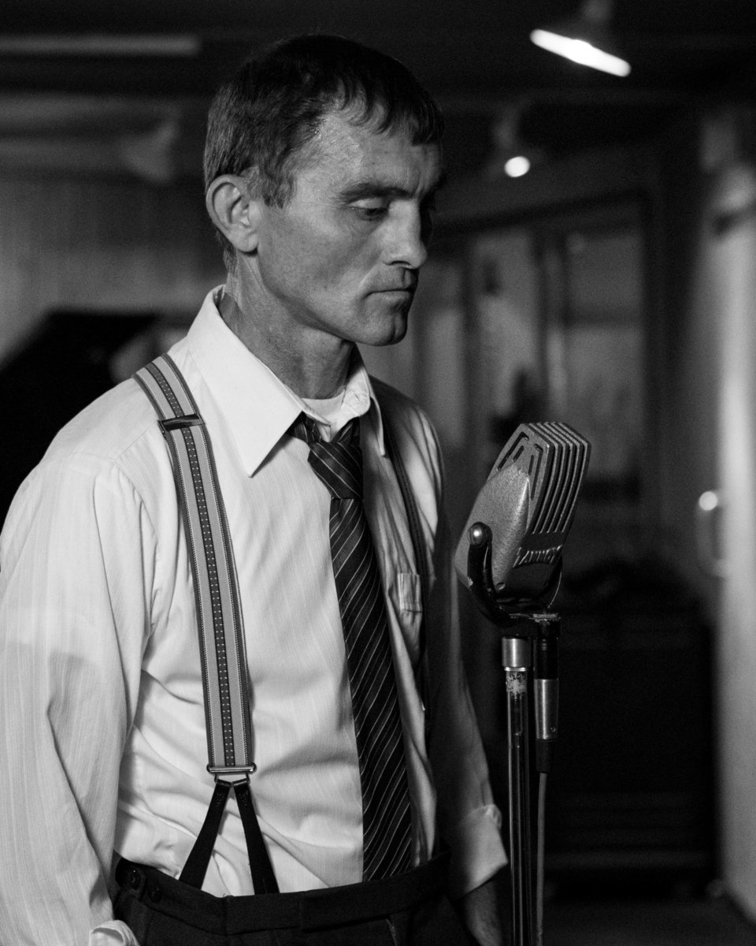

Photo caption: A still from Song of Granite
Photo credit: Pat Collins

Who/What: Filmmaker Pat Collins screens and discusses his feature film Song of Granite, exploring the life and music of Irish sean nós singer Joe Heaney.
When: Friday, April 6 at 1:00 p.m. (Note earlier time than usual for Fund for Irish Studies Series events)
Where: Princeton Garden Theater, 160 Nassau St., Princeton, NJ
Free and open to the public

(Princeton, NJ) Acclaimed filmmaker Pat Collins will screen and discuss his feature film, Song of Granite, a portrayal of the life of sean nós singer Joe Heaney and his music, on Friday, April 6 at 1:00 p.m. at the Princeton Garden Theater, 160 Nassau Street. An audience discussion with the filmmaker will follow the screening. The event, which is free and open to the public, is presented by the Fund for Irish Studies at Princeton University. Guests should note that this event is earlier in the day than usual for Fund for Irish Studies Series events.

Joe Heaney was widely regarded as the greatest practitioner of sean-nòs, a form of traditional unaccompanied Irish singing. Shaped by the myths, fables, and songs of his upbringing in the west of Ireland, his emergence as a gifted artist came at a personal cost. Heaney was said to have a repertoire of over 500 songs in his memory. He became a star in the American folk music revival of the 1960s, first at the Newport Folk Festival and then in various cities across the country, where he performed to sold-out crowds.

The film provides a portrait of the artist, covering his childhood in Connemara in the 1930s, his travels throughout the U.K. and U.S. in the 1960s, and then his reflection on his past and his legacy as an elderly man in the U.S. Collins’ film does not attempt to cover all the details about the singer’s life but rather mirror’s Heaney’s reputation as an elusive and enigmatic man. The film features performances by Colm Seoighe, Macdara Ó Fátharta, Jaren Cerf, Lisa O’Neill, Damien Dempsey, and sean nós singers Mícheál Ó Chonfhaola and Pól Ó Ceannabháin, and black and white cinematography by Richard Kendrick. Song of Granite had its world premiere at the 2017 South by Southwest Film Festival and was Ireland’s official entry as Best Foreign Language Film in the 2018 Academy Awards. The film is presented in both English and subtitled Gaelic.

Steve Greene of Indiewire notes that the film, “delivers a profile of not just a singer but the country that made him…Song of Granite is a stirring solemn tribute.”

Collins, who directed and co-wrote the film, has been making films since 1998 and has directed over 30 films, including feature films, documentaries and short experimental works. He has made documentaries on the writers Michael Hartnett, Nuala Ní Dhomhnaill, and John McGahern, and he co-directed a documentary on Iranian filmmaker Abbas Kiarostami. In 2012, he completed the feature film Silence, which had its international premiere at the London Film Festival and was distributed by Element Films in Ireland and New Wave Films. Song of Granite is his second dramatic feature film.

The Fund for Irish Studies, chaired by Princeton professor Clair Wills, affords all Princeton students, and the community at large, a wider and deeper sense of the languages, literatures, drama, visual arts, history, politics, and economics not only of Ireland but of “Ireland in the world.” The series is co-produced by the Lewis Center for the Arts. The spring 2018 edition of the series is organized by Fintan O’Toole as acting chair of the Fund for Irish Studies.

The final event in the 2017-18 series will feature Alvin Jackson, the Sir Richard Lodge Professor of History at the University of Edinburgh, who will present a lecture, “John Redmond and Edward Carson: Bloodshed, Borders and the Union State,” on April 27.

The Fund for Irish Studies is generously sponsored by the Durkin Family Trust and the James J. Kerrigan, Jr. ’45 and Margaret M. Kerrigan Fund for Irish Studies.

To learn more about the more than 100 public performances, exhibitions, readings, screenings, concerts, lectures and special events, presented each year by the Lewis Center for the Arts, most of them free, visit arts.princeton.edu.

###

