March 23, 2018

Lewis Center for the Arts’ Program in Visual Arts presents
A Panel Discussion with Big Chief Demond Melancon and Big Chief Darryl Montana on the Art of the New Orleans Black Masking Indians
Panel in conjunction with exhibition organized by faculty member Jeff Whetstone of suits and aprons designed and worn by chiefs of the Black Masking Indians of New Orleans

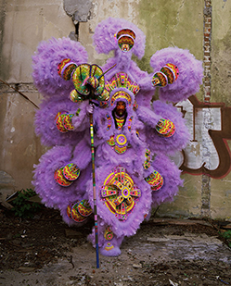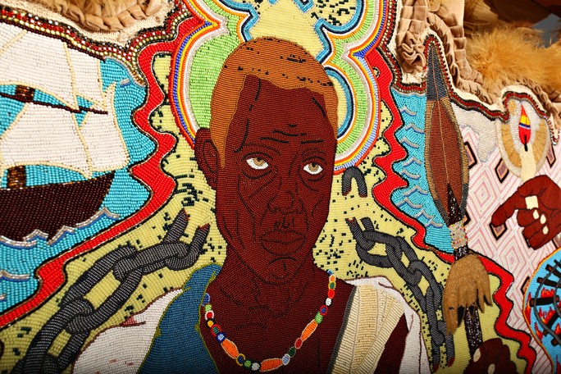

Photo caption 1: “Circle Dance – A Tribute to John Scott,” one of the suits by Darryl Montana in the exhibition Big Chief Wears a Golden Crown: Arts of the New Orleans Black Masking Indians
Photo credit 1: Eric Waters
Photo caption 2: A detail from “Bras‐Coupé (Tan Suit),” (2015) one of the suits in the exhibition Big Chief Wears a Golden Crown: Art of the New Orleans Black Masking Indian
Photos credit 2: Photo courtesy of artist Demond Melancon

What: A panel discussion on the exhibition Big Chief Wears a Golden Crown: Art of the New Orleans Black Masking Indians, ceremonial suits and aprons made by Chiefs of New Orleans Black Masking Indian Tribes that are a traditional aspect of Mardi Gras celebrations.
Who: Featuring Big Chief Demond Melancon of the Young Seminole Hunters and Big Chief Darryl Montana of the Yellow Pocahontas Hunters, creators of the work, and moderated by Princeton Associate Professor of History and African American Studies Joshua Guild. Organized by Princeton Professor of Visual Arts Jeff Whetstone. Presented by the Lewis Center for the Arts and cosponsored by the Princeton Environmental Institute
When: Panel discussion April 3 at 5:00 p.m. with pre-panel artist reception at 4:30 p.m.; exhibition runs March 25 through April 7, open daily 12 p.m. to 8 p.m.;
Where: Panel discussion in the Forum with exhibition in the CoLab, both at the Lewis Arts complex on the Princeton campus (122 Alexander St.)
Free and open to the public

(Princeton, NJ) The Lewis Center for the Arts’ Program in Visual Arts at Princeton University will present a panel discussion on April 3 at 5:00 p.m. in the Forum at the Lewis Arts complex featuring Big Chief Demond Melancon of the Young Seminole Hunters and Big Chief Darryl Montana of the Yellow Pocahontas Hunters. The discussion will focus on the tradition of creating the elaborate ceremonial suits and aprons on display in the exhibition Big Chief Wears a Golden Crown: Art of the New Orleans Black Masking Indians. The work in the exhibition, created by the two chiefs and other artists, are a traditional aspect of Mardi Gras celebrations. The panel, which is free and open to the public, will be moderated by Princeton Associate Professor of History and African American Studies Joshua Guild and preceded by an artist reception at 4:30 p.m.

The exhibition is on view March 25 through April 7 in the CoLab at the Lewis Arts complex on the Princeton campus and is open free to the public daily from 12 p.m. to 8 p.m. The panel and exhibition were organized by Professor of Visual Art Jeff Whetstone and cosponsored by the Princeton Environmental Institute.

The exhibition and panel discussion are connected to Whetstone’s spring course, “The Port of New Orleans: Culture and Climate Change.” The course acknowledges that New Orleans is decades ahead of any other U.S. city with respect to climate change. Its culture embodies exuberance and improvisation, and inspires confidence, openness, and collaboration. These qualities, married with scientific inquiry, are posed in the course as a possible strategy for the city’s survival. Visiting scholars and artists are examples of how cooperation between cultural and scientific communities can provide valuable, sustainable strategies. Montana and Melancon are two of those guests. The class will spend spring break in New Orleans visiting sites of artistic and scientific intervention, and students are creating models, media, and other creative works in response to research data.

Darryl Montana is the Big Chief of the Yellow Pocahontas Hunters Black Masking Indian Tribe. According to the chief, the New Orleans indigenous Black Indian movement of “masking Indian” on Carnival Day began in the late 1800’s in the Montana family. Hailing from a prominent family of Black masking Indians and son of the Chief of Chiefs Allison “Big Chief Tootie” Montana, he uses sequins, beads, pearls, marabou, feathers and stones to create multi-dimensional Mardi Gras costumes for each year’s carnival in New Orleans. The techniques and use of materials have been passed down to him from his father. He began learning how to string beads at age six and made his first suit when he was eleven using a used vinyl raincoat as his canvas. His suits can take up to 5,000 hours to complete and they are in response to themes like metamorphosis and evolution. He says that on Carnival day, “he is in full regalia representing a culture that unites the community around the tradition of masking and simply being the prettiest.” In addition to creating these massive pieces, Montana passes his techniques on to children and teaches them how to construct sculptural costumes. Montana’s work is in the public collections of the International Folk Art Museum and the Joan Mitchell Foundation and private collections of the late John Scott, Diego Cortez, Ron Bechet, and Mapo Kinnord-Payton, to name a few.

Demond Melancon is a multidisciplinary contemporary artist and performer with extensive roots in the Black Masking culture of New Orleans. With a career spanning almost three decades, Melancon is well-known for his meticulous hand-sewn beadwork used to create massive Mardi Gras Indian suits which are composed of intricately beaded patches depicting actual and imagined events from African and American history. His complex and multidimensional portrayals draw inspiration from indigenous people in America, enslaved Africans, and inspirational leaders from history. His work draws from a broad variety of stylistic influences, features imagery rich with symbolism and meaning, addresses stereotypical representations of black people, and tells powerful stories from his experience of the African diaspora. Melancon was born in 1978 and grew up in the Lower Ninth Ward of New Orleans. He was initially taught by a prolific Mardi Gras Indian elder named Big Chief Ferdinand Bigard. Melancon went on to study under Nathanial Williams in connection with a 1993 Louisiana Folklife Apprenticeship Grant. Melancon joined the Seminole Hunters and masked as a Spy Boy for over 15 years under Big Chief Keitoe Jones. In 2012 the elders of the Mardi Gras Indian community declared that Melancon would then be known as Big Chief Demond Melancon of the Young Seminole Hunters, his very own tribe based in the Lower Ninth Ward of New Orleans.

According to Whetstone, the unique tradition of elaborate suits and aprons visible in the exhibition shows the intersections between African and Indigenous cultural practices. “Each intricately crafted suit takes up 5,000 hours to complete,” he notes, “and represent some of the most exuberant costumes being made today.” African-Americans originated The Black Masking tradition almost two hundred years ago to pay homage to American Indians. Also referred to as Mardi Gras Indians, these groups, referred to as "tribes," organize by neighborhood and perform during Mardi Gras, St. Joseph's Day, and for important community celebrations. The costumes can weigh up to 150 pounds, are traditionally hand-sewn, and worn for only one year.

Guild specializes in 20th-century African American social and cultural history, urban history, and the making of the modern African diaspora, with particular interests in migration, black internationalism, black popular music, and the black radical tradition.

For more information on this event, the Program in Visual Arts, or any of the more than 100 performances, exhibitions, readings, screenings and lectures presented annually by the Lewis Center for the Arts, most of them free, visit arts.princeton.edu.

###

