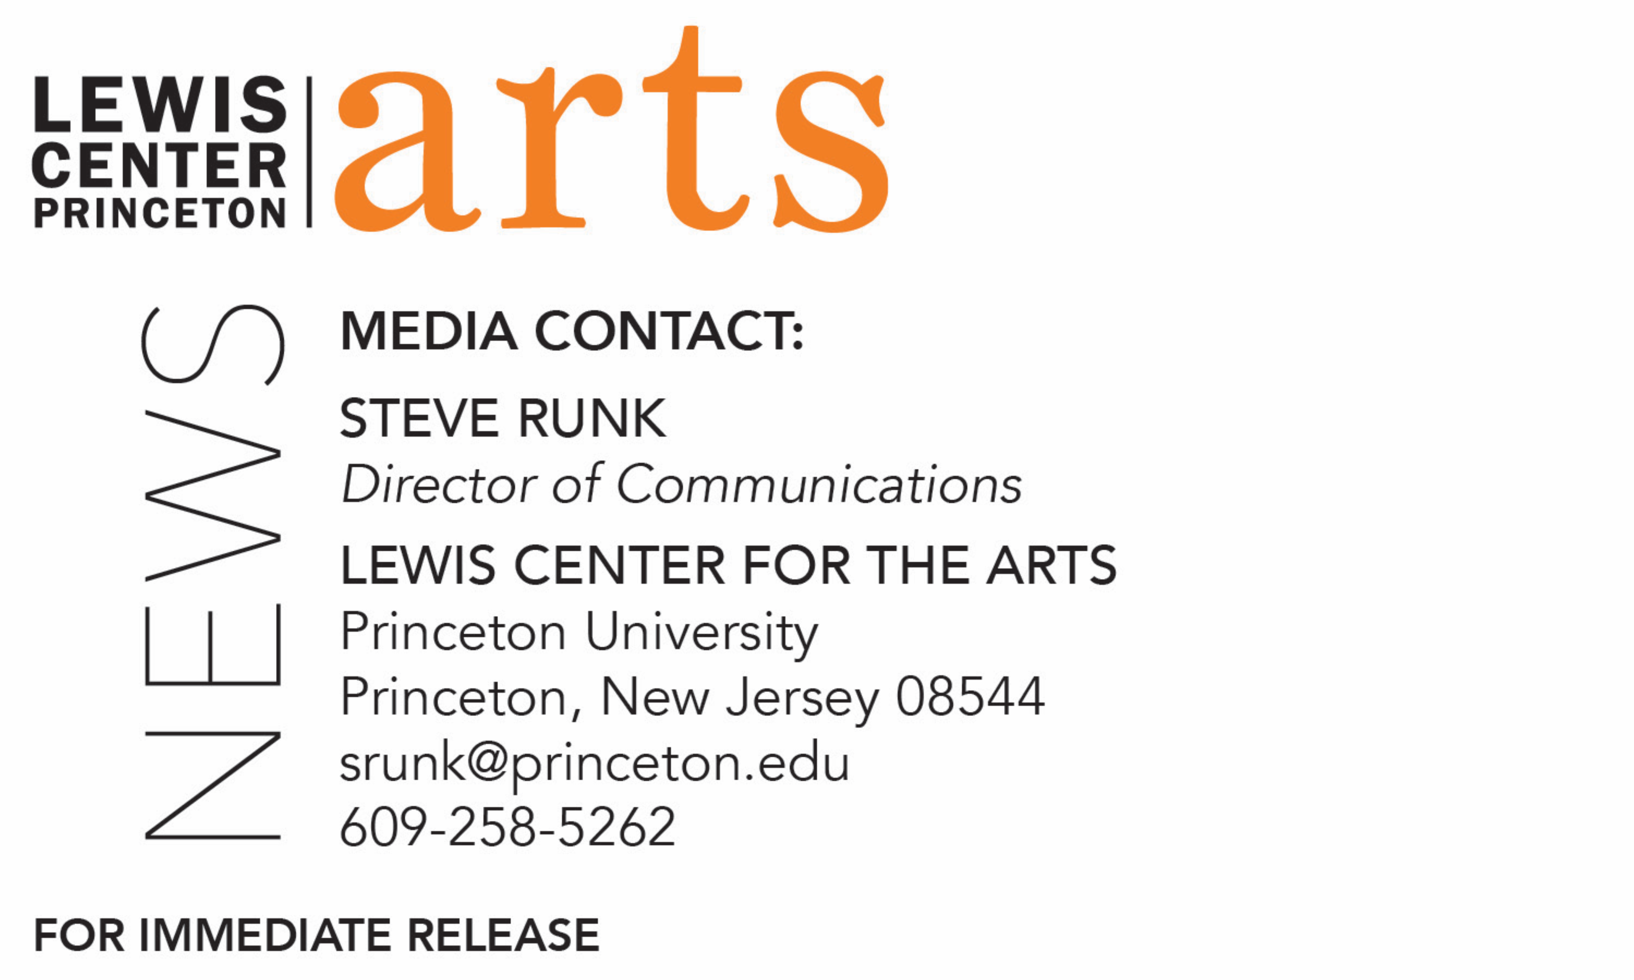

March 23, 2018

Lewis Center for the Arts’ Programs in Theater and Music Theater present
Turning Inward, a new song cycle written by Princeton senior Evan Gedrich and directed by alumnus Ryan Gedrich
A performance of new songs based in the folk traditions of America and the Old World.

What: Turning Inward, a new song cycle presented by the Lewis Center for the Arts’ Programs in Theater and Music Theater, is an intimate portrayal of the self as mediator between the world outside and the world within, through new songs based in the folk traditions of America and the Old World.
Who: Conceived and written by Princeton senior Evan Gedrich, directed by alumnus Ryan Gedrich, and performed by a cast of student actor-musicians.
When: March 29 at 7:30 p.m., March 30 at 7:30 and 9:30 p.m., and March 31 at 3 p.m. and 7:30 p.m.
Where: Wallace Theater at Lewis Arts complex on the Princeton University campus
Free and open to the public; no tickets required

(Princeton, NJ) The Lewis Center for the Arts’ Programs in Theater and Music Theater at Princeton University will present Turning Inward, a song cycle that is an intimate portrayal of the self as mediator between the world outside and the world within, through new songs based in the folk traditions of America and the Old World. Princeton senior Evan Gedrich conceived and wrote the music and lyrics for this song cycle, which will be directed by alumnus Ryan Gedrich, Princeton Class of 2016, and performed by a cast of student actor-musicians. All 12 songs focus on introspection and extroversion with each falling along the spectrum of these personalities. Performances will be held in the Wallace Theater at the Lewis Arts complex on Thursday, March 29 at 7:30 p.m.; Friday, March 30 at 7:30 and 9:30 p.m.; and Saturday, March 31 at 3:00 and 7:30 p.m.

Evan Gedrich is a neurosciences major pursuing certificates in theater, music theater, and cognitive sciences. He has been working on the songs for this production since his freshman year. He has appeared in Lewis Center productions of Once, Mad Forest, and Hairspray all during his junior year. He also performs with The Triangle Club, the Princeton University Rock Ensemble, and the Princeton University Players. Last year, he wrote the music for a new musical developed in English Professor Susan Wolfson’s course and based on an 1827 play that was inspired by Mary Shelley's novel Frankenstein. He is largely self-taught as a composer and has composed for a range of instruments.
For Turning Inward, the cast of eight will perform in the actor-musician style, both singing and playing instruments. Gedrich, who will also be one of the performers, was partly influenced to present this song cycle in the actor-musician style by a course he took with Broadway director John Doyle, who often works in this format.
The show is directed by Ryan Gedrich, Evan's brother and a Class of 2016 Princeton graduate with a certificate in theater. Though they had never worked together before, Evan knew from his experience working on other Princeton productions that he wanted a dedicated director for Turning Inward so he could focus on the new work’s development.
Ryan is currently working as Producing Fellow with the new play development group Clubbed Thumb in New York City, as well as doing freelance producing and dramaturgy for new plays and occasionally acting. Ryan's senior thesis was a performance in a play by Enda Walsh. He also appeared in Lewis Center productions of Chekhov's The Seagull, the Sondheim musical Sunday in the Park with George, the new play Eyes Up High in the Redwood Tree, and James Magruder’s Moliére adaptation Der Bourgeois Bigwig. He also performed with the student theater companies of Theatre Intime, Princeton University Players, and The Triangle Club, as well as with the student dance group BodyHype.
To learn more about this event, the Program in Theater, and the more than 100 other performances, exhibitions, readings, screenings, concerts, and lectures presented by the Lewis Center, most of them free, visit arts.princeton.edu.

###

