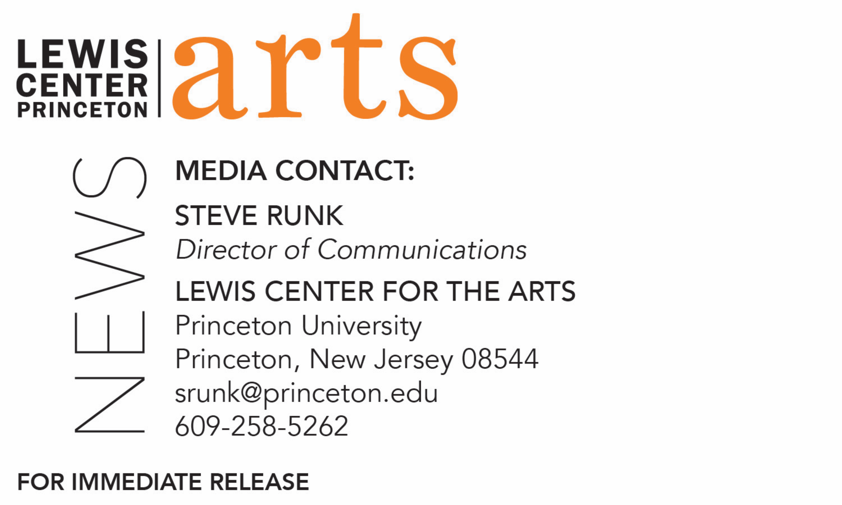

April 27, 2018

Lewis Center for the Arts awards over $115,000
for summer projects in the arts to 45 Princeton students

Photo caption 1: Princeton students (left to right) Anna Berghuis, Eli Berman, and Cooper Young are recipients of funding through the Lewis Center for the Arts’ Alex Adam ’07 Award or 2018.
Photo credits 1: (left to right) Allegra Dobson, Margaret Li, and Michelle Yeh

Photo caption 2: Princeton students (left to right) Mohammad Adnan and Amanda Morrison are recipients of funding through the Lewis Center for the Arts’ Mallach Senior Thesis Fund for 2018.
Photo credits 2: (left to right) Justin Goldberg

(Princeton, NJ) The Lewis Center for the Arts announces more than $115,000 in awards to support the summer projects and research of 45 Princeton undergraduates, chosen from 85 applicants. For many recipients, the funding provides the resources to conduct research, undertake training, and pursue other opportunities critical to achieving their senior thesis project goals in the arts.

Three students — Anna Berghuis, Eli Berman, and Cooper Young — have been selected for the Alex Adam ’07 Award. Established in memory of Alexander Jay Adam ’07 and made possible by a generous gift from his family, the award provides $7,500 in support to each of three Princeton undergraduates who will spend a summer pursuing a project that will result in the creation of new artistic work. While a student at Princeton, Alex Adam pursued artistic interests in creative writing and theater. Joyce Carol Oates, his creative writing professor, praised his work as “sharp-edged, unexpectedly corrosive and very funny.” He was also an actor, and performed with the Princeton Shakespeare Company, Theatre Intime, and the Program in Theater.

“The Alex Adam Award was created in loving memory of a wonderfully creative student,” says Michael Cadden, Chair of the Lewis Center. “Thanks to his family’s generosity, our young artists are able to pursue dream projects around the globe. Many past recipients have begun to build significant careers in the arts.”

This summer, junior Anna Berghuis, an art history and visual arts major, will follow the path of her paternal ancestors who were exiled from Germany to Holland during the Protestant Reformation. Berghuis will document her quest and the people she meets through digital photography. Last summer, Berghuis received Lewis Center funding to trace her maternal ancestral history through portrait photography in Eastern Europe and Russia, where her ancestors were persecuted for being Jewish. Through portraits of local people, Berghuis will create what she calls the second chapter of her quest to trace her lineage, culminating in the Netherlands, where the Berghuis family eventually settled. Berghuis’ project, through the mode of photography, oil painting, and drawing, confronts identity, family, religion, persecution and belonging.

Sophomore Eli Berman, an early concentrator in music, will delve into the art of genderqueer music as a non-binary transgender composer-vocalist this summer, working under the guidance of notable experimental musicians and professors in Los Angeles and Berkeley, California including Ken Ueno, Carmina Escobar, and Voice Science Works (Laurel Irene and David Harris). During the summer, Berman plans to craft a performance art piece that explores how personal, gendered experiences like sexual trauma/liberation and gender dysphoria can inform approaches to various vocal techniques, compositional structures, and music-making processes. This past year, Berman began investigating some of these relationships in original works like Fingering Myself, which was workshopped and performed by the Grammy Award-winning vocal octet Roomful of Teeth, and a recently commissioned piece, It Happened Again, which was recently premiered by the Eschaton Ensemble of Vanderbilt University. Currently, Berman is completing their first junior paper with a series of structured, improvisational modules that explore social identity and decision making in musical ensembles. Recently, Berman also sang at the Morgan Library and Museum in a concert of music by Eve Beglarian, Princeton Class of 1980, that was positively reviewed by The New York Times. This summer, Berman seeks to couple their recent development as both a composer and a vocalist by expanding their research on genderqueer identity in music composition to include explorations in vocal performance practice. Berman will also spend part of the summer at the Banff Centre for Arts and Creativity in Alberta, Canada, where they were accepted as a part of the (R)evolution: Resonant Bodies residency to study with prominent vocalists such as Tony Arnold, Pamela Z, Lucy Dhegrae, and Anthony Roth Costanzo, Princeton Class of 2004.

Cooper Young, a member of the class of 2020, will spend eight weeks in Japan, tracing a journey poet Matsuo Bashō’ took 330 years ago as he crafts his own poetic travel experience. Beginning in Tokyo, Young plans to visit every major city along Bashō’s route while immersing himself in local culture and gathering enough material for a book-length manuscript. His trip will culminate in Kyoto, where he plans to pay his respects at Bashō’s grave, assemble his writings, and connect with fellow poets in the area. Bashō is considered the greatest master of the poetic form known as haiku.

Juniors Mohammad Adnan and Amanda Morrison have been selected for funding through the Mallach Senior Thesis Fund. This award, established by Douglas J. Mallach ’91, supports the realization of one or two proposed senior thesis projects that incorporate historical research and create an alternative path to learning history.

Adnan is a history major pursuing certificates in South Asian studies and creative writing. He plans to explore transnational migration and what it means to leave--or return to--a home. Based upon his own family history, Adnan’s project begins in Paris, where he will interview Iranians who fled after the Islamic Revolution, and continues in Casablanca, Morocco, where he will investigate its history of Jewish migration. Finally, Adnan’s project comes to a close in Kampala, Uganda, where he will document and explore the memories of those who had known his ancestors before the expulsion of South Asians from the country in 1972. From these gathered stories he intends to create a “Directory of Exiles,” a user-contributed digital archive sustained by the narratives of those who have undergone exile.

For her senior thesis in film, Morrison — a junior in the Woodrow Wilson School pursuing certificates in East Asian studies and visual arts — plans to explore the Chinese feminist movement through a creative approach in documentary film. Inspired by a previous summer studying Mandarin in Beijing and her Woodrow Wilson School Task Force on human rights in China, Morrison’s film will focus on the “Feminist Five,” five Chinese women’s rights activists who were arrested the day before International Women’s Day in 2015 for protesting sexual harassment and gender discrimination. From New York City to London to Beijing, Morrison plans to gather interviews, archival information, and memories of the events in 2015. She will place them in relation to the history of women’s rights in China in order to shed light on the country’s role in the contemporary global feminist movement.

Juniors Kara Bressler and Jessica Zhou have received grants from the E. Ennalls Berl 1912 and Charles Waggaman Berl 1917 Senior Thesis Award in Visual Arts, which was established in 1999 by Marie Broadhead to provide support for research, travel or other expenses of current juniors undertaking senior thesis work in the Program in Visual Arts.

Juniors Lauren Auyeung, Michelle Yeh, and Julia Yu, along with first-year student Leah Linfield, have received funding through The Sam Hutton Fund for the Arts instituted by Thomas C. Hutton ’72 to support undergraduate summer study, travel and thesis research in the Lewis Center.

Juniors Caroline de Brito Gottlieb and Cody Kohn and sophomore Abigail Hack are recipients of the Lucas Summer Fellowship, which is presented annually to one or more visual arts concentrators for summer thesis work in any media.

Junior Elena Anamos and sophomores Abigail Kostolansky and Rosamond van Wingerden have received support from the Mellor Fund for Undergraduate Research, which underwrites course, travel, and/or research costs related to studies in the creative and performing arts.

Juniors Kyra Gregory and Susan Liu have been awarded grants from the Mary Quaintance ’84 Fund for the Creative Arts established in her memory to foster talents similar to those Quaintance developed in writing, film studies, and literature in the creative arts programs at Princeton.

Junior Katie Duggan received a travel stipend from the Timothy K. Vasen Award for Summer Research, established in memory of Vasen, who directed plays and taught classes in the Program in Theater from 1993 through 2015 and served as the Program’s Director from 2012 until his untimely death in 2015. This fund supports summer travel for students who are pursuing creative projects at the Lewis Center.

Sophomore Diana Chen and juniors Hudson Cooke and Yuanyuan Zhao are beneficiaries of the Lawrence P. Wolfen ’87 Senior Thesis Award established for travel or research costs, materials, equipment or other expenses of current juniors for thesis work in the creative arts, especially the visual arts or graphic arts.

Junior John Gibson received support through the Carpenter Family Fund for Comparative Literature and the Creative Arts, established by Katherine R.R. Carpenter ’79 for collaborative projects between the Lewis Center and Department of Comparative Literature.

In addition, 20 other students have received support through the Peter B. Lewis Summer Fund, with grants ranging from $355 to $5,000.

This year’s Lewis Center summer funding also benefited from a grant from the Rita Allen Foundation, a Princeton-based foundation supporting discoveries in their earliest stages that will ultimately improve human health, democracy and understanding across the country.

To learn more about the Lewis Center for the Arts, the funding available to Princeton students , and the more than 100 other performances, exhibitions, readings, screenings, concerts, and lectures presented by the Lewis Center, most of them free, visit arts.princeton.edu.

###

