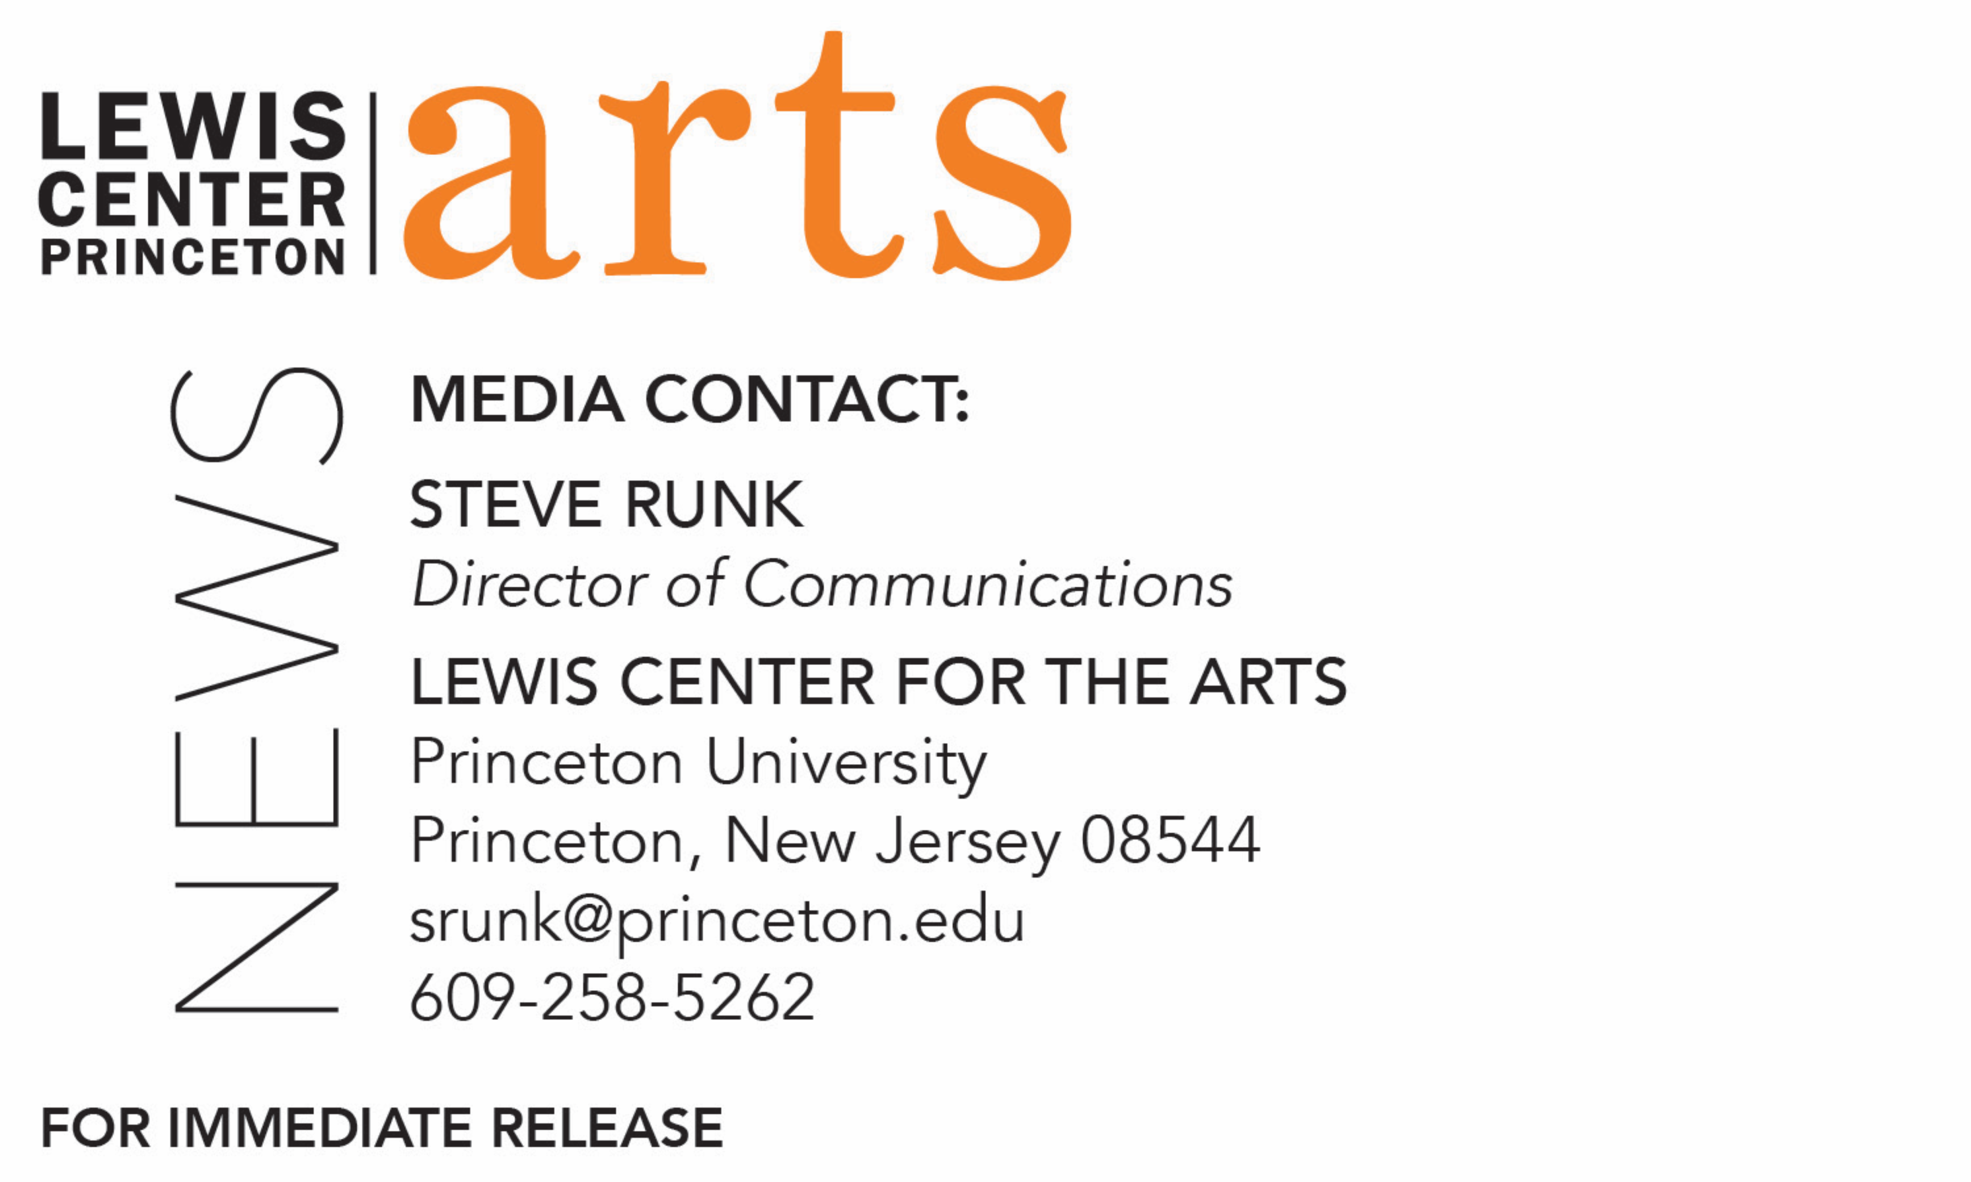

April 20, 2018

Award-winning Writer and Princeton Alumna Jenny Xie Reads with
Six Seniors in Princeton’s Creative Writing Program on April 27
The C.K. Williams Reading Series is organized by Princeton students in collaboration with Labyrinth Books

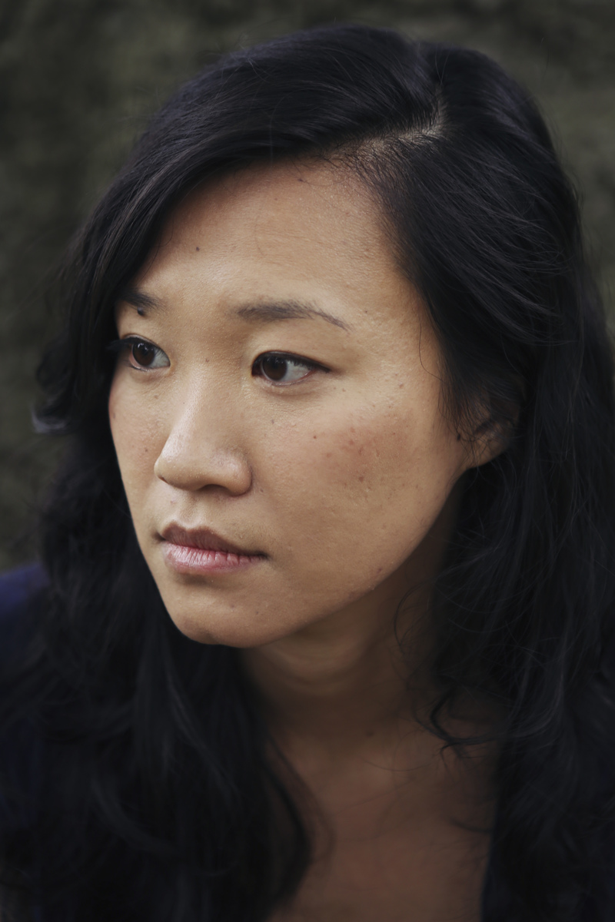
Photo caption: Award-winning writer and Princeton alumna Jenny Xie
Photo credit: Teresa Mathew

What/Who: Reading by award-winning writer and Princeton alumna Jenny Xie and six seniors in Princeton's Program in Creative Writing, part of the C.K. Williams Reading Series
When: Friday, April 27 at 6:00 p.m.
Where: Labyrinth Books, 122 Nassau St., Princeton
Free and open to the public

(Princeton, N.J.) Award-winning writer and Princeton alumna Jenny Xie and six seniors in the Lewis Center for the Arts’ Program in Creative Writing at Princeton University will read from their work at 6:00 p.m. on Friday, April 27 at Labyrinth Books, 122 Nassau Street. The reading is part of the C.K. Williams Reading Series, named in honor of the Pulitzer Prize and National Book Award-winning poet who served on Princeton’s creative writing faculty for 20 years.

The series showcases senior thesis students of Princeton’s Program in Creative Writing alongside established writers as special guests. Featuring student writers Mim Ra Aslaoui, Nicolas Freeman, Isabella Grabski Alicia Lai, Lavinia Liang, and Rosed Serrano, the event is free and open to the public.

Jenny Xie is the author of Eye Level (Graywolf Press, 2018), recipient of the Walt Whitman Award of the Academy of American Poets, and Nowhere to Arrive (Northwestern University Press, 2017), recipient of the Drinking Gourd Prize. She holds a B.A. from Princeton University, Class of 2008, and an M.F.A. from New York University's Creative Writing Program, and she has received fellowships and support from Kundiman, the Fine Arts Work Center in Provincetown, the Elizabeth George Foundation, and Poets & Writers. She teaches at New York University.

The five seniors, who are pursuing a certificate in creative writing in addition to their major areas of study, will read from their senior thesis projects. Each is currently working on a novel, a screenplay, translations, or a collection of poems or short stories as a part of a creative thesis for the certificate. Thesis students in the Program in Creative Writing work closely with a member of the faculty, which includes Jeffrey Eugenides, Jhumpa Lahiri, Yiyun Li, Paul Muldoon, Kirstin Valdez Quade, James Richardson, Tracy K. Smith, Susan Wheeler, and a number of distinguished lecturers.

To learn more about this reading series, the Program in Creative Writing, and the more than 100 public performances, exhibitions, readings, screenings, concerts and lectures presented each year by the Lewis Center for the Arts, most of them free, visit arts.princeton.edu.

###

