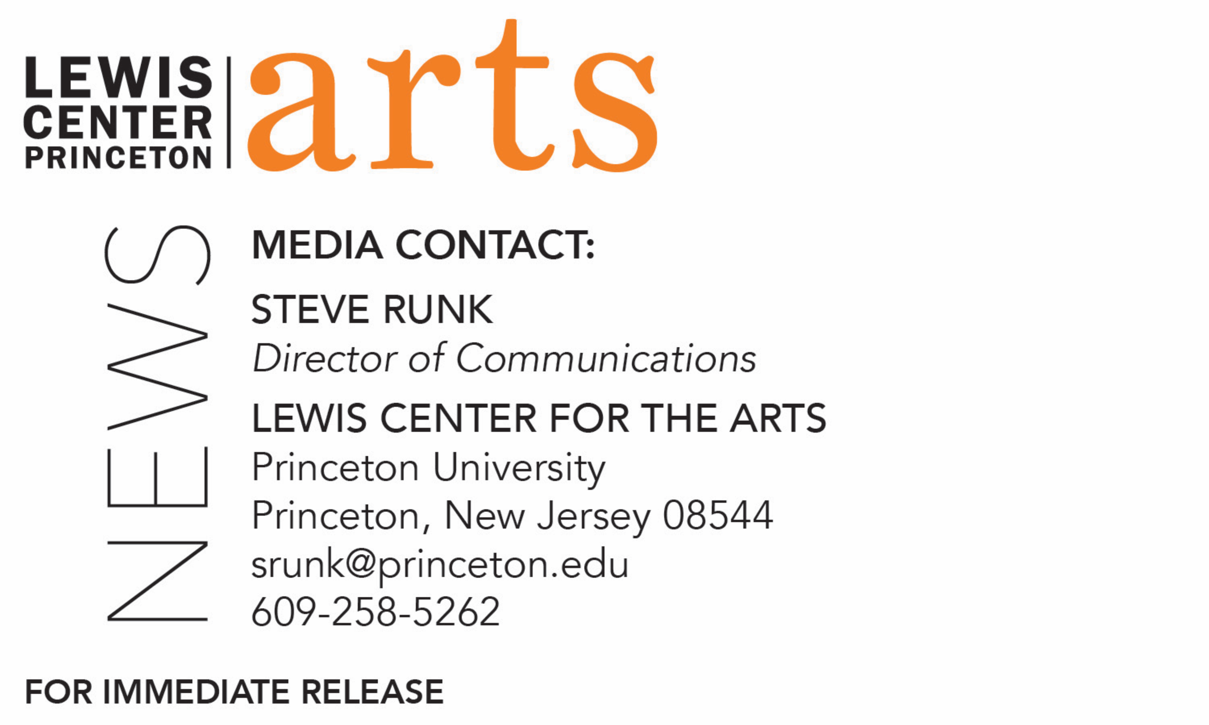

April 13, 2018

Lewis Center for the Arts’ Program in Creative Writing presents
A Reading with Jane Hirshfield and Walter Mosley
Award-winning writers next in Althea Ward Clark W’21 Reading Series at Princeton

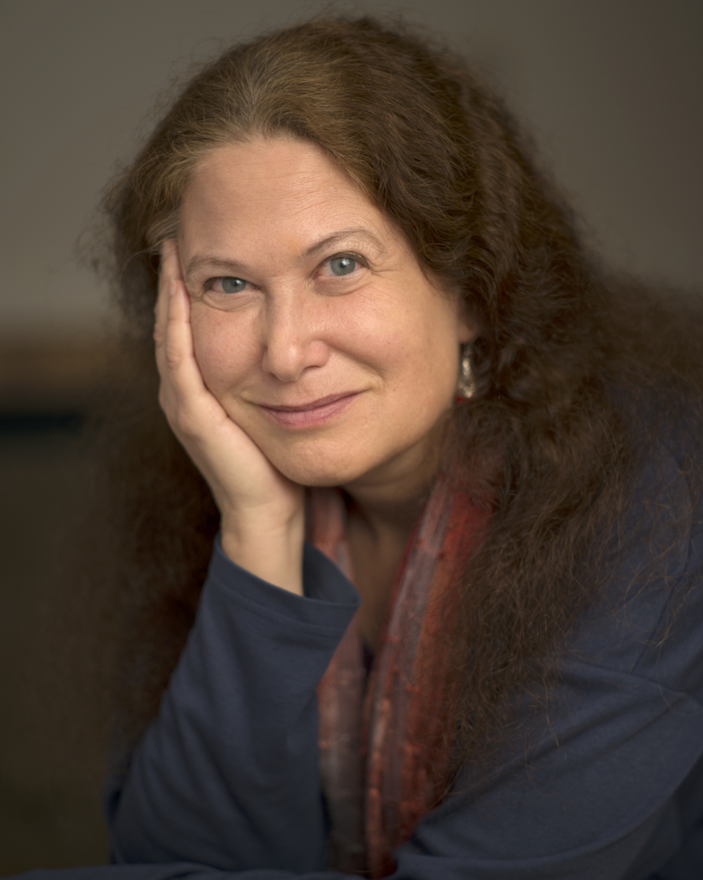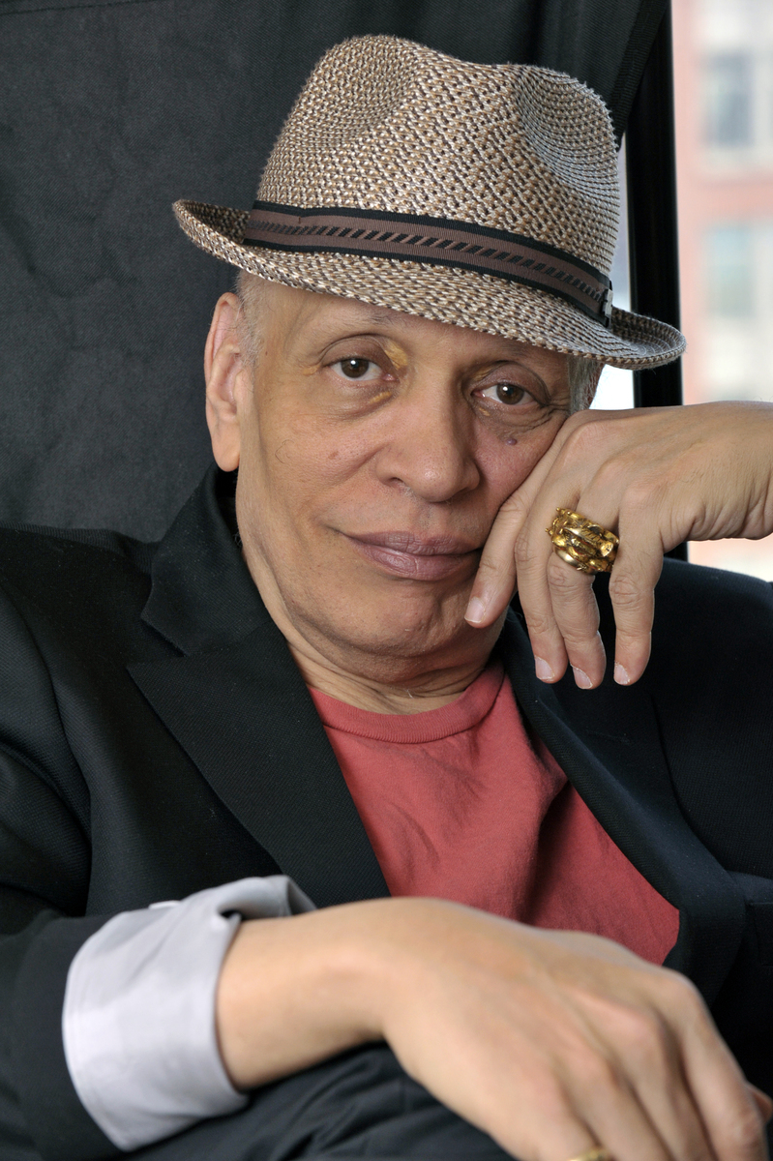

Photo caption 1: Acclaimed poet Jane Hirshfield
Photo credit 1: Curt Richter
Photo caption 2: Award-winning novelist Walter Mosley
Photo credit 2: Marcia Wilson, Wide Vision Photography

Who/What: Reading by acclaimed poet and Princeton alumnus Jane Hirshfield and award-winning novelist Walter Mosley, part of the 2017-18 Althea Ward Clark W’21 Reading Series
When: Wednesday, April 18, at 4:30 p.m.
Where: Wallace Theater at Lewis Arts complex on the Princeton University campus
Free and open to the public
***NOTE different time and location than previous readings in this series***

(Princeton, N.J.) On Wednesday, April 18, critically acclaimed poet and Princeton alumnus Jane Hirshfield will read with award-winning novelist and activist Walter Mosley as part of the Althea Ward Clark W’21 Reading Series of the Program in Creative Writing at the Lewis Center for the Arts at Princeton University. The reading, beginning at 4:30 p.m. in the Wallace Theater at the Lewis Arts complex, is free and open to the public.

Jane Hirshfield’s poetry speaks to the central issues of human existence—desire and loss, impermanence and beauty, the many dimensions of individuals’ connections with others and the the wider world. Described by The New York Times as “radiant and passionate” and by other reviewers as “ethically aware,” “insightful and eloquent,” and as conveying “succinct wisdom,” her subjects range from the metaphysical and passionate to the political, ecological, and scientific to subtle unfoldings of daily life and experience. Hirshfield is the author of eight collections of poetry, including, most recently, The Beauty, which was longlisted for the National Book Award; After, which was shortlisted for England’s T.S. Eliot Prize and named a “best book of 2006” by the Washington Post, the San Francisco Chronicle, and the London Financial Times; and Given Sugar, Given Salt, a finalist for the 2001 National Book Critics Circle Award. She has also edited and co-translated four books containing the work of poets from the past, The Heart of Haiku, on Matsuo Basho, named an Amazon Best Book of 2011. Hirshfield’s work has appeared in The New Yorker, The Atlantic, The Times Literary Supplement, Harper’s, The Nation, Orion, The American Poetry Review, Poetry, eight editions of The Best American Poetry, five Pushcart Prize Anthologies, and many other publications. Her work frequently appears on Garrison Keillor’s “Writers Almanac” program, and she has been featured in two Bill Moyers PBS television specials. In fall 2004, Jane Hirshfield was awarded the 70th Academy Fellowship for distinguished poetic achievement by The Academy of American Poets, an honor formerly held by such poets as Robert Frost, Ezra Pound, William Carlos Williams, and Elizabeth Bishop. In 2012, she was elected a Chancellor of the Academy of American Poets. She is a member of Princeton’s Class of 1973.
Hirshfield will be introduced by James Richardson, an award-winning writer, Princeton Class of 1971, and Professor of Creative Writing at Princeton.

Novelist and social commentator Walter Mosley is noted as among the most powerful and prolific writers working in any genre today. He is the author of more than 40 books, ranging from the crime novel to literary fiction, nonfiction, political essay, young adult, and science fiction. The New York Review of Books called him "a literary master as well as a master of mystery," and The Boston Globe declared him “one of the nation's finest writers." Mosley’s fiction tracks the African American experience from the migration from the Deep South to post-Obama election-era New York City. His characters are the sorts of "fully formed, complex black men who have been absent from much of contemporary literature,” he says. Several of Mosley's books have been adapted for film and television, with new projects in development at FX, Cinemax, and HBO. To adapt his works for television and feature films, Mosley teamed up with producer Diane Houslin to create his own production house, Best of Brooklyn Filmhouse. With over a dozen entries, his Easy Rawlins detective series began with Devil in a Blue Dress, which was made into a feature film starring Denzel Washington. His latest Rawlins mystery, Charcoal Joe, was released in June 2016. Mosley’s nonfiction, such as Folding the Red into the Black; Twelve Steps Toward Political Revelation and Life Out of Context, examines contributions to economic inequality, politics, and justice in America. An editorial board member of The Nation, he conceived “Ten Things,” a monthly feature connecting readers to opportunities for advocacy and activism. The first African-American to serve on the board of directors of the National Book Awards, Mosley has received an O’Henry Award, The Sundance Risktaker Award, a Grammy, and two NAACP Image Awards for Outstanding Literary Work. In 2016, he received the Lifetime Achievement Award at the Annual Edgar Awards and was named the first African-American “Grand Master” by the Mystery Writers of America.

Kirstin Valdez Quade, an award-winning writer and Assistant Professor of Creative Writing at Princeton, will introduce Mosley.

The Lewis Center’s Program in Creative Writing annually presents the Althea Ward Clark W’21 Reading Series, which provides an opportunity for students, as well as all in the greater Princeton region, to hear and meet the best contemporary writers. All readings are free and open to the public. This year’s series will conclude in May with readings of new work by students in the Program.

To learn more about this reading series, the Program in Creative Writing, and the more than 100 public performances, exhibitions, readings, screenings, concerts and lectures presented each year by the Lewis Center for the Arts, most of them free, visit arts.princeton.edu.

###

