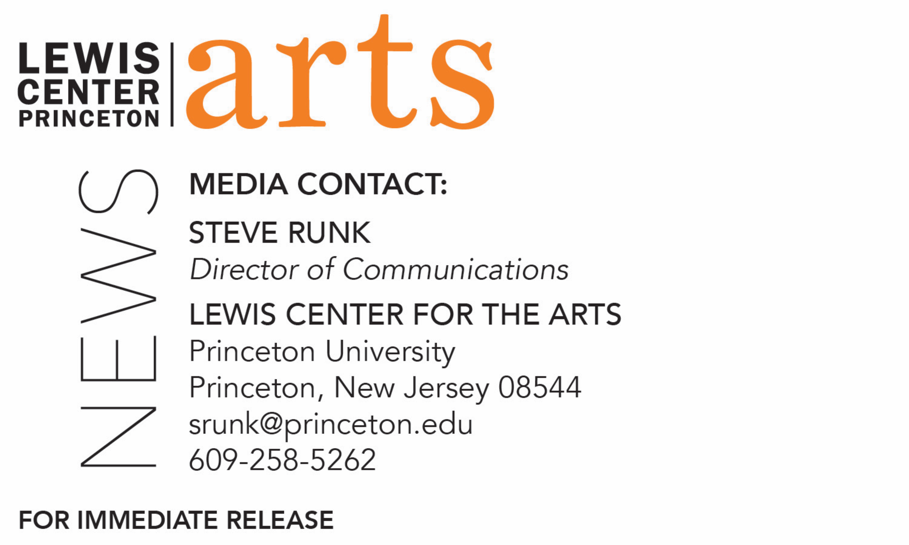

April 18, 2018

A Conversation with Actor Mark Feuerstein
Princeton alumnus and critically acclaimed actor (9JKL, Royal Pains, West Wing) discusses his life and career on stage and screen with
Lewis Center for the Arts Chair Michael Cadden

Photo caption: Actor Mark Feuerstein
Photo credit: Courtesy of Mark Feuerstein

Who: Critically acclaimed actor and Princeton alumnus Mark Feuerstein, Class of 1993
What: A conversation on his life and career on stage and screen with Lewis Center for the Arts Chair Michael Cadden
When: Monday, April 23 at 7:00-9:00 p.m. with pre-event reception at 6:45 p.m.
Where: Wallace Theater at the Lewis Arts complex on the Princeton University campus
Presented by the Center for Jewish Life-Princeton Hillel and the Lewis Center for the Arts
Free and open to the public with advance reservation encouraged at http://feuerstein.eventbrite.com/

(PRINCETON, NJ) Critically acclaimed actor, producer, and Princeton University alumnus Mark Feuerstein, Class of 1993, will speak about his life and career on stage and screen in a conversation with Lewis Center for the Arts Chair Michael Cadden. The conversation will take place on Monday, April 23 from 7:00 p.m. to 9:00 p.m. in the Wallace Theater in the Lewis Arts complex on the Princeton University campus. The event, which is free and open to the public, is cosponsored by Princeton’s Center for Jewish Life-Princeton Hillel and will be preceded by a reception at 6:45 p.m.

Over the past 15 years, Feuerstein has received critical acclaim for his roles in feature film, television and theater, but he is best known for his lead role as Dr. Hank Lawson in the series Royal Pains. Inspired by his real-life experience, he wrote and created 9JKL, a new CBS family comedy, with his wife, executive producer Dana Klein. Most recently, he appeared on Prison Break as arch-villain Jacob Ness. Additional television credits include The West Wing, Sex and the City, Once and Again, Fired Up! and Good, Morning, Miami. This past summer, Feuerstein was also recently seen in Wet Hot American Summer: 10 Years Later. His feature film credits include Defiance, In Her Shoes, Abandon, What Women Want, The Muse, Rules of Engagement, Woman on Top and Practical Magic. Additionally, he played the lead in the independent feature Larry Gaye: Renegade Male Flight Attendant, which he also produced.

Feuerstein made his Broadway debut starring in Alfred Uhry’s Tony Award-winning play The Last Night of Ballyhoo. He was on stage at the Geffen Theatre in Some Girls, written and directed by Neil LaBute. Also, he played to sold out audiences and garnered strong reviews for his performance in Roger Kumble’s dark comedy Turnaround. Additional theater credits include Awake & Sing, Dark Rapture, The Misanthrope, Macbeth, and Three Sisters.

Feuerstein grew up in New York City. He attended The Dalton School from 6th through 12th grade where he was captain of the football and wrestling teams and senior class president. While at Princeton University, he started acting in plays such as Orphans, Henry IV, Twelfth Night, Kiss of the Spider Woman, King Lear, and A Streetcar Named Desire. In 1994, he received a Fulbright scholarship to study acting at the London Academy of Music and Dramatic Art. While in London, he also studied Clowning at the Ecole Philippe Gaulier.

While at Princeton, Feuerstein will teach “Complicité: A Workshop for Actors” for Princeton students focusing around physical comedy. The workshop will include memory and dream work exercises designed to help actors access parts of their unconscious, and scene work from a selection of plays. Feuerstein will also hold a breakfast discussion for students at the Center for Jewish Life.

Reservations for the conversation can be made at https://feuerstein.eventbrite.com/

For more information on this event, the Program in Theater, and the more than 100 performances, exhibitions, readings, screenings, concerts and lectures offered each year by the Lewis Center for the Arts, most of them free, visit arts.princeton.edu.

###

