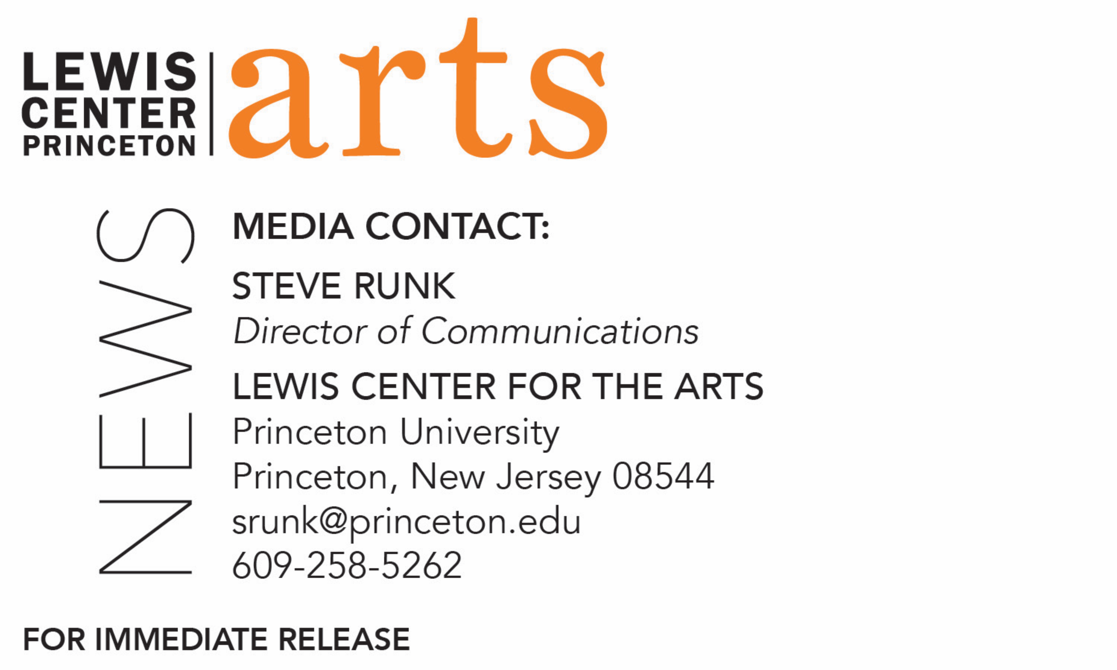

April 20, 2018

Fund for Irish Studies at Princeton University presents
“John Redmond and Edward Carson: Bloodshed, Borders
and the Union State”
A lecture by Alvin Jackson, the Sir Richard Lodge Professor of History at the
University of Edinburgh

Photo caption: Alvin Jackson, the Sir Richard Lodge Professor of History at the University of Edinburgh
Photo credit: Johnny Bambury

What: “John Redmond and Edward Carson: Bloodshed, Borders and the Union State,” a lecture presented by Princeton’s Fund for Irish Studies on two of the biggest names in modern Irish history, John Redmond and Edward Carson, who at the peak of their careers as senior members of the British parliament, were locked together in combat over Home Rule, a conflict that led to an outcome that neither of them wanted: the partition of Ireland and the creation of a border that, with Brexit, again poses apparently insoluble problems.
Who: Professor Alvin Jackson, the Sir Richard Lodge Professor of History at the University of Edinburgh
When: Friday, April 27 at 4:30 p.m.
Where: East Pyne Room 010 on the Princeton University campus
Free and open to the public

(Princeton, NJ) Acclaimed Irish historian and scholar Alvin Jackson will conclude the spring 2018 Fund for Irish Studies lecture series by giving a lecture, entitled “John Redmond and Edward Carson: Bloodshed, Borders and the Union State,” on Friday, April 27 at 4:30 p.m. in East Pyne Room 010 on the Princeton University campus. The lecture is free and open to the public.

John Redmond and Edward Carson are two of the biggest names in modern Irish history. At the peak of their careers as senior members of the British parliament, they were locked together in combat over the issue of Home Rule. That conflict led to an outcome that neither of them wanted: the partition of Ireland and the creation of a border that, with Brexit, again poses apparently insoluble problems. Jackson’s book, Judging Redmond and Carson, was recently published by the Royal Irish Academy.

Jackson is the Sir Richard Lodge Professor of History at the University of Edinburgh. He studied Modern History at Corpus Christi College and Nuffield College, Oxford, and completed a D.Phil. in 1986. Previously, Jackson was a British Academy Post-Doctoral Fellow; Lecturer in Modern History at University College Dublin; Professor of Modern Irish History at Queen’s University Belfast; and the John Burns Visiting Professor at Boston College, Massachusetts. At the University of Edinburgh, Jackson has served as Head of the School of History, Classics and Archaeology and recently as Dean of Research and Deputy Head of the College of Humanities and Social Science. Jackson’s research has been supported by three major national awards – a British Academy Research Readership in the Humanities (2000), a British Academy-Leverhulme Senior Research Fellowship (2009), and a Leverhulme Major Research Fellowship (2014). He is an Honorary Member of the Royal Irish Academy and a Member of the Academia Europaea.

The Fund for Irish Studies, chaired by Princeton professor Clair Wills, affords all Princeton students, and the community at large, a wider and deeper sense of the languages, literatures, drama, visual arts, history, politics, and economics not only of Ireland but of “Ireland in the world.” The series is co-produced by the Lewis Center for the Arts. The spring 2018 edition of the series is organized by Fintan O’Toole as acting chair of the Fund for Irish Studies.

The Fund for Irish Studies is generously sponsored by the Durkin Family Trust and the James J. Kerrigan, Jr. ’45 and Margaret M. Kerrigan Fund for Irish Studies.

To learn more about the more than 100 public performances, exhibitions, readings, screenings, concerts, lectures and special events, presented each year by the Lewis Center for the Arts, most of them free, visit arts.princeton.edu.

###

