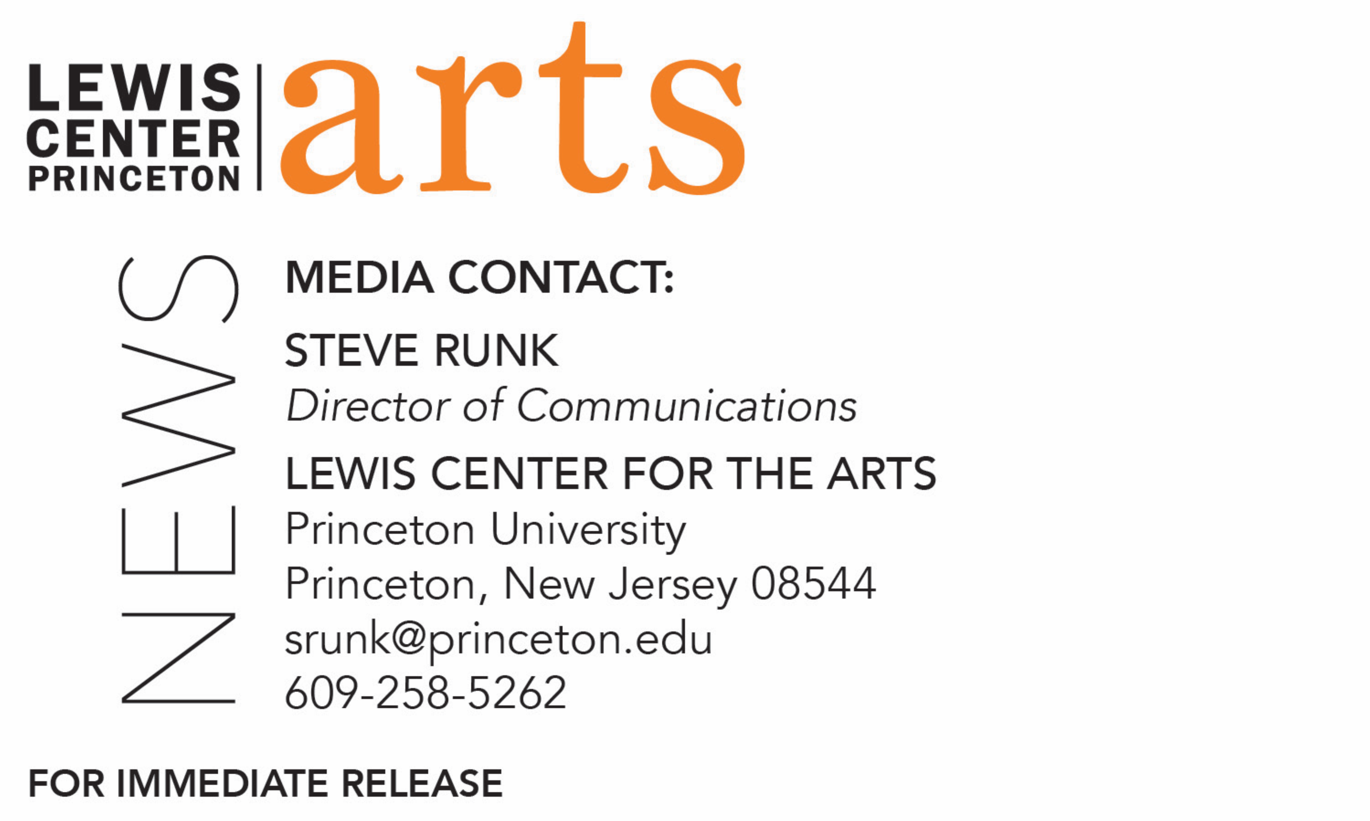

April 12, 2018

Lewis Center for the Arts at Princeton University hosts
María Irene Fornés Institute Symposium in collaboration with
Latinx Theatre Commons
A full day dedicated to one of the most influential yet perhaps least widely known American theater-makers of the 20th century

Photo caption: María Irene Fornés
Photo credit: James M. Kent

What/Who: Latinx Theatre Commons’ María Irene Fornés Institute Symposium hosted by Princeton University’s Lewis Center for the Arts, an intergenerational “community gathering” of artists, academics, students, and others for a day of vigorous, Fornés-inspired creativity, conversation, and conviviality focused on one of the most influential yet perhaps least widely known American theater-makers of the 20th century.
When: April 14 from 9 a.m. through evening performances and events
Where: Lewis Arts complex on the Princeton University campus
Most activities free and open to the public with some sessions requiring registration – for details visit arts.princeton.edu/fornes.

(Princeton, NJ) The Lewis Center for the Arts’ Program in Theater at Princeton University will host the Latinx Theatre Commons’ María Irene Fornés Institute Symposium on April 14 from 9:00 a.m. through the evening at the Lewis Arts complex on the Princeton campus. The symposium is an intergenerational “community gathering” of artists, academics, students, and others for a day of vigorous, Fornés-inspired creativity, conversation, and conviviality focused on one of the most influential yet perhaps least widely known playwrights. Most of the day’s activities are free and open to the public with a few sessions requiring registration. The events on April 14 are part of a larger scope of activities in Princeton and New York City April 12 through 22 related to the playwright, who is a nine-time Obie award winner, finalist for the Pulitzer Prize, and teacher to some of theater’s most exciting contemporary voices, including Migdalia Cruz, Paula Vogel and Nilo Cruz.

Fornés, born in Havana, Cuba in 1930, is regarded as among the most influential American theater-makers of the 20th century. A defining force within the off-off-Broadway movement of the 1960s and 1970s, Fornés -- as playwright, director, designer and teacher -- became a guiding presence for emerging theater artists of the 1980s and 1990s, especially those invested in staging feminist, queer and latinx aesthetics and experiences. Fornés’ experiments in theatrical form and her transformative teaching techniques continue to challenge and inspire new generations of theater-makers today. Even so, the living legacy of Fornés remains remarkably under-acknowledged among contemporary theater artists, students and scholars. Currently 87 years old, Fornés resides on the Upper West Side of Manhattan. Due to late stage Alzheimer’s disease, she is no longer writing or teaching.

The Latinx Theatre Commons’ María Irene Fornés Institute Symposium is being hosted at Princeton by Assistant Professor of Theater Brian Herrera and is designed to activate broader awareness about Fornés’s multifaceted legacy.

The convening of the Latinx Theater Commons on April 14 at the Lewis Arts complex will begin at 9:00 a.m. with a buffet breakfast with the day officially kicking off at 10 a.m. with an opening ceremony featuring welcoming remarks by the organizers and brief performances by Princeton student cast members of the Program in Theater production of I Am in Fifth Grade, You Are in Kindergarten and INTAR Theatre’s Unit 52. The first interlude (or breakout) sessions begin at 11:15 a.m. and will feature a mix of hosted conversations, creative workshops and performances, including a presentation by actors from the legendary Actors Studio under direction of Academy Award Winner Estelle Parsons. Interlude sessions are open to pre-registrants with any remaining seats available free to the general public; non-registrants can sign up for seats in interlude sessions starting at 9 a.m. in the Forum on a first-come, first-reserved basis. Throughout the day, the “Living Legacy Exhibit” will invite participants to share their experiences and impressions of Fornés’s life, work and legacy in an interactive archival exhibit. At 1:00 p.m. a book exhibition will open organized by Labyrinth Books of Princeton. The second round of interlude sessions -- again featuring a mix of performances, workshops and hosted conversations -- begins at 2:00 p.m. (also requiring registration) along with a screening of the new documentary film on Fornés, The Rest I Make Up. Directed by Michelle Memran, who will be in attendance. At 4:00 p.m. the second plenary session will feature participant reflections on the day’s proceedings and will conclude with the performance of a new poem by playwright and Fornés friend/student Migdalia Cruz. Options for the evening, all scheduled for 8:00 p.m., include I Am in Fifth Grade, You Are in Kindergarten, an evening of two one-act plays with music celebrating the work of Fornés at the Berlind Theatre at McCarter Theatre Center with the audience seated on stage (open to the public, ticketed); a site-specific performance of Fornés’ landmark play, Fefu and Her Friends, at the historic Maclean House on the Princeton campus (free but ticketed with limited seating); and a second screening of The Rest I Make Up (free and open to the public) in the Wallace Theater at the Lewis Arts complex.

I Am in Fifth Grade, You Are in Kindergarten features FNU LNU by Mac Wellman, a fellow avant garde playwright of Fornés, and the world premiere of The Book of Miaou-Wow-Wow: Don’t Drink Everything Your Mother Pours You by Migdalia Cruz. Cruz’s new play was commissioned through the Lewis Center for the Arts’ Roger S. Berlind Playwright in Residence program. Both plays are directed by faculty member Elena Araoz and include original music by Vince di Mura, the Lewis Center’s resident music director and composer, who serves as music director for both plays. Performances will also be presented on April 13, 19, 20, and 21 at 8:00 p.m. The title of the evening of one-act plays, I Am in Fifth Grade, You Are in Kindergarten, is a quote by Fornés made to a student in one of her playwriting classes, indicating the student may be at the beginning of their journey as a playwright akin to being in kindergarten, and while Fornés as the teacher may be ahead of them, she is still learning herself.

Other events surrounding the María Irene Fornés Institute Symposium, in addition to the activities on April 14, include Princeton’s Department of African American Studies Annual James Baldwin Lecture on “The Dramatist’s Call to Action: Realizing the Provocative Prescience of James Baldwin and María Irene Fornés” by Herrera on April 12 at 4:30 p.m. at 101 McCormick Hall, free and open to the public, and on April 15 New York University’s Tisch School of the Arts will present a colloquium on Fornés, which will feature a panel of experts on the playwright, a roundtable of women directors discussing the influence of Fornés’ directorial work, and a concert reading of her musical Promenade.

The Latinx Theater Commons María Irene Fornés Institute Symposium is presented by Princeton University’s Lewis Center for the Arts in partnership with the Latinx Theater Commons and is made possible with support from the Stephen Trask Lecture Series Fund, the Vice President for Campus Life, the Humanities Council, Center for Collaborative History, Department of English, and the Programs in American Studies, Latino Studies, Gender and Sexuality Studies, and Latin American Studies.

To learn more about this event, the Programs in Theater, and the over 100 performances, exhibitions, readings, screenings, concerts, and lectures presented each year at the Lewis Center, most of them free, visit arts.princeton.edu.

###

