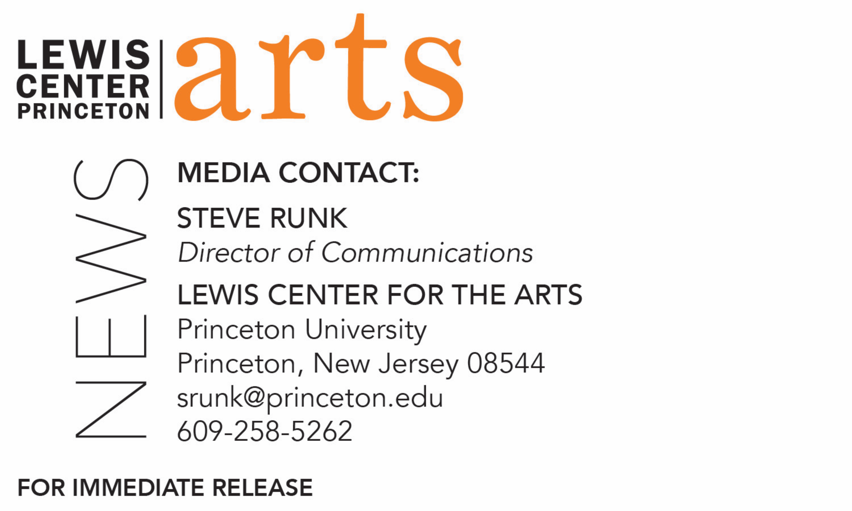

April 27, 2018

Lewis Center for the Arts presents performance of original songs by students in the spring course, “How to Write a Song” led by poet Paul Muldoon and composer Steve Mackey

Photo caption: Students perform an original song created in the course “How to Write a Song”
Photo credit: Courtesy of Lewis Center for the Arts

What: Students perform a concert of original songs with music and lyrics written over the past semester as part of the course “How to Write a Song” co-taught by Pulitzer Prize-winning poet Paul Muldoon and Grammy Award-winning composer Steve Mackey.
Who: Presented by Lewis Center for the Arts’ Program in Creative Writing
When: Tuesday, May 1 at 4:30 p.m.
Where: Frist Film/Performance Theatre at Frist Campus Center on the Princeton University Campus
Free and open to the public

(Princeton, NJ) Students in Princeton University’s spring course “How to Write a Song,” offered by the Lewis Center for the Arts’ Program in Creative Writing and the Department of Music, will present original songs at a concert on May 1 at 4:30 p.m. at the Frist Film/Performance Theatre at the Frist Campus Center on the Princeton campus. The students will perform selected new work completed over the past semester. The concert is free and open to the public.

Co-taught by Pulitzer Prize-winning poet Paul Muldoon and Grammy Award-winning composer Steve Mackey, this enormously popular course required students to write new songs throughout the semester inspired by a broad range of varying emotions. Each week the students, all with varying levels of literary and musical backgrounds, split into different groupings of two to three participants and wrote lyrics and composed tunes on an assigned emotional topic, such as, joy, despair, defiance, or desire. At each class, the students performed their pieces for Muldoon, Mackey, and their classmates, who then provided critiques.

“It’s been a delight spending the past semester with these students,” notes Muldoon. “They have demonstrated amazing creativity and dedication in bringing new work to class each week, and have offered incredibly insightful comments on one another’s work. At some level, Steve and I could step away and this group of artists could continue making exciting new work.”

Muldoon is the Howard G.B. Clark ’21 University Professor in the Humanities, Professor of Creative Writing in the Lewis Center for the Arts, and Director of the Princeton Atelier. He has been described by the The Times Literary Supplement as “the most significant English-language poet born since the Second World War” and has published numerous volumes of poetry, among them The Annals of Chile (1994), for which he won the T.S. Eliot Prize, and Moy Sand and Gravel (2002) for which he won the Pulitzer Prize for Poetry and the Griffin Poetry Prize. He is a Fellow of the Royal Society of Literature in England and the American Academy of Arts and Letters. Between 2007 and 2017 he served as the Poetry Editor at The New Yorker.

Steve Mackey is a Professor of Music at Princeton. The significant influences on his work as a composer are his experience as a rock/blues guitar player in early 1970s bands and as a renaissance and baroque lutenist in late 1970s early music ensembles. He is regarded as one of the leading composers of his generation and has composed for orchestra, chamber ensembles, dance and opera and has received numerous awards, including a Grammy in 2012. Mackey's orchestral music has been performed by major orchestras around the world, including the Los Angeles Philharmonic, San Francisco and Chicago Symphonies, BBC Philharmonic, Concertgebouw orchestra, Austrian Radio Symphony, Sydney Symphony, and Tokyo Philharmonic. As a guitarist, Mackey has performed his chamber music with the Kronos Quartet, Arditti Quartet, London Sinfonietta, Nexttime Ensemble (Parma), Psappha (Manchester), and Joey Baron.

For more information on this event, the Program in Creative Writing, or any of the more than 100 performances, exhibitions, readings, screenings, concerts, and lectures presented each year by the Lewis Center for the Arts, most of them free, visit: arts.princeton.edu.

###

