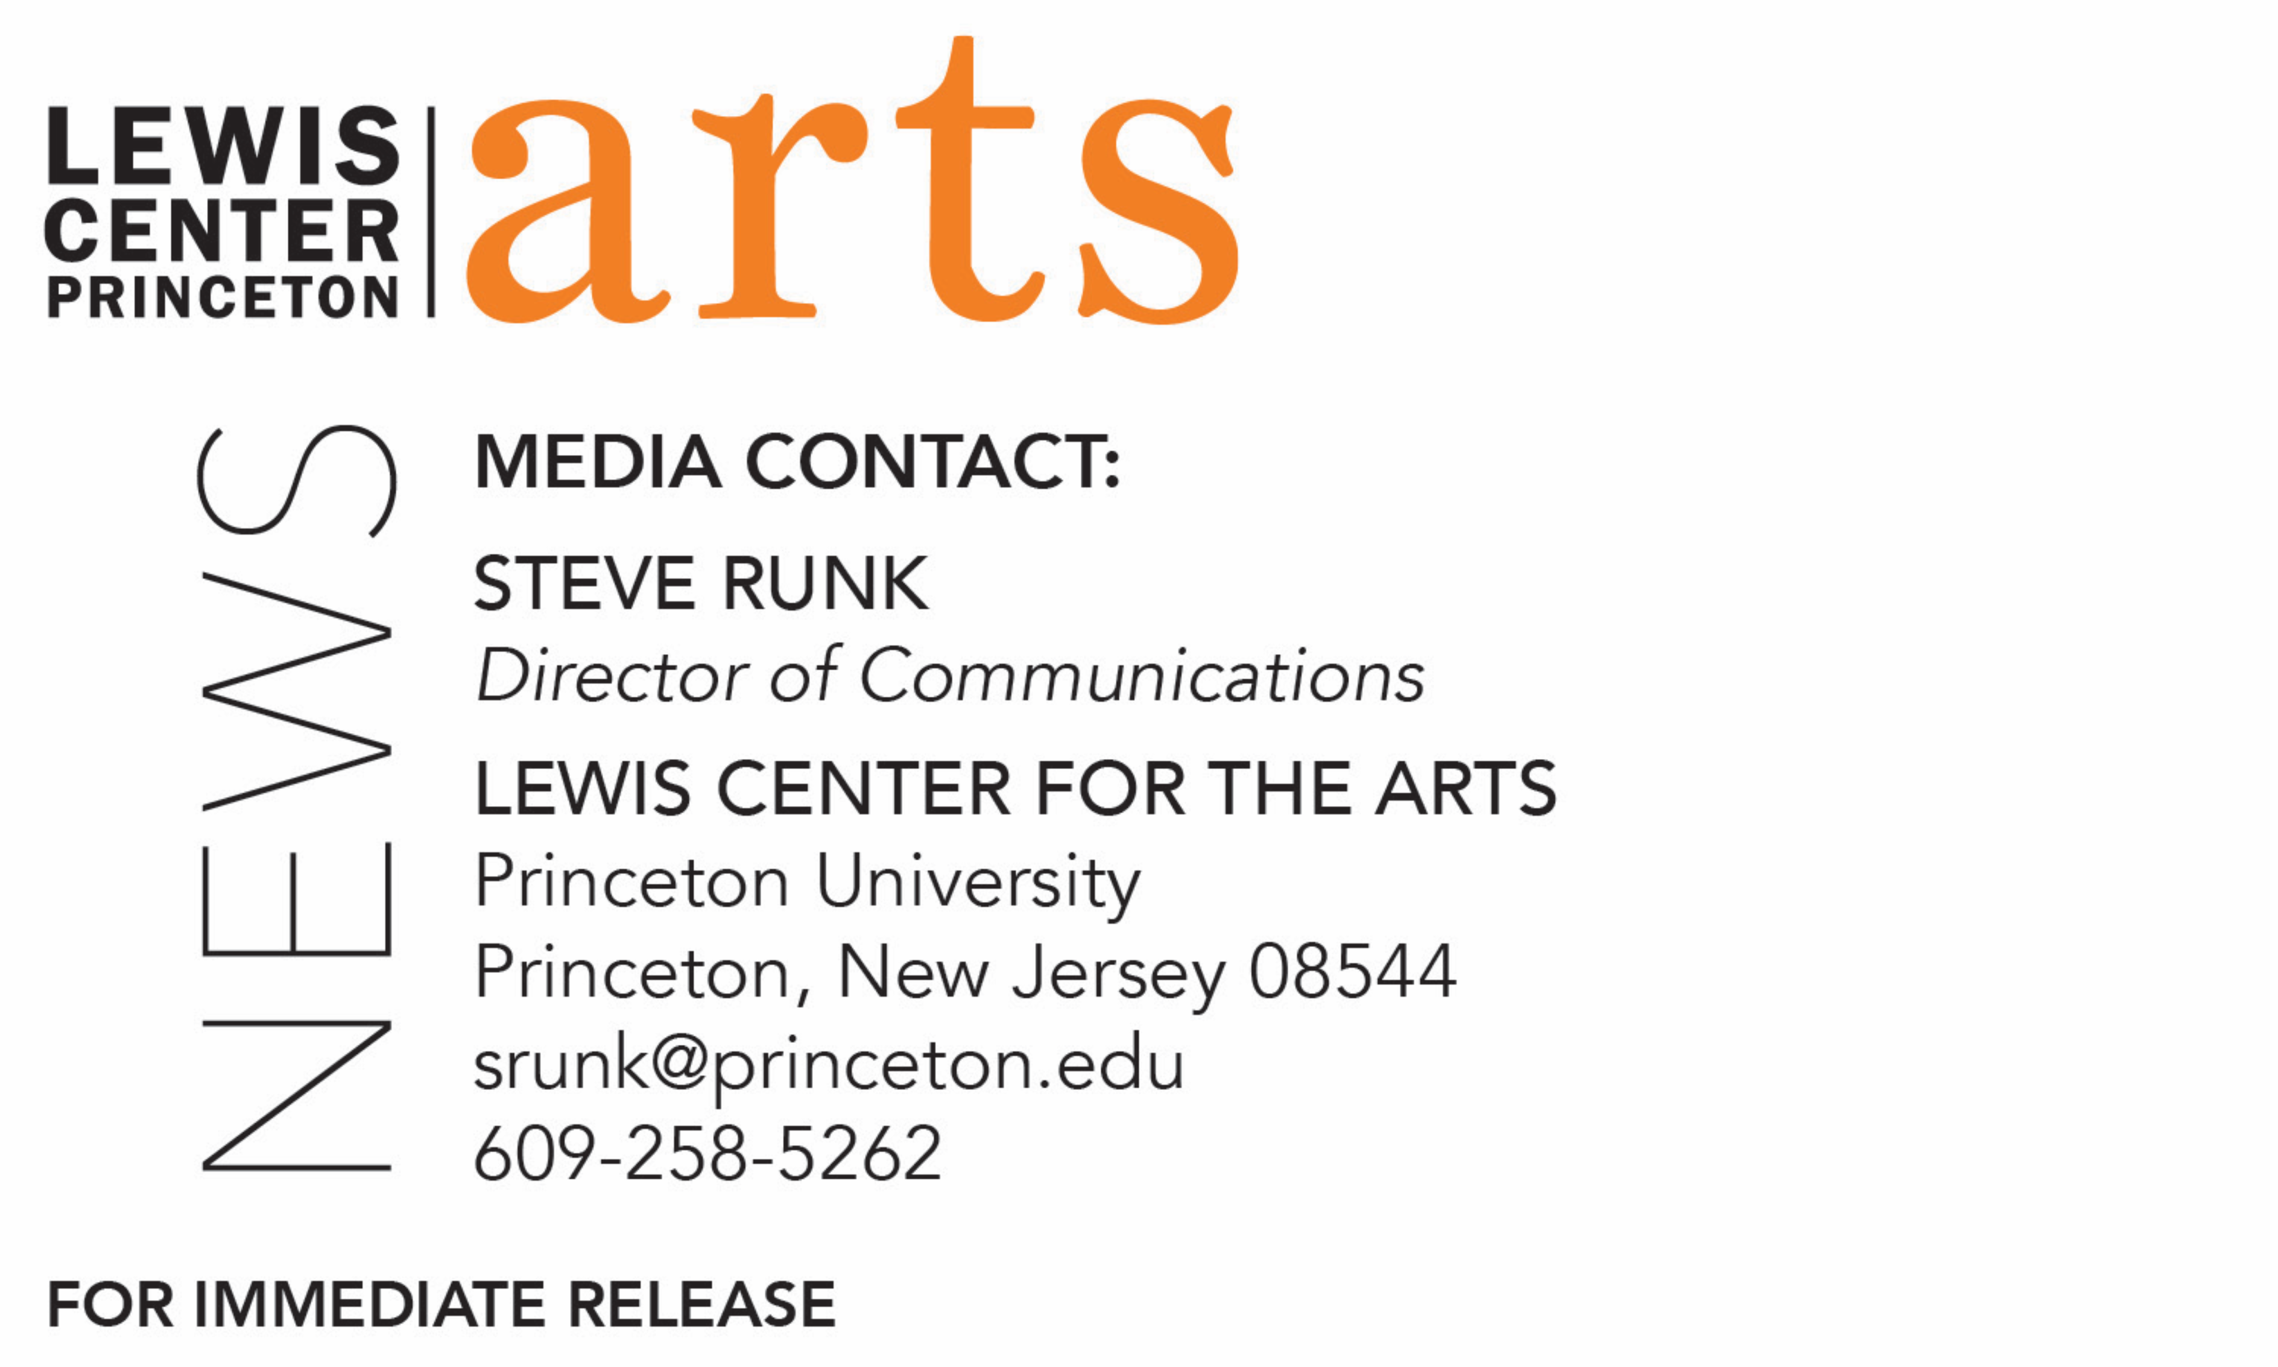

April 30, 2018

Lewis Center for the Arts presents Junior + Senior Film Screening
Screening of three new films by Princeton juniors and seniors

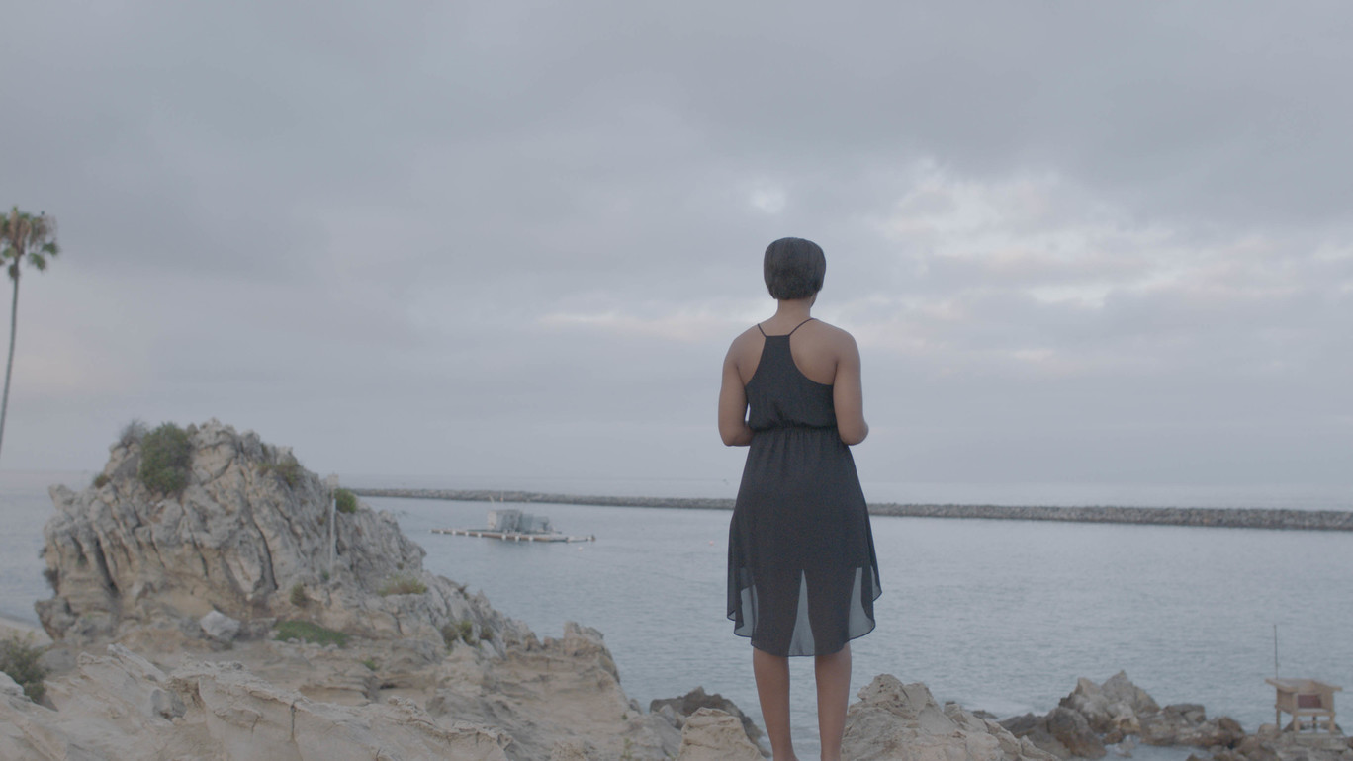
Photo caption: A still from Princeton senior Mariah Wilson’s film, Ibeji
Photo credit: Mariah Wilson

What/Who: Two open screenings of three films by a junior and two seniors in Princeton’s Program in Visual Arts who are focusing on filmmaking: Fishing the Short Run by Pat Rooney, Ibeji by Mariah Wilson, and Perfidia by David Lopera.
When and Where: May 7 at 7:30 p.m. in the Frist Film/Performance Theatre at Frist Campus Center and May 10 at 11:00 p.m. in the Garden Theater, 160 Nassau Street, Princeton
Both showings are free and open to the public

(Princeton, NJ) The Program in Visual Arts in the Lewis Center for the Arts at Princeton University will present a Junior + Senior Film Screening featuring three new short films by students in the Program: Fishing the Short Run by senior Pat Rooney, Ibeji by senior Mariah Wilson, and Perfidia by junior David Lopera. The screening on Monday, May 7 at 7:30 p.m. in the Frist Film/Performance Theatre at Frist Campus Center will be repeated on May 10 at 11:00 p.m. at the Garden Theater at 160 Nassau Street. Both screenings are free and open to the public.

The three student filmmakers are pursuing degrees or certificates in the Program in Visual Arts with a focus on film. Mariah Wilson is a senior majoring in comparative literature and pursuing certificates in visual arts and creative writing, Pat Rooney is a senior majoring in visual arts and pursuing a certificate in environmental studies, and David Lopera is a junior majoring in visual arts.

Pat Rooney’s short film, Fishing the Short Run, tells the story of Alaskan homesteaders and Natives who still live off the land by fishing the salmon run. Recent changes have left many asking, "Where'd all the fish go?" and the answer is bigger than they could have imagined.

Ibeji, by Mariah Wilson, follows a woman, Zora King, who is forced to reconcile with the memory of her younger sister after the sudden death of her mother as Zora is asked to take care of her mother’s “coping bot,” who resembles her sister in more ways than one. A melancholic drama with a touch of science fiction, Ibeji is at its heart a rumination on grief.

Perfidia, by David Lopera, tells the story of a photography project between two friends that takes a wicked turn.

To learn more about this event, the Program in Visual Arts, and the more than 100 other performances, exhibitions, readings, screenings, concerts and lectures offered each year by the Lewis Center, most of them free, visit arts.princeton.edu.

###

