April 26, 2018

Reading and Launch of Nepantla, An Anthology for Queer Poets of Color, presented by the Lewis Center for the Arts
Princeton Arts Fellow Erika Sánchez hosts a reading by poets Natalie Diaz, Dawn Lundy Martin, and Christopher Soto, preceded by a reception and book sale

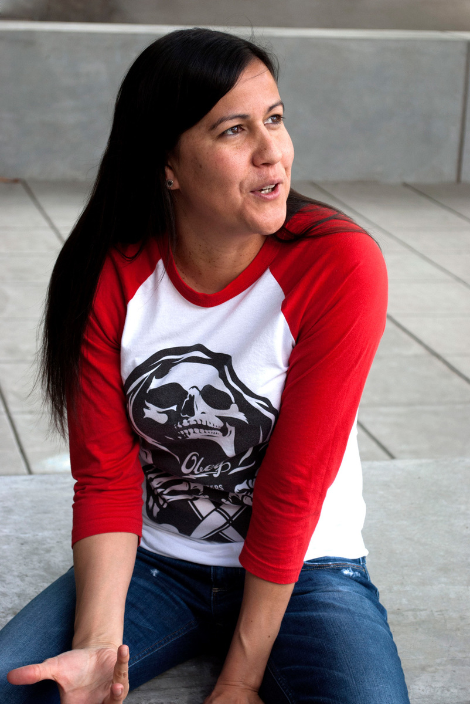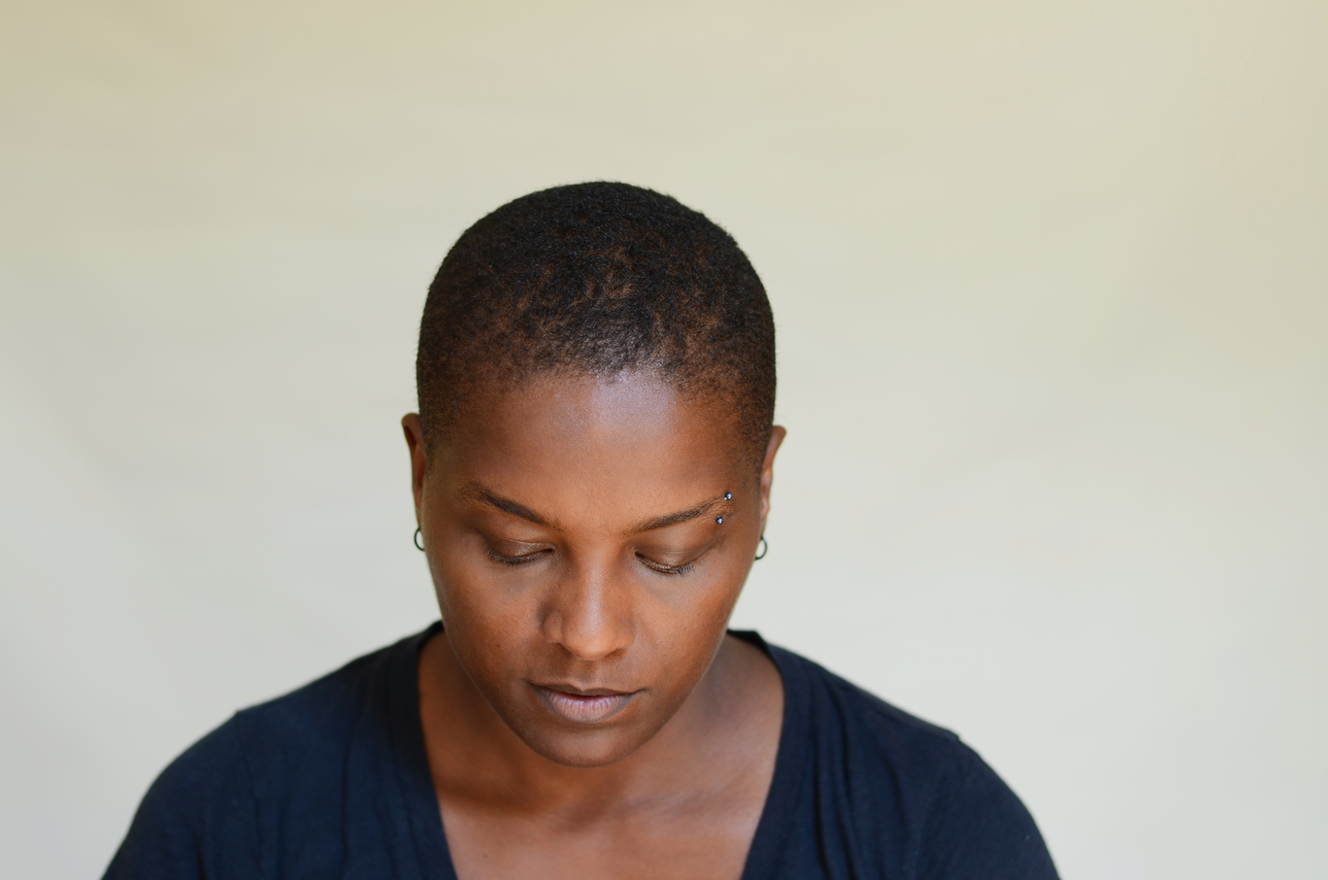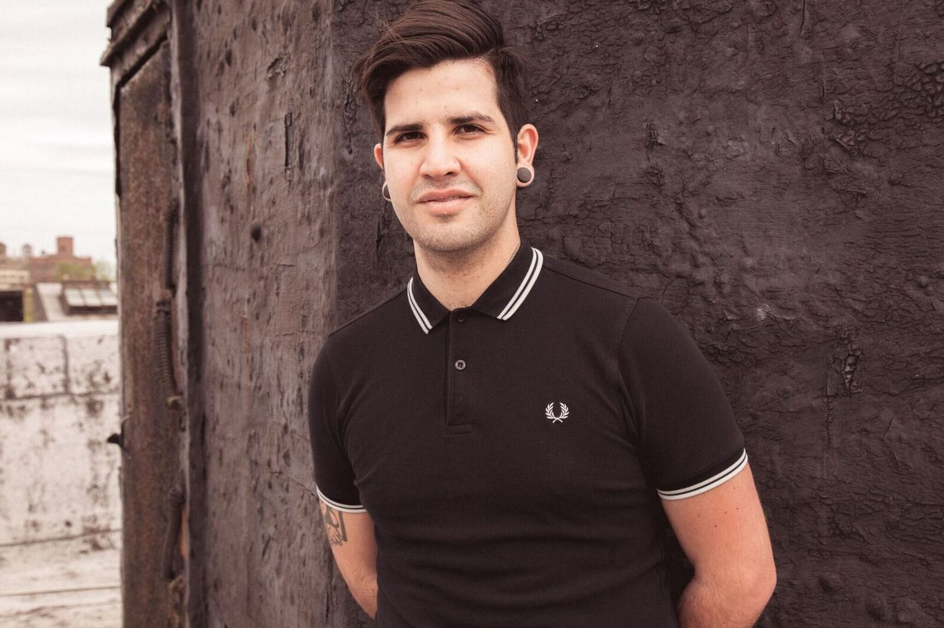
Photo 1 caption: Poet Natalie Diaz
Photo 1 credit: Cybele Knowles
Photo 2 caption: Poet Dawn Lundy Martin
Photo 2 credit: Max Freeman
Photo 3 caption: Poet Christopher Soto
Photo 3 credit: Rachel Eliza Griffiths

What/Who: Reading and Launch of Nepantla, An Anthology for Queer Poets of Color, presented by the Lewis Center for the Arts in collaboration with Lambda Literary and cosponsored by Labyrinth Books in Princeton
When: Tuesday, May 1 at 4:30 p.m. with reception and book sale starting at 4:00
Where: Wallace Theater at the Lewis Arts complex on Princeton University campus
Free and open to the public

(Princeton, NJ) Princeton Arts Fellow Erika Sánchez will host a reading by poets Natalie Diaz, Dawn Lundy Martin, and Christopher Soto in celebration of the launch of Nepantla, An Anthology for Queer Poets of Color (Nightboat Books, May 2018) on Tuesday, May 1 at 4:30 p.m. at Princeton University. The reading will take place in the Wallace Theater at the Lewis Arts complex on the Princeton campus and will be preceded by a reception and book sale in the Forum just outside the theater entrance starting at 4:00 p.m. Presented by the Lewis Center for the Arts and co-organized by Erika Sánchez and Christopher Soto in collaboration with Lambda Literary, and cosponsored by Labyrinth Books in Princeton, the event is free and open to the public.

Nepantla is the first anthology in the English language that spans approximately 100 years of queer poets of color, from the Harlem Renaissance until the present, including work by Langston Hughes, Robert Hayden, Audre Lorde, June Jordan, Erika Sánchez, Natalie Diaz, and Eduardo C Corral.

Erika L. Sánchez, a 2017-19 Princeton Arts Fellow and daughter of Mexican immigrants, is a poet, novelist, and essayist. Her debut poetry collection, Lessons on Expulsion, was published by Graywolf in 2017, and her debut young adult novel, I Am Not Your Perfect Mexican Daughter, was released by Knopf Books for Young Readers in fall 2017. She received a CantoMundo Fellowship, Bread Loaf Scholarship, the 2013 Discovery/Boston Review Prize, and in 2015 was awarded a Ruth Lilly and Dorothy Sargent Rosenberg Poetry Fellowship from The Poetry Foundation. Her work has appeared or is forthcoming in Pleiades, Hunger Mountain, Crab Orchard Review, Hayden’s Ferry Review, Ostrich Review, Copper Nickel, Vinyl Poetry, Guernica, diode, Boston Review, ESPN.com, Paris Review, Gulf Coast, and POETRY Magazine. Her poetry has also been featured on “Latino USA” on NPR and published in Please Excuse This Poem: 100 New Poems for the Next Generation (Viking Press, 2015). From 2012-2015 Sánchez was the sex and love advice columnist for Cosmopolitan for Latinas. She graduated Phi Beta Kappa and Magna Cum Laude from the University of Illinois at Chicago, then went onto Madrid, Spain, on a Fulbright Scholarship and received an M.F.A. in Creative Writing from the University of New Mexico. She has been a contributor to The Guardian, NBC News, Rolling Stone, Al Jazeera, Truthout, Salon, BuzzFeed, Cosmopolitan, Jezebel, Kirkus Review, and The Huffington Post. She is currently working on a collection of personal essays.

Christopher Soto is a poet based in Brooklyn, New York. He is the author of Sad Girl Poems (Sibling Rivalry Press, 2016) and the editor of Nepantla: An Anthology Dedicated to Queer Poets of Color (Nightboat Books, 2018). He cofounded the Undocupoets Campaign and worked with Amazon Literary Partnerships to establish grants for undocumented writers. In 2017, he was awarded “The Freedom Plow Award for Poetry & Activism” by Split This Rock and was invited to teach a “Poetry and Protest Movements” course at Columbia University, as part of the June Jordan Teaching Corp. In 2016, Poets & Writers honored Soto with the “Barnes & Nobles Writer for Writers Award.” He frequently writes book reviews for the Lambda Literary Foundation. His poems, reviews, interviews, and articles can be found at The Nation, The Guardian, The Advocate, Los Angeles Review of Books, American Poetry Review, Tin House, and more. His work has been translated into Spanish, Portuguese, and Thai. He has been invited to speak at university campuses across the country and is currently working on a full-length poetry manuscript about police violence and mass incarceration. He received his M.F.A. in poetry from New York University, where he was a Goldwater Hospital Writing Workshop Fellow.
Dawn Lundy Martin is a poet, essayist, and conceptual-video artist. She is the author of four books of poems: Good Stock Strange Blood (Coffee House, 2017); Life in a Box is a Pretty Life (Nightboat Books, 2015), which won the Lambda Literary Award for Lesbian Poetry; DISCIPLINE (Nightboat Books, 2011), A Gathering of Matter / A Matter of Gathering (University of Georgia Press, 2007), and three limited edition chapbooks. Her nonfiction can be found in The New Yorker, Harper's, and elsewhere. In 2018 she won the National Endowment for the Arts Creative Writing Fellowship in Prose. Martin is professor of English in the writing program at the University of Pittsburgh and co-director of the Center for African American Poetry and Poetics.
Natalie Diaz was born and raised in the Fort Mojave Indian Village in Needles, California, on the banks of the Colorado River. She is Mojave and an enrolled member of the Gila River Indian Tribe. Her first poetry collection, When My Brother Was an Aztec, was published by Copper Canyon Press. She is a Lannan Literary Fellow and a Native Arts Council Foundation Artist Fellow. She was awarded a Bread Loaf Fellowship, the Holmes National Poetry Prize and a Hodder Fellowship, both from Princeton University, and a PEN/Civitella Ranieri Foundation Residency, as well as being awarded a U.S. Artists Ford Fellowship. Diaz teaches at the Arizona State University Creative Writing M.F.A. program. She splits her time between the east coast and Mohave Valley, Arizona, where she works to revitalize the Mojave language.

For more information on the more than 100 performances, exhibitions, readings, screenings, concerts, and lectures presented each year by the Lewis Center for the Arts, most of them free, visit arts.princeton.edu.

###

