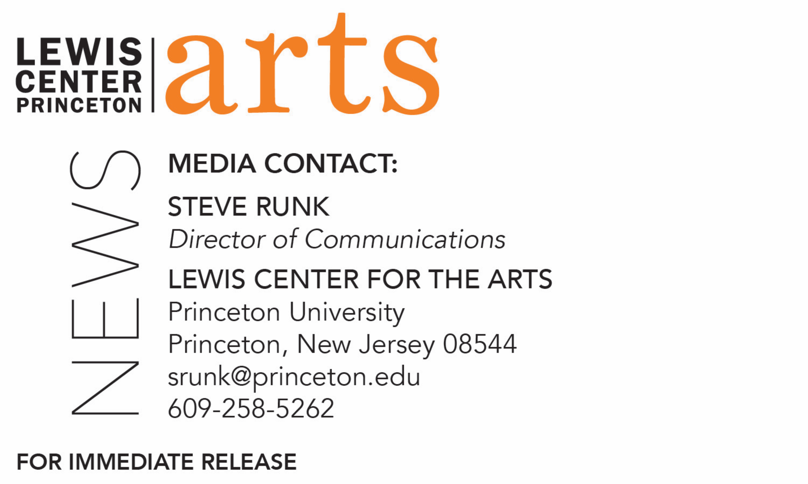

April 30, 2018

Lewis Center for the Arts presents

Readings of New Work by Students in the Creative Writing Program

What: Three Student Readings - Althea Ward Clark W’21 Reading Series

When: Wednesday, May 2 at 5:00 p.m.

Where: Chancellor Green Rotunda on the Princeton University campus
Who: Students in the Lewis Center for the Arts’ Program in Creative Writing workshops read from recent work they created during the spring semester in fiction, poetry, screenwriting and literary translation.
Free and open to the public

When: Tuesday, May 8 at 4:30 p.m.

Where: Prospect House on the Princeton University Campus
Who: Seniors in Princeton’s Program in Creative Writing read from the screenplays, collections of poems, or translations written as their senior theses under mentorship of professional writers on the faculty.
Free and open to the public

When: Wednesday, May 9 at 4:30 p.m.

Where: Prospect House on the Princeton University Campus
Who: Seniors in Princeton’s Program in Creative Writing read from the novels or collections of short stories written as their senior theses under mentorship of professional writers on the faculty.
Free and open to the public

(Princeton, NJ) Students in the Lewis Center for the Arts’ world-renowned Program in Creative Writing at Princeton University will present new work in a series of readings. On May 2 at 5:00 p.m. at Chancellor Green Rotunda on the University campus, 26 students from spring workshops in fiction, poetry, screenwriting, and literary translation will read from work they have completed during the past semester. At two additional readings, seniors completing a certificate in the Program will read from their thesis work, which they completed over the course of the 2017-2018 academic year. On May 8 at 4:30 p.m. in Prospect House, senior thesis students will read from their recent work in poetry, screenwriting, and translation; on May 9 at 4:30 p.m., also in Prospect House, seniors will read from their recent work in fiction. The readings, part of the Program in Creative Writing’s Althea Ward Clark W’21 Reading Series at the Lewis Center for the Arts, are free and open to the public.

Through the Program, students can earn a certificate in creative writing in addition to their degree in a major. They have the opportunity to pursue original work in fiction, poetry, screenwriting, and translation under the guidance of practicing, award-winning writers, including Jeffrey Eugenides, Jhumpa Lahiri, Yiyun Li, Paul Muldoon, James Richardson, Tracy K. Smith, Kirstin Valdez Quade, and Susan Wheeler. Small workshop courses, averaging eight to ten students, provide intensive feedback and instruction for both beginning and advanced writers. Each year, 20 to 30 seniors work individually with a member of the faculty on a creative writing thesis, such as a novel, screenplay, or a collection of short stories, poems, or translations.

On May 8, seniors who will be presenting work in poetry are Mim Ra Aslaoui, Nicolas Freeman, Isabella Grabski, Edric Huang, Alicia Lai, Sang Lee, Robert Marshall, Sarah Reeves, Catherine Saterson, and Rosed Serrano. Fiona Bell and Jay Kim will read from their work in translation, and Anhar Karim, Kevin Romero, David Shin, and Mariah Wilson will read from their work in screenwriting.

Seniors presenting work in fiction on May 9 are Kyle Berlin, Adam Berman, Joy Chen, Katherine Frain, Aidan Gray, Elliot Hirsch, Rebecca Kahn, Lavinia Liang, Allison Light, Allie Mendelsohn, Rebecca Schnell, and Lydia Weintraub.

Graduates of the Program include such well-known and diverse writers as Jonathan Ames ’87, Jane Hirshfield ’73, Jodi Picoult ’87, Jonathan Safran Foer ’99, and Monica Youn ’93.

The Althea Ward Clark W’21 Reading Series annually brings a number of distinguished writers to campus to read and discuss their work, in addition to readings by students. Writers who read from their works over the past academic year included Yiyun Li, Eduardo C. Corral, Nathaniel Mackey, Rachel Cusk, Hoa Nguyen, Alaa Al Aswany, Linda Gregerson, Luc Sante, Osama Alomar, Walter Mosley, and Jane Hirshfield. All readings are free and open to the public.

To learn more about the Program in Creative Writing, the reading series, and the more than 100 performances, exhibitions, readings, screenings, concerts and lectures offered each year by the Lewis Center for the Arts, most of them free, visit arts.princeton.edu.

###

