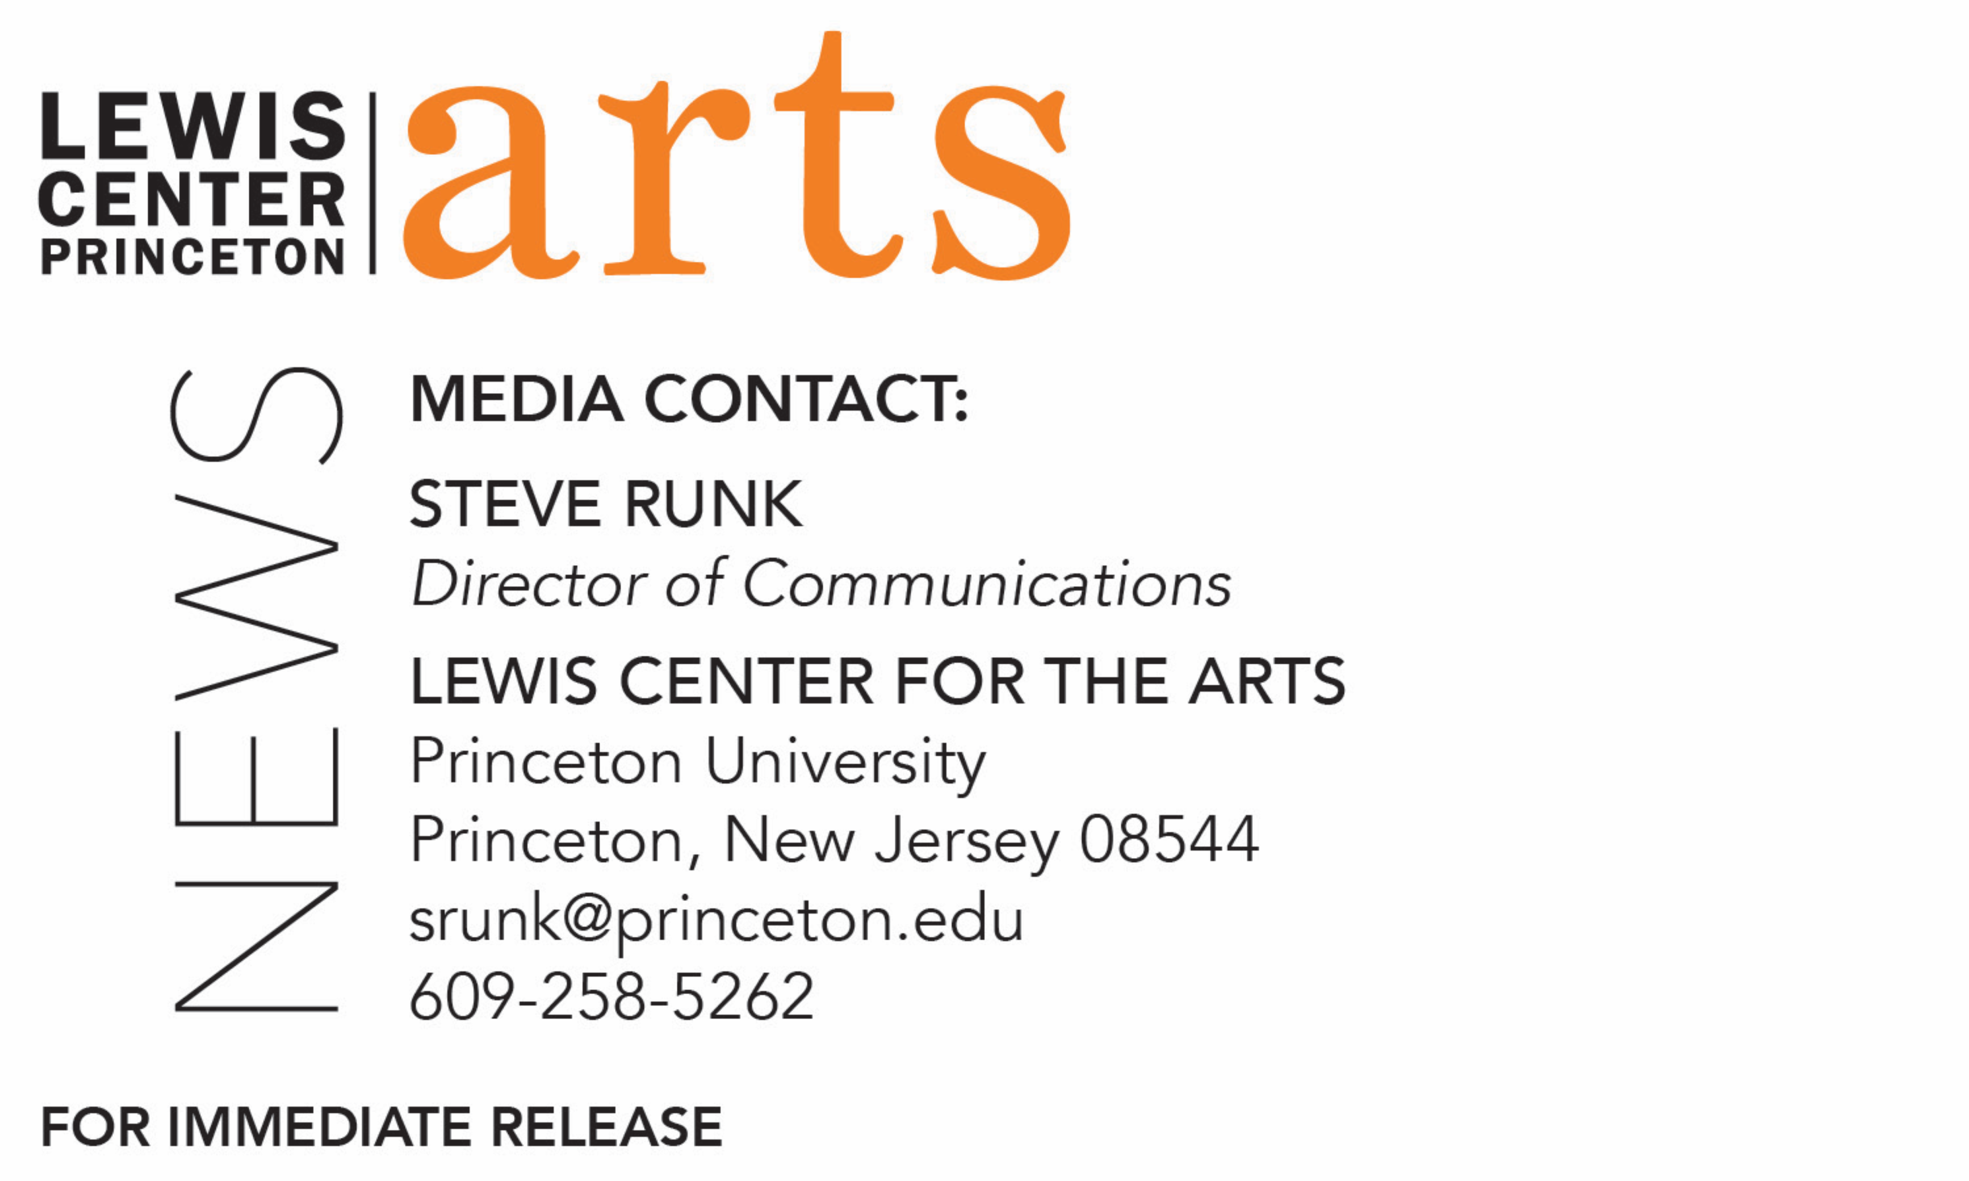

May 15, 2018

The Lewis Center for the Arts presents
The Big Time Senior Wrap-Up Kick-Off Blowout Expo ’18
A special, mixed media exhibition of work by graduating seniors in the Visual Arts program

Photo caption 1: An installation view of senior Angélica María Vielma’s exhibition The Incorruptible Body (left image)
Photo caption 2: A work from senior Imani Ford’s exhibition Wound (right image)
Photo credits: Justin Goldberg

What: The Big Time Senior Wrap-Up Kick-Off Blowout Expo ’18, an exhibition of recent work in a wide range of media
Who: Work created by 19 graduating seniors in the Lewis Center for the Arts’ Program in Visual Arts at Princeton University
When: Thursday, May 17 - Wednesday, June 6; opening reception on Thursday, May 17 from 6:00 p.m. - 7:30 p.m.
Where: Hurley Gallery at the Lewis Arts complex on Princeton University Campus.
Gallery Hours: Daily from 10:00 a.m. - 8:30 p.m
Free and open to the public

(Princeton, NJ) The Visual Arts Program in the Lewis Center for the Arts at Princeton University will present an exhibition of recent work in a wide range of media by 19 graduating seniors in the Program. The exhibition, titled The Big Time Senior Wrap-Up Kick-Off Blowout Expo ’18, will highlight work by students completed as part of their senior thesis projects and will be on view from Thursday, May 17 to Wednesday, June 6 in the Hurley Gallery in the Lewis Arts complex on Princeton University campus. An opening reception at the gallery will be held on May 17 from 6:00 p.m. to 7:30 p.m. The exhibition and reception are free and open to the public.

This multimedia show, including film work showcased on monitors in the gallery, features the work of 19 seniors: Sandy Carpenter, Gabrielle Chen, Gabriella Chu, Logan Dziak, Imani Ford, Gabrielle Gibbons, Gwyndolyn Goldfeder, Heather Grace, Mihika Kapoor, Anhar Karim, Paulina King, Eric Li, Helen Lin, Kathleen Ma, Pat Rooney, Rachel Schwartz, Angélica María Vielma, Mariah Wilson, and Jonathan Zong.

The work featured in this exhibition has been selected from among photography, paintings, drawings, prints, sculpture, photography, film, video and multimedia installations created by students majoring in visual arts or earning a certificate in visual arts in addition to a degree in their major. Each presented a solo exhibition or a screening of new work during the past semester as a requirement of the program.

The seniors’ exhibitions and bodies of work included diverse explorations including: how viral East Asian subculture impacts the construction of Asian-American identity and how the subculture was pushed into mainstream attention by female-dominated adolescent “productive consumerism; a fashion show of reconstructed and repurposed clothes that comments on the incredibly lucrative but flawed fast fashion industry; a film that tells the story of Alaskan homesteaders and Natives who still live off the land by fishing the salmon run and recent changes that have impacted this community and its livelihood; mixed media works that explore themes of authority, instructions, agency, and individual/collective responsibility; a series of portraits of children with cranial facial disorders that addresses the metaphors used to limit people with disabilities and their potential; an examination of the difficulties of presenting graphic design outside of its context; and a show by a visual arts major pursuing a certificate in dance that focused on an interdisciplinary exploration of how we express and experience personal relationships through food.

Many of the seniors plan to continue working in the visual arts field when they graduate, while others will take what they have learned as student artists into a career in another field.

The Hurley Gallery is open daily from 10:00 a.m. to 8:30 p.m.

To learn more about the exhibition, the Program in Visual Arts, and the more than 100 performances, exhibitions, readings, screenings, concerts and lecture presented each year at the Lewis Center, most of them free, visit arts.princeton.edu.

###

